Task 3 — Analysis of the Learning Process (extended reading copy)
Neyshekar Persian ASR · 3 epochs, 6,270 optimizer steps on a single NVIDIA L4

1. What was measured, and how
Quantity | Frequency | How it is computed
Training loss | every 10 steps | teacher-forced cross-entropy on the training batch
Validation loss | every 1,500 steps | teacher-forced cross-entropy on held-out data
WER and CER | every 1,500 steps | free autoregressive generation, then compared to the reference

That gives 627 training-loss points and five evaluation points across the run.
Loss and error rate are not the same measurement. Loss is computed with teacher forcing: at every position the model is handed the correct previous tokens and only has to predict the next one. WER and CER require it to generate the whole transcript unaided, so an early mistake propagates. The two can move independently, and the error rates are the harder test. This matters for reading everything below — a falling loss does not by itself mean the transcripts are getting better.
The evaluation subset. Each in-training evaluation ran over a fixed, deterministically sampled 500-row subset of the validation split rather than all 5,900 rows. Generation is expensive: those five evaluations cost 49 minutes as it was, and the full split took 1 h 53 min on its own. The final reported metrics were measured over the whole split at the end. Where the two disagree, section 5 uses the disagreement rather than ignoring it.

2. Results
Step | Epoch | Train loss | Val loss | WER % | CER %
1,500 | 0.72 | 0.4192 | 0.16152 | 16.30 | 4.77
3,000 | 1.44 | 0.2081 | 0.12877 | 12.50 | 3.12
4,500 | 2.15 | 0.1110 | 0.10067 | 9.57 | 2.28
6,000 | 2.87 | 0.0779 | 0.08704 | 8.19 | 1.94
6,270 | 3.00 | 0.0678 | 0.08567 | 8.17 | 1.90
final, all 5,900 rows | 3.00 | — | 0.08627 | 8.05 | 2.00

The training-loss column is the single value logged at that step, and single values are noisy — each is the mean over 10 steps, or 160 samples. At step 1,500 the logged value is 0.4192 while the mean of the ten surrounding points is 0.3563. The trend matters more than any individual reading, which is why Figure 1 carries a moving average.
 | First evaluation | Last evaluation | Reduction
Validation loss | 0.16152 | 0.08567 | 47.0%
WER | 16.30% | 8.17% | 49.9%
CER | 4.77% | 1.90% | 60.2%

3. Training loss
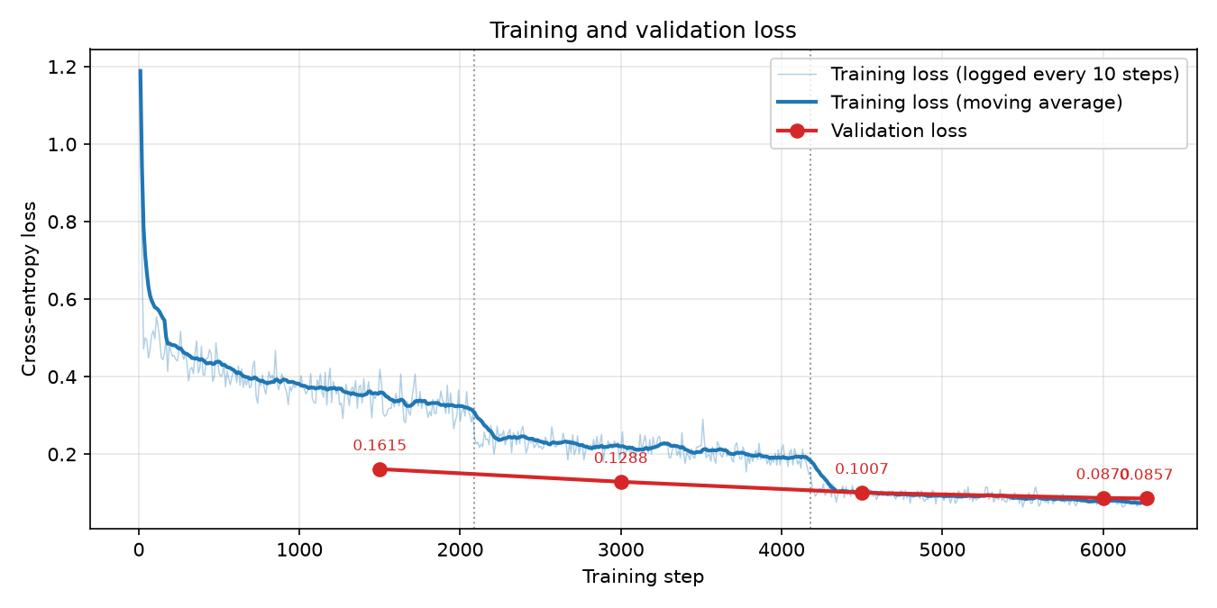
Figure 1 — Training and validation loss. Dotted lines mark the epoch boundaries.
Training loss fell from 1.1888 at step 10 to 0.0678 at step 6,270, with a minimum of 0.0633. The decline is not smooth, and the shape is more informative than the endpoints.

The first thirty steps
Step | Loss | Learning rate
10 | 1.1888 | 1.8e-04
20 | 0.6919 | 3.8e-04
30 | 0.4717 | 5.8e-04
60 | 0.4483 | 9.99e-04 (peak)
300 | 0.4350 | 9.60e-04

Most of the total drop happens in three logged points, and it is complete before the learning rate finishes warming up — at step 30 the rate was still only 5.8e-04 of an eventual 1e-03. Between steps 30 and 300 the loss then sits between 0.44 and 0.51 with no trend at all.
The natural reading is that this first collapse is not the model learning Persian. It already knows Persian. What it is adjusting to is the transcription convention of this particular corpus — the spacing, the colloquial verb endings, the absence of numerals — and that adjustment is largely a change in output formatting, which is cheap. The slow part comes afterwards.

What happens at the epoch boundaries
The curve steps down sharply where each epoch ends rather than declining evenly. Measuring the 200 steps either side separates that step from the within-epoch trend:
 | Decline within the epoch | Step at the boundary that follows
Epoch 1 (steps 1–2,090) | 0.5294 → 0.3115 (−0.2179) | 0.3115 → 0.2384 (−0.0731)
Epoch 2 (steps 2,091–4,180) | 0.2384 → 0.1863 (−0.0521) | 0.1863 → 0.1050 (−0.0813)
Epoch 3 (steps 4,181–6,270) | 0.1050 → 0.0748 (−0.0302) | —

This is the most telling thing in the run. From the second epoch onward, the drop at the instant of crossing an epoch boundary is larger than the entire decline across the epoch that follows it: −0.0813 at the boundary against −0.0302 over the whole of epoch 3. Counting the whole run, 34% of the total training-loss reduction happens at two instants, and if the first epoch is excluded as initial adaptation, the boundaries account for 65% of everything that follows.
Nothing about the optimizer changes at an epoch boundary — the learning rate decays linearly straight through it. The only thing that changes is that the model starts seeing examples it has already seen. A step down at exactly that point means the improvement is coming from re-exposure to specific training examples rather than from continued generalisation. Validation loss, by contrast, has no steps anywhere: it falls smoothly and decelerates. Those two facts together locate where the remaining training-loss reduction was actually coming from by the third epoch.
Mean training loss per epoch was 0.3851, 0.2146 and 0.0897 — each roughly half the last, which reads as steady progress until the decomposition above shows how much of it happened at the joins.

4. Validation loss, and where the curves cross
Validation loss fell at every measurement: 0.16152 → 0.12877 → 0.10067 → 0.08704 → 0.08567. It never rose.
Step | Training | Validation | Which is lower
1,500 | 0.4192 | 0.16152 | validation, by 0.258
3,000 | 0.2081 | 0.12877 | validation, by 0.079
4,500 | 0.1110 | 0.10067 | validation, by 0.010
6,000 | 0.0779 | 0.08704 | training, by 0.009
6,270 | 0.0678 | 0.08567 | training, by 0.018

Validation loss starting below training loss looks wrong at first glance and is not. Two mechanical reasons: LoRA dropout of 0.05 is active while training loss is measured and disabled during evaluation, so the model is handicapped in the first measurement and not the second; and training loss is averaged over a window during which the model is still improving, while validation loss is a snapshot taken at the end of it.
The lines cross between step 4,500 and step 6,000, and the gap then widens — 0.009, then 0.018. That is the point at which the model begins to fit the training set more closely than the held-out set, and it lines up with the epoch-boundary pattern in section 3. It is the beginning of the process that becomes overfitting if training continues, not overfitting itself: validation loss was still falling when training stopped.

5. Word and character error rate
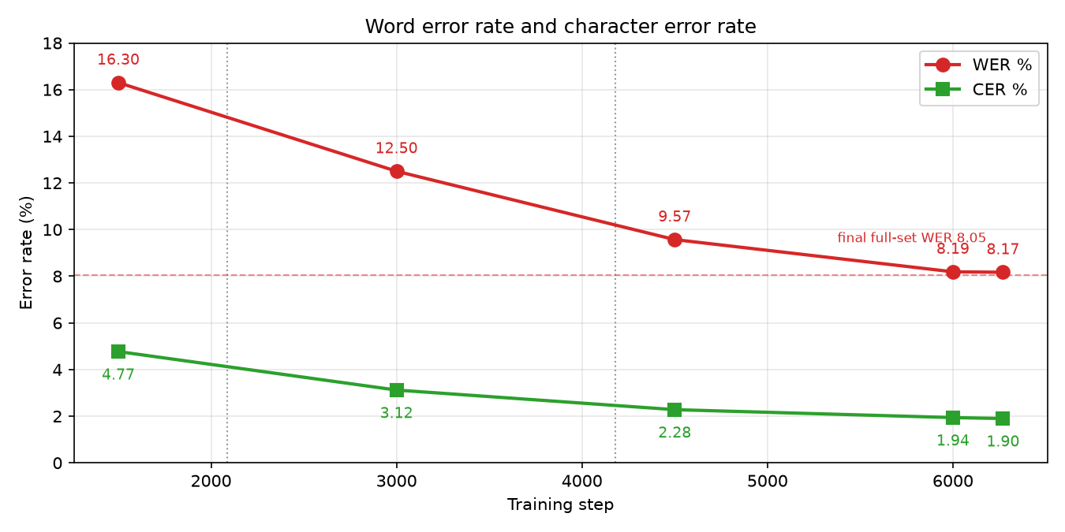
Figure 2 — WER and CER at each evaluation. The dashed line is the final full-split WER.
WER improved from 16.30% to 8.17%, CER from 4.77% to 1.90%. The returns diminish sharply:
Interval | WER change | Steps
1,500 → 3,000 | −3.80 points | 1,500
3,000 → 4,500 | −2.93 points | 1,500
4,500 → 6,000 | −1.38 points | 1,500
6,000 → 6,270 | −0.02 points | 270

How much of that last figure is real. The final 270 steps moved WER by 0.02 points while training loss fell from 0.0779 to 0.0678 over the same interval. It is tempting to read the 0.02 as a small real improvement, but the measurement is not precise enough to support that. The same checkpoint scored 8.17% on the 500-row subset and 8.05% on the full 5,900 rows — a 0.12-point disagreement between two measurements of one identical model. The last observed change is six times smaller than that, so it sits well inside the sampling noise of a 500-row estimate. The honest statement is that WER stopped moving measurably after step 6,000, not that it improved slightly.
The subset also disagreed with the full split in different directions for the two metrics — WER higher on the subset, CER lower — which is what sampling noise looks like rather than a systematic bias in either.
Why CER is so much lower than WER. The final ratio is 8.17 to 1.90, better than four to one. WER marks a whole word wrong if one character differs; CER counts only the characters that differ. A ratio this wide means most of what remains is small differences inside otherwise-correct words rather than whole words misrecognised. Task 4 takes those errors apart and finds that a quarter of them are Persian spacing and homophone-letter conventions, which is exactly the kind of error that inflates WER while barely touching CER.

6. Did it overfit, and had it converged?
Overfitting: no. Validation loss decreased at all five measurements and was still decreasing at the end. WER and CER decreased monotonically. The training/validation gap at the end was 0.018. Overfitting is the opposite pattern — training loss falling while validation loss and error rates rise — and it does not appear anywhere in this run.
Two structural reasons make it unlikely at this scale. LoRA trains 15.7 M of 1.56 B parameters, 1.01%, which is very little capacity in which to memorise 33,432 samples. And the linear schedule had decayed the learning rate to 1.6e-07 by the end, so the last updates were negligible in size.
Convergence: effectively yes, by step 6,000. WER did not move measurably over the final 270 steps, and the training-loss decomposition in section 3 shows where the remaining improvement was going. A fourth epoch would very likely have continued that trade — better training loss, another step down at the boundary, and little or nothing on the held-out set. The run stopped at a reasonable place, though it stopped there because the brief specified three epochs rather than because a stopping criterion fired.
One caveat belongs here rather than being left to the reader. Task 1 established that 51.9% of validation transcripts also occur in the training split, with different audio. The decoder has therefore already been trained to produce half of these sentences, which makes validation loss and WER more forgiving than they would be on unseen text. That affects the level of every number in this section. It does not affect the shapes — the epoch steps, the crossover, the flattening — which are what the analysis rests on.

7. Stability
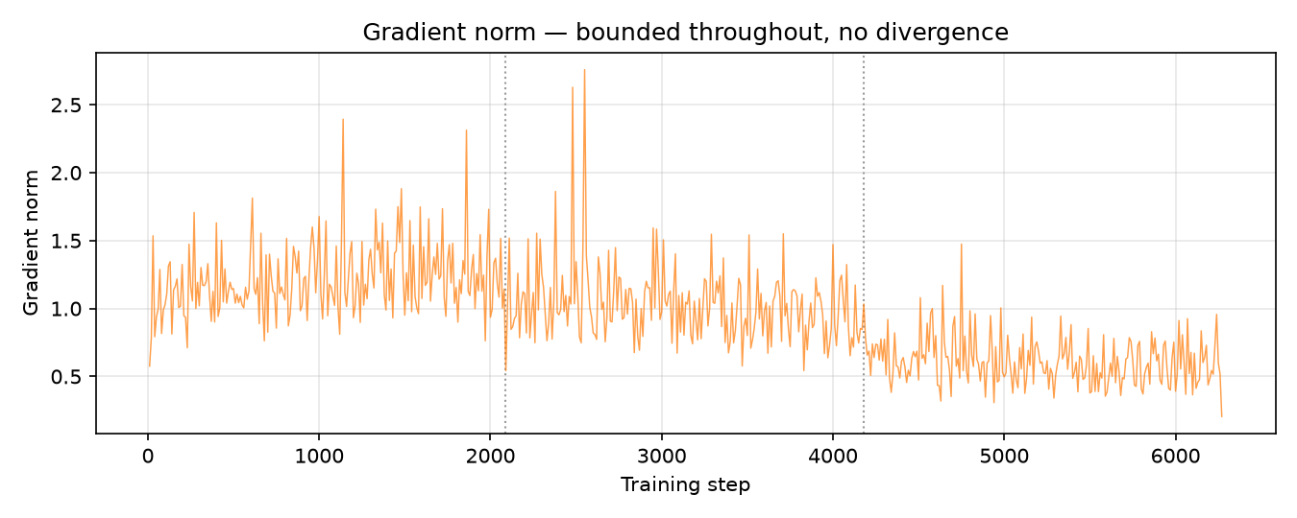
Figure 3 — Gradient norm across the run.
Gradient norm | Value |  | Count
Minimum | 0.205 | Above 1.0 (the clipping threshold) | 279 of 626 (44.6%)
Maximum | 2.759 | Above 1.5 | 36
Mean | 0.950 | Above 2.0 | 4
Median | 0.948 | NaN | 1

Clipping was active, and this matters for how the table is read. train.py does not set max_grad_norm, so the Trainer's default of 1.0 applied throughout. The logged norm is the value before clipping, and 44.6% of updates exceeded the threshold and were rescaled. It would be wrong to describe this run as one where clipping was never needed. The evidence for stability is different and more specific: the norm stayed bounded, only four points in 626 went above 2.0, the maximum was 2.759, and there is no drift or growth over the run. Clipping was doing routine work, not rescuing a diverging optimisation.

The single NaN
step 1050 loss 0.3622 grad norm 0.946
step 1060 loss 0.3691 grad norm 1.178
step 1070 loss 0.4082 grad norm 1.158
step 1080 loss 0.3433 grad norm NaN <- scaler overflow, update skipped
step 1090 loss 0.3335 grad norm 1.023
step 1100 loss 0.3319 grad norm 1.460
One NaN gradient norm was logged, at step 1,080. This is the documented behaviour of fp16 mixed precision: the gradient scaler detected an overflow, skipped that optimizer update and halved the loss scale. The neighbouring norms are ordinary and the loss continues falling straight through the event without a spike. One occurrence in 627 logged points is the scaler working, not training becoming unstable.

Learning rate schedule
50 warmup steps, then linear decay to zero over the remaining 6,220. The logged values confirm the schedule ran exactly as configured: 1.8e-04 at step 10, which is 1e-03 × 9/50; a peak of 9.986e-04 just after warmup ends; and 1.608e-07 at step 6,270, which is 1e-03 × 1/6,220. The warmup is visible in the loss curve as the initial collapse described in section 3, and the decay is why the final steps could not have moved the model far even if there had been more of them.

8. Summary
Question | Answer
Did the model learn? | Yes — WER halved, CER fell 60.2%, validation loss fell 47.0%
Did it overfit? | No — validation loss fell at every measurement and was still falling
Was training stable? | Yes — norm bounded, max 2.759, one benign fp16 scaler event
Had it converged? | Effectively by step 6,000; the last 270 steps moved WER less than the measurement noise
Best checkpoint | Step 6,270, the final one — WER improved monotonically
Where was the last improvement going? | Into the training set: 65% of post-epoch-1 training-loss reduction occurred at the two epoch boundaries

