Introduction to Time Series Analysis and Data Types

1. What is Time Series Analysis?
Time series analysis is a statistical technique used to analyze temporal data. It involves examining time-ordered data points to identify patterns, trends, and seasonal variations to make predictions or understand underlying processes.

2. Objectives of Time Series Analysis
- Descriptive Analysis: Summarizing data behavior over time.
- Forecasting: Predicting future values.
- Modeling Relationships: Understanding dependencies between variables.
- Control and Monitoring: Identifying anomalies or shifts in trends.

3. Applications of Time Series Analysis
Time series analysis has a wide range of applications across various domains:
- Finance: Stock price prediction, risk management, and algorithmic trading.
- Economics: GDP forecasting, unemployment rate analysis, and inflation prediction.
- Weather Forecasting: Predicting temperature, rainfall, and other meteorological factors.
- Healthcare: Monitoring patient vitals, predicting disease outbreaks, and analyzing medical data over time.
- Retail: Sales forecasting, inventory management, and customer demand analysis.
- Energy: Electricity load forecasting, renewable energy production analysis, and energy consumption patterns.

4. Types of Data
- Time Series Data: Data collected at different time points in a sequential manner (e.g., daily stock prices, monthly rainfall).
Example:
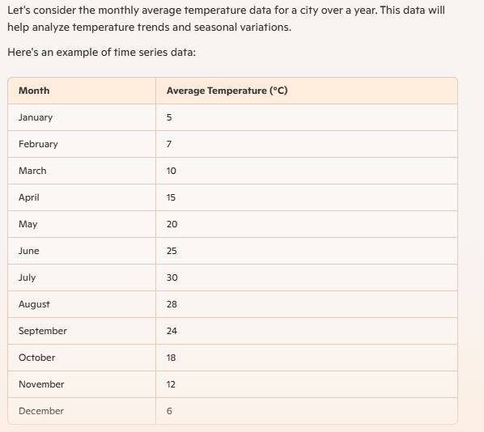

- Cross-Sectional Data: Data collected at a single point in time across multiple subjects (e.g., income levels of different households in a city at one time).
Example:
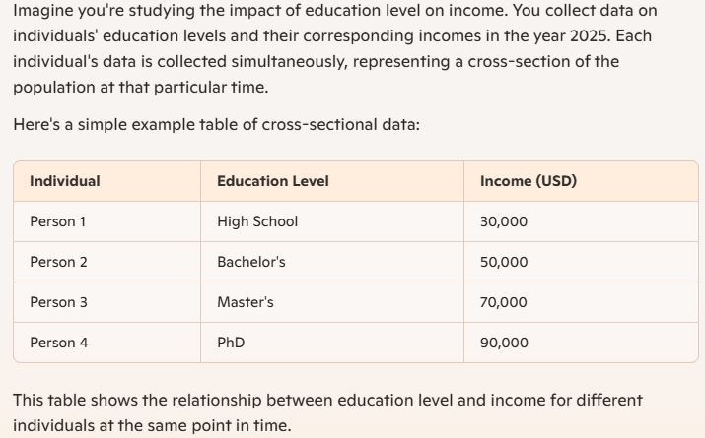
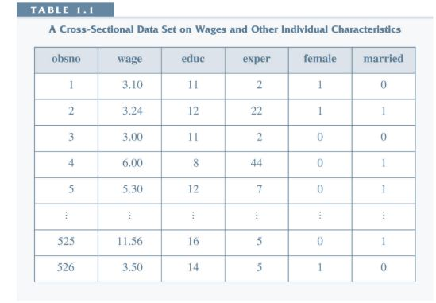
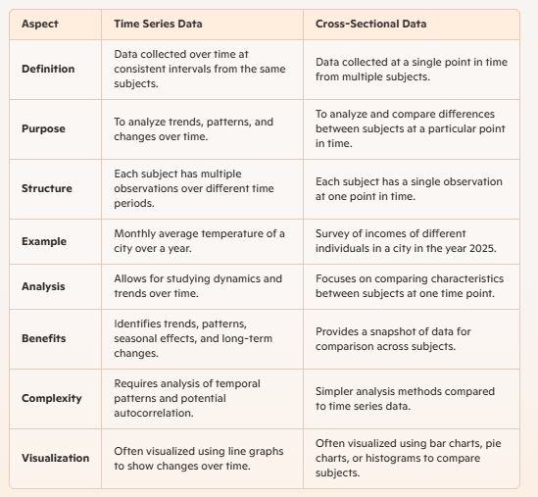
- Pooled Data: Combination of cross-sectional and time series data where repeated observations are taken over different subjects but not necessarily in a panel structure.
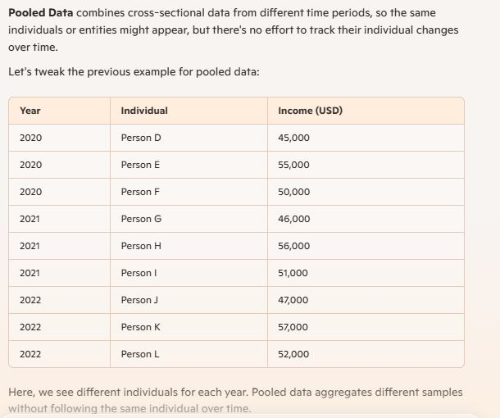

- Panel Data (Longitudinal Data): Data collected from the same subjects over multiple time periods (e.g., tracking economic growth of specific countries over years).
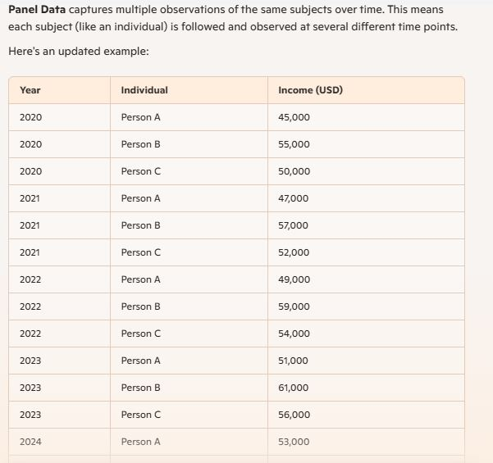
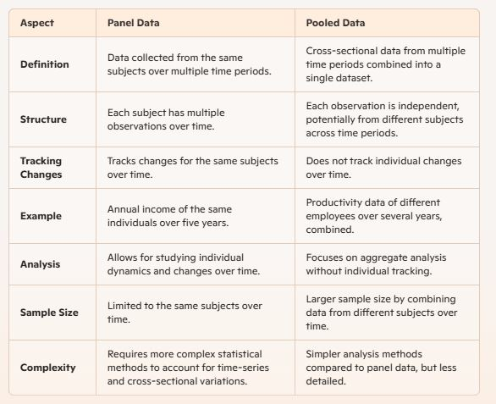
  - Definition of Time Series
A time series is a sequence of data points collected or recorded at specific time intervals. These data points are typically ordered in time, and the analysis involves understanding the underlying structure to make predictions or inferences.
- Components of Time Series Data
A time series can be decomposed into several components, each representing a different aspect of the data:
- Trend (T): The long-term movement in the data. It represents the underlying direction (upward, downward, or stationary) over a long period.
- Seasonality (S): The repeating short-term cycle in the data. It is a pattern that repeats at regular intervals, such as daily, monthly, or quarterly.
- Cyclical (C): The fluctuations that are not of a fixed period. These are often influenced by economic or other external factors and can last for several years.
- Irregular (I): The random or noise component that cannot be explained by the trend, seasonality, or cyclical components. It represents the unpredictable variations in the data.
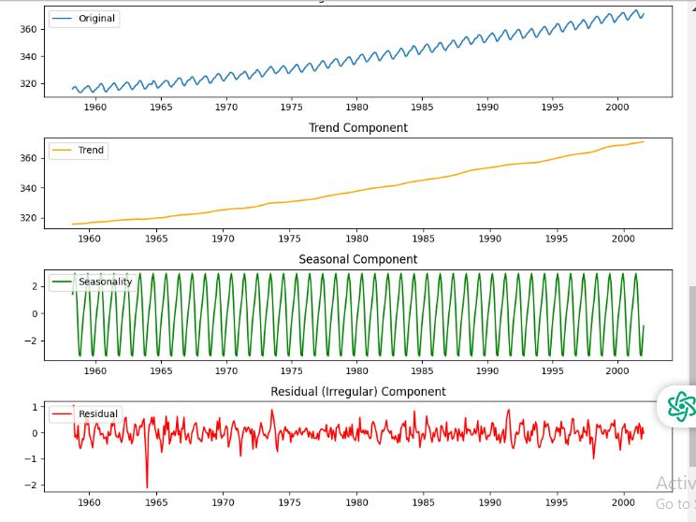
The decomposition can be additive or multiplicative:
- Additive Model: Y(t)=T(t)+S(t)+C(t)+I(t)Y(t)=T(t)+S(t)+C(t)+I(t)
- Multiplicative Model: Y(t)=T(t)×S(t)×C(t)×I(t)Y(t)=T(t)×S(t)×C(t)×I(t)
Time series data can be decomposed into several key components:
- Trend (Tt): The overall direction of the data.
- Seasonality (St): Repetitive and predictable fluctuations.
- Cyclical Component (Ct): Long-term oscillations due to economic conditions.
- Irregular Component (It): Unpredictable, random variations.

Challenges in Time Series Analysis
- Non-stationarity: Many time series are non-stationary, meaning their statistical properties change over time. This requires transformations like differencing to make the series stationary.
- Missing Data: Handling missing data points is a common challenge, requiring imputation techniques.
- Outliers: Detecting and managing outliers that can skew the analysis.
- High Dimensionality: Dealing with multivariate time series where multiple variables are recorded over time.

5. Time Series Models

a) Additive Model
Yt=Tt+St+Ct+It Used when seasonal variations remain constant over time.

b) Multiplicative Model
Yt=Tt×St×Ct×It Used when seasonal variations change proportionally with level.

References
- Hyndman, R.J., & Athanasopoulos, G. (2018). Forecasting: principles and practice. OTexts.
- Box, G.E.P., Jenkins, G.M., & Reinsel, G.C. (2008). Time Series Analysis: Forecasting and Control. Wiley.

