INCIDENT RESPONSE REPORT
MySQL Database Compromise & Extortion – Host corp-na01-bp123na
Field | Value
Report date | August 19, 2026
Prepared by | SOC Analyst – [name] (Cowork-assisted draft; requires analyst review)
Affected asset | corp-na01-bp123na (MySQL database server)
Incident window (log evidence) | Aug 14, 2026 08:47 MT – Aug 18, 2026 01:42 MT (times as recorded in source logs, America/Denver)
Data sources reviewed | MySQLAudit_CL AuthLogs.csv (231 events), MySQLAudit_CL Queries.csv (927 events)
Data sources NOT available for this review | DeviceLogonEvents, DeviceProcessEvents, DeviceRegistryEvents, DeviceNetworkEvents, DeviceFileEvents, NTANetAnalytics
Classification | Unauthorized database access – data destruction / extortion (“ransom-note” MySQL wiper). Severity: High

1. Executive Summary
Between Aug 14 and Aug 18, 2026, the internet-reachable MySQL server corp-na01-bp123na was accessed as root from external IP 64.89.163.89 after only two failed login attempts, and within roughly two minutes the attacker dropped all tables and databases (lnp_corp, sakila, world – including customers, orders, payments, credentials, and staff_list tables), replaced them with a ransom note table, and revoked root's own DDL/DML privileges. Over the following three days, at least four more sessions from related external IPs (mostly in the 64.89.163.0/24 range, plus 194.32.120.109) returned to re-create or re-drop the ransom note, once raising the demand from 0.0134 to 0.0132–0.0135 BTC. The pattern – rapid credential success, scripted DROP/CREATE/INSERT sequence, a generic ransom note, and repeat automated “check-in” visits – is consistent with an opportunistic, automated MySQL ransom-note campaign scanning for exposed servers with weak root credentials, not a targeted intrusion. The provided logs do not show evidence of data exfiltration (no network/transfer telemetry was available) or host-level compromise; only the database audit trail was reviewed for this report.

2. Incident Details
Field | Details
Detection date/time | Not determined from available logs – no SIEM alert or ticket timestamp was provided; window shown is derived from the audit log evidence itself.
Reporter | Not determined from available logs
Incident type | Unauthorized remote database access; mass data destruction (DROP DATABASE/TABLE); extortion (ransom note left in-database)
Severity | High – confirmed loss of production tables including a credentials table, no confirmed recovery in the reviewed data
Affected host | corp-na01-bp123na (only device name present in the MySQL audit logs)
Affected databases | lnp_corp (appears to be the production database, based on naming convention); sakila and world (MySQL sample databases present on the same instance)
Affected tables (confirmed dropped) | credentials, customers, orders, payments, staff_list, store, city, country, countrylanguage

3. Impact Assessment

Confidentiality
The ransom note claims data was “backed up” by the attacker before deletion, which is standard extortion-bot boilerplate. No outbound transfer/network evidence was available in this review to confirm or rule out exfiltration. Because a credentials table was among those dropped, treat any credentials it contained as compromised regardless of confirmed exfiltration.
Not determined from available logs: whether data was actually exfiltrated (would require DeviceNetworkEvents / NTANetAnalytics for the incident window, not provided).

Integrity
High impact. All observed tables across three databases were dropped (foreign keys removed first, then tables, then databases) and replaced with a single ransom-note table (recover_your_data), which itself was repeatedly deleted and recreated by later visits.

Availability
Severe. Production tables became unavailable starting 2026-08-14 18:19 MT with no evidence of restoration in the log window reviewed (through 2026-08-18 01:42 MT).

Scope & business impact
One database host, at least one production database (lnp_corp) and two reference/sample databases (sakila, world). Business impact scales with what lnp_corp served – likely order/customer/payment processing, based on table names – but the owning application was not identified in the available data.
Not determined from available logs: downstream application/business impact, RTO/RPO, and whether backups exist.

4. Indicators of Compromise
IOCs below are taken directly from the ransom-note text and correlated session activity in the provided logs (values differ from the illustrative examples in the report template – these are what the data actually shows).
Type | Value | Context
BTC address | bc1q7jps5432akuflg9flw2vu6hgmmj5hrrdu6c5gm | Ransom payment address, present in every recover_your_data note insert
Ransom demand | 0.0132 – 0.0135 BTC (varies by visit) | Amount increased/varied across the three note-insertion events (Aug 14: 0.0135; Aug 16: 0.0134; Aug 17: 0.0132)
Contact email | ak+2ne16@onionmail.org | Extortion contact address in ransom note
Reference URL | hxxps://bit[.]ly/22mysql | Payment-instructions link in ransom note (defanged)
DATAID | 2NE16 | Victim/campaign identifier embedded in ransom note
Ransom artifact | Database/table `recover_your_data` (and `recover_your_data_info` / READ_ME column) | Created, dropped, and recreated across 5 separate sessions
Source IP – initial access & mass deletion | 64.89.163.89 | First successful root logon (2026-08-14 18:19:04 MT); ran the DROP/REVOKE sequence
Source IP – revisit | 194.32.120.109 | Created recover_your_data_info(READ_ME) table, 2026-08-16 20:33–20:34 MT
Source IP – revisit | 64.89.163.90 | Dropped/recreated ransom table, 2026-08-16 23:41–23:42 MT
Source IP – revisit | 64.89.163.176 | Recreated ransom database only (check-in), 2026-08-17 00:09 & 00:42 MT
Source IP – revisit | 64.89.163.97 | Dropped/recreated ransom table with updated demand, 2026-08-17 23:22–23:23 MT
Scanner IP – heaviest brute force | 68.178.163.174 | 100 failed logons (root, root_dev) in ~2 minutes, 2026-08-16 23:08–23:10 MT; no success observed
Scanner/opportunistic IPs (no destructive activity observed) | 77.90.185.30, 77.90.185.21, 213.209.159.115, 64.89.163.154, 64.89.163.148, 8.138.154.105, 202.189.4.123, 34.38.245.25, 64.89.163.94, vmi3498073.contaboserver.net | Generic connect + `SELECT @@max_allowed_packet` handshake only, consistent with mass internet scanning of exposed MySQL

5. Timeline
All times as recorded in the source logs (America/Denver, per RawData UTC offset).
Time (MT) | Event | Source
Aug 14, 08:47–13:20 | Four failed local (localhost) root logon attempts; unrelated baseline noise or health checks, not tied to the external attack | MySQLAudit_CL AuthLogs
Aug 14, 18:16:53 | First failed remote root logon attempt from 64.89.163.89 | AuthLogs
Aug 14, 18:19:04 | Successful root logon from 64.89.163.89 – initial access | AuthLogs
Aug 14, 18:19:16–17 | DROP TABLE payments, credentials, customers, orders; first ransom-note insert | Queries
Aug 14, 18:20:23–39 | Foreign keys dropped; DROP TABLE staff_list, store, city, country, countrylanguage | Queries
Aug 14, 18:20:40–41 | DROP DATABASE lnp_corp, sakila, world; CREATE DATABASE recover_your_data | Queries
Aug 14, 18:20:44 | REVOKE INSERT, UPDATE, DELETE, DROP, CREATE ON *.* FROM root@'%' (attacker revoked its own further write access) | Queries
Aug 16, 20:33:35–20:34:17 | Revisit from 194.32.120.109; repeatedly creates recover_your_data_info(READ_ME) table | AuthLogs + Queries
Aug 16, 23:08:45–23:10:38 | 100 failed root/root_dev logon attempts from 68.178.163.174; no success | AuthLogs
Aug 16, 23:41:24–23:42:48 | Revisit from 64.89.163.90; drops and recreates recover_your_data (demand: 0.0134 BTC) | AuthLogs + Queries
Aug 17, 00:09:43–00:09:55 & 00:42:20–00:42:53 | Revisit from 64.89.163.176; recreates ransom database only (no new drop – check-in) | AuthLogs + Queries
Aug 17, 23:22:59–23:23:11 | Revisit from 64.89.163.97; drops and recreates recover_your_data (demand updated: 0.0132 BTC) | AuthLogs + Queries
Aug 18, 00:24:19–01:42:17 | Continued generic scanning (admin/sa/root) from 77.90.185.30; no destructive activity observed | AuthLogs
Not determined | Detection / analyst notification | Not determined from available logs

6. Root Cause / Attack Vector
- MySQL on corp-na01-bp123na was reachable from the public internet – at least 17 distinct external IPs attempted root/admin/sa logons over the 4-day log window, with no evidence of IP allowlisting or rate limiting (one IP alone generated 100 failed attempts in ~2 minutes).
- The initial compromise (64.89.163.89) authenticated as root after only two failed attempts, then immediately ran destructive DDL – consistent with a weak, blank, or easily-guessed root password rather than a slow brute force.
- Post-authentication behavior (identical scripted DROP/CREATE/INSERT sequence, generic ransom note, repeat automated “check-in” visits from a cluster of related IPs) matches known automated “recover_your_data” MySQL ransom-bot campaigns that mass-scan for exposed instances with weak root credentials, rather than a targeted, hands-on-keyboard intrusion.

7. Response Actions

Containment (recommended)
- Restrict MySQL (3306) to internal/VPN sources only via firewall or security group; remove direct internet exposure.
- Disable remote root login; if the instance must stay internet-facing, require a named least-privilege service account per application.
- Rotate the root password and all other MySQL account credentials on this instance immediately.

Eradication
- Audit `mysql.user` for any accounts created outside expected change history – no CREATE USER statements were observed in the reviewed query log, but the full account list was not available for confirmation.
- Review and reset the privileges the attacker REVOKEd from root@'%' (INSERT, UPDATE, DELETE, DROP, CREATE) once a trusted admin path is confirmed.
- Check for leftover triggers/scheduled events tied to the recover_your_data database before dropping it during cleanup.

Recovery
- Restore lnp_corp (and sakila/world if needed) from the last known-good backup predating 2026-08-14 18:19 MT.
- Validate integrity of restored customers, orders, payments, credentials, staff_list, store, city, country, and countrylanguage tables.
- Treat any credentials that existed in the dropped `credentials` table as compromised; force resets for associated accounts regardless of confirmed exfiltration.

8. Evidence
- MySQLAudit_CL AuthLogs.csv.csv – 231 authentication events, corp-na01-bp123na, 2026-08-14 08:47 MT – 2026-08-18 01:42 MT (project file).
- MySQLAudit_CL Queries.csv.csv – 927 query events, same host and window (project file).
- Ransom-note text recovered verbatim from 4 unique `INSERT INTO RECOVER_YOUR_DATA` statements (2026-08-14, 2026-08-16, 2026-08-17).
- REVOKE statement at 2026-08-14 18:20:44 MT (root@'%' self-lockout).
Defender Advanced Hunting tables (DeviceLogonEvents, DeviceProcessEvents, DeviceRegistryEvents, DeviceNetworkEvents, DeviceFileEvents, NTANetAnalytics) were listed as potentially available but were not provided for this review. Paste results below once run.
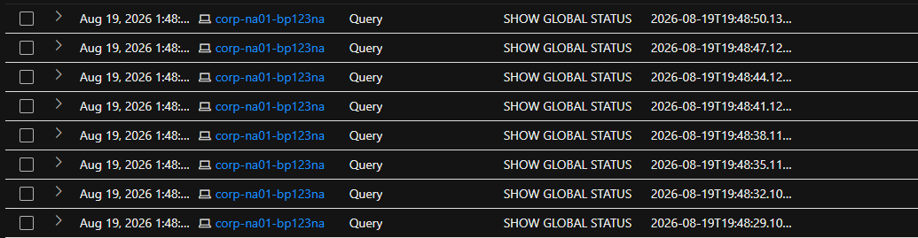

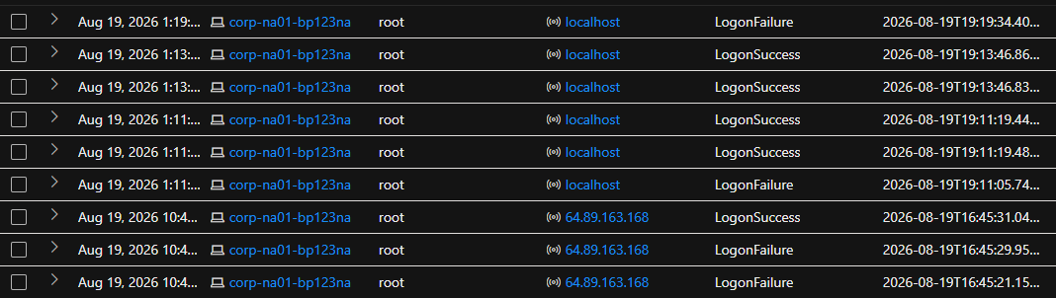

9. Lessons Learned / Recommendations
Prioritized 1 (highest) – 6:
- (1 – Critical) Remove MySQL from direct internet exposure; restrict to VPN/bastion or known application IPs only.
- (2 – Critical) Eliminate remote root login; enforce least-privilege named service accounts and rotate all credentials on this instance.
- (3 – High) Stand up tested, offsite/immutable backups for lnp_corp with a defined RTO/RPO, and verify restore works – recovery could not be confirmed from available data.
- (4 – High) Forward MySQL audit logs to the SIEM in near-real-time with alerting on DROP DATABASE/DROP TABLE and mass privilege changes; this incident had to be reconstructed after the fact with no detection timestamp available.
- (5 – Medium) Add brute-force/rate-limit protection (e.g., connection throttling, fail2ban-style blocking, or a DB firewall) – one IP alone made 100 failed attempts in under 2 minutes with no lockout.
- (6 – Medium) Onboard corp-na01-bp123na to Defender for Endpoint (or equivalent) so future incidents have host-level telemetry – process, network, and file events – rather than database audit logs alone.
