Computer systems

EXERCISE: Users, groups and permissions

We have a PC with Windows 10 that consists of two groups: Vocational and
Secondary. The user “VocationalUser” will belong to “Vocational” and the user “SecondaryUser” will belong to “Secondary”. There is also a user called Teacher which belongs to the group Administrators.

Complete all the exercises considering two scenarios: disabling inheritance and with inheritance.

- Create all the users and groups mentioned above.
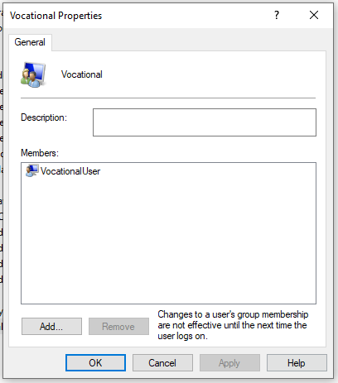
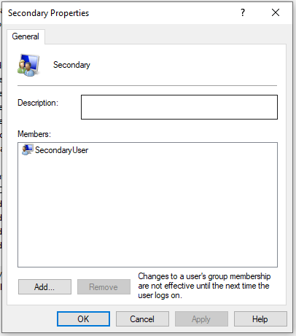
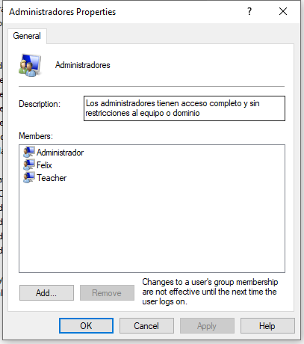

- Create the following directory tree with the permissions below.

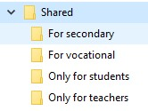

  - The directory known as “Shared” is able to be accessed by two users: “VocationalUser” and “SecondaryUser”, but they cannot delete or create subfolders and files. The user Teacher has Full Control over this directory.

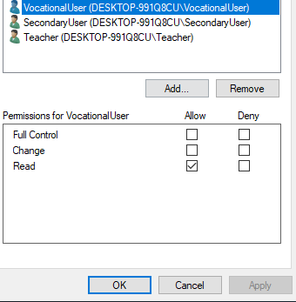

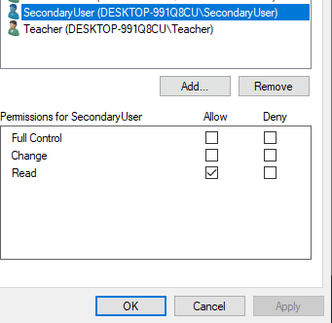

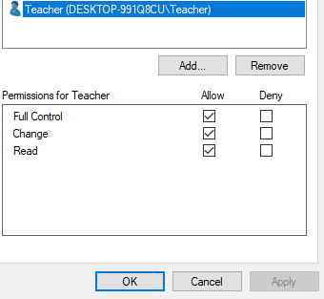

  - The directory “For secondary” cannot be accessed by the group “Vocational”, while the group “Secondary” is able to do everything except change permissions.

  - The directory “For vocational” cannot be accessed by the group “Secondary”, while the group “Vocational” is able to do everything except delete this folder and change permissions.

  - The directory “Only for students” can be accessed exclusively by all students regardless of the group. They will able to create files within this folder.

  - The directory “Only for teachers” can be accessed exclusively by all teachers and only with read and execute permissions.

