PES UNIVERSITY, BANGALORE
SOFTWARE ARCHITECTURE & DESIGN SPECIFICATION
for
HOSTEL MANAGEMENT SYSTEM
Version 1.0
Team 3 — 5-J
USN | Team Member
PES1UG24CS924 | Raiesh Giriyapanavar
PES1UG24CS565 | Chiranthan Sathrasala
PES1UG24CS581 | Neha K S
PES1UG24CS573 | Harsh M

Reference: Hostel Management System SRS v1.0, 06 September 2026
Prepared by Harsh M, for Software Engineering Mini-Project Evaluation

Document Control
Item | Details
Document | Software Architecture & Design Specification
System | Hostel Management System (HMS)
Version | 1.0
Base Requirements | HMS SRS v1.0 dated 06-Sep-2026
Related Verification Document | HMS Test Plan
Team | Team 3, Class 5-J
Preparation Date | 02-Oct-2026

Revision History
Name | Date | Reason For Changes | Version
Team 3 | 02-Oct-2026 | Initial architecture and design specification based on SRS v1.0 | 1.0

Basis and Scope of this Document
This document defines the software architecture and detailed design for the Hostel Management System. It follows the section structure specified for the Software Architecture & Design Specification and uses the functional and nonfunctional requirements in the team's SRS as the baseline. The supplied repository snapshot contains the SRS and Test Plan documents; therefore, implementation-specific details that are not defined in those documents are presented here as the proposed design contract and should be kept consistent with the final codebase.

Contents
3. Software Architecture & Design Specification
3.a Architecture
3.a.1 Component Diagram and Description
3.a.2 Architectural Pattern
3.a.3 Architecture Decisions and Responsibilities
3.a.4 Traceability to Requirements
3.a.5 Security Architecture
3.a.6 Deployment and Data Architecture
3.a.7 Other Architecture Sections
3.b Design
3.b.1 UML Sequence Diagram — Student Registration and Login
3.b.2 UML Sequence Diagram — Room Allocation
3.b.3 API Design
3.b.4 Error Handling
3.b.5 Data and Component Design
3.b.6 Other Design Sections

3. Software Architecture & Design Specification

3.a Architecture

3.a.1 Component Diagram and Description
The architecture is organized as a web-based three-layer system. The browser provides the role-specific user interface, the application/API layer implements authentication and hostel business rules, and the relational database provides persistent storage. The modules in the application layer are separated by responsibility so that the requirements can be implemented and tested independently.
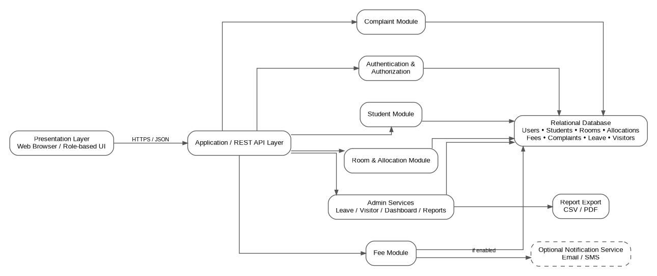
Figure 1. Component-level architecture of the Hostel Management System.
The major components and their responsibilities are listed below.
Component | Responsibility | Primary Requirements
Presentation Layer | Provides student and admin/warden screens, forms, dashboards, validation feedback, and report download actions. | FR-001 to FR-005, NFR-001
Authentication & Authorization | Registration, login, password verification, failed-login lockout, role checks, and session control. | FR-001, NFR-002
Student Module | Student profile/dashboard data, room and fee status, complaint history, and leave request access. | FR-001, FR-003, FR-004, FR-005
Room & Allocation Module | Room filtering, allocation, reallocation, vacating, capacity checks, and active-allocation rules. | FR-002
Fee Module | Fee ledger, payment recording, balance calculation, status tracking, and optional due-date notification trigger. | FR-003
Complaint Module | Complaint creation, category-level open-complaint rule, status updates, remarks, and history. | FR-004
Admin Services | Leave approval, visitor logging, dashboard aggregation, and report generation. | FR-005
Relational Database | Stores users, students, rooms, allocations, fee records, complaints, leave requests, and visitor records. | All persistent requirements
Report Export | Produces student, fee, and complaint reports in CSV/PDF form. | FR-005.5
Optional Notification Service | Sends fee due-date notifications when an external email/SMS service is enabled. | FR-003.3

3.a.2 Architectural Pattern
The recommended architectural pattern is a layered, modular monolithic web application with a REST API. This is appropriate for the project because the SRS specifies a web front end, a back-end application server, a relational database, and REST/JSON communication. The modules remain logically separated without introducing the operational overhead of multiple independently deployed services.
Layer | Main Role | Design Rule
Presentation | Browser-based student and admin interfaces. | Do not access the database directly; communicate through the API.
Application / API | Business rules, authentication, authorization, validation, module workflows, and response generation. | Keep module responsibilities separate and validate business rules before database updates.
Data | Relational persistence and transactionally consistent updates. | Use controlled data access; maintain referential integrity and enforce one active allocation per student.

The architecture follows a separation-of-concerns principle. For example, the room module is responsible for capacity and allocation rules, while authentication is responsible for identity and role checks. This reduces coupling and allows the test cases in the Test Plan to map to individual functional modules.

3.a.3 Architecture Decisions and Responsibilities
Decision | Rationale | Effect on System
REST API with JSON | Explicitly specified in the SRS software-interface requirements. | Provides a consistent contract between browser and application server.
Relational database | Required by the SRS and suitable for related hostel records. | Supports relationships, constraints, transactions, and reporting.
Role-based access control | Required because students and Warden/Admin users have different operations. | Prevents students from invoking protected administrative functions.
Modular application layer | Functional requirements naturally divide into authentication, rooms, fees, complaints, and admin services. | Simplifies development, testing, maintenance, and traceability.
Centralized validation | Business rules must be enforced even if a request bypasses the normal UI. | Prevents invalid allocation, complaint, leave, and payment operations.

3.a.4 Traceability to Requirements
The following matrix connects each SRS requirement to the architecture/design section that realizes it and to the corresponding test group. Test-case identifiers follow the supplied Test Plan; the table uses the group identifiers FR001–FR005 and NFR test groups used in the SRS traceability matrix.
Req. ID | Requirement | Architecture Area | Design Section | Verification
FR-001.1 | Student registration with required details | Authentication & Student Module | 3.a.1, 3.b.3, 3.b.4 | FR001 test cases
FR-001.2 | USN and email uniqueness validation | Authentication & Student Module | 3.a.3, 3.b.4 | FR001 test cases
FR-001.3 | Login and 15-minute lockout after 5 failures | Authentication & Authorization | 3.a.5, 3.b.3, 3.b.4 | FR001 test cases
FR-002.1 | Room availability by block/floor/sharing type | Room & Allocation Module | 3.a.1, 3.b.3, 3.b.5 | FR002 test cases
FR-002.2 | Allocate room and update occupancy | Room & Allocation Module | 3.a.1, 3.b.2, 3.b.5 | FR002 test cases
FR-002.3 | Prevent allocation beyond capacity | Room & Allocation Module | 3.a.3, 3.b.2, 3.b.4 | FR002 test cases
FR-002.4 | Only one active allocation per student | Room & Allocation Module | 3.a.6, 3.b.2, 3.b.5 | FR002 test cases
FR-003.1 | Record due, paid, date, and balance | Fee Module | 3.a.1, 3.b.3, 3.b.5 | FR003 test cases
FR-003.2 | Display Paid/Partially Paid/Due status | Fee Module | 3.a.1, 3.b.3 | FR003 test cases
FR-003.3 | Notify when due date is within 7 days if enabled | Fee Module + Notification Service | 3.a.1, 3.a.7, 3.b.3 | FR003 test cases
FR-004.1 | At most one open complaint per category | Complaint Module | 3.a.1, 3.b.4, 3.b.5 | FR004 test cases
FR-004.2 | Admin status and remarks updates | Complaint Module | 3.a.1, 3.b.3, 3.b.4 | FR004 test cases
FR-004.3 | Student complaint history with timestamps | Complaint Module | 3.a.1, 3.b.3, 3.b.5 | FR004 test cases
FR-005.1 | Student leave request | Admin Services Module | 3.a.1, 3.b.3, 3.b.4 | FR005 test cases
FR-005.2 | Admin approve/reject leave; student views status | Admin Services Module | 3.a.1, 3.b.3 | FR005 test cases
FR-005.3 | Visitor entry and exit logging | Admin Services Module | 3.a.1, 3.b.3, 3.b.5 | FR005 test cases
FR-005.4 | Dashboard occupancy, vacancies, dues, complaints | Admin Services Module | 3.a.1, 3.a.6, 3.b.3 | FR005 test cases
FR-005.5 | Export student/fee/complaint reports as CSV/PDF | Admin Services + Report Export | 3.a.1, 3.b.3 | FR005 test cases
NFR-001 | 3-second standard page load and 200 concurrent users | Application Infrastructure | 3.a.2, 3.a.7, 3.b.6 | NFR performance tests
NFR-002 | Hashing, RBAC, and 30-minute session expiry | Authentication & Authorization | 3.a.5, 3.b.4 | NFR security tests

3.a.5 Security Architecture
Security is implemented as a cross-cutting concern around authentication, authorization, session management, input validation, and protected data access. The controls below directly address NFR-002 and the related business rules.
Security Control | Design | Requirement / Risk Addressed
Password storage | Store only a secure one-way password hash; never store plaintext passwords. | NFR-002
Authentication | Validate credentials through the authentication module and return a controlled authenticated session. | FR-001.3
Login lockout | Track consecutive failed attempts and lock the account for 15 minutes after 5 consecutive failures. | FR-001.3
Role-based authorization | Check the authenticated role before room, fee, complaint, leave, visitor, and report operations. | NFR-002; business rules
Session expiry | Expire authenticated sessions after 30 minutes of inactivity and require re-authentication. | NFR-002
Transport security | Use HTTPS between browser and server. | SRS Communications Interface
Input validation | Validate required fields, formats, date ranges, amounts, identifiers, and business rules at the API boundary. | FR-001 to FR-005
Protected critical actions | Require administrator confirmation for critical actions such as room de-allocation and fee-record deletion. | SRS operational controls
Data protection | Use hostel administration data only for authorized system purposes and restrict access by role. | Other Requirements
Backups | Perform daily database backups as an operational safeguard. | SRS database requirement

Security Request Flow
- The browser sends an HTTPS request containing the required authentication/session information.
- The API authentication middleware validates the session and determines the user's role.
- The target module checks whether that role is authorized for the requested operation.
- The module validates request data and business rules before changing persistent data.
- The database operation is executed only after validation and authorization succeed.
- The API returns a controlled JSON response without exposing passwords, internal database details, or sensitive implementation information.

3.a.6 Deployment and Data Architecture
The deployment model is a conventional client-server web deployment. Students and administrators use a supported browser. The application server hosts the REST API and business modules. The relational database is kept behind the application layer rather than being directly accessible from the browser.
Node / Store | Contents | Communication
Student/Admin Device | Browser UI and temporary client-side session state. | HTTPS to application server
Application Server | REST API, authentication, business modules, validation, reporting logic. | HTTPS from clients; database connection to data store
Relational Database | Users, students, rooms, allocations, fee records, complaints, leave requests, visitor records. | Private application-to-database connection
Optional External Notification Provider | Email/SMS delivery when enabled. | Server-side integration only

The logical data model follows the entities identified in the SRS: User, Student, Room, Allocation, FeePayment, Complaint, LeaveRequest, and Visitor. Student-to-Allocation is one-to-many over time, while only one allocation may be active for a student. Room capacity is used to prevent occupancy from exceeding the configured limit.

3.a.7 Other Architecture Sections

Scalability and Performance
NFR-001 requires standard pages to load within 3 seconds and the system to support at least 200 concurrent users under normal load. The architecture supports this target by keeping the browser lightweight, using a centralized API layer, separating modules, and keeping persistent state in a relational database. Actual 200-user capacity requires load testing in an environment capable of generating that traffic; it is not claimed as verified by this document.

Reliability and Consistency
- Room allocation and occupancy updates should be treated as one logical transaction so that occupancy is not changed without a corresponding allocation record.
- Reallocation should release the old allocation and create/update the new allocation consistently.
- Fee balance should be derived from the stored due and paid values rather than manually entered independently.
- Daily backups should be retained according to the project's deployment policy.
- Errors in one functional module should return controlled API responses rather than exposing internal exceptions.

Maintainability
The module boundaries are intentionally aligned with the functional requirements and test groups. This gives the team a direct mapping between requirements, application components, APIs, database entities, and test cases. Authentication and role-based access are isolated so they can be reused in future academic projects, as requested by the SRS.

3.b Design

3.b.1 UML Sequence Diagram — Student Registration and Login
The following sequence describes the common authentication path. Registration and login share the authentication component, while registration additionally creates a user record after uniqueness and field validation.
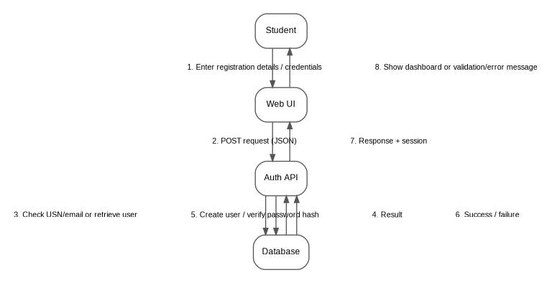
Figure 2. Sequence flow for student registration/login and authentication.

Sequence Description
- The student enters registration details or login credentials through the web interface.
- The web interface sends a JSON request to the authentication API over HTTPS.
- For registration, the API checks mandatory fields and verifies that the USN and email are not already registered.
- For login, the API retrieves the relevant account and verifies the supplied password against the stored password hash.
- After successful registration, the account is created. After successful login, an authenticated session is established.
- The API returns a controlled response. The interface either displays the dashboard or an appropriate validation/authentication message.
- Repeated failed logins are counted; after five consecutive failures, the account is locked for 15 minutes.

3.b.2 UML Sequence Diagram — Room Allocation
The room allocation sequence shows how the system enforces the two main business constraints: the room must have capacity and the student must not already have another active allocation.
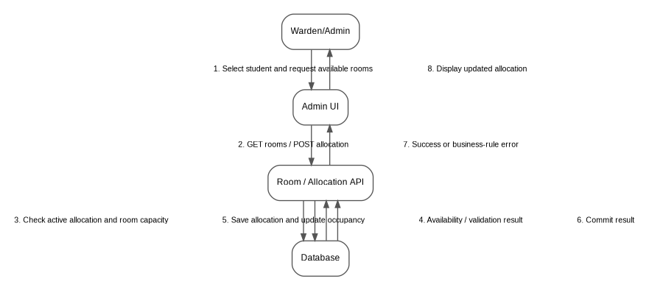
Figure 3. Sequence flow for Warden/Admin room allocation.

Sequence Description
- The Warden/Admin selects a registered student and requests available rooms using the admin interface.
- The interface requests matching rooms from the room/allocation API using the selected block, floor, and sharing filters.
- Before saving an allocation, the API checks the student's active allocation state and the selected room's current occupancy/capacity.
- If either business rule fails, the API returns a controlled error and no persistent allocation change is made.
- If validation succeeds, the allocation and occupancy update are committed as one logical operation.
- The updated allocation is returned to the admin interface, where the new room status is displayed.

3.b.3 API Design
The SRS specifies REST APIs with JSON request and response data. The following endpoint set is the proposed design contract for the documented HMS features. Exact route naming may be adjusted to match the final codebase, but the request/response responsibilities should remain equivalent.
Method | Endpoint | Role | Purpose | Typical Status
POST | /api/auth/register | Student | Register a student account. | 201 / 400 / 409
POST | /api/auth/login | Student/Admin | Authenticate user and establish session. | 200 / 401 / 423
POST | /api/auth/logout | Authenticated user | End current authenticated session. | 200 / 401
GET | /api/students/{usn}/dashboard | Student/Admin | Return room, fee, complaint, and leave summary. | 200 / 401 / 403 / 404
GET | /api/rooms | Warden/Admin | Filter rooms by block, floor, sharing type, and availability. | 200 / 401 / 403
POST | /api/allocations | Warden/Admin | Create an active room allocation after validation. | 201 / 400 / 403 / 409
PUT | /api/allocations/{id}/reallocate | Warden/Admin | Move a student to another room. | 200 / 400 / 403 / 409
POST | /api/allocations/{id}/vacate | Warden/Admin | Deactivate an allocation and release occupancy. | 200 / 400 / 403 / 404
POST | /api/fees/payments | Warden/Admin | Record a fee payment and update balance. | 201 / 400 / 403 / 404
GET | /api/fees/{usn} | Student/Admin | View fee status, balance, and payment history. | 200 / 401 / 403 / 404
POST | /api/complaints | Student | Create a complaint subject to category rule. | 201 / 400 / 409
PUT | /api/complaints/{id} | Warden/Admin | Update complaint status and remarks. | 200 / 400 / 403 / 404
POST | /api/leaves | Student | Submit a leave request. | 201 / 400
PUT | /api/leaves/{id}/decision | Warden/Admin | Approve or reject a leave request. | 200 / 400 / 403 / 404
POST | /api/visitors | Warden/Admin | Record visitor entry details. | 201 / 400 / 403
PUT | /api/visitors/{id}/exit | Warden/Admin | Record visitor exit timestamp. | 200 / 400 / 403 / 404
GET | /api/admin/dashboard | Warden/Admin | Return occupancy, vacancies, pending dues, and open complaints. | 200 / 401 / 403
GET | /api/reports/{type} | Warden/Admin | Generate/export student, fee, or complaint report. | 200 / 400 / 403

API Request and Response Convention
POST /api/auth/login
Content-Type: application/json
{
"usn": "PES1UG23CS001",
"password": "Pass@123"
}
Success:
{
"success": true,
"message": "Login successful",
"data": {
"role": "student"
}
}

Passwords are shown only as example input data in the request format above. They must never be returned in API responses or stored as plaintext. Authentication/session details should be represented using the mechanism selected by the final implementation.

Common JSON Error Format
{
"success": false,
"error": {
"code": "ROOM_FULL",
"message": "Room at full capacity",
"details": {}
}
}

A common response structure keeps frontend handling consistent across modules. The error code should be stable enough for the frontend to identify the error category, while the message should remain understandable to the user.

3.b.4 Error Handling
Errors are divided into validation errors, authentication/authorization errors, business-rule conflicts, resource errors, and unexpected server errors. The API should return an appropriate HTTP status code and a safe message. Internal stack traces, database credentials, SQL statements, and other implementation details must not be returned to the browser.
Category | HTTP Status | Example | Expected Handling
Validation | 400 Bad Request | Missing phone number; invalid email; end date before start date; negative payment. | Reject request and identify the invalid input.
Authentication | 401 Unauthorized | Invalid credentials; expired session. | Require login or re-authentication.
Authorization | 403 Forbidden | Student attempts room allocation. | Deny operation and do not modify data.
Conflict | 409 Conflict | Duplicate USN/email; full room; second active allocation; duplicate open complaint category. | Reject operation and explain the business-rule conflict.
Not Found | 404 Not Found | Unknown student, room, complaint, leave, or visitor record. | Return resource-not-found message.
Locked | 423 Locked | Login attempted during 15-minute lockout. | Reject login and return lockout information without revealing unnecessary account details.
Server Error | 500 Internal Server Error | Unexpected application/database failure. | Log internally; return a generic safe message to the client.

Validation Rules
- USN and email must be unique before account creation.
- Required registration fields must not be blank.
- Room allocation requires a registered student, an available room, and no existing active allocation.
- Room occupancy must not exceed configured capacity.
- Payment amount must be a positive value and must be processed against the student's current fee record.
- Leave end date must not precede the start date.
- A student cannot create a second open complaint in the same category.
- Protected administrative operations must pass role authorization before business validation is applied.

3.b.5 Data and Component Design
The data design follows the entities listed in the SRS and keeps operational records separate enough to support history. The following logical entities form the core database design.
Entity | Important Attributes | Relationship / Constraint
User | user_id, USN/email, password_hash, role, failed_attempts, lock_until, session information | Authentication identity; role controls protected functions.
Student | student_id, USN, name, email, phone | Associated with a user account; referenced by hostel records.
Room | room_id, block, floor, sharing_type, capacity, occupancy | Capacity is an upper bound on occupancy.
Allocation | allocation_id, student_id, room_id, start/end or active state | A student may have historical allocations but only one active allocation.
FeePayment | payment_id, student_id, amount_due, amount_paid, payment_date, balance/status | References Student; supports payment history.
Complaint | complaint_id, student_id, category, description, status, remarks, timestamps | At most one open complaint per student/category.
LeaveRequest | leave_id, student_id, start_date, end_date, reason, status | Admin decision changes Pending to Approved/Rejected.
Visitor | visitor_id, student_id, name, contact, purpose, entry_time, exit_time | References the student being visited.

Module-to-Entity Mapping
Module | Primary Entities
Authentication & Student | User, Student
Room & Allocation | Student, Room, Allocation
Fee | Student, FeePayment
Complaint | Student, Complaint
Admin Services | Student, LeaveRequest, Visitor, Room, FeePayment, Complaint
Reports | Student, Room, Allocation, FeePayment, Complaint, LeaveRequest, Visitor

Transaction Boundaries
- Allocation: validate student and room state, create/update allocation, and update room occupancy as one logical transaction.
- Reallocation: validate destination room, release the previous allocation/occupancy, and establish the new allocation consistently.
- Vacating: mark the allocation inactive and release the room occupancy together.
- Fee payment: validate amount, persist payment, and update/recalculate the outstanding balance consistently.
- Complaint update: persist status and remarks together so the history shown to the student matches the administrative action.

3.b.6 Other Design Sections

User Interface Design Principles
- Use separate role-appropriate dashboards for Student and Warden/Admin users.
- Clearly mark mandatory fields and show validation messages close to the relevant form input.
- Use simple status labels such as Paid, Partially Paid, Due, Pending, Approved, Rejected, Open, In Progress, and Resolved.
- Require confirmation before critical operations such as vacating a room.
- Do not expose administrative controls in the student interface; server-side authorization remains mandatory even when UI controls are hidden.

Reporting Design
Reports are generated from the same persistent records used by the dashboards so that exported values remain consistent with the application's current state. CSV export is suitable for structured data processing, while PDF export is intended for readable administrative records. Report generation is restricted to authorized admin users.

Logging and Audit Considerations
The implementation should record operational events that are useful for troubleshooting and accountability, such as authentication failures, room allocation changes, fee updates, complaint status changes, leave decisions, and visitor entry/exit updates. Logs should avoid storing passwords or unnecessary sensitive personal data.

Design Constraints and Assumptions
- The final technology stack and selected relational database are determined by the team's implementation environment.
- The browser communicates with the application server through HTTPS and JSON-based REST requests.
- The application server and database are assumed to be available during normal operation.
- Optional email/SMS notification functionality depends on the selected external provider.
- The architecture does not claim that the NFR-001 200-concurrent-user target has been experimentally verified; such verification requires appropriate load-testing infrastructure.

References
- Hostel Management System — Software Requirements Specification, Version 1.0, Team 3, 06 September 2026.
- Hostel Management System — Test Plan, Team 3, prepared with reference to SRS v1.0.
- IEEE 830-style SRS template/instructions supplied for the Software Engineering course.

