Northwind Outdoor Gear
Returns & Warranty Claim Triage Agent
Discovery Note & Architecture Decision Record

Part 1 — Problem Framing & Discovery

Stakeholders
- Returns team (4 people): wants routine claims off their desk entirely so time goes to the ~20% of claims that genuinely need judgment. They are the ones who inherit any mistake the agent makes, so they also want visibility into why the agent decided what it decided — not a black box.
- Customers: want a fast, consistent decision that matches what the policy actually says — whether that's approval or a denial. A slow queue treats a straightforward exchange the same as a genuine edge case, which is the main source of frustration.
- Finance / loss prevention: cares about the dollar exposure of auto-approvals. A wrongly auto-approved $220 jacket return is a real loss; a wrongly auto-approved $12 water bottle is not. This stakeholder wants the guardrails, not the speed.
- Returns team lead: is accountable for whatever lands in the escalation queue. Wants escalated claims to arrive with context already attached (retrieved policy, the agent's reasoning) so they aren't starting from zero — but wants the final call to stay theirs.
- Trust & abuse / fraud: cares about the repeat-claimant pattern specifically — a customer's 4th claim in a quarter can look perfectly legitimate in isolation, and this stakeholder wants that pattern caught regardless of how clean any single claim reads.

The Real Problem
“It's slow” is the symptom; the diagnosis is that there is no triage step before human review. All ~200 claims/week enter one undifferentiated FIFO queue read serially by four people, so a straightforward size exchange that a policy answers in one sentence waits exactly as long as a $220 color-preference return that genuinely needs a judgment call. The team isn't slow at deciding — they're slow because they have no way to skip ahead on the 70-80% of claims that don't need their judgment at all. That's specifically painful for customers with routine claims (the majority) and for the team, who spend attention re-deriving the same policy lookups over and over instead of only on the cases that need a human.

What Success Looks Like (3 months out)
- At least 65-70% of weekly claim volume (roughly 130-140 of ~200/week) is auto-resolved — decided and actioned — within minutes of submission, with no human touch.
- Median time-to-decision on routine claims drops from multi-day queue wait to under 1 hour.
- The human review queue shrinks to genuine edge cases only, and the returns team's per-claim review time drops because each escalated claim arrives pre-annotated with the retrieved policy and the agent's reasoning.
- The wrongly-approved rate (auto-approvals later reversed or disputed) stays flat or improves versus today's manual baseline — speed must not be bought with more leakage.

What Must Never Be Auto-Approved
- 1. Item value ≥ $150 (policy pol-004). This is Northwind's own written escalation policy, and it exists because the dollar exposure of a single wrong call is high enough that finance wants a human name attached to the approval, independent of how confident an agent is.
- 2. More than 3 prior claims in a rolling 90 days (pol-008). This is a pattern signal, not a claim-quality signal — the 4th claim can read as perfectly reasonable text and still be part of an abuse pattern. An agent grounded only in the current claim's text will never see this; it has to be enforced on the structured field, in code, before the model is even asked.
- 3. No policy in the KB clearly covers the situation. Claim-06 (a 60-day-old non-defective item) doesn't cleanly match the 30-day standard window, the 45-day exchange window, or the 1-year defect warranty. An agent forced to pick approve/deny/escalate anyway will rationalize an answer against near-miss policy text. If retrieval doesn't return a confident, applicable match, the only safe default is escalate — letting the model decide against thin or absent grounding is how these systems quietly start hallucinating policy.
- 4. Defect claims ≥ $75 with no verifiable photo evidence (pol-002). The policy itself requires a photo above this threshold; a free-text web form doesn't guarantee one was actually attached and reviewable. If evidence can't be confirmed, the claim must escalate rather than have the agent take the customer's description on faith for a threshold policy explicitly says needs proof.
Note on asymmetry: these four guardrails are about protecting against wrongly *approving* something. A confident denial (e.g. final-sale exclusion, pol-003) carries much less downside — it's reversible on appeal and costs Northwind nothing if wrong — so denials are held to a lower escalation bar than approvals throughout this design.

Part 2 — Architecture

Agent Count — Fewer Than the Reference Build
This problem needs one LLM call, not a multi-agent pipeline. The reference Enterprise Support Agent needed multiple agents partly because tone, sentiment, and open-ended judgment are hard to reduce to a rule. Here, the two dimensions that actually decide risk — item value and claim history — are already structured fields Northwind collects on every claim. That means the “critic” role the reference build needed an agent for can instead be two if-statements. The architecture below has exactly one Decision Agent, wrapped by deterministic guardrail code on both sides.

Where RAG Happens
Retrieval runs once per claim, against the 8-article return_policy_kb.json, using the claim's free text plus its category signals (defect language, “wrong item,” “final sale,” etc.) as the query. It returns the top matching policy article(s) by keyword/embedding score. The Decision Agent is then shown only that retrieved text — never the full policy set — so its reasoning is auditable back to a specific article, and it cannot quietly invent a policy that doesn't exist.

Where Guardrails Are Enforced
Entirely in code, on both sides of the single LLM call, never as an instruction inside the prompt:
- Pre-check (before retrieval/LLM even run): value ≥ $150, or prior_claims_90d > 3 → escalate immediately. The LLM is never consulted — there is nothing for it to override.
- Post-check (after the LLM responds): stated confidence below threshold, no policy match was retrieved, or a defect claim ≥ $75 lacks confirmable photo evidence → the code overrides an “approve” into “escalate” regardless of what the model said.

What Happens on Escalation
The claim, the retrieved policy text, every guardrail check result, and the agent's reasoning (if an LLM call happened at all) are attached to a ticket in the returns team lead's queue. Critically, the agent's output is shown as context, not a recommendation banner — the goal is to save the human re-derivation work, not to anchor their judgment on the model's guess.

The One Backend Action
issue_refund_or_replacement(customer_id, order_id, action) — the single write operation that fires once a claim is auto-approved. Denials and escalations don't need a backend mutation (a denial is a message citing the policy; an escalation is a ticket creation, which is lower-stakes than moving money or inventory).

Least-Certain Decisions
Two calls we're least sure about: (1) whether “no confident policy match” should be a hard pre-check guardrail like the other two, rather than something the Decision Agent itself flags via low confidence — we chose to let the agent flag it so retrieval quality differences don't need a second hard-coded threshold, but a stricter build might force it in code too. (2) Whether the LLM's self-reported confidence score is trustworthy enough to gate on at all versus being decorative — for the MVP we treat it as a soft signal only, always backed by the deterministic checks, never as the sole reason to auto-approve.
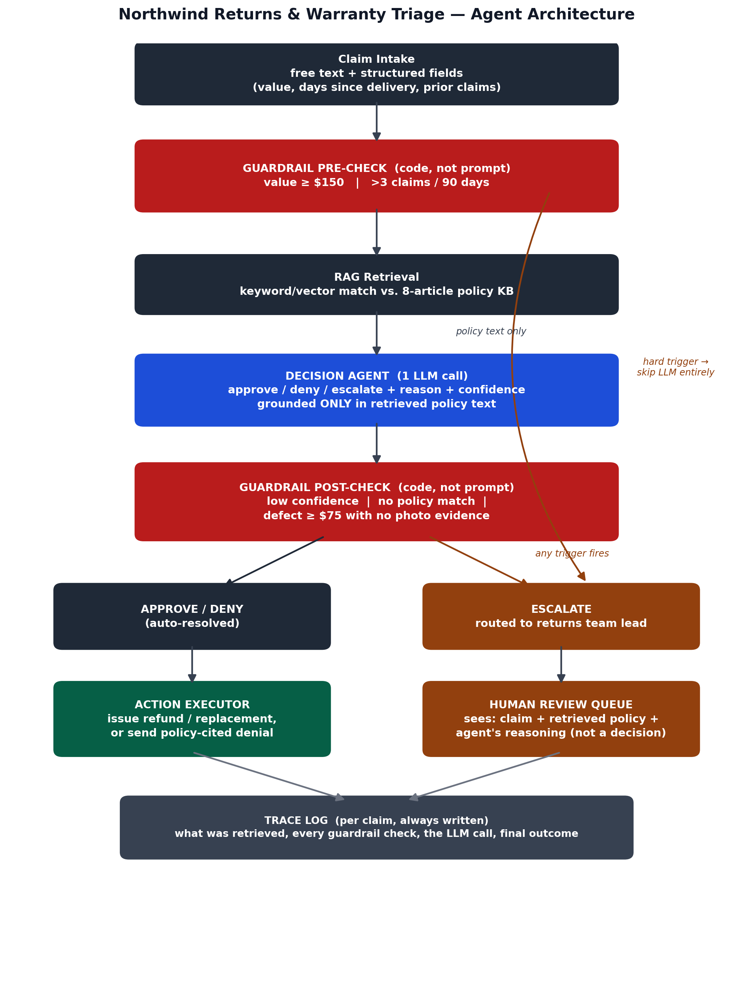
Figure 1. Claim triage pipeline — red = hard guardrail enforced in code, blue = the single LLM decision call, amber = human-in-the-loop.

