2018级软件 OOAD 月考（2）2020.12.1

1. **Briefly describe following concept （40 points ）**
2. List three key points to define a Pattern?
3. Write out full name of GRASP in Chinese.
4. The difference between **Pure Fabrication** and **Indirection?**
5. Following is a solution for MonoPolyGame. Please re-design it with **Polymorphism** to make it suitable for squares with different behaviors.

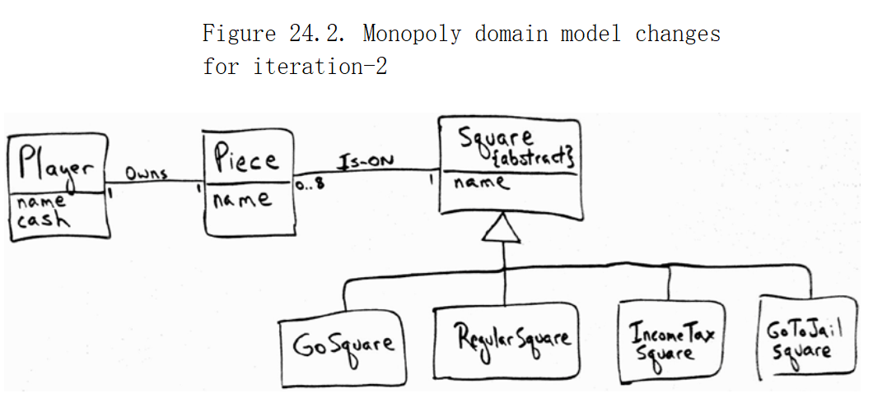

1. How do you understand “**Protected Variations**” of GRASP?
2. Is a Controller in GRASP part of the system to be develop or an actor?
3. There are **four common ways that visibility** can be achieved from object A to object B. Please List them out.
4. In which situation, we can ignore high coupling?
5. **Translate to Chinese （10 points ）**

The first category of controller is a facade controller representing the overall system, device, or a subsystem. The idea is to choose some class name that suggests a cover, or facade, over the other layers of the application and that provides the main point of service calls from the UI layer down to other layers. The facade could be an abstraction of the overall physical unit, such as a Register.

1. **According to following problem description: (each 50)**

1、design a class diagram （25）

2、show GRASP (creator、controller、information expert) being used in your design by Sequence Diagram(可以画一个顺图或多个顺图) (15)

3、describe where/how did you consider about coupling & cohesion (10)

An Exhibition(展览会) requires a system that will enable exhibition staff to keep track of guided tours of the Exhibition hall. When a party of visitors arrives, a staff member must be able to record the date, start time and number of visitors undertaking the tour. Also, a staff member must be able to assign a guide to the tour, from available tour guides (i.e., those not currently conducting a tour or performing some other duty); the assigned guide will be notified of the assignment.

During a tour, its guide must be able to record special incidents that might occur, such as a visitor becoming ill. Each such incident will be related to the tour on which it occurred and will include a description and a time. Incident reports must be communicated to the Exhibition’s Safety Office.