CLARA GRC Reviews AI Assistant
User Guide

Author: Sarthak Hota (sarthah@)
Date: June 04, 2026
Version: v1.0
Audience: GRC Reviewers, GRC Approvers, GRC Controllership

Table of Contents
- 1. Overview
- 2. Accessing CLARA
- 3. For GRC Reviewers
- 3.1 Open Your Review
- 3.2 Read CLARA Insights
- 3.3 Confirm Ownership
- 3.4 Step 1: Confirm Control Details
- 3.5 Step 2: Control Review Questions
- 3.6 Step 3: IPA Questions
- 3.7 Attach Evidence
- 3.8 Re-analyze and Validate
- 3.9 Submit
- 4. For GRC Approvers
- 4.1 Open Review from Approval Queue
- 4.2 Read CLARA Executive Summary
- 4.3 Review Risk Flags
- 4.4 Approve or Reject
- 4.5 Feedback Controls
- 4.6 Re-analyze Rate Limiting and Time-Outs
- 5. Tips and Best Practices
- 6. FAQ

1. Overview
CLARA (Compliance Learning and Review Assistant) is an AI-powered assistant integrated into the GRC 2.0 platform. It helps reviewers and approvers complete quarterly SOX control reviews faster and with fewer errors by providing:
- Pre-filled response recommendations based on historical patterns and control page data
- Real-time insights explaining why each answer is recommended
- Evidence validation — reads attached files and flags invalid or missing evidence
- Executive summaries for Reviewers and Approvers with risk flags and key assertions
- Smart N/A detection for inapplicable questions based on control type

Important: CLARA assists with drafting but does not make decisions. All final responses are owned by the reviewer. AI content is fully suppressed once a review is submitted — auditors never see CLARA suggestions.

2. Accessing CLARA
CLARA is available on all control reviews in the GRC 2.0 platform (prod environment). To access:
1. Navigate to https://grc.a2z.com
2. Open any review assigned to you from the review queue
3. CLARA Insights panel appears automatically at the top of the review page

No setup or configuration is required. CLARA activates automatically for all reviews in the pilot.

3. For GRC Reviewers
This section walks you through the complete review workflow with CLARA assistance.

3.1 Open Your Review
Navigate to your review from the review queue. The page loads with two key sections visible:
- CLARA Insights panel (top) — Executive Summary and Critical Context
- Review content (below) — Ownership confirmation and questionnaire

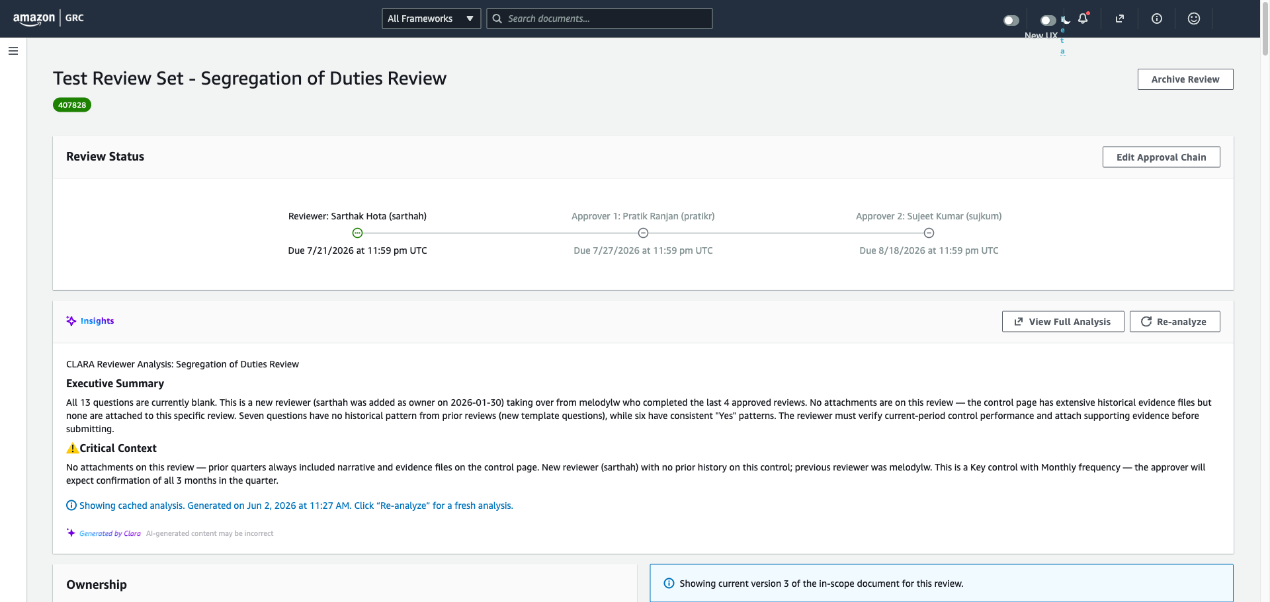
Figure 1: Review page overview showing CLARA Insights at top

3.2 Read CLARA Insights
Before answering any questions, read the CLARA Insights panel at the top of the page. It contains:
- Executive Summary — key findings, risks, and required actions
- Critical Context — blocking issues that must be resolved before submission
- "View Full Analysis" button — opens detailed per-question analysis in a modal
- “Re-analyze" button — refreshes the analysis after you make changes

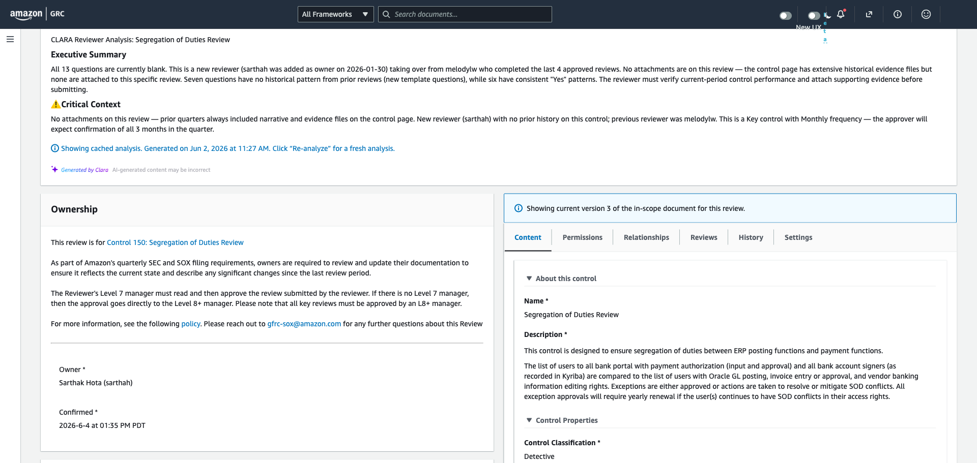
Figure 2: CLARA Insights panel with Executive Summary and action buttons

3.3 Confirm Ownership
Before proceeding to the questionnaire, you must confirm that you are the owner of this review.
- If you ARE the Review owner:
1. Select "Yes"
2. Click "Confirm and next" (orange button)

- If you are NOT the owner:
1. Select "No"
2. Enter the correct owner's name in the transfer field
3. Click "Transfer"

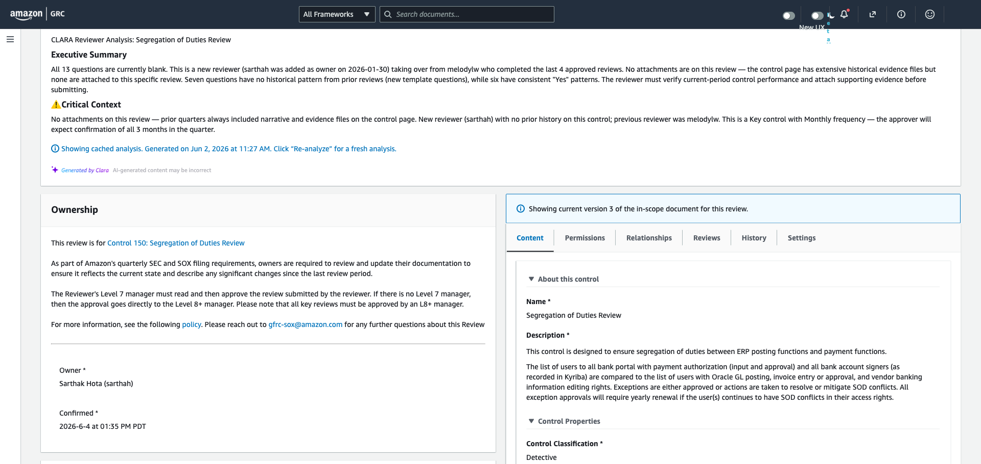
Figure 3: Ownership confirmation — select Yes/No and confirm or transfer

3.4 Step 1: Confirm Control Details
Confirm that the control details on the control page are accurate and up to date for the review period. CLARA provides a recommendation based on detected changes (or lack thereof).
- Review the CLARA recommendation panel below the question
- Expand "Insights" to see why CLARA recommends this response
- Accept the recommendation, edit it, or write your own response
- Check the control page (right panel) to verify details yourself
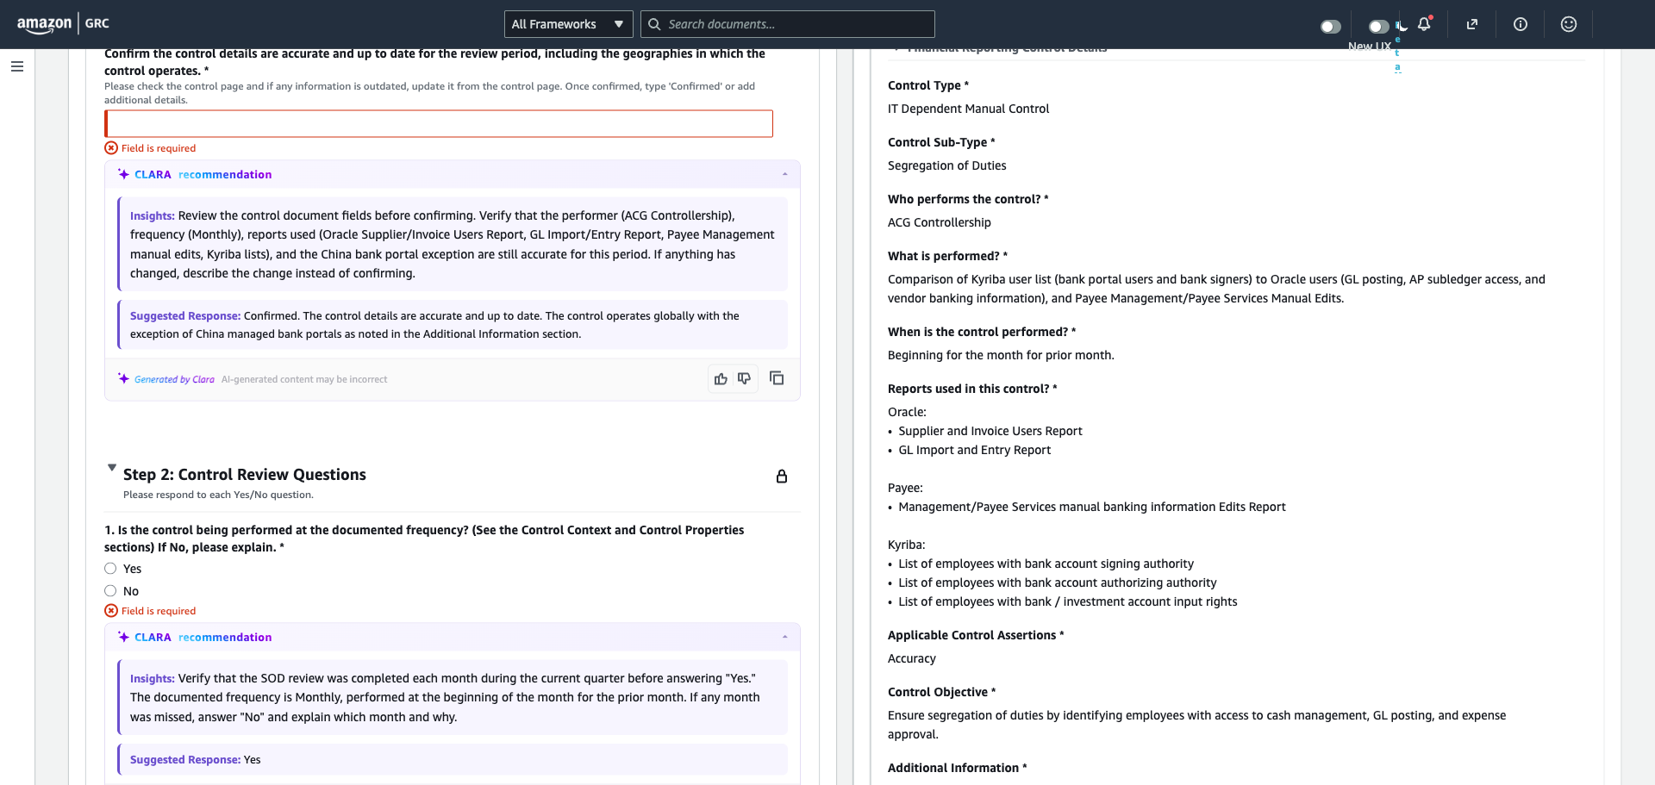
Figure 4: Step 1 with CLARA recommendation and control page details

3.5 Step 2: Control Review Questions
Answer each Yes/No question about control effectiveness, evidence, and compliance. CLARA provides per-question recommendations with supporting insights.
For each question:
1. Read the CLARA recommendation (Yes/No/N/A)
2. Expand "Insights" to understand the reasoning
3. Select your answer (you can disagree with CLARA)
4. Add comments if the question requires explanation
Important: CLARA's recommendations are suggestions based on historical patterns – last five quarters of responses (as applicable). Always verify independently before accepting — especially for effectiveness questions.
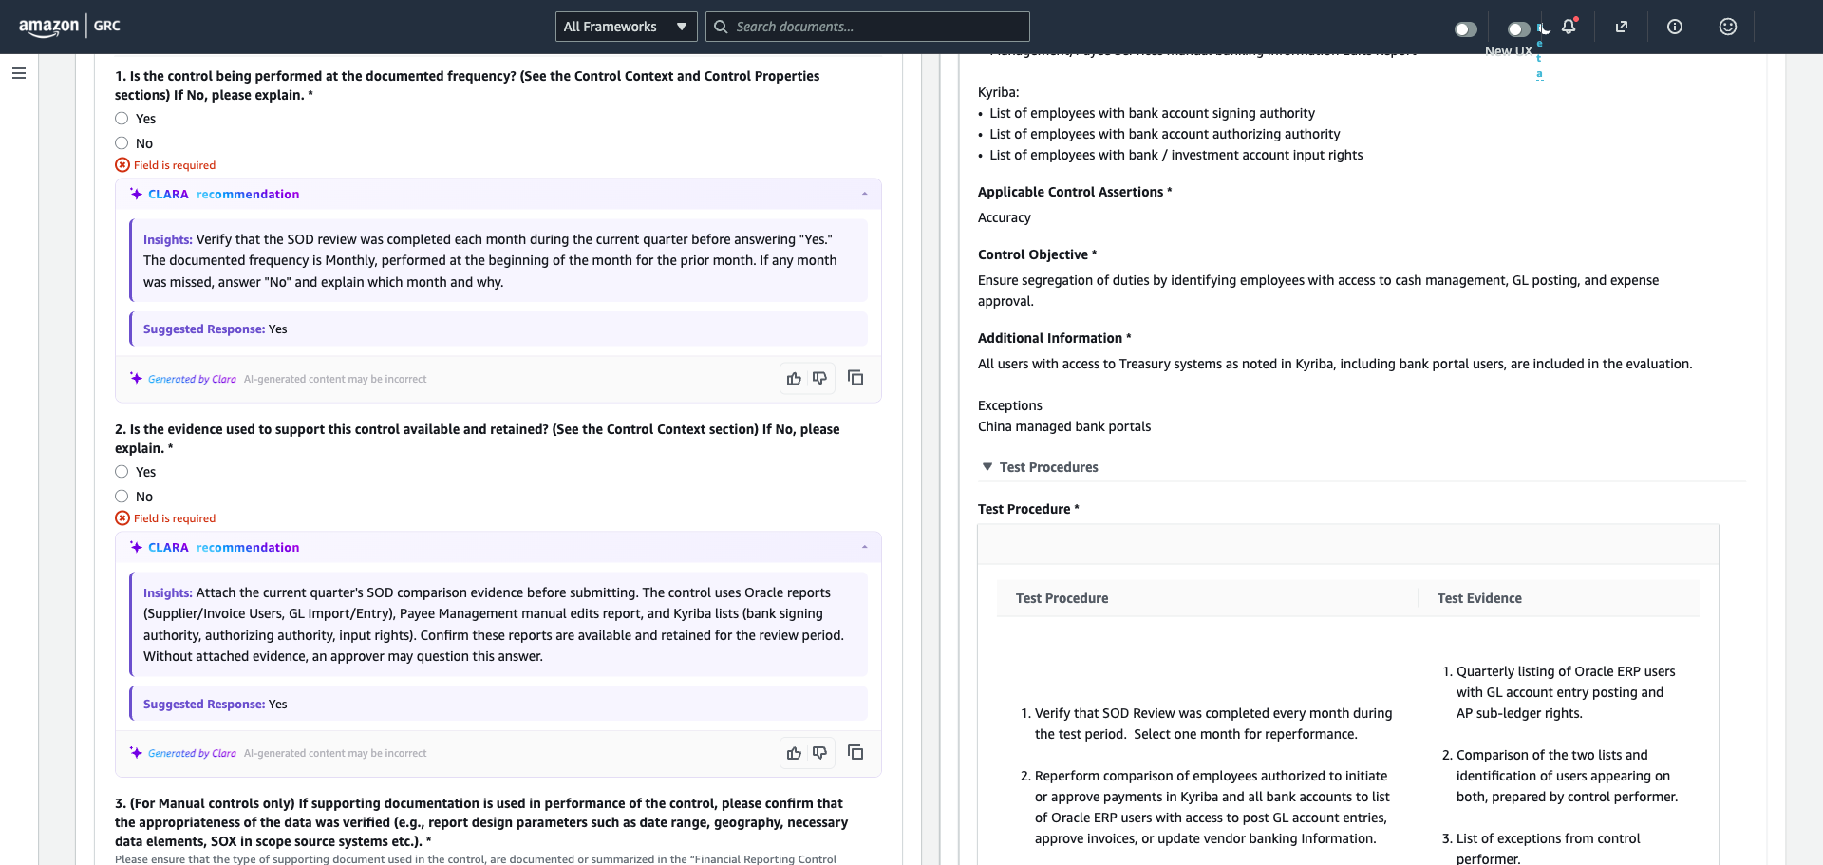
Figure 5: Step 2 questions with CLARA recommendations per question

3.6 Step 3: IPA Questions
IPA (Information Produced by Amazon) questions apply to manual and IT-dependent manual controls. For automated controls (IT General Controls), CLARA typically recommends N/A.
- If your control is automated: follow CLARA's N/A recommendation
- If your control is manual with IPA: document source systems, queries, and owners
- CLARA will flag if you select N/A when IPA documentation exists

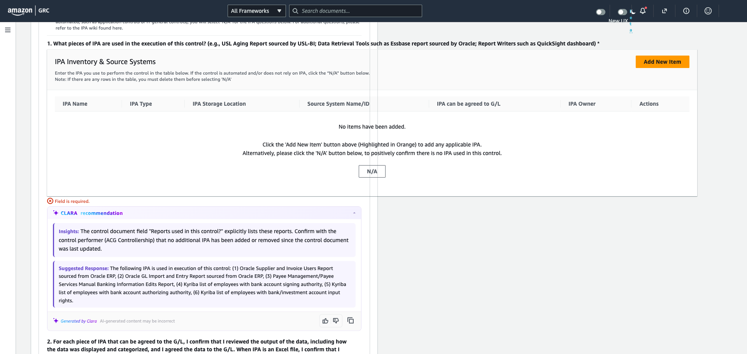
Figure 6: Step 3 IPA questions with CLARA recommendations

3.7 Attach Evidence
Note: Attaching Evidence is currently optional as per Amazon SOX 302 Certification guidelines.
Upload supporting evidence required by the test procedure. CLARA validates attached files — if a file doesn't match the expected evidence type, it will flag the issue.
1. Scroll to "Files & external link" section
2. Click "Add attachment"
3. Upload the required evidence (e.g., audit report, dashboard screenshot)
4. Ensure the file name and description clearly identify the evidence
Tip: After attaching evidence, click "Re-analyze" to have CLARA verify your attachment is valid and matches the test procedure requirements.
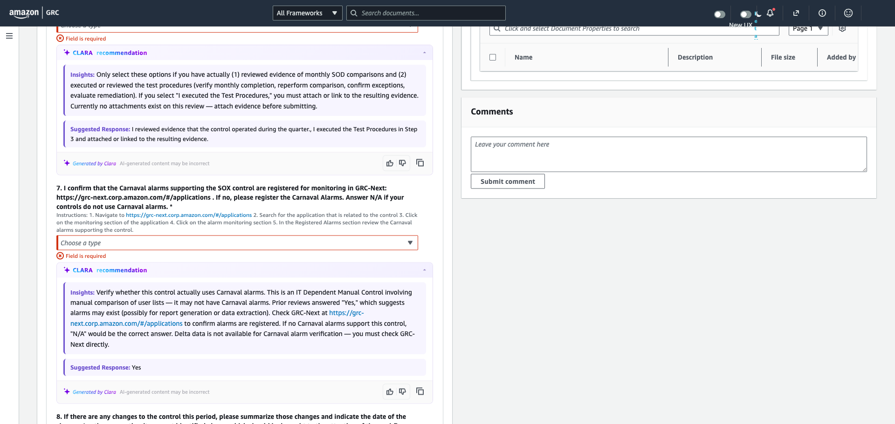
Figure 7: Files & external link section for evidence upload

3.8 Re-analyze and Validate
After completing your responses and attaching evidence (optional), click "Re-analyze" to have CLARA validate your submission. This will:
- If attaching evidence in GRC, check evidence validity (CLARA reads file content and matches against the steps listed in the test procedure and historical patterns)
- Identify contradictions between your answers
- Update the Executive Summary with current state
- Flag any remaining issues before submission
Review the updated Insights panel. If Critical Context shows issues, address them before submitting.

3.9 Submit
Once all questions are answered, evidence is attached, and CLARA shows no critical flags:
1. Verify all required fields are complete (Submit button enables when ready)
2. Click "Submit" to send the review to your approver
After submission, CLARA content is automatically hidden from the review. Your approver sees only your human-authored responses.

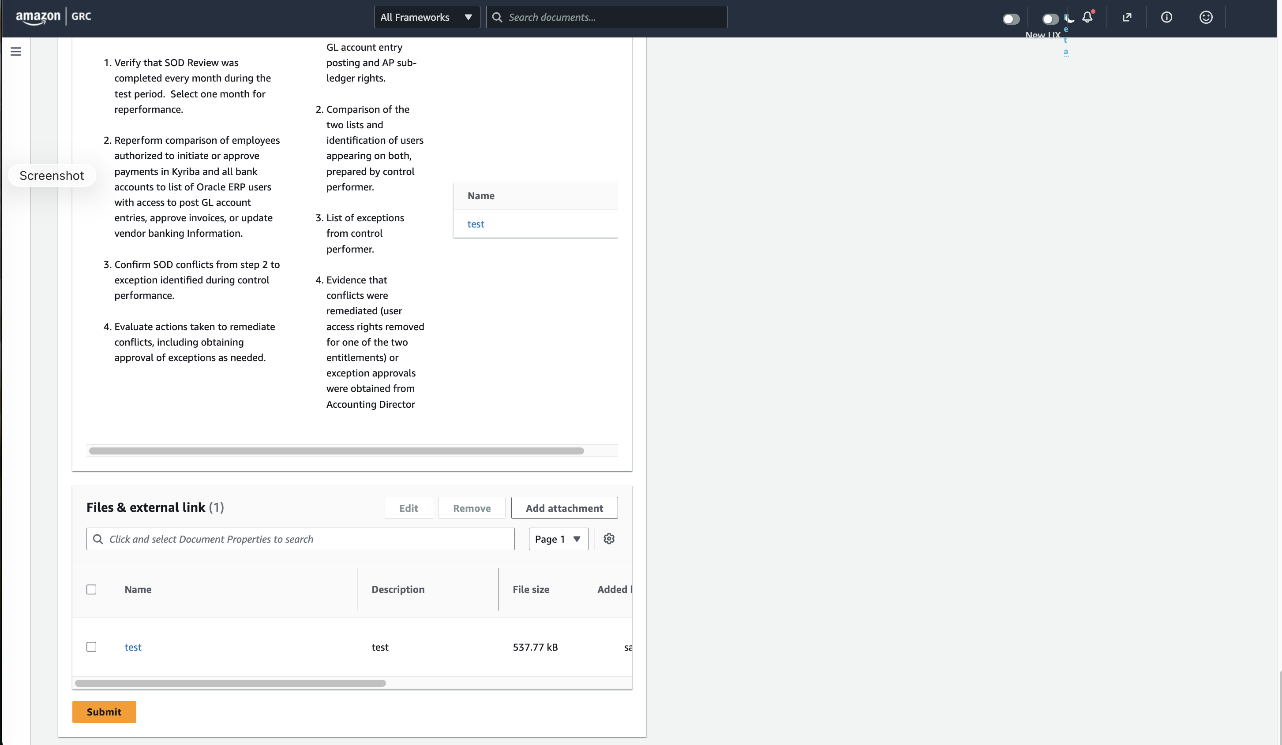
Figure 8: Submit button (enabled when all required fields are complete)

4. For GRC Approvers
As an approver, CLARA provides you with an AI-generated summary to help you make informed approval decisions quickly.

4.1 Open Review from Approval Queue
Open a submitted review from your approval queue. CLARA's Executive Summary appears at the top of the page with key assertions and risk flags.

4.2 Read CLARA Executive Summary
The summary shows:
- Key assertions from the reviewer's responses
- Evidence status (attached, validated, or missing)
- Variance vs. last quarter (what changed)
- Critical issues that may warrant rejection

4.3 Review Risk Flags
If CLARA identifies issues, they appear in the Critical Context section. Common flags:
- Invalid or placeholder evidence attached
- Contradictions between reviewer answers (e.g., Q2 says "Yes" but Q8 admits evidence is missing)
- Missing change disclosures
- Prior-quarter effectiveness failures

4.4 Approve or Reject
Based on your assessment:
- Click "Approve" if the review meets all requirements
- Click "Reject with comment" if issues need to be addressed — provide specific feedback so the reviewer knows exactly what to fix

Tip: Use CLARA's identified issues as the basis for your rejection comment — this ensures the reviewer gets actionable, specific feedback.

4.5 Feedback Controls
Each CLARA recommendation includes three feedback controls at the bottom of the insight card:

Control | Icon | When to Use
Thumbs Up (Helpful) |  | Click when the recommendation or insight was accurate and useful. This automatically paste the suggestion in the response field.
Thumbs Down (Not helpful) | 👎 | Click when the recommendation was inaccurate, irrelevant, or unhelpful. This signals CLARA to improve its suggestions for similar controls.
Copy | 📋 | Click to copy the CLARA recommendation text to your clipboard. Useful when you want to paste the suggestion into the response field and then edit it.

Your feedback is not anonymous (we will capture it by your user alias used to log into GRC). We will use the feedback to solely to improve CLARA's recommendations. It does not affect your review submission or approval status.

4.6 Re-analyze: Rate Limiting and Time-Outs
CLARA enforces rate limiting on the Re-analyze function to manage system resources. You may encounter a time-out under these conditions:
1. Multiple browser sessions are open for the same review and Re-analyze is clicked across those sessions simultaneously.
2. Re-analyze is clicked multiple times within a 5-minute window on the same review.
What happens when rate-limited:
- CLARA displays a time-out message indicating the analysis cannot run right now
- The time-out typically lasts 5–10 minutes
- Your existing analysis (from the last successful run) remains visible and valid
What to do:
- Wait 5–10 minutes before clicking Re-analyze again
- Close duplicate browser tabs/sessions for the same review
- Continue working on your responses — the rate limit only affects Re-analyze, not your ability to answer questions or submit
This is expected behavior, not an error. If the time-out persists beyond 15 minutes, contact sarthah@amazon.com or slack with your issue in #ask-grc-team channel.

5. Tips and Best Practices
Always click Re-analyze after changes: CLARA analysis is cached. After attaching evidence or changing answers, click Re-analyze to get updated validation.
Don't blindly accept recommendations: CLARA bases suggestions on historical patterns. If your situation is different this quarter, override the recommendation.
Check the Full Analysis for flags: The inline insights are brief. Click "View Full Analysis" for detailed per-question analysis including confidence levels and flags.
Attach evidence BEFORE submitting: CLARA validates evidence content. Attaching the right evidence early prevents approver rejection.
Review Critical Context first: If there are blocking issues, address them before spending time on questions.

6. FAQ
Q: Can auditors see CLARA suggestions?
A: No. Once a review is submitted, all AI content is automatically suppressed. Auditors only see human-authored responses.

Q: What if CLARA is wrong?
A: CLARA provides recommendations, not mandates. You can always override with your own response. Use the "Discard" option to write from scratch.

Q: Why does CLARA say "Generated by Clara — AI-generated content may be incorrect"?
A: This is a standard disclaimer. CLARA assists with drafting but may not have complete context. Always verify independently.

Q: What happens if I don't click Re-analyze?
A: The CLARA analysis remains cached from the last run. New evidence or answer changes won't be reflected in the Insights panel until you re-analyze.

Q: Can I use CLARA for all control types?
A: CLARA is available for all control types. Per-question recommendations may vary in availability depending on the control type and historical data.

Q: Who sees my review before I submit?
A: Only you. CLARA assists you privately during the draft phase. After submission, only your approver sees the final responses.

