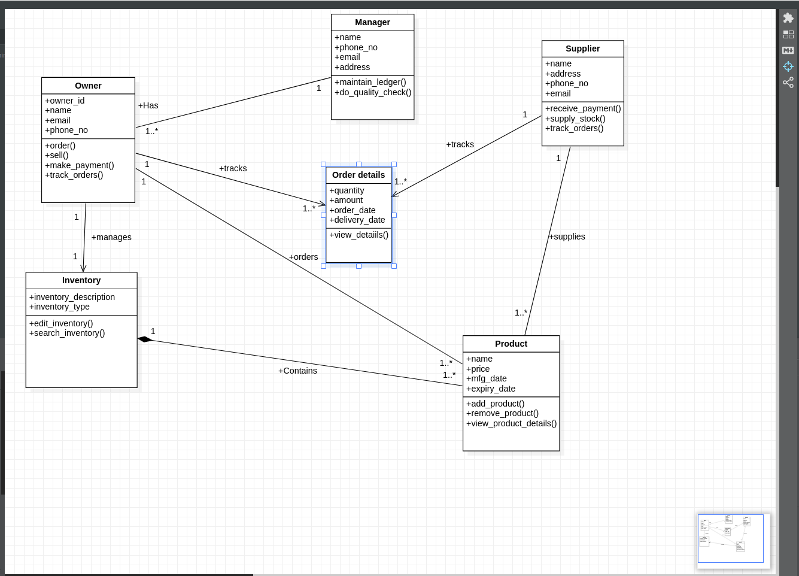
INVENTORY MANAGEMENT SYSTEM

CLASS DIAGRAM

STATE DIAGRAM
