LE STRUM  Instrument Stand  1. Peel protective film from both sides of all pieces of the kit (if present)  2. Fit the top and bottom faces and the side pieces together making sure all the tabs are fully interlocked  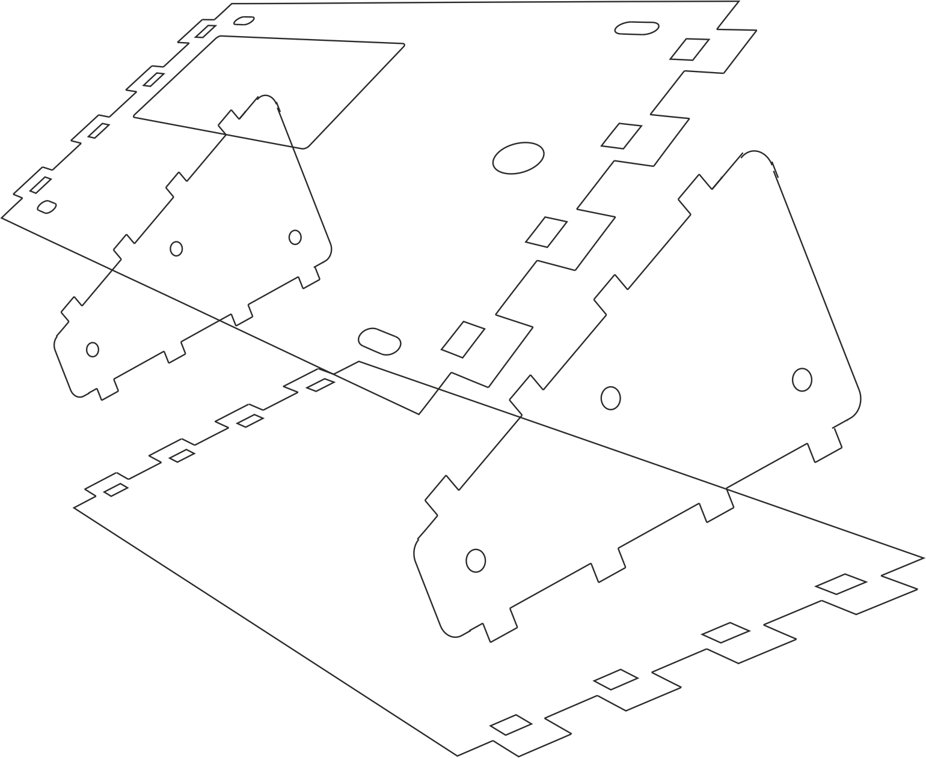  3. Fit the coloured end pieces to the protruding tabs (this is a tight fit – try not to force it too hard - and make sure the parts are fully engaged)  4. Use six bolts and nuts to secure the end pieces.  5. Remove the legs from the LE STRUM board and use four bolts, nuts and spacers to attach LE STRUM to the stand. The battery holder should fit through the cut-out in the top face of the stand.  6. Attach the four rubber feet  7. Enjoy!  sixtyfourpixels@gmail.com | LE STRUM  Instrument Stand  1. Peel protective film from both sides of all pieces of the kit (if present)  2. Fit the top and bottom faces and the side pieces together making sure all the tabs are fully interlocked  3. Fit the coloured end pieces to the protruding tabs (this is a tight fit – try not to force it too hard - and make sure the parts are fully engaged)  4. Use six bolts and nuts to secure the end pieces.  5. Remove the legs from the LE STRUM board and use four bolts, nuts and spacers to attach LE STRUM to the stand. The battery holder should fit through the cut-out in the top face of the stand.  6. Attach the four rubber feet  7. Enjoy!  sixtyfourpixels@gmail.com

