ARPIE
Monophonic MIDI Arpeggiator
User Guide
Revision 1.00
16 April 2013

Introducing ARPIE
ARPIE is a monophonic MIDI arpeggiator based around open-source software and hardware. The Arduino-based firmware enables simple code customisation and repurposing by users. The hardware is designed for easy DIY assembly and customisation.
Despite its simple construction and appearance, ARPIE is full featured with various chord arpeggiation and tempo synchronisation features, together with features to enable ARPIE to be used creatively without an attached MIDI keyboard.
A distinctive feature of ARPIE is the minimal control surface. While this has only simple LEDs for visual feedback, it is simple to use once you get familiar with it.
This manual is designed to provide a handy guide to using supplied ARPIE firmware and standard hardware. However it is not the full set of documentation available.
For information on troubleshooting, building, customising etc., as well as firmware updates, source code and hardware files please see https://github.com/hotchk155/arpie

Quick Start
I know you just want to get started... So connect up your MIDI keyboard to MIDI in, and a sound module to MIDI out. Switch on the ARPIE.. after a short delay (1-2 seconds) the 16 blue data display LEDs should light and the CLK LED should start blinking.
Hold down a chord on the MIDI keyboard. The RX LED should blink as notes are received, and the TX LED should blink rapidly as notes are sent. Press the HOLD button once, the HOLD LED should illuminate. Now when you play a chord, the Arpeggiator continues to play after you have released the keys.
If you don't have a keyboard handy, turn on HOLD, press INST and then press the small button below the right-most blue LED. This should start playing a C major chord arpeggio.
OK, now we've broken the tension lets move on :o)

Connections And Power
The rear panel of ARPIE is shown below:
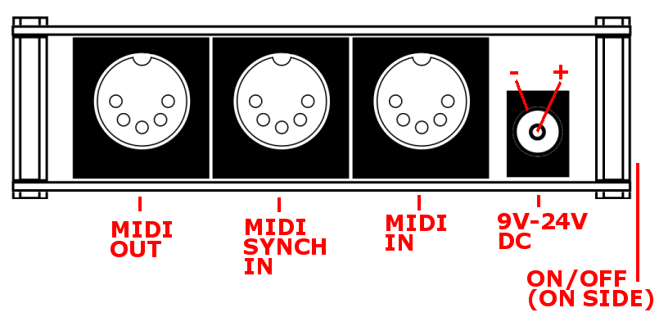
The minimal requirements to make music with ARPIE are
- A synthesizer or other sound module connected to MIDI OUT
- A power source. This can be an internally mounted PP3 battery or a DC supply of between 9 and 24V connected to the rear 2.1mm, centre-positive socket. The socket automatically disconnects the battery when a plug is inserted.
Additionally, you can connect a MIDI controller to MIDI IN. Typically a piano type keyboard is used to play chords which provide input for ARPIEs arpeggiation engine however ARPIE can also be initialised with random or fixed chords without an external keyboard.
Optionally a MIDI clock source can be connected to MIDI SYNCH IN. For example you might want ARPIE to synchronise as a slave to a drum machine which can output a MIDI beat clock.
ARPIE can also slave to a MIDI beat clock on MIDI IN, though often the note controller and master clock sources will often be separate devices, which is where the external synch input is useful.
The main power switch is on the side of the device, close to the DC socket. Slide the switch toward the back of the unit to switch on power. The power LED (close to the switch) lights when power is on.

The Control Surface
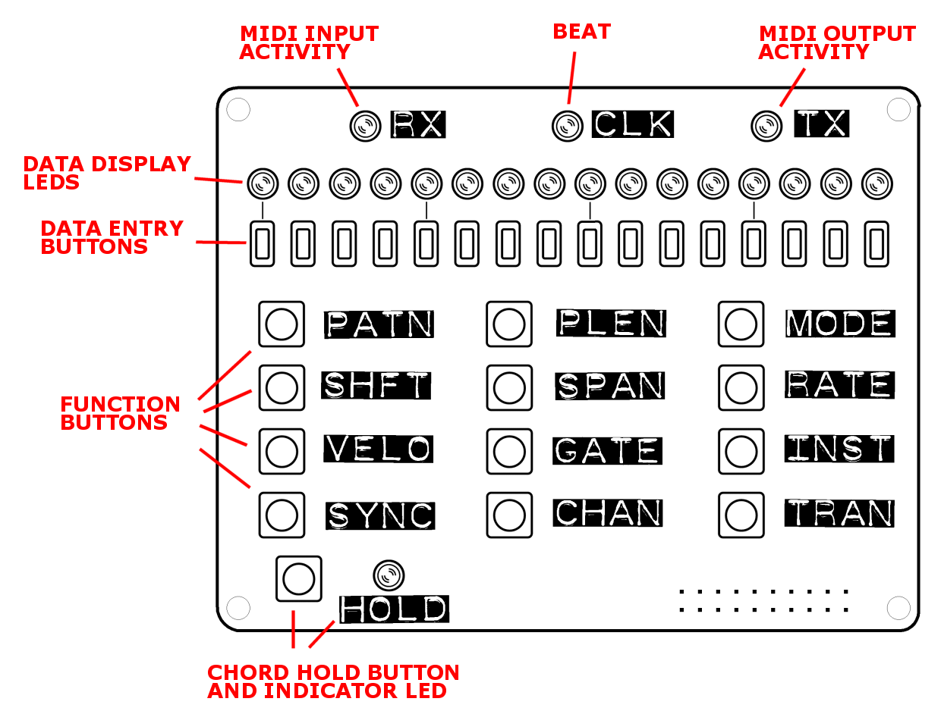
The top row contains three activity LEDs:
- The RX LED flickers when MIDI information is received via the input port
- The CLK LED - flickers at the start of each beat
- Then TX LED flickers when MIDI information being sent via the output port
The function of the Data Display LEDs and Data Entry Buttons depends on which of the function buttons was last pressed. Each function assigns specific meanings to each of the LEDs and Data Entry buttons. If no buttons are pressed for a few seconds the display function returns to Pattern Mode (PATN)
The HOLD button toggles the chord hold function on and off. An indicator LED beside the HOLD button shows when the chord hold function is in effect. This function means that a chord you press on a controller keyboard will continue to play after you release the keys. The HOLD feature also has some more subtle effects regarding sequencing and step timing, which are listed later.
Each function button is described in the following sections:

PATN - Pattern Edit
In this mode the sixteen data display LEDs show a pattern of “note” (LED on) or "rest" (LED off). You can toggle an LED on and off by pressing the data button below the LED.
This pattern of notes and rests and allows a rhythmic structure to be applied to the currently playing arpeggio. Arpeggiated notes are muted when they coincide with a rest in the pattern.
PATN is the default function, and the one to which ARPIE returns when you don't press anything for a while. You can return to this mode immediately by pressing PATN at any time.

PLEN - Pattern Length
Press the PLEN button to view and change the length of the rhythmic pattern (from 1-16 steps). The current pattern length is indicated with a brighter LED and can be changed by pressing a data button.
The pattern restarts when it reaches the point defined by PLEN. This can be different from the length of the arpeggio sequence, allowing some interesting effects as the rhythmic pattern of notes and moves across the arpeggio sequence.

TYPE - Arpeggio Type
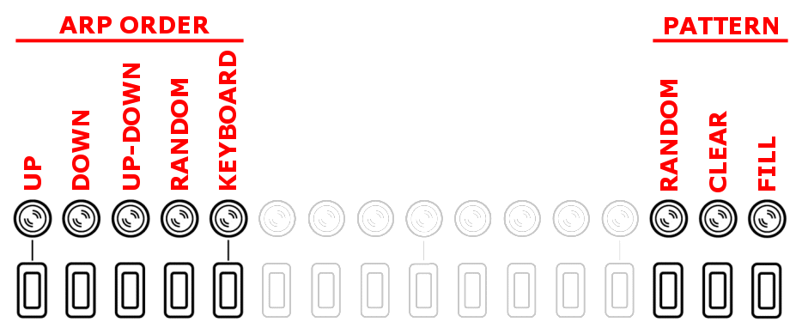
This mode allows you to select the basic way in which the Arp sequence is built from a chord. It also contains some buttons which can be used to initialise a pattern
ARP ORDER
- UP - notes of the chord are sorted into ascending order
- DOWN - notes of the chord are sorted into descending order
- UP-DOWN - notes of the chord are sorted into ascending, then descending order If the sequence spans multiple octaves, all octaves are spanned on the way "up" before returning "down". The highest note is not repeated.
- RANDOM - notes placed into a random order.
- KEYBOARD - notes of the chord are not reordered, so will be in the order they were received by MIDI.
PATTERN SETUP
- RANDOM - The rhythmic pattern (PATN mode) is randomised and its length (PLEN) is set to a random number.
- CLEAR - Pattern is cleared (all rests) and set to 16 step length.
- PATTERN FILL - Pattern is filled (all notes on) and set to 16 step length.

SHFT - Octave shift
Transposes the arpeggiated sequence by whole octaves.
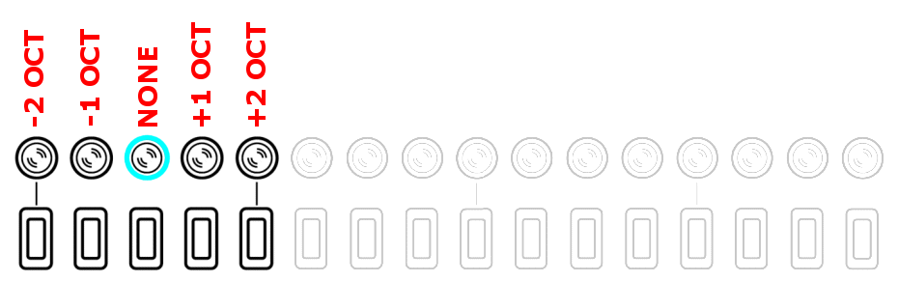
The default “no shift” position is indicated by a slightly brighter LED.

SPAN - Octave Span
Determine the number of octaves the arpeggiated sequence will be extended over.
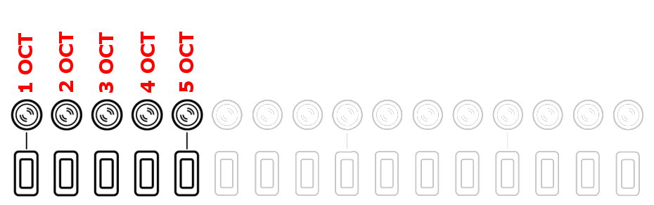

RATE - step length
Determines the length of notes in the arpeggiated sequence, as a fraction of a beat (It does not alter the tempo/BPM)
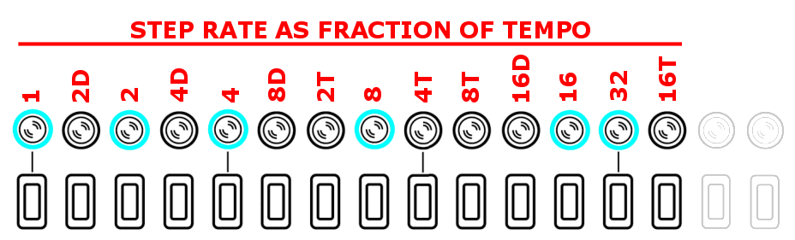
The above labels can be interpreted as follows:
NOTE TIME DIVISION
- 1 – full note
- 2 – half note
- 4 – quarter note (1 beat)
- 8 – eighth notec
- 16 – sixteenth note
- 32 – thirty-second note
SUFFIX
- D – dotted time (one and a half times normal note duration)
- T – triplet time (two thirds normal note duration)
Whole time divisions (Without suffix) are shown on the display with brighter LEDs to assist interpreting the display.

VELO - Velocity
Controls the MIDI velocity of the notes output by the sequencer.
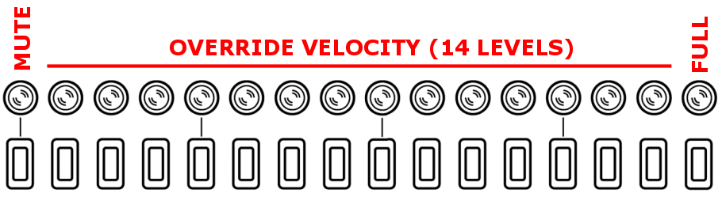
There are two velocity modes and you can toggle between them by pressing and holding the VELO button.
- Original velocity mode plays each arpeggiated note using the velocity of the note as it was played in the chord on the input device. This mode can be identified by the right-most LED being on and all the others off. In this mode the data entry buttons have no function.
- Adjustable velocity mode allows you to override the velocity of all arpeggiated notes to one of 16 levels (including muted and full velocity) as indicated below

GATE - note Length
Controls the gate length of the notes output by the sequencer - as proportion of the current note length. The highest setting means that one note is "tied" to the next (The note is not stopped until the next note is started, with the MIDI note off message being sent after the next MIDI note on)

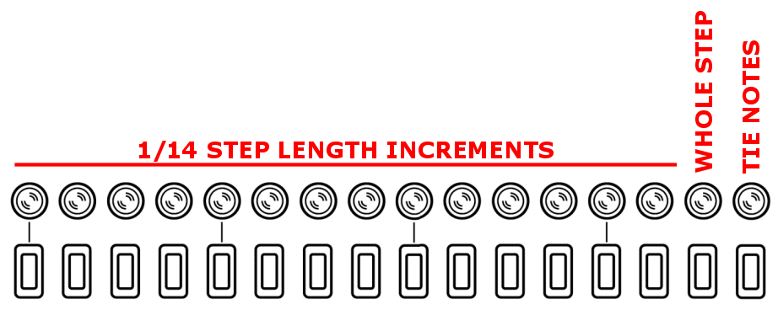
INST - Note insertion
Extends the length of the arp sequence by repeating notes from the chord according to specific modes as defined below. This screen also has some options for inserting chords without a keyboard for demo purposes. The "Hold" switch must be enabled for this to work.
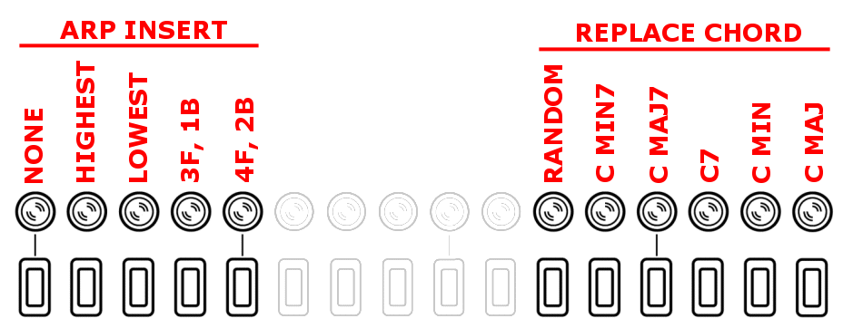

SYNC - MIDI Synch
This screen controls the arp MIDI SYNCH mode and internal metronome (BPM). When ARPIE is running on its internal clock, the data display LED's indicate the approximate BPM. Pressing one of the nine BPM buttons sets the tempo to a specific value.
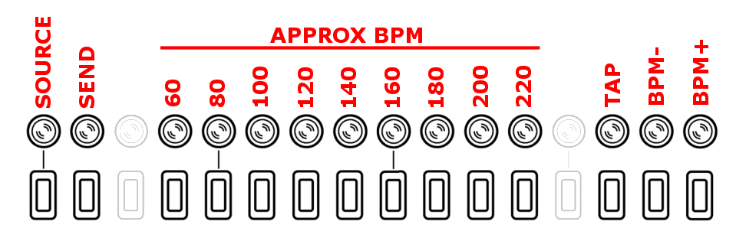
The SOURCE button controls the SYNCH clock source:
- ON – Internal clock source
- OFF – External clock source via the MIDI IN or SYNCH IN sockets
The SEND button controls whether ARPIE sends a MIDI beat clock to the MIDI OUT port. This button can also be used to start/stop and synchronise MIDI slave devices. More late rin the manual
- ON – Send MIDI synch messages out of MIDI OUT port
- OFF – Don't send MIDI synch messages
The BPM+ and BPM- buttons can be used to adjust the BPM by steps of 1.
Pressing the TAP button two or more times allows you to set the tempo interactively.
BPM defaults to 120 when ARPIE is switched on.
The internally generated BPM is approximate (but good enough for most stuff). However, an external clock source is recommended if a precise BPM is needed.

CHAN - MIDI Channel
When pressed, selects and displays the MIDI channel for output
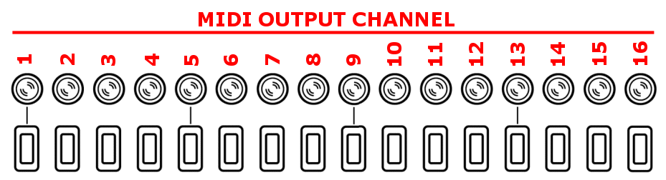
If the CHAN button is pressed and held for a couple of seconds, you can Select The MIDI Input Channel. By default ARPIE will accept input from any MIDI channel (OMNI mode) but you can also select a specific channel, which affects MIDI Thru behaviour (see below)
OMNI mode is indicated by all the Data Display LEDs showing brightly. Pressing any single button will select an individual input channel. Pressing the same button again will restore OMNI mode.

TRAN - note transpose
Transpose the MIDI output. Buttons represent -3. -2, -1, 0, +1, +2 through to +12 semitones. The default (no shift) position is indicated with a brighter LED.
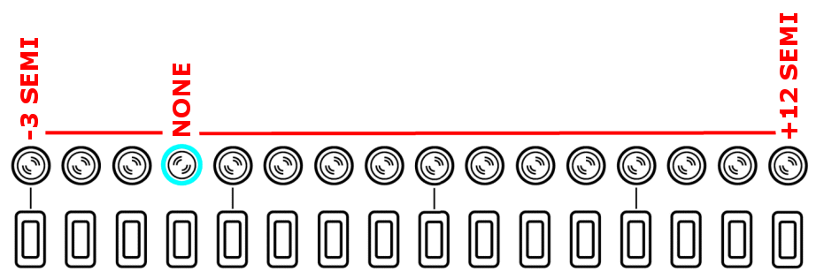

More About HOLD
Here is everything you wanted to know about the hold button. And some more.
HOLD is OFF | One or more keys are pressed and held | Arpeggiation starts from beginning of pattern and plays immediately. Beat time is reset
HOLD is OFF | One or more keys are released from a chord but at least one key remains held | Arpeggio is rebuilt but position in pattern and timing of next beat are unaffected
HOLD is OFF | One or more additional keys are pressed while a chord is held
HOLD is OFF | Final key is released | Arpeggiation stops
HOLD is OFF | HOLD pressed while keys are held | HOLD is ON using the current chord. Pattern position and next beat time are unaffected
HOLD  is ON | One or more keys are initially pressed | Arpeggiation starts from beginning of pattern. Next beat timing is unaffected so the first step plays according to the current beat time
HOLD  is ON | Some keys are released from the chord | No effect. The released keys remain in the arpeggio
HOLD  is ON | Additional keys are pressed while at least one key of the chord remains held | Arpeggio is rebuilt but position in pattern and timing of next beat are unaffected
HOLD  is ON | All keys are released | No effect
HOLD  is ON | One or more keys pressed after releasing all keys of the previous chord | Arpeggio is replaced but position in pattern and timing of next beat are unaffected
HOLD  is ON | HOLD pressed while keys remain held | All notes removed from the arpeggio except any that are still physically pressed on keyboard. HOLD is OFF
HOLD  is ON | HOLD pressed while no keys are held | Arpeggiation stops. HOLD is OFF

More about synch
SOURCE | SEND
INTERNAL  (LED is ON) | OFF | STANDALONE  - Running on internal beat clock  - Internal beat clock is not sent to MIDI output  - Incoming synch messages are ignored
INTERNAL  (LED is ON) | ON | MASTER  - Running on internal beat clock  - Incoming synch messages are ignored  - Internal beat clock is sent to MIDI output  - When SEND goes from OFF-ON the beat clock is restarted and MIDI restart message is sent to downstream devices  - When SEND goes from ON-OFF the beat clock is stopped and a MIDI stop message is sent to downstream devices
EXTERNAL  (LED is OFF) | OFF | SLAVE  - Requires external synch  - Both MIDI IN and SYNCH IN are active (but only one should be used to receive synch messages at any time)  - Incoming synch messages are not passed to output
EXTERNAL  (LED is OFF) | ON | SLAVE + THRU  - Requires external synch  - Both MIDI IN and SYNCH IN are active (but only one should be used to receive synch messages at any time)  - Incoming synch messages are not passed to output

More About MIDI Thru
Input Channel Mode | Behaviours
OMNI mode (default) | MIDI note on/note off messages from any input channel are passed to the arpeggiator engine and are not passed to the output
OMNI mode (default) | Other MIDI channel messages (such as pitch-bend and mod-wheel) are passed through to output but the channel is always changed to equal ARPIEs selected output channel
OMNI mode (default) | Incoming MIDI beat clock message are only passed to output if SYNCH SOURCE is EXTERNAL and SYNCH SEND is ON
OMNI mode (default) | Other Realtime/SysEx are passed through
Specific Input Channel | MIDI note on/note off messages from the specific input channel are passed to the arpeggiator engine and are not passed to the output
Specific Input Channel | MIDI note on/note off messages for other channels are passed are passed through to output on their original channels
Specific Input Channel | Other MIDI channel messages (such as pitch-bend and mod-wheel) are passed through to output on their original channels
Specific Input Channel | Incoming MIDI beat clock messages are only passed to output if SYNCH SOURCE is EXTERNAL and SYNCH SEND is ON
Specific Input Channel | Other Realtime/SysEx are passed through

MIDI thru is handed in ARPIEs firmware (there is no hardware thru) which can cause latency if the arpeggiator engine is busy - and possibly even dropped messages in situations of very high thru volume.

Stored settings
ARPIE stores the following settings in EEPROM, which means that they are remembered when the device is switched off, and used as defaults next time it is switched on
- Synch SOURCE setting
- Synch SEND setting
- MIDI input channel (or OMNI) setting
- MIDI output channel setting

