**LATCHBOX MODULE - SIXTY FOUR PIXELS LTD – 2 DECEMBER 2019**

**Product Description**

The module converts a momentary switch input to a latching switch output and is intended for adapting momentary accessibility switches for video game inputs etc. that require a switch to be “held down” for a period of time. The device is designed for housing within a Hammond type 1593 enclosure with a 3 x AAA battery holder. A replacement front panel is provided for the box with etched legend and pre-cut holes for the sockets, LEDs and switch.

An external switch is connected to the IN socket via a 3.5mm jack. When the tip of the jack is shorted to the sleeve this is detected by a microcontroller (MCU). An input pin on the MCU, which is usually held high by an internal pull-up resistor, is pulled low. The firmware on the MCU detects this change and, after applying debounce logic, toggles an output pin which in turn controls a small reed relay via a switching transistor. The output contacts of the reed relay are connected to the output 3.5mm jack socket, shorting the tip to sleeve when the relay is activated.

The MCU input is protected by a diode D4 to prevent current flow from over-voltage input. Clamp diode D6 with current limiting resistor R1 protect against negative voltage input.

The module can run from 3xAAA batteries. A PTC resettable fuse guards against the battery power being short-circuited within the module and a series Schottky diode guards against reverse polarity. The module is able to switch its own power on and off via a P channel MOSFET (Q1). An NPN transistor (Q3) drives the MOSFET gate. When switch S1 is closed, the MOSFET gate is pulled low and power can flow into the module allowing the MCU to initialise. After a 1 second delay (to guard against accidental power on) the MCU sets an output pin high to keep the MOSFET gate pulled low via the NPN transistor Q3.

The MCU can detect the state of S1 via in internally pulled up input pin. When S1 is released, the firmware starts up and normal operation begins. The MCU will turn off its own power, by turning Q3 off, when it detects that S1 is pressed again or when a period of time has elapsed without any change at the switch input (auto power off)

The module can also run by USB power. In this case the MOSFET switch is bypassed, which means that the module is powered up and running normally for as long as USB power is applied. This allows it to be powered up while a games console is running (where the console provides USB power). The data lines on the micro USB socket are unconnected.

Schottky diodes D1 and D2 prevent backflow of current when both USB and battery power is present. In that case the higher voltage (~5V) USB supply will provide current over the lower voltage (~4.5V) battery power.

Two LEDs provide feedback on power status (red) and output switch status (blue). The MCU drives these LEDs at approx. 50% duty to reduce brightness and power consumption.

**Product Schematic**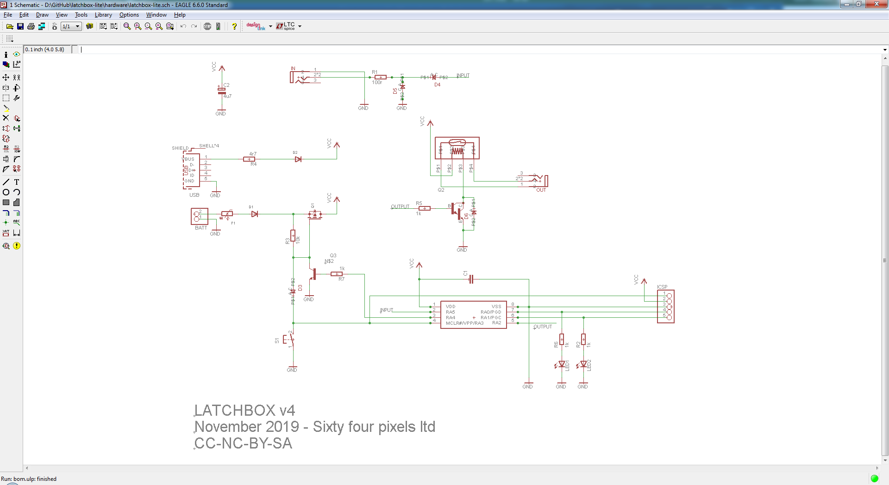

**Bill Of Materials**

|  |  |  |  |
| --- | --- | --- | --- |
| **Reference** | **Description** | **Manufacturer** | **Supplier Ref** |
| C1 | MC0805B104K250CT 100nF ceramic capacitor 0805 case | Multicomp | Farnell order code 2310668 |
| C2 | 4.7uF 20% 50V 85°C 5mm electrolytic capacitor | Forever | Rapid order code 11-1522 |
| D1, D2 | MBR0520LT1G schottky diode SOD-123 case | On Semi | Farnell order code 2317669 |
| D3, D4, D5, D6 | TS4148 small signal diode 0805 case | Taiwan Semiconductor | Farnell order code 2839607 |
| F1 | MC36207 PTC resettable fuse 30V/200mA 1206 case | Multicomp | Farnell order code 1861187 |
| IC1 | PIC12F1822-I/SN microcontroller SOIC8 case | Microchip | Farnell order code 1971857 |
| IN, OUT | MX-387GL 3.5mm Audio Connector | Pro Signal | Farnell order code 1267376 |
| LED1 | 3501 3mm Red Diffused LED | Kitronic | Kitronic order code 3501 |
| LED2 | 3565 Blue Diffused 3mm LED | Kitronic | Kitronic order code 3565 |
| Q1 | IRLML2246TRPBF P channel MOSFET SOT-23 | Infineon | Farnell order code 1888166 |
| Q2 | MMBTA13 NPN Darlington transistor SOT-23 | Fairchild | Farnell order code 9846590 |
| Q3 | MMBT3904 NPN transistor SOT-23 | On Semi | Farnell order code 9846727 |
| R1 | MC01W08051100R 100R 1% resistor 0805 case | Multicomp | Farnell order code 2129034 |
| R2, R5, R6, R7 | MC01W080511K 1K 1% resistor 0805 case | Multicomp | Farnell order code 2129113 |
| R3 | MC01W0805110K 10K 1% resistor 0805 case | Multicomp | Farnell order code 2129195 |
| R4 | MC01W080514R7 4R7 1% resistor 0805 case | Multicomp | Farnell order code 9333304 |
| RLY1 | Reed Relay 9007-05-01  5V, 500 ohm, 500 mA | Coto Technology | Farnell order code 1081622 |
| S1 | SKHHLUA010 right angle tact switch 5.85mm stem | ALPS Alpine | RS Stock No. 758-2001 |
| USB | 629105150521 micro USB connector | Wurth Electronic | Wurth part no. 629105150521 |
| Reflow Solder Paste | Loctite GC 10 Lead Free Solder Paste | Henkel | RS order code 910-6790 |
| Solder wire | 0.7mm Lead Free Solder Wire 0.5% Cu, 96.5% Sn, 3% Ag | RS Pro | RS order code 756-8884 |
| Printed Circuit Board | Printed circuit board Pb free (custom design) | ALLPCB | custom |
| Front Panel | Laserables II acrylic laminate panel (custom laser cut) | Innovative Plastics | Hindleys SKU SUR1210 |

**Manufacturing Process**

1. The fascia for the unit is laser-etched and cut from a two part bonded acrylic sheet. It is then cleaned using a foam cleanser (Servisol 30)
2. The printed circuit boards are fabricated in panels of eight boards. A steel stencil is used to apply solder paste to the panel, then all surface mount components are manually picked and placed on the boards using tweezers.
3. The panel is heated in an infra-red reflow oven to complete the soldering process of the surface mount components.
4. The panels are visually checked, and electrically checked using a digital ohm meter to ensure there are not short circuits present resulting from solder spread during the reflow process
5. Through hole components and USB socket are added. These are hand soldered using a soldering iron and solder wire
6. The boards are cleaned using isopropyl alcohol and a visual quality check is carried out.
7. The microcontroller chips are programmed using the in-circuit serial programmer (ICSP) connection on the board.
8. A micro USB plug is connected to the USB socket and, via a connected break-out board, continuity checks are carried out to make sure there is no shorting of the USB socket pins
9. Via the same break out board, 5V power is applied over USB and current consumption is checked to ensure it does not exceed 20mA at 5V. A higher current draw could indicate a fault. The LEDs are checked to ensure that both light when powered.
10. An external 4.5V power supply is connected to the battery box clips and the power on/off functionality is tested. Current consumption is checked to ensure it does not exceed 20mA at 4.5V. A higher current draw could indicate a fault.
11. Using a specially made test jig, the latching action is tested by connecting a push button switch to the input socket and an LED and CR2032 3V battery in series to the output socket. This allows the latching action to be tested directly.
12. The front fascia is attached and the module is packaged and packed into shipping box