

**FACULTY OF COMPUTING AND INFORMATICS**

# TCP2201 Project

**Trimester 2310**

**By <<Group 6>>**

| **Name** | **ID** | **E-mail** | **Phone Number** |
| --- | --- | --- | --- |
| **Sadman Zuifiquer** | **1221301874** | **1221301874@student.mmu.edu.my** | **018-271 8422** |
| **Ho Teck Fung** | **1211102399** | **1211102399@student.mmu.edu.my** | **012-369 0301** |
| **Tan Teng Hui** | **1211102289** | **1211102289@student.mmu.edu.my** | **011-1060 0910** |
| **Teng Wei Joe** | **1211102797** | **1211102797@student.mmu.edu.my** | **017-330 0623** |

# 

# Table Content

**TCP2201 Project 0**

**Table Content 1**

**Compile & Instructions 2**

**Command Line 2**

**BlueJ 3**

**Visual Studio Code 4**

**UML Class Diagram 6**

**Use Case Diagram 7**

**Sequence Diagram 8**

**User Documentation 12**

# Compile & Instructions

After extracting the zip file, choose either command line, BlueJ, or VSCode folder.

## Command Line

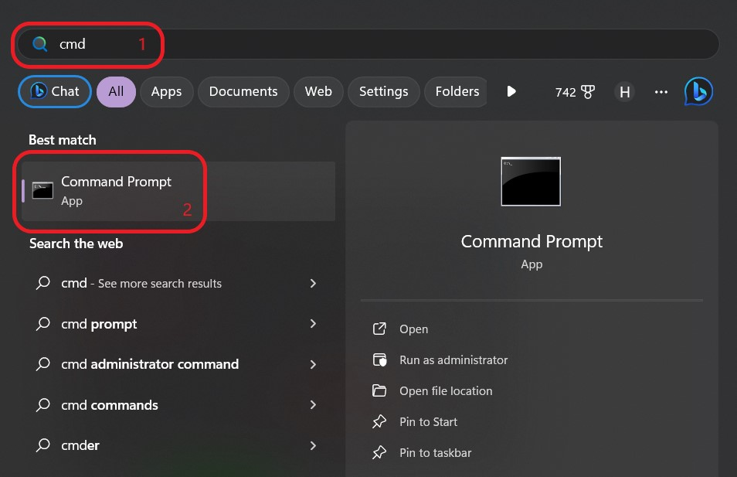

1. Search “**cmd**” and open it if you’re using Windows OS. Search “**terminal**” if you’re using Mac OS.

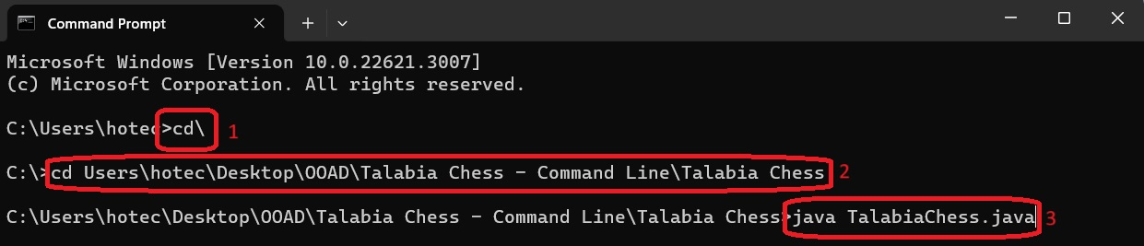

1. Navigate to the outermost directory, also known as the root directory, you can use the following command: “**cd\**”.
2. Go to the directory \***[Talabia Chess - Command Line\Talabia Chess]\***.
3. Run the command “**java TalabiaChess**”.

*To locate the precise path, navigate to the folder you extracted from the zip file. Once inside the folder, copy the file path from the upper section of the file explorer.*

## BlueJ

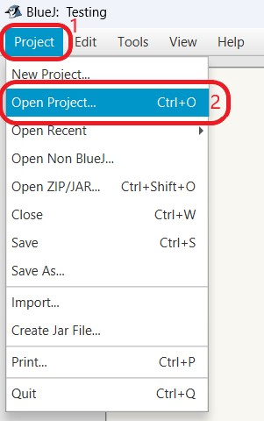

**Open Project** > Select folder “**Talabia Chess**” inside “**Talabia Chess - BlueJ**”.

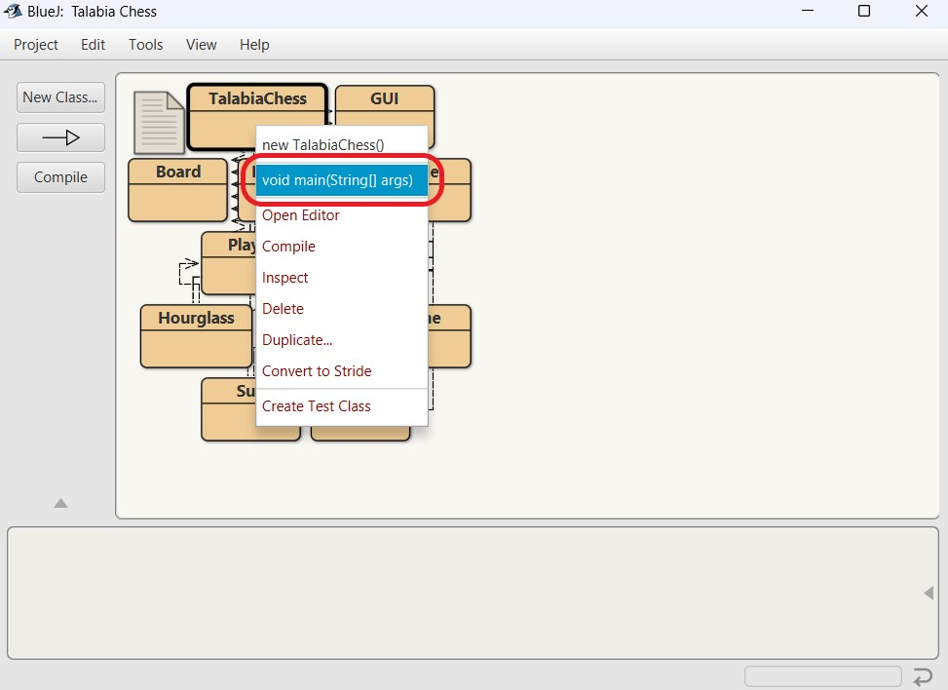

Right-click“**Talabia Chess**”and click“**void main(String[] args)**”.

## Visual Studio Code

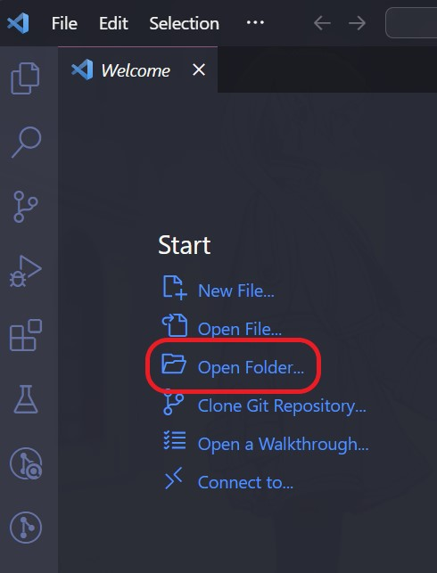

Select “**Open Folder**” in Visual Studio Code.

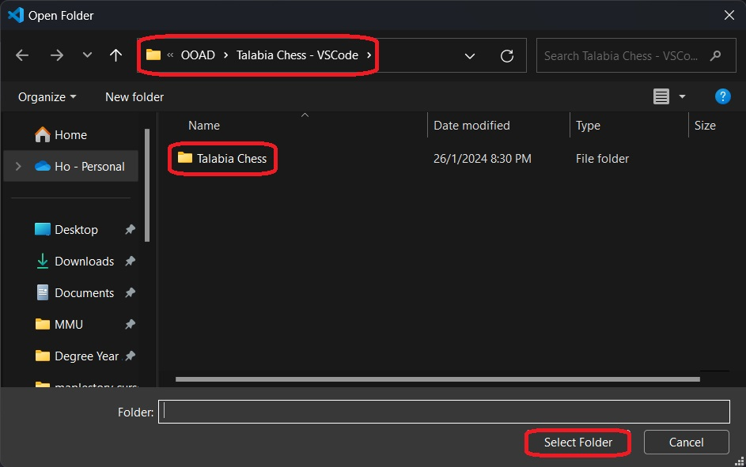

Select the folder “**Talabia Chess**” inside “**Talabia Chess - VSCode**”.

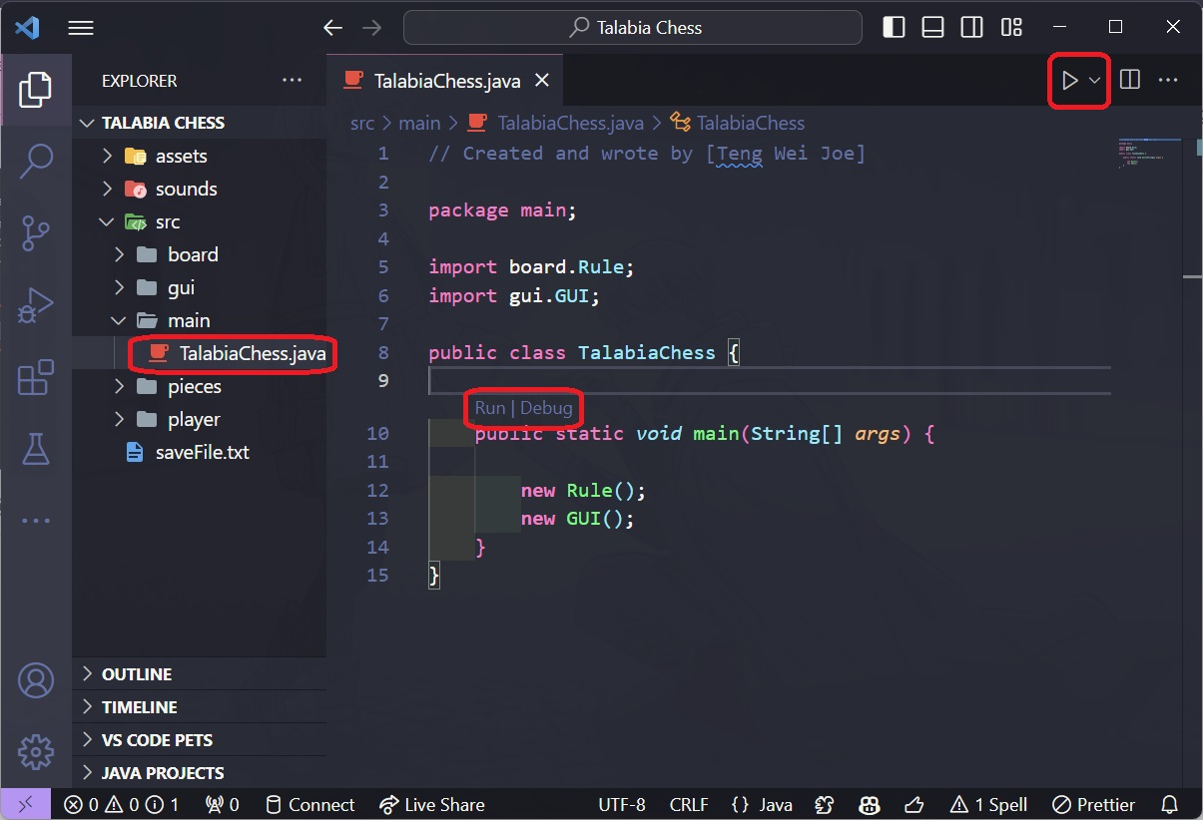

Open “**TalabiaChess.java**” > hold “**Ctrl + F5**” or choose any of the **3** ways to run the TalabiaChess.java:

1. Click the “**Run**” button beside the “Go” button.
2. Click the **Arrow** icon(Run) in the top right corner.
3. Click the “**Run | Debug**” button in the “**TalabiaChess.java**”.

# UML Class Diagram

# Use Case Diagram

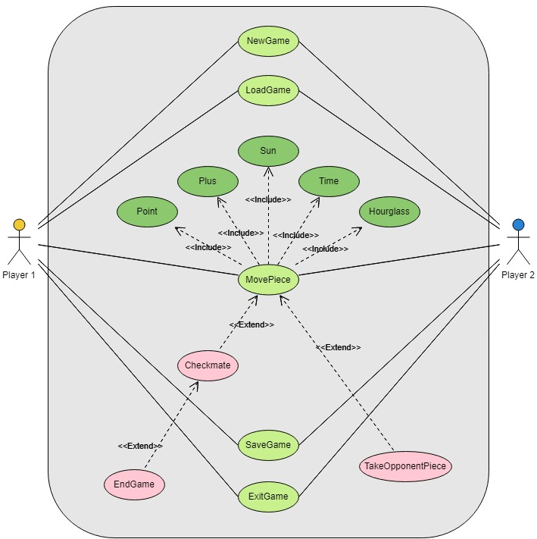

# Sequence Diagram

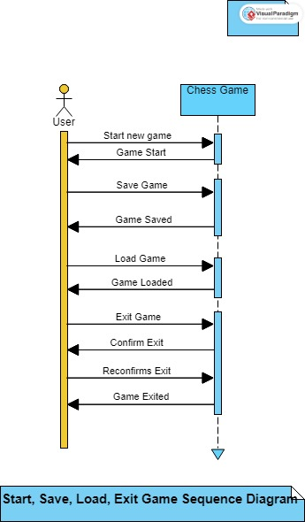

**Start, Save, Load, Exit Game Sequence Diagram**

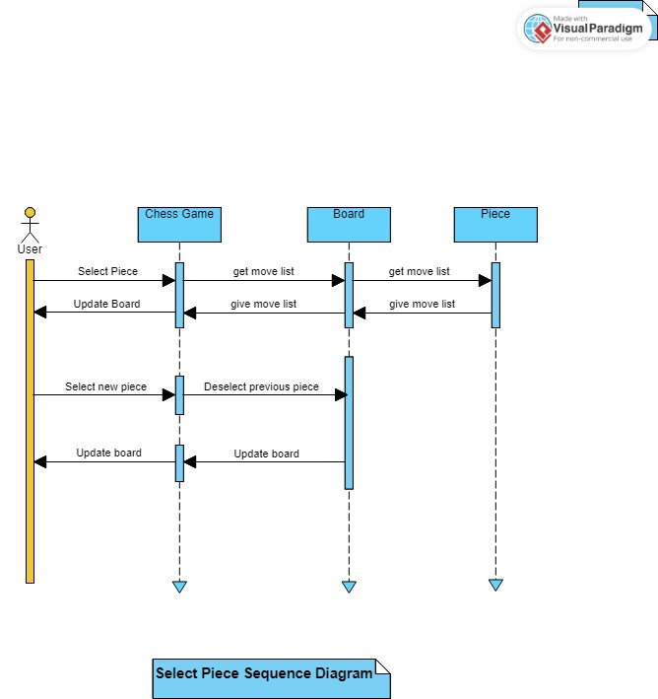

**Select Piece Sequence Diagram**

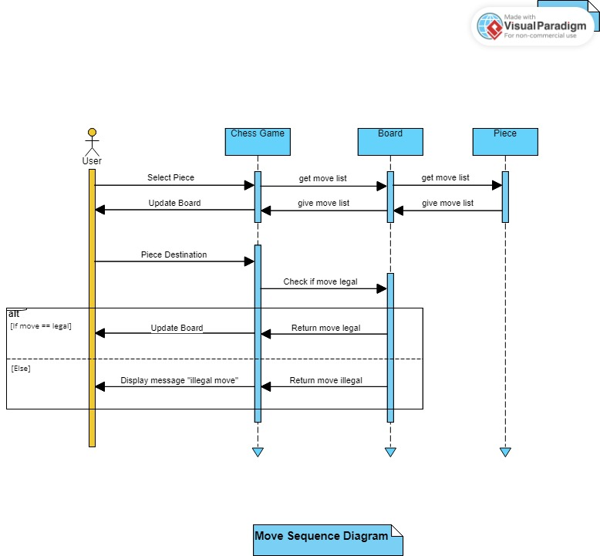

**Move Sequence Diagram**

**Checkmate Sequence Diagram**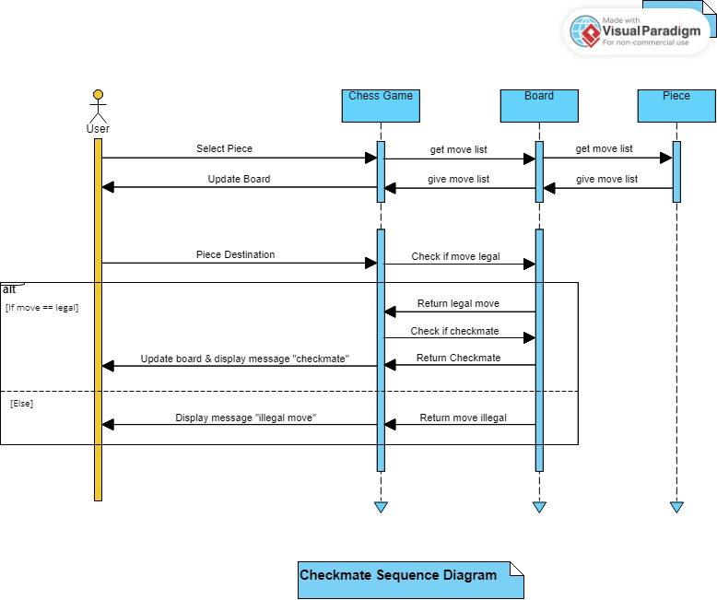

# User Documentation

**How to use the program**

**Piece movement**

Step 1: Choose the piece you want to move. (Single click)

Step 2: Choose the destination you want the piece to move to. (Single click)

**File** menu:

* **New Game**: creates a new game
* **Save Game**: saves current game
* **Load Game**: loads previously saved game
* **Exit Game**: exits game

# 