**horner's algorithm:** 3x^5 - 5x^4 + 5x^3 + x^2 - 20 ⇛ A = [-20, 0, 1, 5, -5, 3]

horner(x, A)

y = A[-1]

for all i ∈ {len(A) downto 0} do y = y*x + a[i]

return y

- n multiplications ⇛ Θ(n) rather than Θ(n²)

**binary exponentiation**

LeftRightBinaryExponentiation(a, b(n))

//Input: A number a and a list b(n) of binary digits bᵢ, ... , b0 in the binary expansion of a positive integer n; Output: The value of aⁿ

product ← a

for i ← I − 1 downto 0 do

product ← product ∗ product

if b i = 1 product ← product ∗ a

return product

**2-3 trees** UPON INSERTION (always into a leaf):

Inserting into 2-node: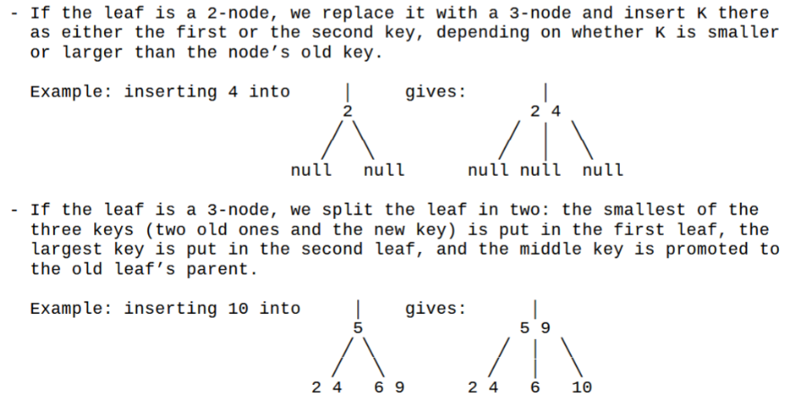

**kruskal**

- O(ElgE)

- sort edges by weight then by node letters

- include edges by increasing weight UNLESS they form a cycle

- find(n) tells you the furthest node from n

- if find(x) = find(y) then don't link

**Prim** finds a minimum spanning tree, O(V²) with adjacency matrix or O(ElgV) with adj. list

chosen edges: | remaining vertices:

a(-, -) | shortest edges connecting all unvisited nodes to any visited node

next-shortest: | (if unreachable from source, weight = ∞)

x(parent, weight)|

**Dijkstra** finds the shortest path from the source to ANY VERTEX

chosen edges: | remaining vertices:

a(-, -) | shortest distance from source to *all* unvisited nodes

lighest edge: | with intermediate = next node on lightest path to root

x(intermediate, weight)| and weight = the weight of that path

**floyd-warshall**

- finds shortest path between ALL vertices in O(V³)

- add all given weights to D0 (diagonal is all 0s)

- vertical is "from", horizontal is "to"

- while the graph still contains distances of infinity

- for vertices i, j, k in V, if D[i][j] > D[i][k] + D[k][j] then D[i][j] = D[i][k] + D[k][j]

**Edmonds-Karp Algorithm** - worst case O(E⁵), average case O(VE²)

- G_f (residual network) is made of all edges (u, v) where c_f(u, v) > 0

- where c_f =

- capacity of (u,v) - current flow of (u,v) if (u,v) exists {i.e. how much more we can push *into* the real edge}

- current flow (v,u) if the backward edge (v,u) exists {i.e. how much we can push *out of* the real edge}

- 0 otherwise.

edmonds-karp(flow network G, source s, sink t)

initialize all flows to 0

while there exists a path from s to t:

do BFS to find shortest path from s to t on residual network

augment real flows on that path by the bottleneck (add to forwards, subtract from backwards)

update residual network

**coin-row** - C = actual list of coins, F = best running sum, S = coin index of last pickup

- F(n) = max(C[n] + F(n - 2), F(n - 1)) for n > 1; otherwise F(0) = 0, F(1) = c₁

**robot coin/collection** - find path thru F in Θ(i+j) time;

- given coin layout table C, we make solution layout F where for all i, j in C, F[i,j] = max(F[i-1, j], F[i, j-1], + C[i, j])

- best coin total is in far bottom-right

- start at top-left move right if/until lower is greater, then move down until right is greater

**max sum descent:** fill in each space of the pyramid with the sum of its max parent, retrace by following max child

**0-1 knapsack** - for item i with weight wᵢ and value vᵢ and knapsack capacity j,

F(i, j) = 0 if i = 0 or j = 0

F(i, j) = max(vᵢ + F(i - 1, j - wᵢ), F(i - 1, j)) if wᵢ ≤ j ≤ W (can fit)

i.e. max(use, lose)

F(i, j) = F(i - 1, j) if 0 ≤ j < wᵢ (can't fit)

- to backtrack: start bottom-right (i is vertical, j is horizontal)

- if a cell has the same value as the one above it, we didn't choose it; go one up

- if a cell is greater than the one above it, then we selected item i; go one up and wᵢ columns left

- stop if current cell equals **0**

**RBT Insertion:**

Properties that could be violated during insertion:

2. The root is not black. (Make it black and check back.)

4. A node is red, but both of its children are not black. In this case:

Case 1: z’s uncle y is red:

p[z].color = black

y.color = black

p[p[z]].color = red

z = p[p[z]]

Z’s parent is a left child and

Case 2a: z’s uncle y is black and z is a right child

z = p[z]

left-rotate(z)

Case 3a: z’s uncle y is black and z is a left child

p[z].color = black

p[p[z]].color = red

right-rotate(p[p[z]])

Z’s parent is a right child and

Case 2b: z’s uncle y is black and z is a left child

z = p[z]

right-rotate(z)

Case 3b: z’s uncle y is black and z is a right child

p[z].color = black

p[p[z]].color = red

left-rotate(p[p[z]])