To start a reimbursement, follow the steps:

- Click the link to go to the page: https://mijn.uu.nl/fiori#Shell-home
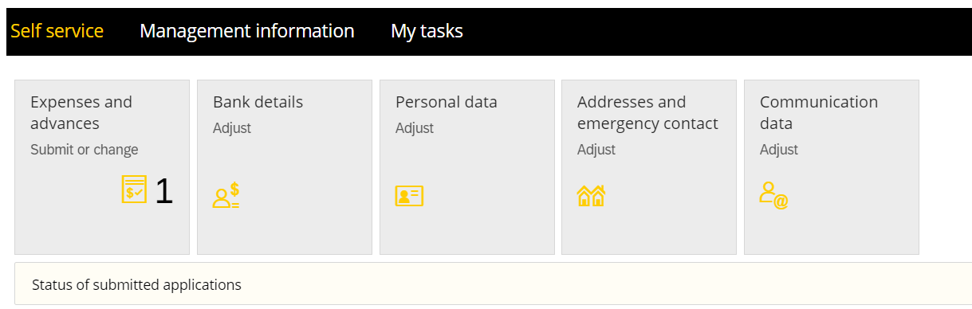
- Click the “Bank detals” to fill in your IBAN to receive money back.
- Then Go to the “Expenses and advances” to start a reimbursement
- Click the “+” to start
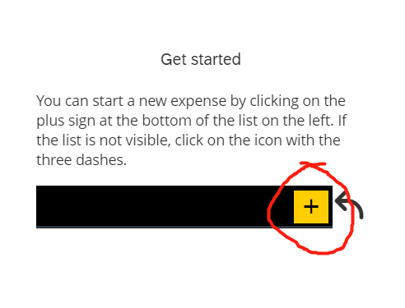
- Click “Add Expense row)
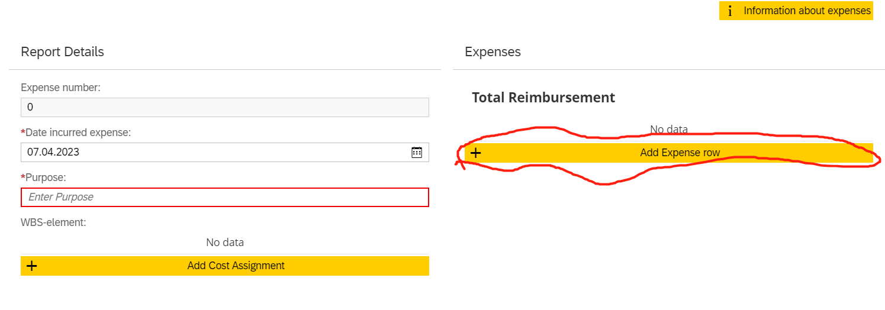
- choose your expense type( for conference, choose the “Congress/course/seminar”) and click” select”
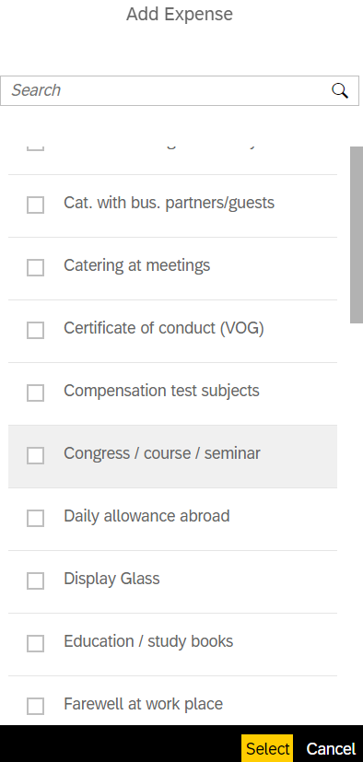
- Upload the invoice in Attachments, and fill in the details, then click”save”
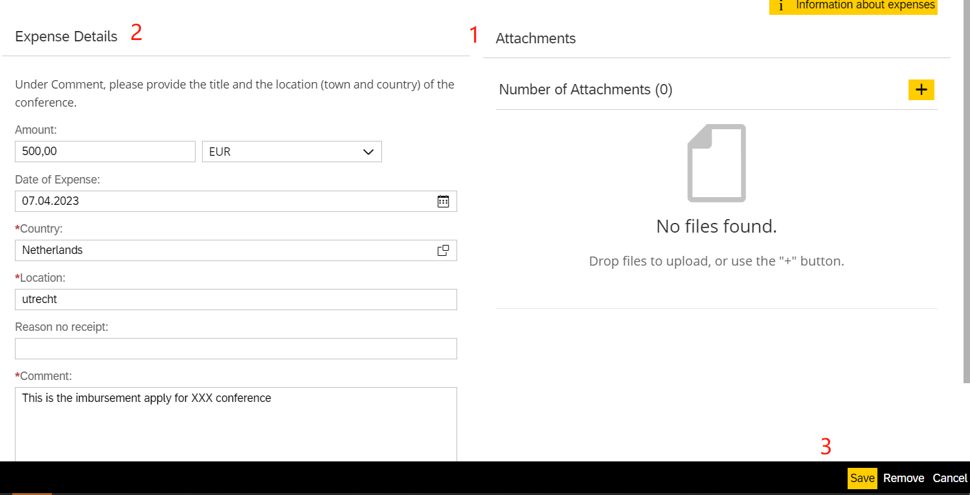

- Click” Add cost Assignment”, and type in the officer information
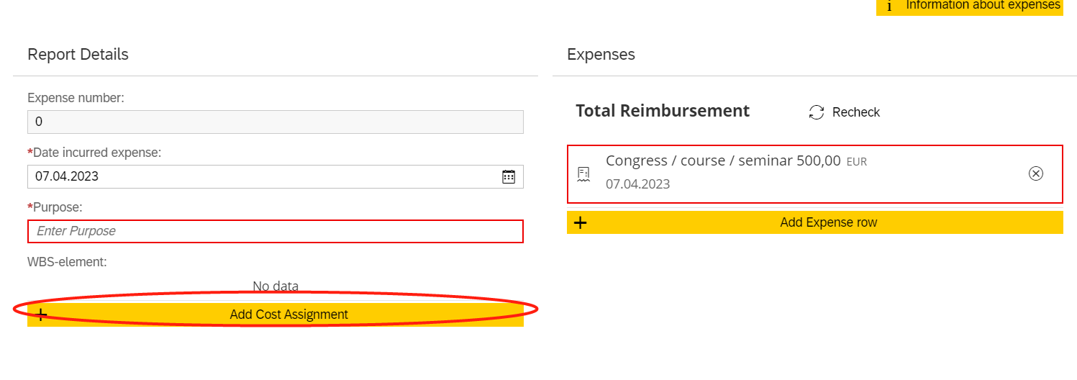
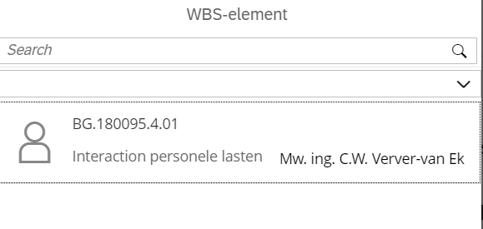
- Finally, click”submit”. Now you should have received an email about your proposal.
