This is a tutorial for using Snellius

- Apply for the snellius account.
- go to request portal:
https://www.surf.nl/en/research-it/apply-for-access-to-compute-services

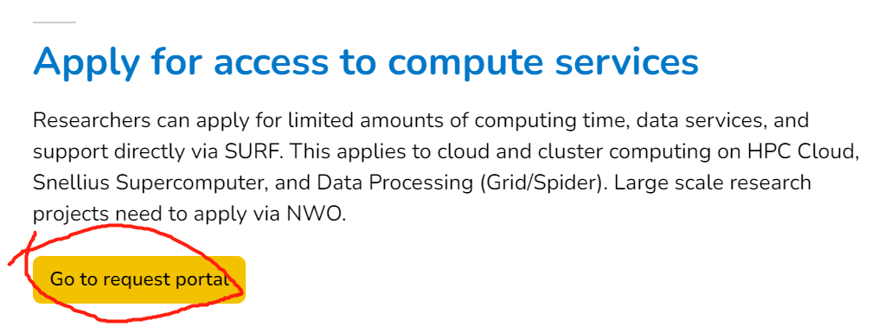
- Login using SURFconext
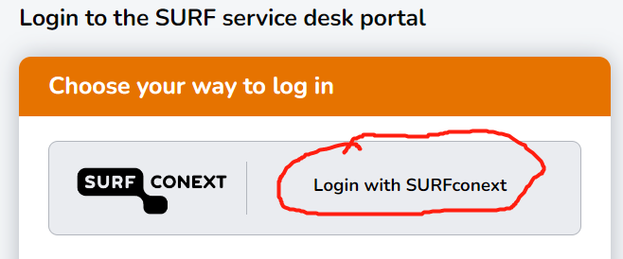
- choose Utrecht University
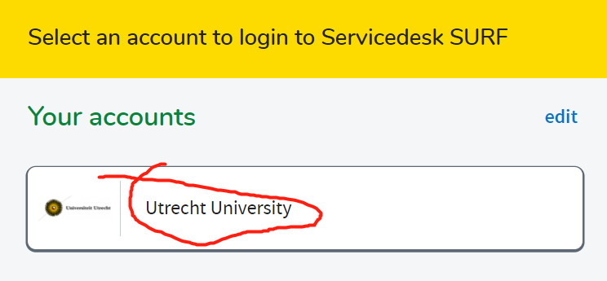
- Sign in using your SolisID
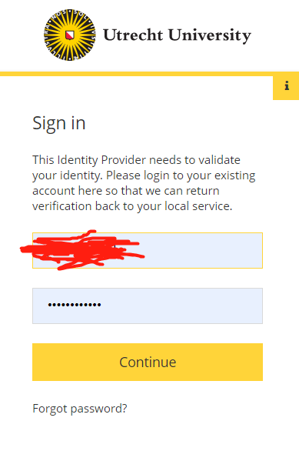
- Create a small NWO request
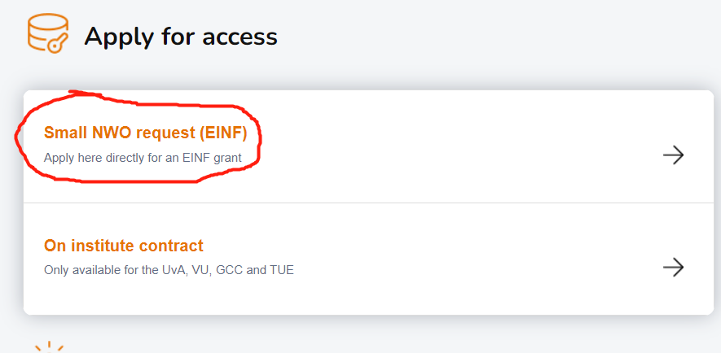
- following the instructions on the application page, fill in the form and choose Snellius as the target.
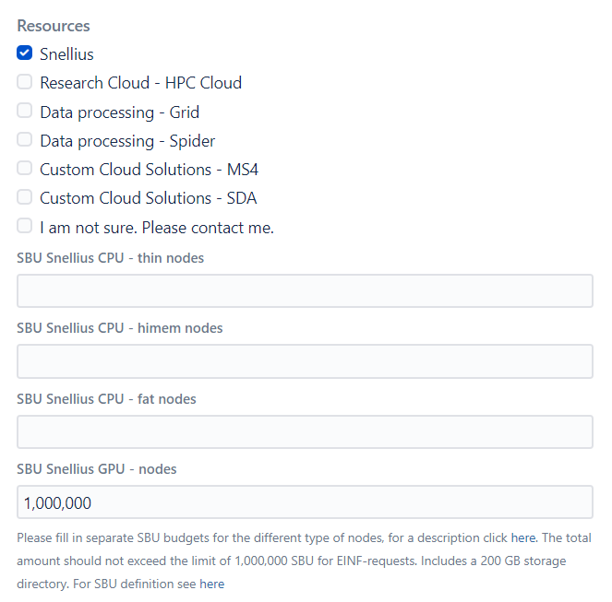
- You should receive two emails from SURF soon, one email contains the username and password for you when using Snellius, and another contains workspace location for you.
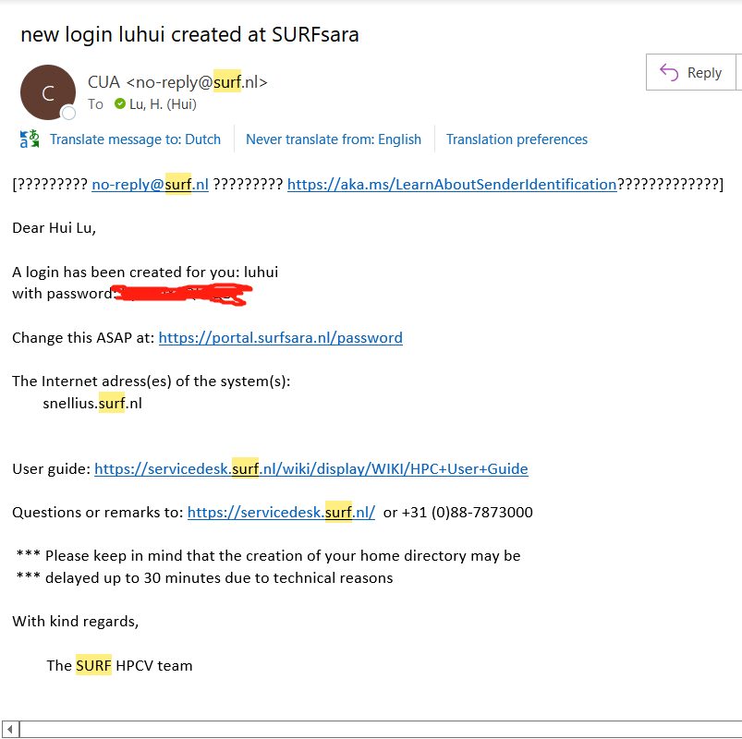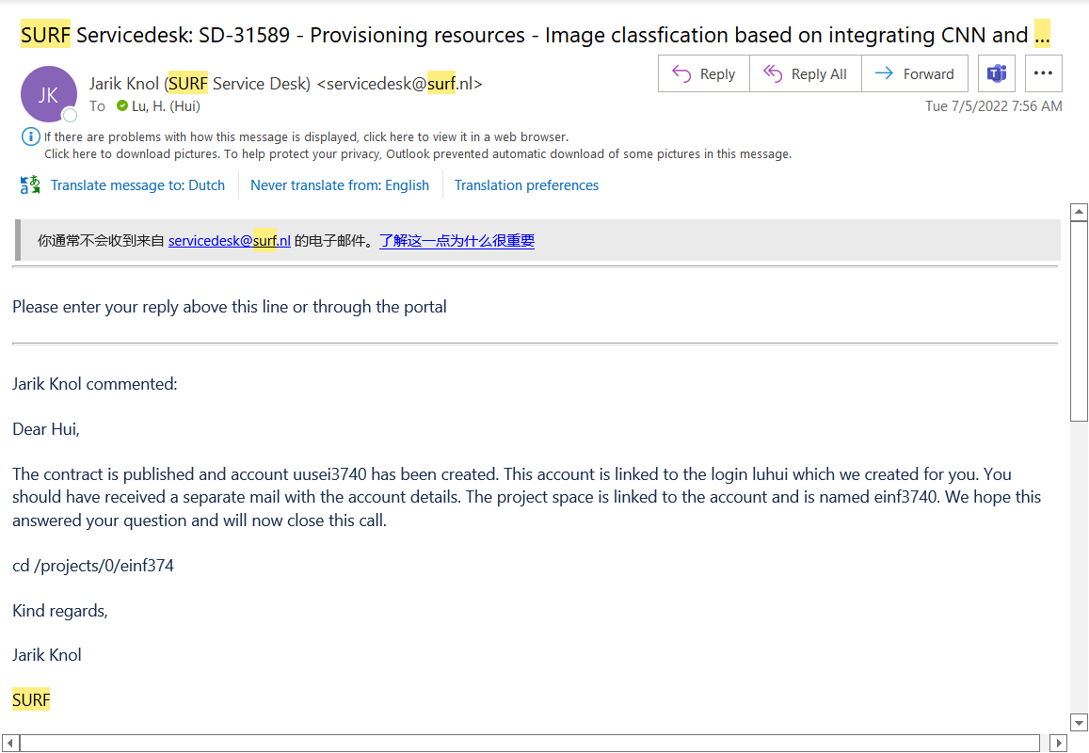
See next section on how to use the snellius.
- How to use the Snellius server
The Snellius is connected using a ssh service, it is suggested to use the MobaXterm to login in the Snellius. See this link for more information about how to use MobaXterm:
https://servicedesk.surf.nl/wiki/display/WIKI/Creating+and+using+an+SSH+key+pair+with+MobaXterm
Once you download the MobaXterm, click this link to check how to connect to Snellius using MobaXterm: https://servicedesk.surf.nl/wiki/pages/viewpage.action?pageId=30660216

- Ticks for Snellius
Check the link to know the hardware system of Snellius:
https://servicedesk.surf.nl/wiki/display/WIKI/Snellius
Check the link to know how to write and submit a job to Snellius:
https://servicedesk.surf.nl/wiki/display/WIKI/Writing+a+job+script
Check the link to know how to use jupyter notebook with Snellius:
https://servicedesk.surf.nl/wiki/pages/viewpage.action?pageId=30660252

Useful Command:
Check whether the job you submitted is in queue: $ Squeue -u you_username
Check you account budget: $accinfo

