You now should have a username and corresponding password created from Ronald, following the instructions to connect and use the Marvin server. For any question, please send message through teams: h.lu1@uu.nl

Connectivity

- You will first need to ssh to the gemini server in order to be within the university faculty of science subnetwork:

$ ssh <your solis id>@gemini.science.uu.nl
(And enter your password)

You should have the screen looks like this:
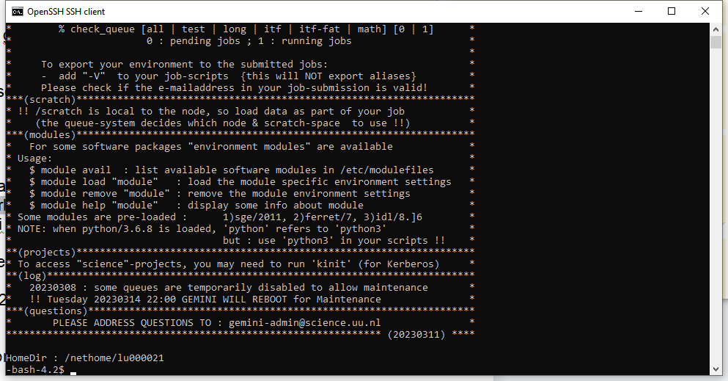

- From here you can then connect to the server (Marvin) by ssh-ing to:

$ ssh <your username>@131.211.81.92
(And enter your password)

You should have the screen looks like this:
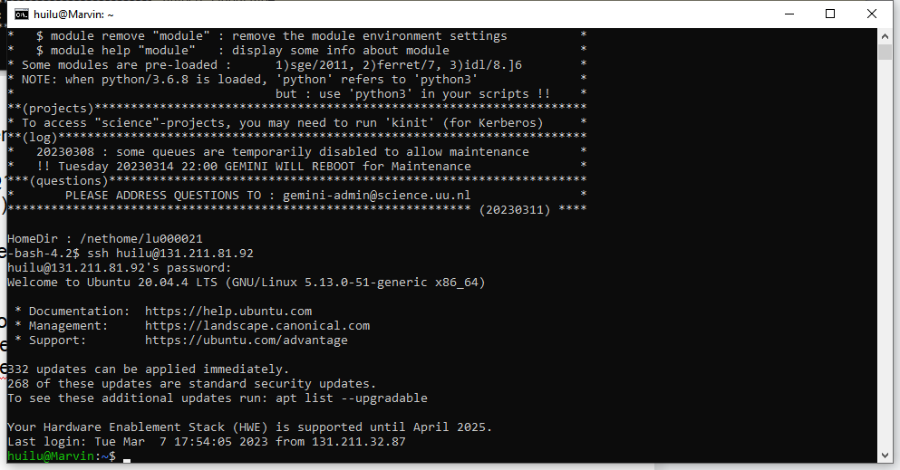

Notice: The previous commands are based on that you are connected to the Utrecht University Wifi, if you are using other sub-networks depending on your office location and floor, you may not have access to gemini or Marvin server. To avoid this, using the following commands

$ ssh -L 8888:127.0.0.1:8888 <your solis id>@gemini.science.uu.nl
(And enter your password)

$ ssh -L 8888:127.0.0.1:8888 <your username>@131.211.81.92
(And enter your password)

Python environment creation

Here it is recommended to use anaconda to manage your python environment, since others are also using the server, so isolating your environment with others using Anaconda is important.

If you are not familiar with Anaconda, you can check the official tutorial website: https://www.anaconda.com/

- Once you are logged in, using the following commands to go to your assigned file location and create a folder named by you, so files from different users are clearly separated.

$ cd ..
$ cd ..
$ cd media/m2ssd_2TB/
$ sudo mkdir <your username>

- Run the command ($ cd <your username>) and check whether you can create a python environment using anaconda command:

$ conda create —name <your environment name>
(if you cannot create your environment, you may check whether anaconda is installed)

You can then activate your environment with:
$ conda activate <your environment name>

- Now you have a custom python environment to install whatever packages you want. If you want to install pip packages you can :

Install pip in your environment:

$ conda install pip

Then install any pip packages with:
$ pip install <package name>
Storage and usage

In terms of storage you can check usage with:

$ df -h

A short description of all the disks are listed below, if you have large files that need to have another location besides your assigned location, please contact the manager.

860EVO (/dev/sda) mounted at /media/860EVO : is a 2TB ssd (~480mb/s max reading speeds). This was the main storage disk for datasets to read data from during training/inference.

m2ssd_1tb (/dev/nvme1n1) mounted at /media/m2ssd_1tb: is a 1TB m2 ssd (3gb/s max read speeds). This is a good disk to use for your code and to run your code from.

m2ssd_2tb (/dev/nvme2n1) mounted at /media/m2ssd_2tb: is a 2TB m2 ssd (3gb/s max read speeds). Another good location to keep your datasets that you train on. Unless your batches are large in size, the reading speeds are not that different from the 860EVO.

Hdd (/dev/sdb2) mounted at /media/hdd: is a 4TB hard drive with fairly slow read speeds (70 mb/s). It will be best to treat this as your backup. You will find that there are already a lot of video datasets installed there. Feel free to copy any of them if you are to use them. It might also be better to not delete any of them as for example Something-Something and Kinetics are either partially or fully unavailable anymore.

Connect to Pycharm
Firstly, build the ssh tunnel using XShell(download link:https://www.xshell.com/zh/xshell/).
- click the upper left “file->new”, and build a new connect. Note the user name is your solid ID and your password
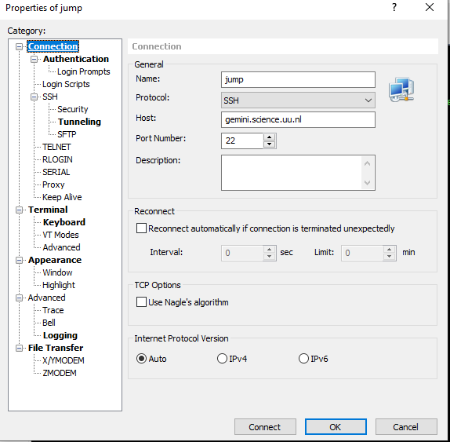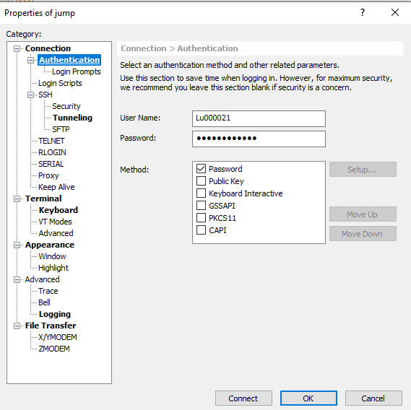
- build a ssh tunnel to connect our server. You need to click the Connect(circle) and see the positive results.
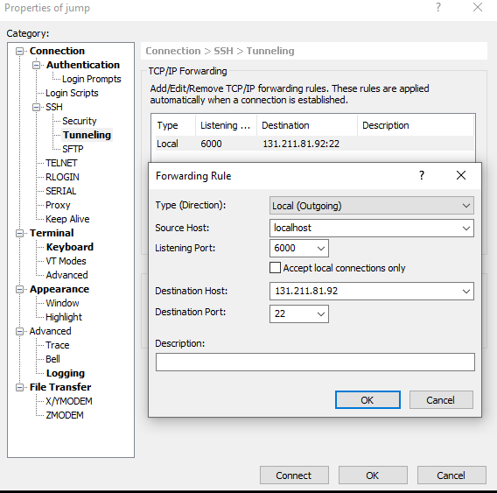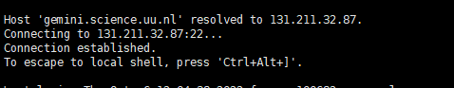

- build another connection so that we could use our server from local machine.Note that the usename is the ID and password that Ronald gives to you. Also, Click the Connect, and see the positive results.
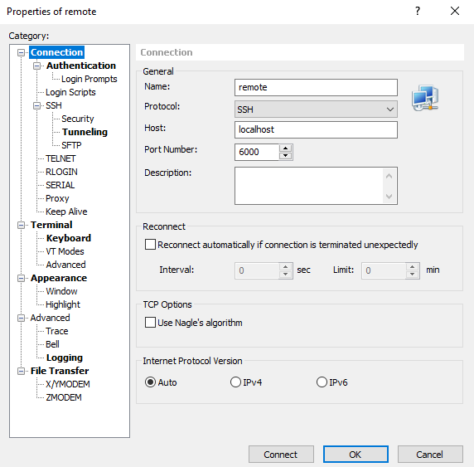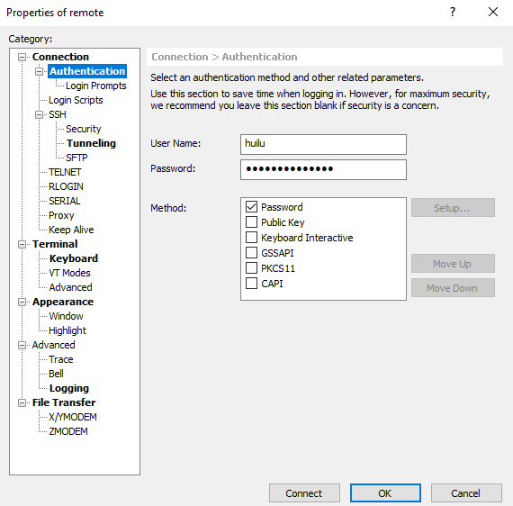

Positive results: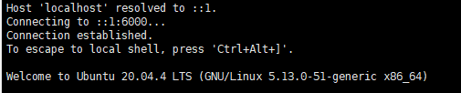

- If everything goes well, open the Pycharm,go to: Tools->Deployment->Configuration:
1.Click the “+” to build a new connection; 2.Choose the SFTP type;3.click the “...”, and set up like the figure below. Note to click the Test Connect to make sure the connection is build. A positive result is shown.

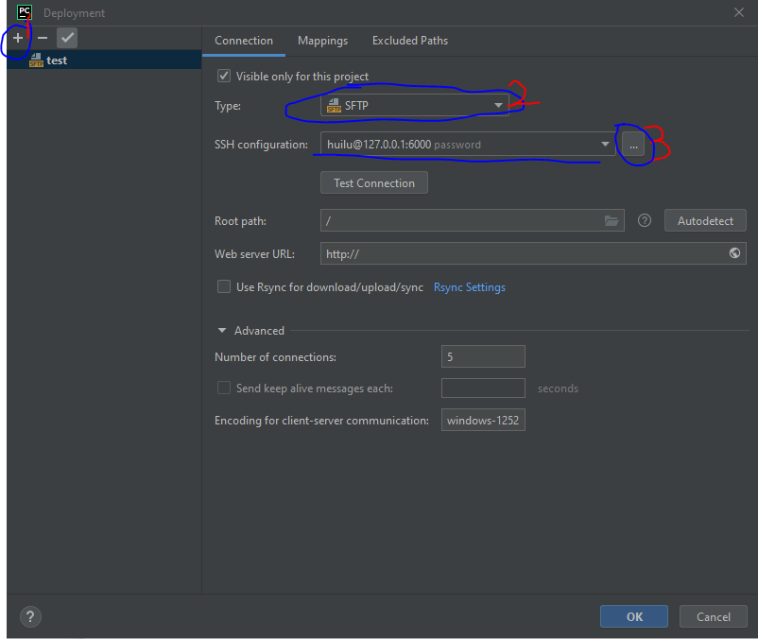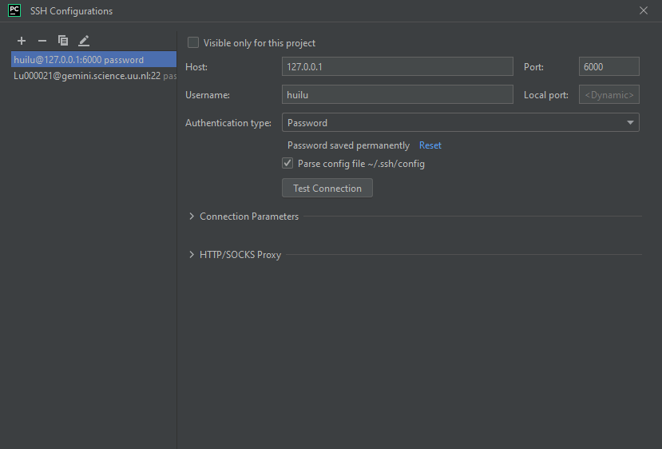
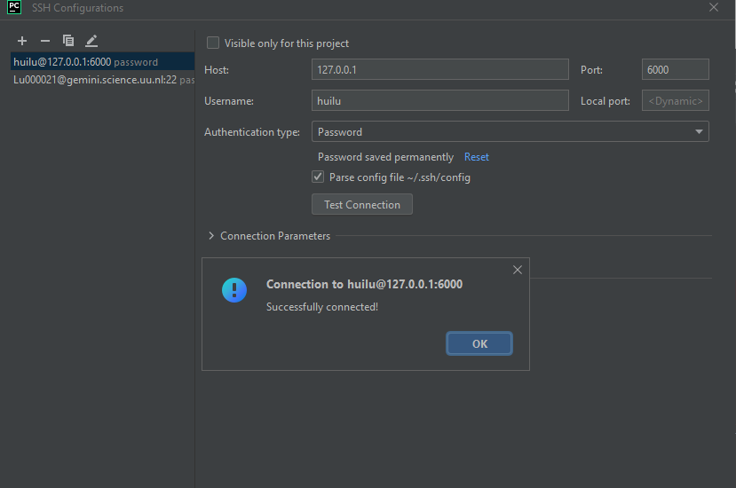

Above are the most important things to build connection with Marvin server, later you could do codes synthesize,debugging and other things with the server, which could be easily done if you use google search.

Easy connect to Jupyter notebook

It’s more convenient to use Jupyter notebook when coding and debugging. Before using jupyter notebook, make sure you have created your anaconda environment and installed the jupyter notebook in your environment.

- After you have connected to the marvin server like above, run the following commands to open the jupyter notebook:

$ cd ..
$ cd ..
$ cd media/m2ssd_2TB/<your username>
$ conda activate <your environment name>

$ jupyter notebook --no-browser --port=8888 --ip=0.0.0.0

You will see the following screenshot, then copy the link in the red circle into your browser
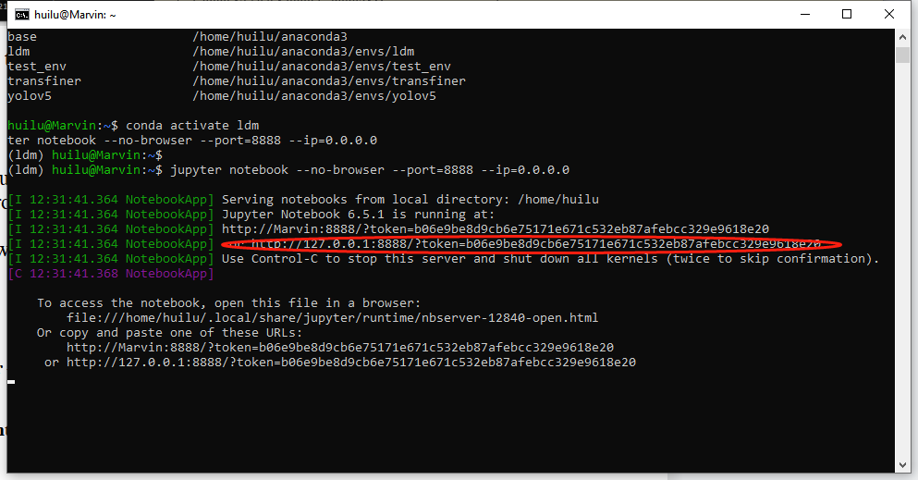

- Then copy the link in the red circle into your browser, and now you are in:
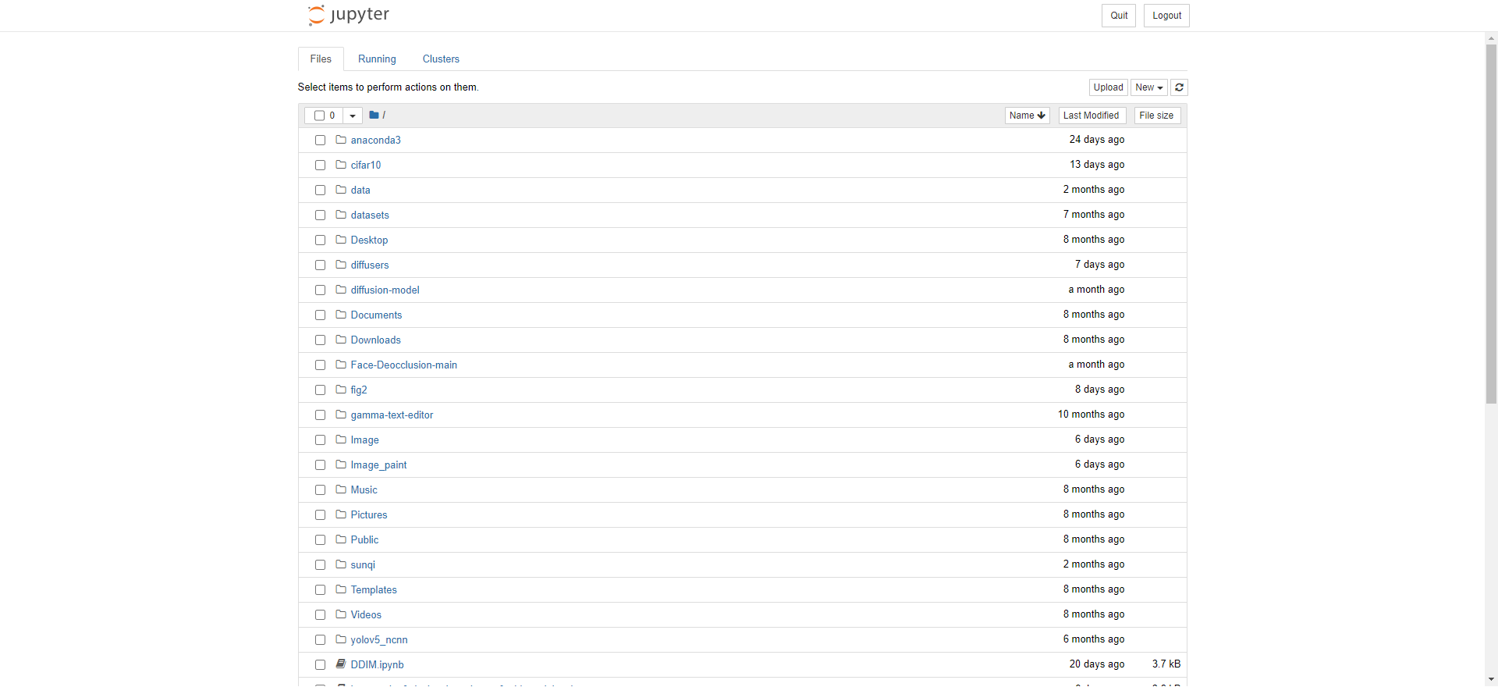

Note: Sometimes you may not be able to open the browser, then open a new terminal and following the commands to build the connection between local portal and marvin server:

$ ssh -L 8888:127.0.0.1:8888 <your solis id>@gemini.science.uu.nl
(And enter your password)

$ ssh -L 8888:127.0.0.1:8888 <your username>@131.211.81.92
(And enter your password)

GPU Utilization

There are four GTX 2080TI in the marvin server, since this is a dynamic assignment, we will not point out here.

