28 March 2023

Documentation for the PLGA force field based on GROMOS-ATB

 | Head monomer | Central monomer | Tail monomer
LAC | 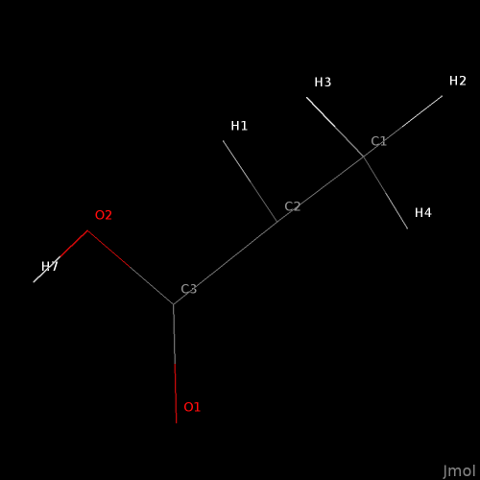  lac1_aa_01.lt | 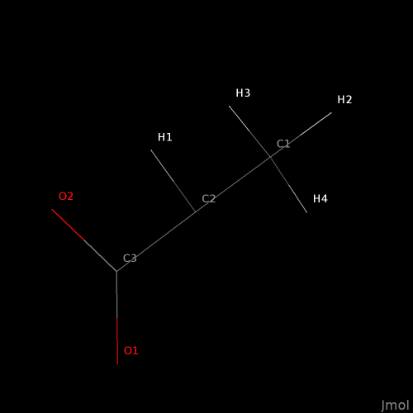  lac_aa_01.lt | 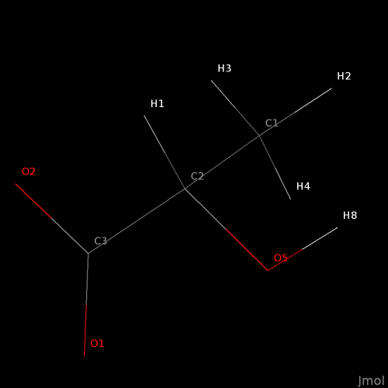  lac2_aa_01.lt
GLY | 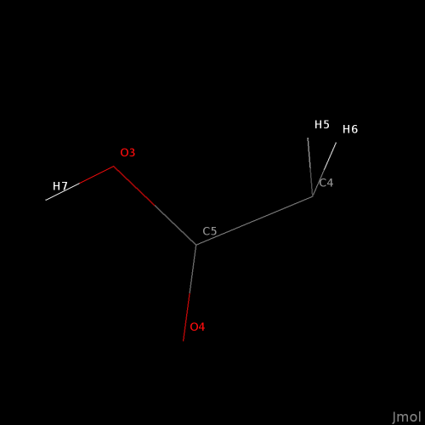  gly1_aa_01.lt | 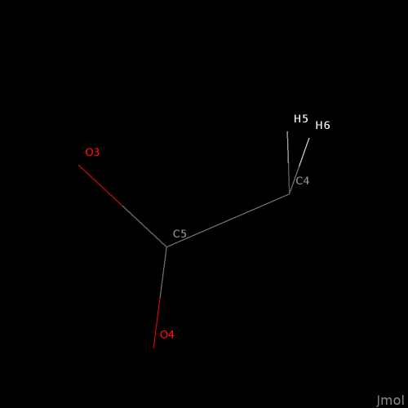  gly_aa_01.lt | 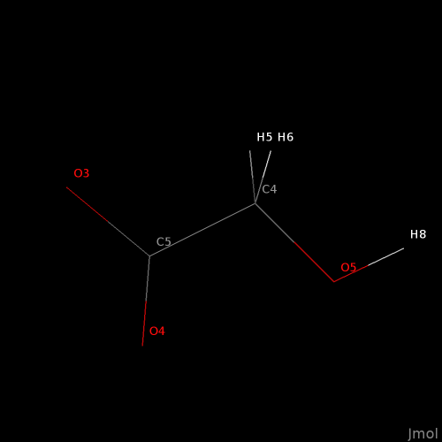  gly2_aa_01.lt

The poly(lactic-co-glycolic acid) (PLGA) polymer is obtained by condensation of alcohol and acid functions, with the creation of a ester bond and elimination of a water molecule. To model the polymer, the repeating units have been cleaved to include only the portion of the lactic or glycolic acid that is left after the reaction. The convention used here is that the head monomer contains the acid group, and the tail monomer contains the alcohol group.
For LAC, the bonding sites are the atoms O2 and C2, while for GLY the bonding sites are O3 and C4.

The proposed work is based on the paper: https://doi.org/10.1557/s43577-022-00380-9, where the PLGA chains are composed of 48 monomers, corresponding to 12 repetitions of the sequence [3 LAC monomers and 1 of GLY monomer]. For this system, the LAMMPS Template (LT) file is called plga_aa_012.lt and has been created with the command:

$ bash plga_aa_polymer.sh 12 > plga_aa_012.lt

The first task is to recreate the simulations described in the paper above, using the same polymer chain length but varying the input geometry or compression protocol in order to obtain different morphologies. The goal is to get familiar with the Moltemplate scripting language. Please refer to the http://www.moltemplate.org/ website and the manual to learn the syntax. In the example simulation plga_amor_01.lt, 90 PLGA chains [(LAC-LAC-LAC-GLY)₁₂] are randomly oriented on a sparse cubic grid and compressed isotropically to give an amorphous solid. Tip: play with the compression speed and temperature to achieve different outcomes. Also, try to freeze the initial chains into rigid bodies and compress the sample with the chain forced in their extended configuration.
Another goal is creating an initial structure where the chains are parallel or slightly tilted around a reference vector, yielding a crystalline polymer. See the following picture for an example of chains parallel to each other with some random shift along a reference vector. To allow room for tilting, a larger spacing should be used. Tip: use the anisotropic barostat to keep the cell vectors orthogonal. To avoid the simulation crashing, use a series of short runs –each time the parameters of the long-range Coulomb solver will be reinitialised. Otherwise, use a lj/cut/coul/cut pair style for the initial equilibration, and switch to the better lj/cut/coul/long pair style when the system has reached a reasonable density.
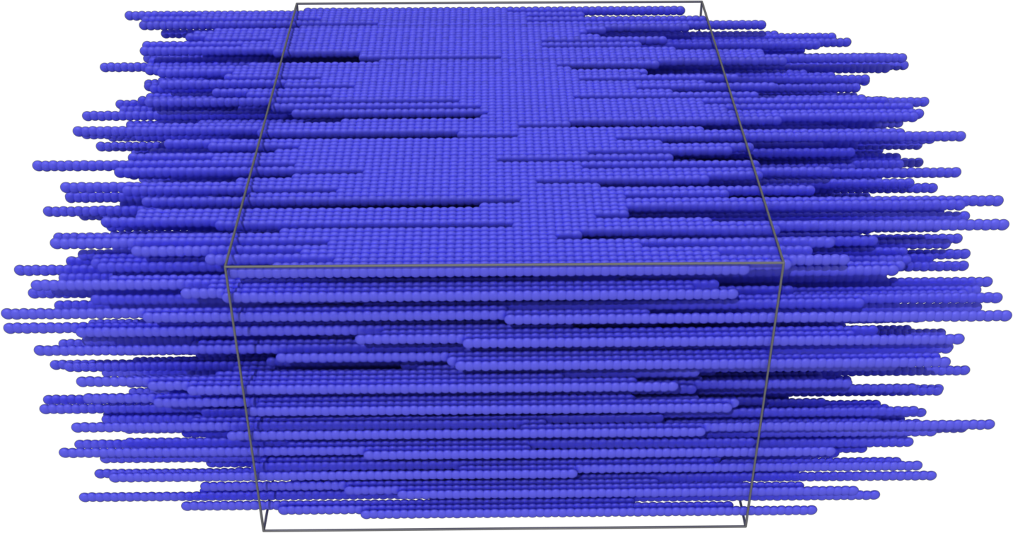
Tip: here a snippet of LT code to run 20 repetitions of a short run command in LAMMPS, implemented in the simulation plga_amor_02.lt:

variable steps equal 20
variable equi equal 10000 # if the simulation crashes, reduce this value.
###
fix NPT all npt temp \$\{tf\} \$\{tf\} \$\{tcouple\} aniso \$p \$p \$\{pcouple\}
label cycle1
variable i loop \$\{steps\}
print "*** Shrinking step \$i/\$\{steps\} ***"
run \$\{equi\}
next i
jump SELF cycle1
variable i delete

The second task is to modify the script plga_aa_polymer.sh to create the PGA polymer, which is composed of only GLY monomers. The task here is to identify the bonding rules between the head, body, and tail monomers. Tip: these rules are already implemented in the original script, which only need being adapted from the LAC-LAC bonding rules.

The third task is to modify the script in order to have a random sequence of LAC and GLY monomers in an arbitrary molar ratio. Here follows an idea of how implement the algorithm, which needs further development:
- Define the total number of molecules n and the fraction of one component, say LAC:
n=183 # total number of monomers.
fa=0.347 # fraction of LAC monomers.
na=$(printf %.0f $(bc -l<<<$n*$fa)) # actual number of LAC monomers.
nb=$((n-na))
- Use the program shuf to create $na random integers out of the total:
$ shuf -i 1-$n -n $na | sort -n > list_a
- Create a sequence of monomers that goes from 1 to $n, where the monomer in list_a correspond to LAC and the rest to GLY.
Use this script to explore the effect of randomness in PLGA chains with 90 monomers. Then explore the effect of polydispersity by creating polymer chains with a random length, say in the range 80 to 160 monomers, and slightly different molar ratio, say from GLY:LAC from 0.23 to 0.27. Tip: the bonding rules must cover all possible combinations between gly, gly1, gly2, lac, lac1, and lac2 monomers.

