After creating the Docker image should test with the following steps

1. 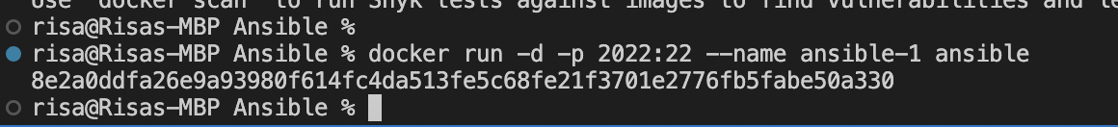Start the image with “run”
2. 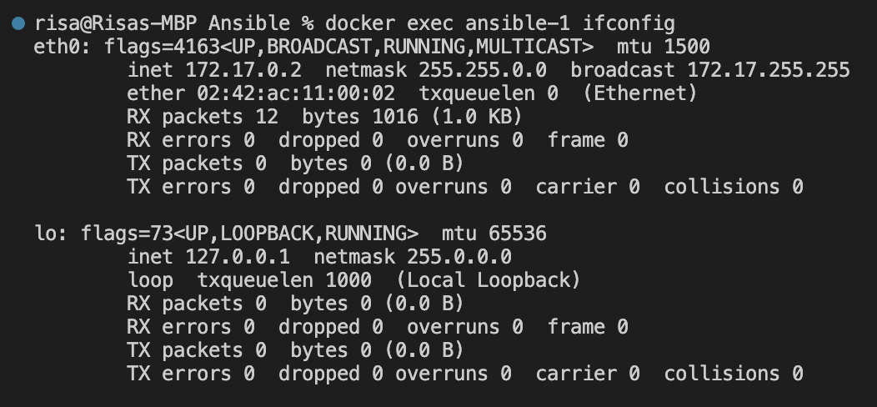Check what is the IP address of the host (e.g. docker exec ifconfig)
3. 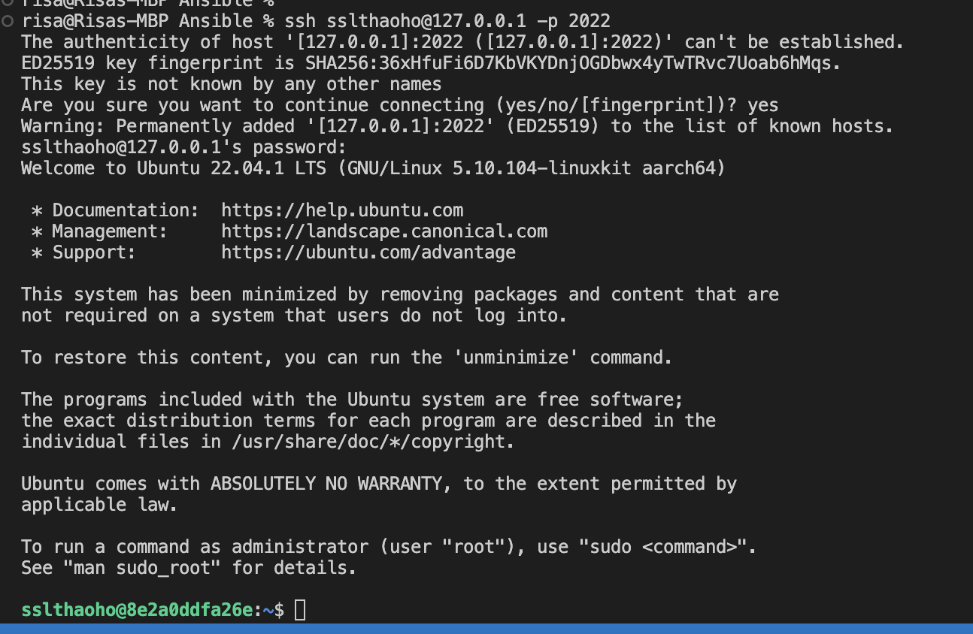Do the ssh-login to the host (ssh ssluser@ipaddress)
4. Test that Python works

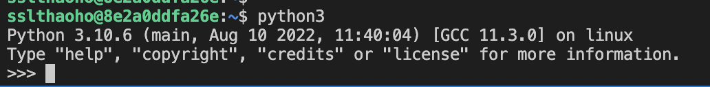

Create an Ansible playbook that has two tasks (plays)

1. Ensure that the image has the latest version of git version management system
2. Queries the uptime (linux command uptime) of target host

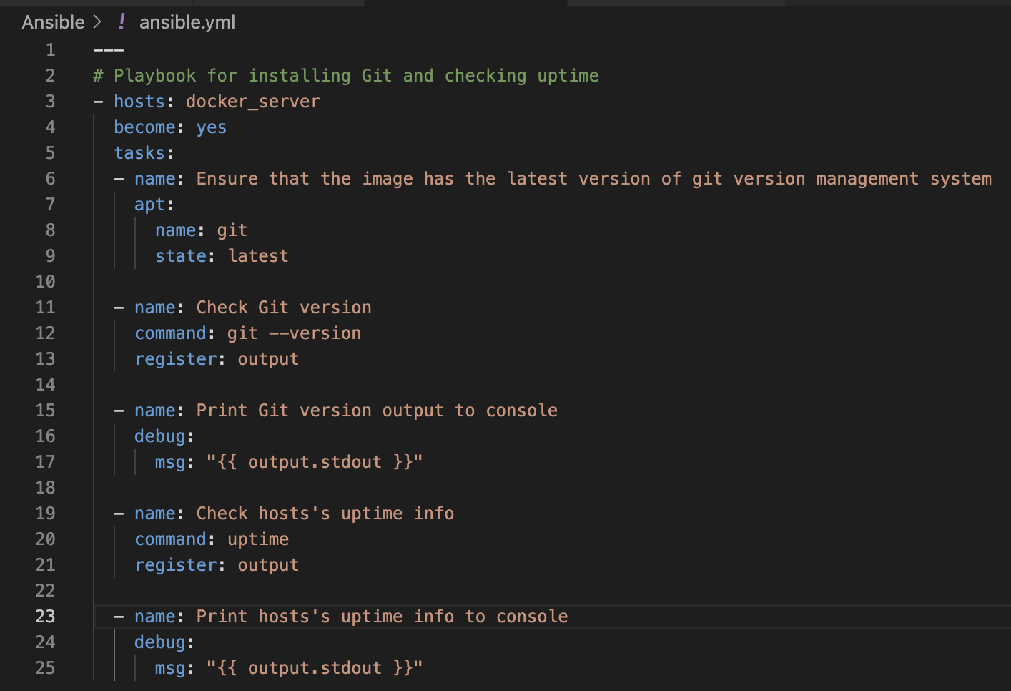

Test the playbook as follows

1. Start one container from the image, get its IP-address.

(in case of password-based authentication you need a manual login after start)



1. Ensure that the IP address is in /etc/ansible/hosts (or some other Ansible configuration file you decide to use).

* Container 1 – port 2022

1. 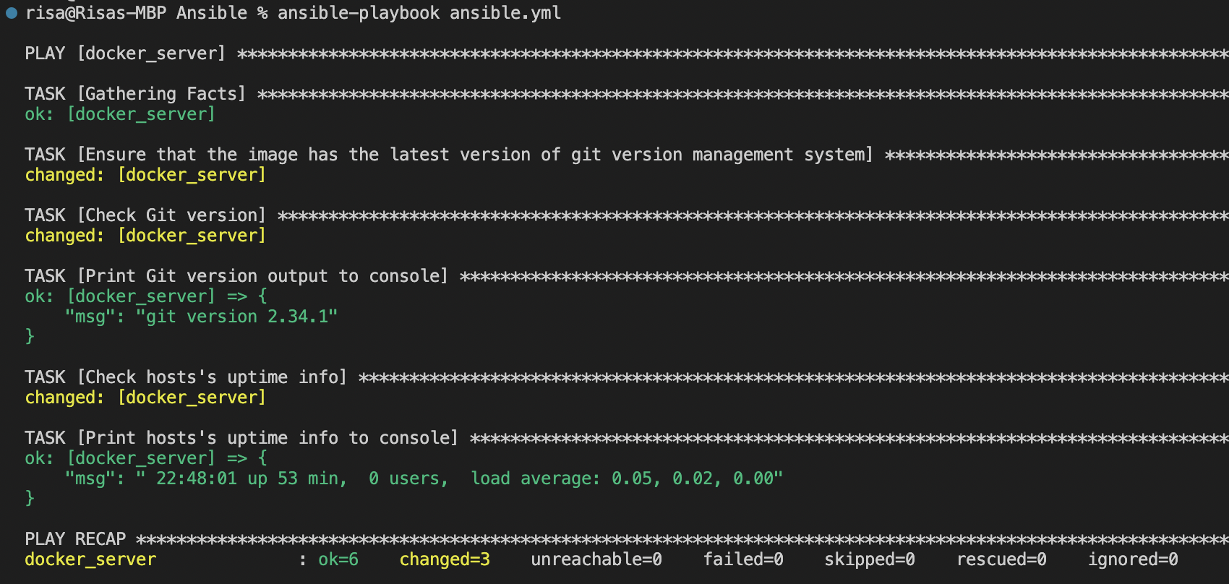Run the playbook and copy the output (O1) – including output of “uptime”
2. 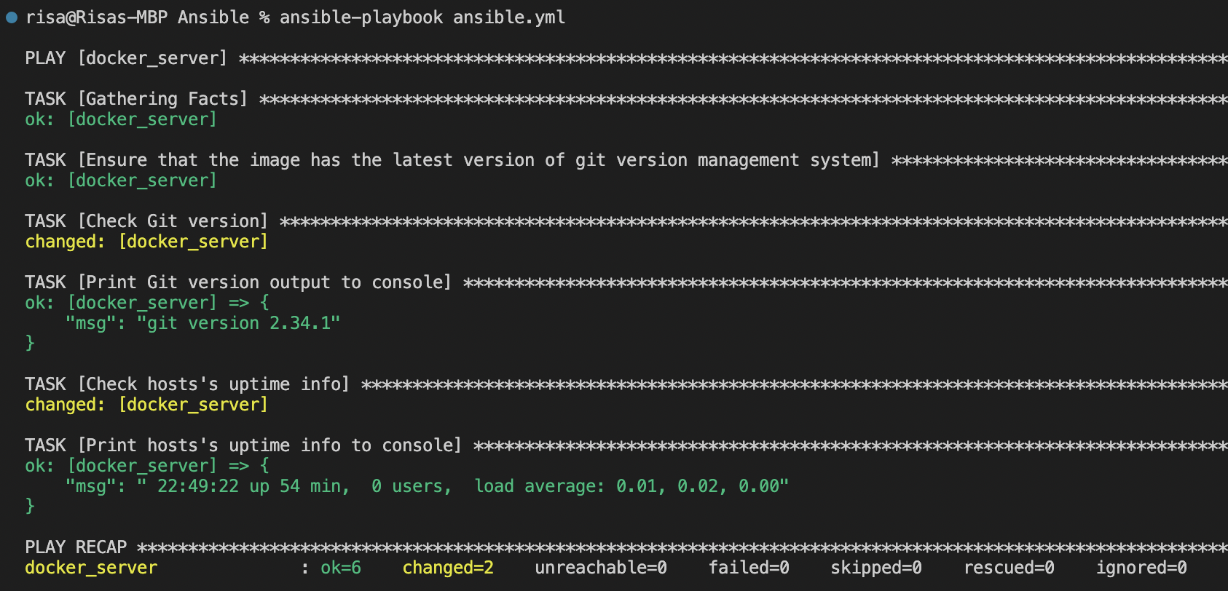Run the playbook again and copy that output, too (O2) – including output of “uptime”
3. 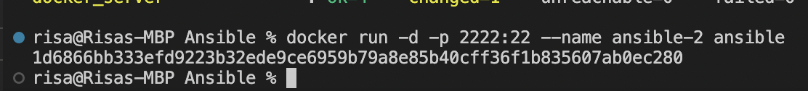Start a second contained from the image, get its IP-address.
4. Ensure that this IP address is in /etc/ansible/hosts (or…) too.

* Container 2 – port 2022



1. 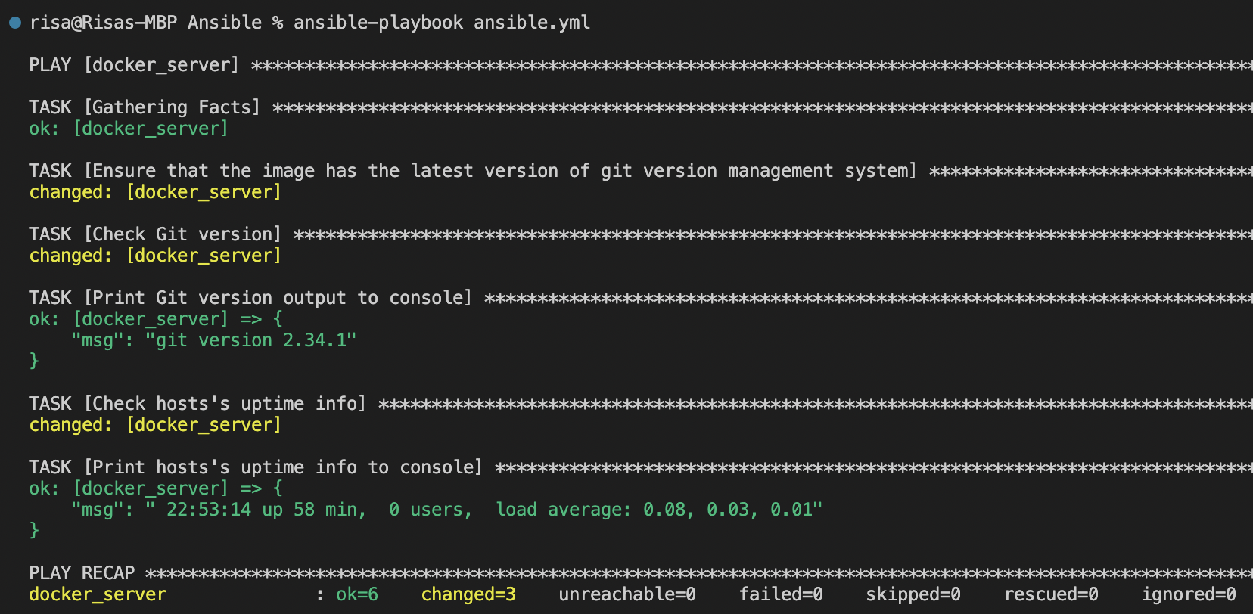Run the playbook and copy the output (O3) – including output of “uptime”
2. Run the playbook again and copy that output, too (O4) – including output of “uptime”

