After running docker-compose up –build, we can output the result by creating the curl request to <http://localhost:8001/>

Docker services run on local computers, so they share the same internal network environment. The IP addresses can be different each time docker-compose build is run. Docker defined a network called backend so that two Docker services could communicate to each other.

* 192.168.48.1 IP address is a local, private, or gateway IP address. 192.168.48.1 is my router's address that computer devices connected to the network will use to send data requests over the internet. So when we curl to service1 from my computer, it will show the remote address for service1 is 192.168.48.1 and the port which is used to send curl request to service1.
* 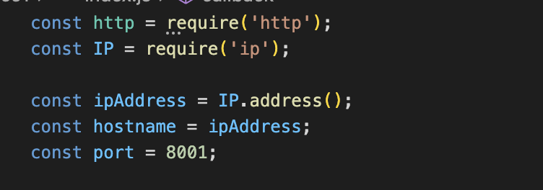192.168.48.3 is a service1’s IP address, and the port is defined in the index.js file from service1 which is mapped from Docker to local host.
* 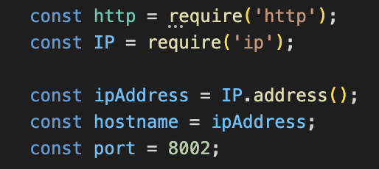192.168.48.2 is a service2’s IP address, and the port is defined in the index.js file from service2 which is mapped from Docker to local host.

To see all the containers, we can run docker container ls

To see all the networks, we can run docker network ls

