uname -a



docker –version

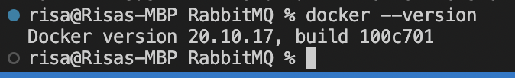

docker-compose --version

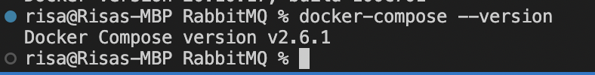

By allowing you to connect listening services and listen to specific subjects, topic-based communication provides advantages over HTTP. If services are busy, it can also maintain traffic balance and retain messages in a queue while they wait to be processed. Since AMQP is an asynchronous protocol while HTTP is synchronous, you should choose AMQP instead of HTTP if you require an asynchronous protocol. Another feature of AMQP that HTTP lacks is guaranteed delivery. Additionally, topic-based communication makes it simpler to locate services.

Before this exercise, I was unfamiliar with AMQP or RabbitMQ, therefore it was interesting to pick up some new information. The topic of Docker volumes was also expanded upon. I used to find them a little hazy.