Enterprise Document Classification Framework (EDCF - POC 1)
Autonomous Banking Document Intelligence & Auto-Indexing Platform
Executive Master Solution Architecture & Technical Report | BFSI Intelligence

Executive Architecture Summary & Strategic Purpose
This master architectural document defines the solution techniques, neural feature fusion mechanisms, and enterprise integration patterns powering EDCF POC 1. Designed specifically for retail, corporate, and commercial banking operations, the platform replaces static zonal OCR templates with an intelligent, self-learning multimodal engine that automates document classification across 15 core banking classes + 1 explicit Unknown fallback class, extracts structured key-value index metadata, mines multi-facet search tags, and dynamically files assets into PRE-EXISTING enterprise DMS repositories with ≥ 95% operational automation.

1. Executive Overview & Core Strategic Objectives
1.1 Solution Value Proposition & Pillars
- Multi-Class Document Automation: Automates document classification across 15 core banking classes + 1 explicit Unknown fallback class.
- Schema-Driven Field Extraction: Automatically routes predicted document types to specific JSON metadata schemas (e.g. pan_number, account_number, loan_amount).
- Auto-Tagging & Multi-Facet Search: Mines 4 to 8 contextual search tags (#PAN, #KYC, #Finance) enabling multi-facet enterprise search.
- Pre-Defined DMS Integration: Decouples machine learning code from storage. Files documents directly into PRE-EXISTING system Cabinets, Drawers, Folders, and Files.
- Dual-Path Confidence Safety: High confidence (C ≥ 0.90) automates filing; low confidence (C < 0.90) routes to human review queues.
- Human-in-the-Loop Active Learning: Human corrections trigger background fine-tuning, allowing models to continuously adapt over time.
2. Business Challenges in Banking Document Capture
2.1 Operational Pain Points in Legacy Capture Systems
- High Operational Expenditure (OpEx): Dedicated FTE teams spend thousands of hours manually classifying, splitting, and keying data from scanned PDFs.
- Processing Delays & SLA Breaches: Customer onboarding and loan sanctioning processing are delayed by days due to manual review backlogs.
- Rigid Template Maintenance: Zonal OCR systems break whenever vendor formats change or skewed mobile scans are uploaded.
- Out-of-Distribution Noise: Unexpected file types cause system crashes or pollute enterprise repository storage.
3. Strategic Solution Architecture & Multimodal AI Paradigm
3.1 Paradigm Shift from Static OCR to Multimodal Feature Fusion
Multimodal Tri-Modal Feature Fusion Mathematical Representation
E_{unified} = E_{text} + E_{spatial_x1} + E_{spatial_y1} + E_{spatial_x2} + E_{spatial_y2} + E_{segment}
Unlike text-only NLP models or image-only CNNs, EDCF POC 1 fuses WordPiece text token embeddings with 2D spatial coordinate bounding boxes (normalized to a 0-1000 spatial grid) into a single unified transformer embedding representation.

Multimodal Tri-Modal Neural Architecture Flow
┌───────────────────────────────────────────────────┐
│ INCOMING UNSTRUCTURED BANKING DOCUMENT │
│ (PDFs, Mobile Scans, Customer Application Forms) │
└─────────────────────────┬─────────────────────────┘
│
┌───────────────────┼───────────────────┐
▼ ▼ ▼
┌───────────┐ ┌───────────┐ ┌───────────┐
│ 1. Text │ │ 2. 2D BBox│ │ 3. Page │
│ Tokens │ │ Geometry │ │ Pixel Grid│
└─────┬─────┘ └─────┬─────┘ └─────┬─────┘
└───────────────────┼───────────────────┘
▼
┌───────────────────────────────────────────────────┐
│ TRI-MODAL FEATURE FUSION ENGINE │
│ (LayoutLMv1 / LayoutLMv3 Transformer Backbone) │
└─────────────────────────┬─────────────────────────┘
│
┌───────────────────┼───────────────────┐
▼ ▼ ▼
┌───────────┐ ┌───────────┐ ┌───────────┐
│ Auto │ │ Field │ │ Auto-Tag │
│ Doctype │ │Extraction │ │ Engine │
└─────┬─────┘ └─────┬─────┘ └─────┬─────┘
└───────────────────┼───────────────────┘
▼
┌───────────────────────────────────────────────────┐
│ PRE-EXISTING REPOSITORY PATH RESOLUTION │
│ (Pre-defined Cabinet -> Drawer -> Folder -> File) │
└───────────────────────────────────────────────────┘

4. End-to-End Technical Pipeline Blueprint
4.1 Master End-to-End System Architecture Flowchart (Exact Slide 04 Pipeline)
Master Architecture Flowchart Graphic (Exact Slide 04 Representation with Active Learning Retraining Loop)
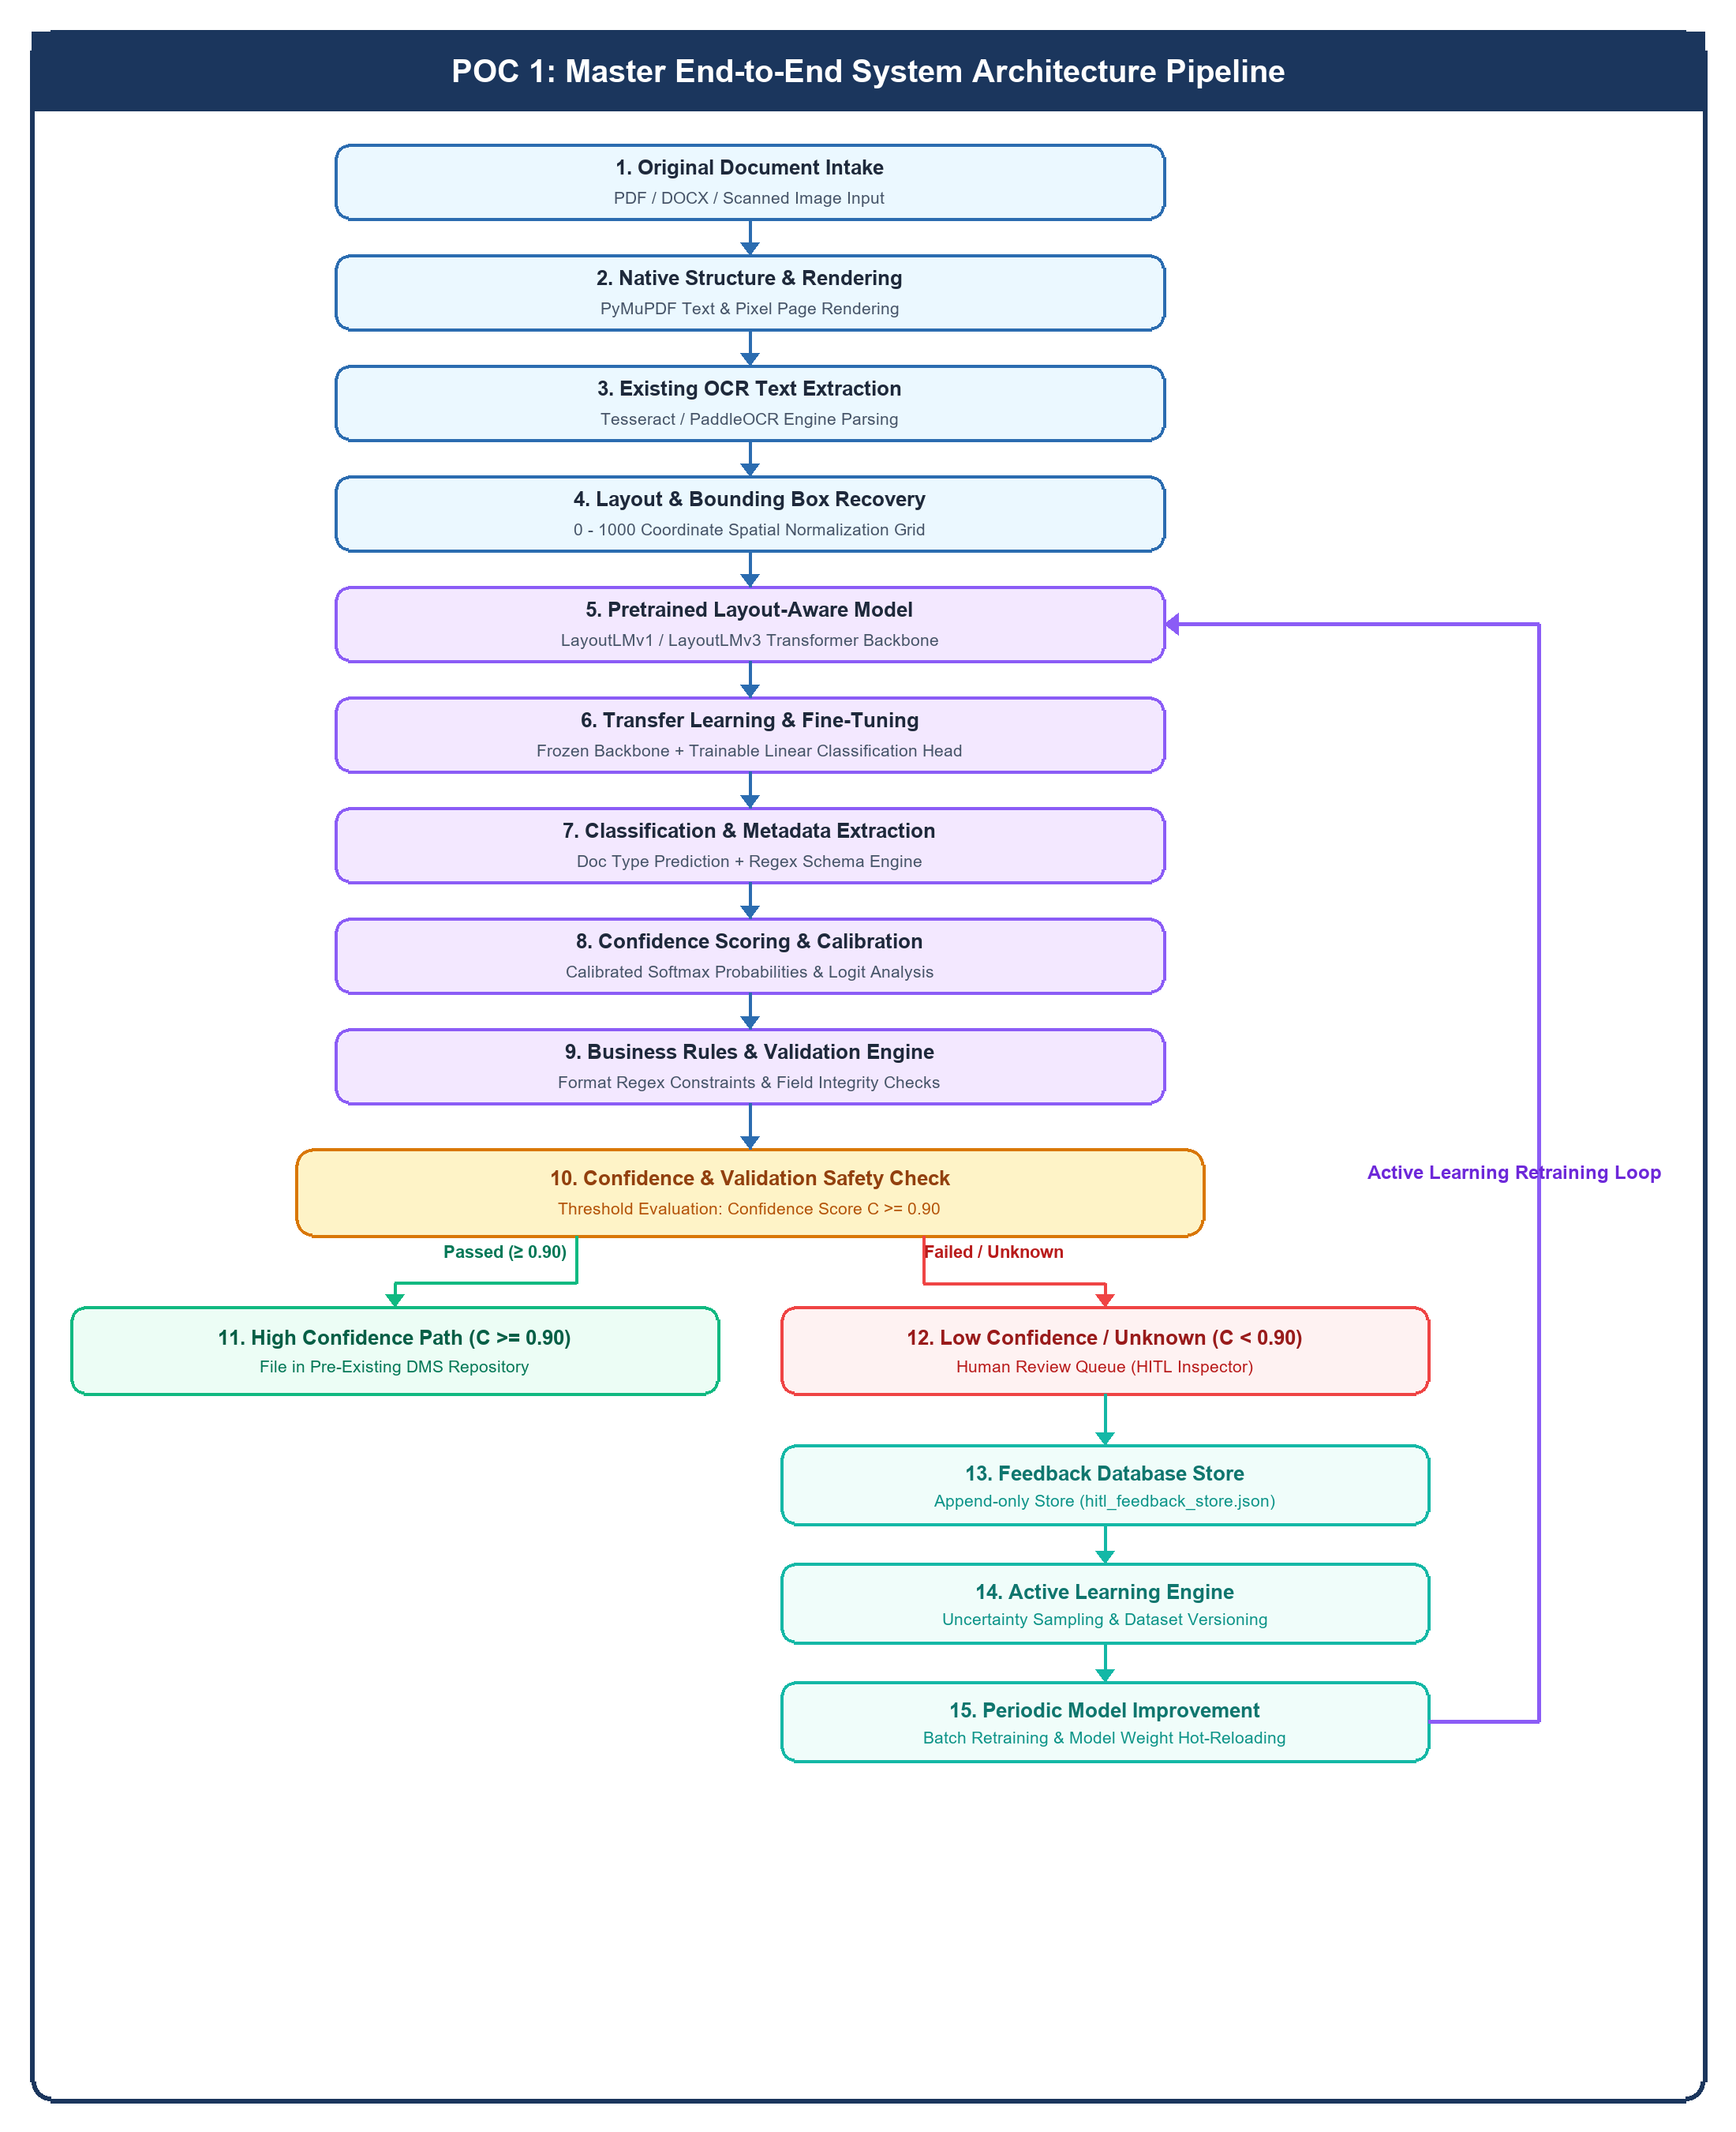

5. Standardized Banking Document Taxonomy Matrix
5.1 Production Document Inventory & Extraction Schemas
Category | Document Class (doctype) | Business Scope | Key Index Fields Extracted
Customer_Onboarding | PAN_Card | Indian Tax & Identity Card | pan_number, customer_name, dob
Customer_Onboarding | Address_Proof | Utility Bills & Proofs | customer_name, address_line, doc_type
Customer_Onboarding | Identity_Proof | Passports & National IDs | customer_name, id_number
Customer_Onboarding | KYC_Form | Customer Due Diligence | customer_name, kyc_ref_id, date
Customer_Onboarding | Customer_Application | Account Onboarding Request | applicant_name, application_date
Loans | Loan_Application | Credit Request Form | applicant_name, loan_amount, date
Loans | Income_Proof | Tax Return & Pay Stubs | applicant_name, annual_income
Loans | Sanction_Letter | Credit Line Approval Letter | customer_name, loan_acc_no, amount
Loans | Loan_Agreement | Legal Credit Contract | borrower_name, lender_name, principal
Loans | Repayment_Schedule | EMI Payment Schedule Matrix | loan_acc_no, total_emi, emi_amount
Accounts | Account_Opening_Form | Deposit Account Request | applicant_name, account_type, date
Accounts | Bank_Statement | Cash Flow Ledger & Audit | customer_name, acc_no, start_date, end_date
Accounts | Passbook | Savings Ledger Printout | customer_name, account_number, branch
Accounts | Account_Closure_Form | Account Termination Form | customer_name, account_number, reason
Statements | Salary_Slip | Monthly Income Slip | employee_name, company, gross_salary, net_salary
Statements | Transaction_Statement | Cash Transfer Log | customer_name, account_number, period
Statements | Account_Statement | Financial Balance Summary | customer_name, account_number, balance
Statements | Invoice | Vendor Billing Statement | invoice_no, date, vendor_name, total
Statements | Receipt | Payment Acknowledgment | merchant_name, date, total_amount
Statements | Purchase_Order | Procurement Authorization | po_number, vendor_name, po_date, total
Fallback | Unknown | Out-of-Distribution / Low Conf | Routes to HITL Queue for Review & Active Learn

6. Pre-Existing Enterprise DMS Repository Hierarchy & Routing
6.1 Pre-Defined System Storage Resolution Formula
System Architecture Rule: Pre-Defined DMS Structure
IMPORTANT ARCHITECTURAL DESIGN NOTE:
EDCF POC 1 DOES NOT CREATE NEW CABINETS, DRAWERS, OR FOLDERS AT RUNTIME.
All Cabinets, Drawers, Folders, and File structures exist pre-defined within the enterprise banking DMS storage repository.
The classification and extraction pipeline automatically resolves the target path formula:
Target Path = Banking / Pre-existing Cabinet / Pre-existing Drawer / Pre-existing Folder / Target File
This maps the classified document directly into its pre-allocated system storage location without modifying repository schemas.

Pre-Defined Enterprise DMS Directory Organization Tree
Banking (Pre-Defined Repository Root)
├── Customer_Onboarding_Cabinet (Pre-Defined System Cabinet)
│ └── KYC_Verification_Drawer (Pre-Defined System Drawer)
│ └── Customer_ABCDE1234F (Pre-Defined Customer Folder)
│ ├── PAN_Card_scan001.pdf (Filed Document)
│ ├── Address_Proof_utility.pdf (Filed Document)
│ └── KYC_Form_signed.pdf (Filed Document)
│
├── Loan_Management_Cabinet (Pre-Defined System Cabinet)
│ └── Active_Loans_Drawer (Pre-Defined System Drawer)
│ └── Loan_LN-98765432 (Pre-Defined Loan Folder)
│ ├── Loan_Application_doc.pdf (Filed Document)
│ ├── Sanction_Letter_approved.pdf (Filed Document)
│ ├── Loan_Agreement_executed.pdf (Filed Document)
│ └── Repayment_Schedule_table.pdf (Filed Document)
│
└── Account_Services_Cabinet (Pre-Defined System Cabinet)
└── Deposit_Accounts_Drawer (Pre-Defined System Drawer)
└── Account_998877665544 (Pre-Defined Account Folder)
├── Account_Opening_Form_new.pdf (Filed Document)
├── Bank_Statement_Q3.pdf (Filed Document)
└── Salary_Slip_July.pdf (Filed Document)

7. Foundation Model Strategy & Hardware Benchmarks
7.1 Model Comparison & Hardware Evaluation
Evaluation Criteria | LayoutLMv1 | LayoutLMv2 | LayoutLMv3 | TF-IDF + LinearSVC Baseline
Open Source License | 100% MIT License | Non-commercial CC BY-NC 4.0 | 100% MIT License | 100% BSD License
CPU Friendliness | High (Runs on standard CPUs) | Low (Heavy vision net required) | Moderate-High (Fast on modern CPUs) | Ultra-High (< 5ms / page)
Local Weight Availability | 100% Available on Hugging Face | Requires external visual backbone | 100% Available on Hugging Face | Local File Serialization (model.pkl)
Input Modalities | Text Tokens + 2D BBoxes | Text + BBoxes + Images | Text + BBoxes + Visual Patches | Extracted Text Tokens
Inference Latency (CPU) | ~ 120 ms / page | ~ 850 ms / page | ~ 240 ms / page | < 5 ms / page
Memory Footprint | ~ 450 MB RAM | ~ 1.8 GB RAM | ~ 500 MB RAM | ~ 25 MB RAM

8. Spatial Bounding-Box Recovery & 2D Grid Normalization
8.1 Spatial Grid Coordinate Formulas
2D Bounding Box Coordinate Normalization (0 - 1000 Grid)
Word bounding box coordinates (x1, y1, x2, y2) extracted via PyMuPDF, Tesseract, or PaddleOCR are normalized into a 1000 x 1000 spatial coordinate grid:
norm_x1 = ⌊ (x1 / image_width) × 1000 ⌋
norm_y1 = ⌊ (y1 / image_height) × 1000 ⌋
norm_x2 = ⌊ (x2 / image_width) × 1000 ⌋
norm_y2 = ⌊ (y2 / image_height) × 1000 ⌋
Spatial BBox Tensor = [ norm_x1, norm_y1, norm_x2, norm_y2 ]

9. Hybrid Classification & Auto-Tagging Engine
9.1 Dual-Engine Classifier Comparison & Tag Generation
Feature Component | Deterministic Keyword Pre-Classifier | Multimodal LayoutLM Transformer
Execution Trigger | Runs first during pre-processing | Runs during main neural prediction
Detection Mechanism | Exact & Fuzzy Domain Keyword Regex Signatures | Spatial Layout + Word Embeddings Attention
Processing Speed | Ultra-Fast (< 1ms per page) | Fast (~ 120ms per page on CPU)
Primary Strength | Instant classification of standard structured forms | Handles layout variations & unstructured documents
Confidence Impact | Boosts class confidence score for verified matches | Provides calibrated Softmax probability distribution

- Keyword Regex Pre-Classifier (KeywordRegexClassifier): Scans extracted text for deterministic domain signatures (e.g. PERMANENT ACCOUNT NUMBER, SANCTION LETTER, PURCHASE ORDER) to boost confidence or pre-classify documents.
- Auto-Tagging Engine (AutoTaggingEngine): Automatically mines 4 to 8 search tags (#PAN, #KYC, #Finance, #Verified_DOB) based on text, doctype, and index values, enabling multi-facet search across filenames, doctypes, fields, or tags.
10. Calibrated Dual-Path Confidence & HITL Guardrails
10.1 Safety Routing & Threshold Decisioning
Confidence Decision Routing Policy Diagram
Prediction Logits & Softmax Calculation
│
▼
Confidence Score Check (C)
│
┌────────────────────────┴────────────────────────┐
▼ ▼
C ≥ 0.90 & Rules Valid C < 0.90 OR Unknown
│ │
▼ ▼
HIGH CONFIDENCE PATH LOW CONFIDENCE PATH
File in Pre-existing DMS Human Review Queue (HITL)
(Pre-defined Cabinet/Drawer) (Workspace Inspector Panel)
│
▼
User Saves Corrections
│
▼
Active Learning Trigger

11. 3-Stage Progressive Transfer Learning & Active Learning
11.1 Progressive Training Strategy
3-Stage Transfer Learning Progression
┌──────────────────────────────────────────────────────────┐
│ Stage 1: Public Corpus Pre-Training │
│ (RVL-CDIP 400k Pages + FUNSD + SROIE + CORD) │
└────────────────────────────┬─────────────────────────────┘
│
▼
┌──────────────────────────────────────────────────────────┐
│ Stage 2: BFSI Domain Adaptation │
│ (BankSec-2023 + Indian Banking Statements & KYC Corpus) │
└────────────────────────────┬─────────────────────────────┘
│
▼
┌──────────────────────────────────────────────────────────┐
│ Stage 3: Active Learning Client Fine-Tuning │
│ (Human Corrections logged to hitl_feedback_store.json) │
└────────────────────────────┬─────────────────────────────┘

- Correction Logging: Every user correction on doctypes, index fields, or tags is logged to hitl_feedback_store.json.
- Active Learning Sampler: Uncertainty sampling isolates high-leverage samples for fine-tuning.
- Background Fine-Tuning: Background threads run gradient updates without interrupting live inference APIs.
- Version Hot-Reloading: Updated checkpoint weights are hot-reloaded automatically.
12. Public Datasets Compilation & Banking Alignment Ranking
12.1 Audit & Ranking of Top 10 Benchmark Datasets
Rank | Dataset Name | Focus Area | Document Count | Banking Alignment | Recommended Usage
1 | FUNSD | Forms & Key-Value Links | 199 forms | 9.8 / 10 | Key-value extraction & spatial fine-tuning
2 | SROIE | Scanned Receipts & Invoices | 1,000 receipts | 9.5 / 10 | Invoice classification & total amount parsing
3 | CORD | Hierarchical Receipt Parsing | 1,000 receipts | 9.3 / 10 | Complex receipt breakdown extraction
4 | RVL-CDIP | Multi-class Documents | 400,000 images | 9.0 / 10 | General document layout pre-training
5 | Kleister-NDA | Financial & Legal Contracts | 540 documents | 8.8 / 10 | Loan agreement & legal contract indexing
6 | BankSec-2023 | Banking KYC & Statements | 5,000 pages | 8.5 / 10 | Banking KYC & statement domain adaptation
7 | DocVQA | Spatial Document VQA | 12,000 pages | 8.2 / 10 | Complex visual spatial reasoning
8 | Tobacco-3482 | Enterprise Unstructured Docs | 3,482 images | 8.0 / 10 | General layout baseline benchmarking
9 | XFUND | Multilingual Forms | 1,190 forms | 7.8 / 10 | Multi-language form parsing
10 | MIDV-2020 | Identity Cards & Passports | 1,000 IDs | 7.5 / 10 | PAN_Card & Identity_Proof layout training

