**【独立口语出题规律】**

**小站教研团队对2018 年迄今为止所有的独立口语题进行整理分析后，总结出如下出题规律：**

**截止到7 月15 日，2018 已进行了22 场托福考试，独立口语共考查44 题。与2017 年相比，独立口语新题量大大增加，占总题量的75%以上，新题难度也明显加大。**

**到目前为止，44 道独立口语中，与往年重复的旧题占10 题。与2017 年题目重复的有2 题，与2016 年重复的有5 题，与2015、2014、2013 年重复的各有1 题。由此可见，独立口语的考试趋势，将以新题+2016 年&2017 年的题目为主。值得注意的是，在今年独立口语task1 部分的22 道考题中，三选一问法的题目数量竟高达16 题，概率高达73%，这是在以往任何一年都没有出现过的状况。建议考生必须熟悉此类题型的答法。在题材方面，2017 年独立口语最热门的题材为教育类、活动类和社会类。特别是社会类题目的数量较往年有所增加，常常会考到一些社会热点问题，**

**如：老年人活动、名人、整容等问题。需要考生平时关注一些社会问题，并多进行思考。**

**预测课主要内容**

**1.技巧巩固复习**

**2.口语预测语料库**

**3.最新重点真题回顾**

**4.8月份重点预测**

**技巧训练篇**

**1 1 5 8训练法**

**1：平行结构  
1：金字塔结构  
5：思路拓展方法  
8：救命稻草**

**平行结构---一个中心，两个基本点**

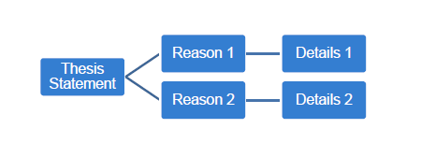

金字塔结构

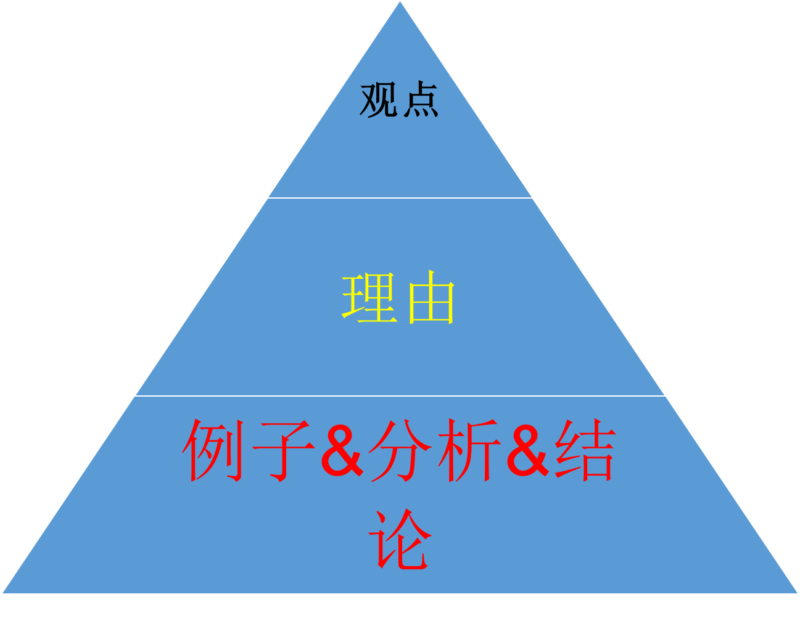

Task1

**Which of the following jobs or careers do you think would be most rewarding?  
A. University professor  
B. Environmental scientist  
C. Newspaper journalist**

**Personally, I think the university professor is the most rewarding job.  
Primarily because they could always keep a young mentality. To be specific, while working, they are staying with young people and know how to embrace new ideas. They know how to learn new things to keep up with those young minds and as a result, they always feel young.  
Also, they share and impart knowledge. In other words, they are cultivating talents for our country. For example, they can help train environment scientists and newspaper journalists. University professors offer them guidance and methodology of their majors. Without professors, they could never achieve their career success.**

**Talk about a popular actor, musician, or artist whose work you do not admire. Explain why you do not like this person’s work. Use specific details and reasons in your response.**

**A popular musician whose work I do not really admire is Lady Gaga.  
Primarily because her work I feel is a little too crazy and way out of my comfort zone. For example, the songs she sings such as Bad Romance, Poker Face, Born This way, and etc.., are too noisy and contain too much rebellious and negative information.  
Also, I don’t really like the way that she dresses. To be specific, the way she dresses up is too exaggerating. For example, in her concert, she may put a piece of pork on top of her head served like a hat, and sometimes she wears bikini to attract audience’s attention which is too much for teenagers.**

**5种细节拓展方法**

**方法1. Domino Effect.  
  
方法2. Giving a list.  
  
方法 3. Giving an Short Example.  
  
方法 4. Giving a Figure / Figures.  
  
方法 5. Compare and Contrast**

**Give a short example**

**第一步：确定自己熟悉的例子背景**

**Student Case**

**彭于晏**

**NBA**

**Pillow**

**Dancing**

**Swimming**

**Badminton**

**Art class (Rembrandt)**

**第二步：根据题目关键词进行Q&A  
1. 题目让你讨论什么？（5W1H/）  
2. 讨论这个人或物的哪些方面？（5E原则+3participants）  
3. 可以运用什么论证方法？（举例，对比，让步，因果，假设，并列等）  
  
Describe the disadvantages of moving to a new place.**

**2.口语预测语料库-常用理由**

**12大类**

**1.娱乐休闲**

**2.教育**

**3.工作**

**4.志愿者**

**5.成功**

**6.环境（交通）**

**7.地点（旅游）**

**8.朋友+家人**

**9人物性格**

**10.生活**

**11.科技**

**12.政府**

**5大常考理由**

**1．As a college student, I am overwhelmed with lots of assignments and I have to prepare for exams, do presentations, do group projects, and stuff like that.**

**2.** **I am on a tight budget since I have to spend money on different things like paying expensive tuitions, covering my living expenses, you know, things like room and board, utility bills and stuff like that.**

**3.** **By doing this, I might come across likeminded people. As the saying goes: “birds of the same feather flock together.” When spending time with people who have the same hobby, one has so much to talk about and share perspectives with each other.**

**4.** **I should learn to appreciate different kinds of music. Music is a big part of our lives; we can develop a taste in music … it brings hope, love, inspiration and stuff like that.**

**5.** **By facing time with parents and friends. Not only can I hear their voice, but also I can see their facial expression and body movement. I makes our communication more efficient**

**具体应用题目**

**1.Which period do you think is most difficult: childhood, teenager or adulthood?**

**2.What are some important effects of the worldwide availability of Internet on modern people's lives? Use specific details and examples to support your response.**

**3. Which of the following groups would you like to join? Campus newspaper, hiking club or dorm improvement committee.**

**4.Your community center now offers classes on the weekends for free. Which of the following classes will you choose to take? Give reason to explain your choice.**

**- A financial course to help you manage money**

**- Car maintenance and repair**

**- Review of Latin-American music.**

**重点真题回顾篇**

**Task1三大类**

**1.描述类（有形+无形）**

**2.三选一**

**3.建议类**

**描述类**

**Task 1: Describe the advantages and disadvantages of open book exams.**

**The benefit of open book exams is that students will be less stressed out by such exams. They don't spend too much time preparing for the exam. You know, students are overwhelmed with lots of schoolwork like doing presentations, doing group projects, and writing lab reports. Thus, students will not be so stressful. However, the drag of open book exams is that the teacher might have a strict grading policy since the exam itself is easy. Consequently, students will not be able to get high grade in the exams and end up getting a lower GPA.**

**三选一**

**Task1: Which of the following kids’ behavior has the most negative impact on others?**

**1．selfishness**

**2．talking rude**

**3．speaking loudly**

**Personally, I would say the most impolite behavior is to speak loudly, especially in public places.**

**Actually, kids should be taught from day one to respect others and keep quiet in public places and speaking out loud is pretty rude. For example, in school, if a kid shouts out in the classroom, the teacher will be annoyed and other students cannot focus on the lecture. Outside of school, if kids speaking out loud in places like restaurants, buses or trains, they will not only disturb others, but also affect their parents’ reputation for not disciplining their kids.**

**建议类**

**Final is coming, and your friend often oversleeps and misses the class. Will you help your friend to review while you also have a lot of exams?**

**Well, I would definitely help my friend to review for the final exams.**

**Primarily because friends are big part of our lives. We should cherish friendship. As the saying goes: “A friend in need is a friend indeed." Thus, I think a good friend should make some concession for each other, and I am sure my friend will make it up for me.**

**Also, helping my friend doesn't mean I will hurt my learning efficiency. Actually, when helping my friend to learn, I am also reviewing the materials. For example, when I explain my biology class notes to my friend face to face, I can retain the information better.**

**Task2**

**两大类**

**1.是非类（agree or disagree)**

**2.喜好类（prefer）**

**是非类**

**Do you agree or disagree with the following statement: it is okay for professors to forbid students to record lectures.**

**Personally, I would say it is okay to forbid students to record lectures. First off, the content of the lecture is the intellectual property of the professors. Students’ recording of the lectures is actually infringement of the professors’ intellectual property. Banning any recording of the lecture shows respect for professors. Additionally, allowing students to record lectures serves as an incentive for students to skip classes since they can ask their classmates to record lectures for them. Eventually, students will have low class attendance.**

**是非类**

**Do you agree or disagree with the following statement: good teachers admit they make mistakes or don’t know something. Using examples and details in your response**

**Personally I believe that teachers should be totally frank about their mistakes and the things that they don't know.**

**Primarily because this will set a good example to students that people should be honest. Admitting one’s mistakes means that the person still aspires to make improvements and be a better teacher. There is nothing wrong about making mistakes.**

**Also, admitting mistakes will help students think critically. My debating teacher, for example, always openly claims that he is wrong and we have better ideas. As a result, we are often be encouraged to think critically and voice our opinions since making mistakes is not a big deal as long as we are willing to make it right.**

**喜好类**

**Task 2: Some people like to speak immediately when they have group discussion while others prefer to wait and listen to others’ opinion before giving their own. Which one do you think is better and why? 重复2017年6月10独立托福口语**

**Well, I would say I like to wait until others give their opinions before giving my own. First off, I can benefit from others’ perspectives and opinions about certain concepts and ideas especially for difficult subjects like chemistry, physics, and even math. After hearing their points of view, hopefully I can offer better views. Additionally, I am the kind of person who doesn't like to take the lead. I am not very confident to speak out in the first place. So, I would like to wait until others give their opinions and then share my opinion with the class.**

**TASK1,TASK2答题结构选择**

**平行结构+freestyle结构**

**Describe an experience in which you hurt another person’s feeling unintentionally**

**平行结构法**

**Personally, I hurt my friend unintentionally by rejecting her visit to me when I was in American high school.**

**Primarily because I hurt her with my cold words. she thought I didn’t treat her as my close friend. When she texted me that she would visit me in US during Christmas time, I just replied coldly that I would not be able to accompany her because of my busy study.**

**Also, I hurt her because I didn’t give her a sincere apology afterwards. I thought she was joking at that time and took for granted that she would not travel that far from China to US to visit me, but the fact was she meant it.。**

**Freestyle法**

**Well, I went to the US for high school, and when I first went there, I was like, overwhelmed by tons of schoolwork, presentations, projects, and stuff. Unexpected pressure fell all down on my thin shoulders. However, my close friend Zhangjing texted me saying that she wanted to visit me around Christmas. To be honest I was frustrated at that time, so I told her I won’t have time to keep her company all the time. I felt that she was disappointed at me because she didn’t contact me for like, a whole year. I felt so sorry for that and I still do.**

**Is it better to use your extra money to buy some objects like clothes or electronic products, or is it better to use the extra money to increase your experience like going for a vacation or a concert? Use specific reasons and examples to support your opinion.**

**平行结构法**

**Personally, my money would go to vacation or concert.**

**Primarily because I can gain some precious experience. To be specific, I could have a wonderful memory. For example, Last summer I bought a round trip plane ticket to Miami with some extra money earned as a cashier. I not only experienced the hospitality of local people who have a different accent, but also witnessed spectacular sunset at the South Beach. These are more valuable than clothes**

**Also, the pleasure I get from vacation would be more lasting. Unlike clothes or some electronic products such as cellphone, computer and stuff, which update every single year, the joy from vacation could last forever.**

**Freestyle 法**

**Since I am from a mid-class family, when it comes to money, I won’t spend a single penny on things I don’t necessarily need. Like electronic devices refreshing yearly, or abundant clothes. However, I am an avid traveler, so it’s always worth the price if money buys me some precious experience. Last summer I bought a round trip plane ticket to Miami with some extra money earned as a cashier. I not only experienced the hospitality of local people who have a different accent, but also witnessed spectacular sunset at the South Beach. These are more valuable than clothes.**

**预测篇**

**1、预测题破题训练**

**Task1**

**170520CN S1 (new)**

**Describe a behavior that many people may do in public that you find inconsiderate.**

**170930CN S1 (new)**

**Parents should teach their kids to learn how to manage money, and what do you think is the most important thing for it, and explain why it’s important.**

**170916CN S1 (new)**

**If the government is going to invest in the following fields, which of the following do**

**you think is the most worthy one?**

**1. land exploration**

**2. education**

**3. health care**

**Task2**

**170826CNS2 (new)**

**Some students enjoy decorating their surroundings; other choose to keep their**

**surroundings simple and free of any decorations. Which do you prefer and why?**

**170826CNS2 (new)**

**Some students like teachers who often supervise their study and work, while others**

**like teachers who allow them to study independently and check their work occasionally.**

**Which one do you prefer? Explain your reasons.**

**170909CN S2 (new)**

**Some people like participating in performance like theatrical or musical show. Others**

**prefer to be in audience watching those plays. Which do you prefer?**

**1、预测题难题精讲**

**Task1**

**160820CN S1**

**In every culture there are some customs or traditions from the past those young people no longer follow. Describe a custom or tradition form the past that is no longer common but that you wish still popular today. Give specific reasons why you wish that still popular**

**Personally, I believe writing letters should be followed by young people.**

**Primarily because it is easier to build an emotional bond between people. To be specific, writing letters makes it possible for young people to organize their thought carefully and choose the right word. For example, couples may find it easier to get their loving messages across through letters because they could meticulously select sweetest words to strengthen their love relationships.**

**Also, it is a good way to train young people’s hand writing skills. Young people nowadays are obsessed with online social networking such as Facebook, Twitter, WhatsApp and stuff. All communication is done through typing with the help of automatic spelling, so their precious ability to write on paper is degrading. Thus, writing letters may help them maintain and improve this skill.**

**160227CN S1**

**Your friend has to work a lot. Please suggest a hobby help him spend his weekend in a more delightful way. Explain why. Please include details and examples in your explanation.**

**Personally, I would like to ask him to work out in a gym.**

**Primarily because working out in a gym could reduce his stress. To be specific, he could temporarily escape from his 9-6 working life by running on the treadmill, lifting dumbbell, doing bench press and stuff.**

**Also, it would be a chance to make him more charming. While relaxing, he could achieve a nice body shape with 6-pack abs, and this is more likely to attract girls’ attention and even start a very romantic love story. This is more than delightful.**

**160903CN S1 三选一话题**

**Which of the following ways is the best in getting to know Italian culture.**

**① watching Italian movies**

**② learning Italian cooking**

**③ attending Italian lectures or classes**

**2 adj法**

**Personally, I would like to attend Italian lectures and classes to learn culture, primarily because**

**It is interesting to learn. To be specific, in classes and lectures, there are more diverse and funny ways to learn. For example, teachers may play some Italian movies or even show us how to cook Italian food with real ingredients from food markets to make his lectures and classes more interesting.**

**Also, it is more flexible to learn. In lectures and classes, when students encounter difficult problems, they may raise questions which could be solved by teachers in time while this is quite hard to do while watching movies or learning cooking.**

**160910CN（下午）**

**Your city is going to build new places to attract more visitors.**

**Among the following three options, which do you think is the best?**

**A. A local history museum**

**B. A modern art and film museum**

**C. A children science museum**

**160228CN S1**

**Describe the disadvantages of moving to a new place.**

**160703CN S1 建议类**

**Your friend is coming to your country for studying, but he or she is worried about the cost, what are the advices you can offer?**

**160326CN S1 描述类**

**Describe what you were like when you started attending school.**

**161105CN S1 三选一**

**Which of the following technological developments have made the greatest impact on students’ lives?**

**1、electronic books**

**2、online classes**

**3、smartphones**

**161112CN S1 三选一**

**If university plans to add a new course that is not being offered to students, which of the following courses, in your opinion, would attract most students?**

**1. Sound engineering and recording**

**2. History of rock music**

**3. Film studies**

**Task2**

**160313CN S2喜好类**

**Some people get to know a person by the first observation while others prefer to get to know a person by long time observation. Which one do you prefer and explain why.（TPO41 TASK4）**

**Primacy Effect**

**When people form opinions about a person or a situation, those opinions are likely to be based on first impressions, on an initial assessment of the person or situation. In other words, the opinions we have of people or situations tend to be based much more on the first information we team about them than on information we learn later. This tendency is called the primacy effect. Researchers believe that the primacy effect occurs because after people have made an initial judgment, they tend to notice evidence that supports that judgment, and disregard or fail to notice evidence that contradicts it.**

**In my point of view, I don’t think judging a person on the basis of first observation is generally correct. First of all, a person usually tries to appear nicer than he or she really is when first meeting someone. Some even pretend to be good on purpose. Second, a good look doesn’t necessarily match good character. People should be wise to realize the possibilities of false impressions they may have at the first glance. In fact, a person’s character can be fairly judged through careful observation ‘cause the true character can only be revealed in the person’s reactions to different events. It takes time to get to know someone and find out the real personality. Therefore, judging a person by the appearance is often wrong.**

**160228CN S2 是非类**

**Do you agree or disagree with the following statement:**

**Schools need to encourage students to be more creative and use imagination to be successful person.**

**Personally, I do think it is necessary for schools to encourage students to be creative.**

**Primarily because imagination is one of the keys to success. If we take a look at successful businesses, they all draw success from the same set of values - hard work, innovation, and a little bit of luck. Iphone is one of the most successfully made phones, and the company slogan is “Think Different”. The CEO of apple will always use the word “innovation” over and over again in his presentations.**

**Also, innovation makes our life easier when people face problems. A good example of this is technological innovation. The creative inventions of the smart phone and tablet computers have made our life so much more convenient than before. And this is all thanks to the creative people working at the technology companies.**

**150530CN S2喜好类**

**Some people prefer to solve a challenge all by themselves. Others prefer to depend on other people's help. Which do you prefer and why? Include details and examples in your explanation.**

**I prefer a job without a lot of communication. Firstly, I wouldn't have to waste energy managing work relationships. It's tiring keeping people happy just so your work can go smoothly. Working alone, I can just focus my energy on my work, instead of thinking about how to shoot down people's ideas politely, avoid conflicts, give people face, and other similar issues. Secondly, I wouldn't have to make compromises in my work. When communicating with others, I'd probably have to compromise on things to get things done. That means it'd be hard to realize my own vision. But if the only person I have to answer to is my boss, then I have a lot more freedom to be creative.**

**160529CN S2是非类**

**Do you think it is a good idea for parents to give kids monetary reward if they have good grades in school. Please include details and examples in your explanation.**

**150712CN S2 喜好类**

**When students have questions about an assignment for class, some prefer to ask their professors for help, others would rather ask fellow students. Which do you prefer?**

**160604CN S2是非类**

**In a workplace, do you think the employer should constantly supervise the employees or is it better that the employer only checks on the employees occasionally? Please include specific reasons and details in your response.**

**150822CN S2 喜好类**

**When you are watching movies, do you prefer to discuss with others or enjoy the movie quietly on your own?**

**160311CN S2 是非类**

**Do you agree or disagree with the following statement:**

**It is more important to maintain relationship with family members than with friends.**

**160702CN S2 是非类**

**Do you agree or disagree the following statement?**

**Older doctors are more knowledgeable than young doctors?**

**Use specific details and examples to explain why.**

**150912CN S2 喜好类**

**Some people prefer to have their schedules fully and specifically arranged. Some people however, prefer to leave themselves a lot of free time. Which do you prefer and why?**

**160821CN S2 是非类**

**Do you agree or disagree with the following statement? If you want to be successful in business, being outgoing and friendly is very important.**

**161015CN S2 是非类**

**Do you agree or disagree with the following statement: a boss or a manager should not form close friendship with their employees.**

**161022CN S2 是非类**

**Do you agree or disagree: Government should not allow violence and bad language in television program.**

**综合口语**

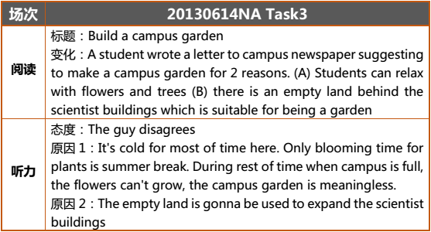

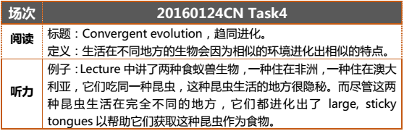

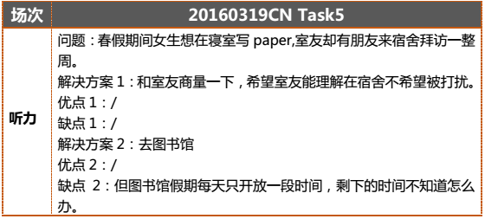

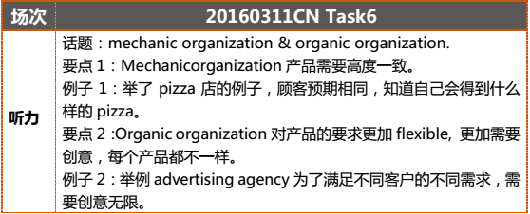

**整套例子**

**Task1**

**Your friend is concerned about a presentation he has to give to the class. What advice would you give to help your friend prepare for the presentation?**

**Preparation time: 15 seconds**

**Response time: 45 seconds**

**Task 2**

**Some teachers prefer students to send questions about coursework and assignments by email. Other teachers prefer students ask these questions in person. Which do you think is better? Explain why.**

**Preparation time: 15 seconds**

**Response time: 45 seconds**

**Task3**

**Reading Time: 45 seconds**

**University Energy Consumption Reduction Plan**

**In accordance with the proposed University Energy Consumption Reduction Plan the university will be making several changes around campus. Old, inefficient windows will be gradually replaced with insulated, energy efficient windows to reduce heating and cooling energy usage. Furthermore, buildings identified as being unused by students during the evening hours will close early to reduce lighting and operational costs. The university appreciates everyone’s contribution in helping the campus reach its energy conservation goals.**

**In the listening the woman expresses her opinion about the university’s Energy Consumption Reduction Plan. State her opinion and explain the reasons she gives for holding that opinion.**

**Preparation Time: 30 seconds**

**Response Time: 60 seconds**

**A: Did you read the school newspaper today?**

**B: No, I didn't. What did I miss?**

**A: The university outlined two steps it plans to take to reduce campus energy usage. I think they are both great ideas.**

**B: Oh really? Why is that?**

**A: First, old and inefficient windows will be replaced with insulated and energy efficient windows. Most of the buildings on campus are pretty old and so are the windows. I know a lot of students that don't like sitting next to the windows because they are so drafty.**

**B: Absolutely. I try not to sit next to the windows too, especially in winter.**

**A: Second, most buildings are usually empty by 9 PM. I think it is a good idea to turn off the lights if the building is empty. If there are students who are using the building late at night, they can always go to the library to work instead.**

**B: That's true. The library is open quite late.**

**A: I am glad that the university is taking steps to reduce its energy consumption.**

**Task4**

**Reading Time: 45 Seconds**

**Syonomone**

**In the field of chemical ecology, scientists study the interactions of organisms with their environment that are mediated by the chemicals they produce. Many organisms communicate via chemical signals. A syonomone is a chemical substance produced by an individual of one species that benefits both the producer and the recipient which is of a different species. This message-bearing substance evokes a behavioral response in individuals of the same or other species.**

**How does the example given by the professor help illustrate the meaning of syonomone? Use specific details in your answer.**

**Preparation Time: 30 seconds**

**Response Time: 60 seconds**

**In the animal kingdom, organisms that lack the ability to make auditory signals and communication often employ the use of chemical signals to communicate. Chemical signals have been classified into several different groups based upon their intended usage. A syonomone is a type of chemical signal that is produced by one individual of one species that benefits both the sender and the receiver which is of a different species. This chemical signal causes a behavioral reaction in the receiver and this behavioral reaction benefits the sender and receiver. Chemical signals are heavily used amongst insects, but did you know that fish can also employ chemicals to communicate? Let’s look at an example so you can better understand this phenomenon. The poly fish is a large fish that emits a syonomone chemical signal into the water. This syonomone signal is received by another fish species, the clownfish. The clownfish is small and colorful fish that is prey for many larger fish. The clownfish upon receiving the poly fish syonomone chemical signal approaches the source of signal and in turn emits its own chemical signal which attracts other species of fish to the clownfish’s location. This third group of fish to arrive is in fact a food source for the poly fish and the clownfish. The poly fish and clownfish are then free to hunt and eat the arriving fish. As you can see, this syonomone signal has worked to the benefit of both the poly fish and the clownfish by altering the behavior of the clownfish and provoking it to release a second chemical signal to attract prey.**

**Task5**

**The speaking discusses two possible solutions to the man’s problem.**

**Describe the problem and the two solutions. Then state which of the two solutions you prefer and why.**

**Preparation Time: 20 seconds**

**Response Time: 60 seconds**

**A: Hey Allen, how are you?**

**B: I'm doing alright, but I do have a small problem.**

**A: Oh really? What is it? Maybe I can help.**

**B: Well I have to finish paper for my American Literature class this weekend but my mom is having a birthday party this weekend as well.**

**A: I see. What are you going to do?**

**B: I could just stay on campus to finish my paper and give my parents a phone call to wish my mom happy birthday. But you know, if I did this, I think my mother would really miss me. She would be disappointed and I would feel bad.**

**A: Is there any other solution?**

**B: I could head home this weekend and write my paper at my parent's house but the birthday party might be a little distracting. I don't know if I would be able to concentrate and write a good paper.**

**A: That's true. I hope you can think of a good way to solve your problem.**

**B: Thanks.**

**Task6**

**Using points and examples from the lecture, describe two ways in which people can make familiar activities more enjoyable.**

**Preparation Time: 20 seconds**

**Response Time: 60 seconds**

**How many of you have been bored before? Maybe you were bored sitting in class or bored on the weekend with nothing to do. Boredom is in fact a psychological and emotional state where people are left without anything in particular to do, no interest in their surroundings, and not stimulated by their environment. If you find yourself often bored, don't worry, there are a few techniques people can use to avoid boredom when doing familiar activities. Let me give you two examples so you understand just what I'm talking about. First, when doing a familiar activity, you can change the location and environment of an activity to make it seem new or less repetitive. For example, when you are on a hike in nature, don't always take the same path or trail. Try going in a new direction and taking a different route to add a little variety and adventure to your routine. If you can change the location or environment in which you do an activity, it will seem less boring and more enjoyable. A second method you can use to avoid boredom when performing a familiar activity is varying the frequency of the activity. For example, let's say that you eat ice cream every day but this has become boring and monotonous. To avoid becoming bored with eating ice cream you can change the frequency to eating ice cream only twice a week. The lower frequency will make this previously familiar activity into a novelty activity and will increase the enjoyment you receive from eating ice cream. As you can see, there are a few techniques which people can employ to make familiar activities more enjoyable and less boring.**

**额外补充题目：**

**（2016 年大陆）**

**161016CN S1 (new)**

**There are many disagreements between friends. Which is one of the effective ways to resolving the disagreements. Use your examples and details to explain.**

**161022CN S1 (new)**

**Describe a time that disappointed you. What happened and what’s your respond.**

**161210CN（上午） S1 (new)**

**In your opinion, which of the following behavior is the most negative one displayed by children?**

**1. Being selfish**

**2. To speak impolitely**

**3. Being loud**

**160109CN S2 (new)**

**Do you agree or disagree with the following statement: current celebrities (like musicians, actor/actress, athlete) set a good example as role model the young people.**

**160124CN S2 (new)**

**Do you agree or disagree that experienced teachers is a deciding factor to the success of a school?**

**160123CN S1 (new)**

**Which course about history are you interested in? Science history, art history or history of 20th century?**

**160313CN S1 (new)**

**Which campus improvement do you suggest your school to invest in: swimming pool, cafeteria or dormitory? Please give specific reasons to support your opinion.**

**160925CN S1 (new)**

**Which of the following three would you choose to do in summer vacation? Working as a librarian, painter in an art center, or life guard in the natatorium?**

**161105CN S1 (new)**

**Which of the following technological developments have made the greatest impact on students’ lives?**

**1、electronic books**

**2、online classes**

**3、smartphones**

**161113CN S1 (new)**

**If you are going to choose a roommate which of the following quality is more important to you.**

**Cleanness**

**Friendliness**

**Quietness**

**160924CN S2 (new)**

**Which would you prefer: doing exercise everyday or only when you are free?**

**161211CN S2 (new)**

**Do you agree or disagree that it is important for young people to learn some domestic skills like cooking, sewing and taking care of children?**

**161217CN S2 (new)**

**Some students choose to enter the university immediately after finishing high school, others prefer taking time off before beginning the university class. Which option do you think is better? Explain why.**

**161203 CN S2 (new)**

**There are two invitations. One is from a party with your friends and the other is that having a dinner party with your parents. Which one would you prefer and why?**

**160820CN S1（new）**

**In every culture there are some customs or traditions from the past those young people no longer follow. Describe a custom or tradition form the past that is no longer common but that you wish still popular today. Give specific reasons why you wish that still popular.**

**161105CN S2（new）**

**Which of the following technological developments have made the greatest impact on students’ lives?**

**1、electronic books**

**2、online classes**

**3、smartphones**

**161112CN S2（new）**

**If university plans to add a new course that is not being offered to students, which of the following courses, in your opinion, would attract most students?**

**1. Sound engineering and recording**

**2. History of rock music**

**3. Film studies**

**161119CN S2（new）**

**Nowadays traffic congestions are increasing, what can we do to reduce the cars in the city?**

**160227CN S1（new）**

**Your friend has to work a lot. Please suggest a hobby help him spend his weekend in**

**a more delightful way. Explain why. Please include details and examples in your explanation.**

**160228CN S1（new）**

**Describe the disadvantages of moving to a new place.**

**160319CN S1（new）**

**If you are a teacher of a tutor group and you are going to take students to a study trip, where would you take them to? A. science museum B. local farm C. theater performance**

**160326CN S1（new）**

**Describe what you were like when you started attending school.**

**160409CN S1（new）**

**Describe one of the most popular websites in your country? Explain why it is popular with details or examples.**

**160423CN S1（new）**

**What do you think is the most important thing that parents should teach their children? Please include details in your response.**

**160604CN S1（new）**

**Describe one or two ways your life may change five years from now. Please include specific reasons and details in your response.**

**160703CN S1（new）**

**Your friend is coming to your country for studying, but he or she is worried about the cost, what are the advices you can offer?**

**160709CN S1（new）**

**What is the ONE thing that makes your country different from other countries?**

**160710CN S1（new）**

**Which of the following choice do you think has the greatest impact on environmental protection?**

**1. Governmental Regulations**

**2. Environmental Awareness Groups**

**3. Individual Efforts**

**160228CN S2（new）**

**Do you agree or disagree with the following statement: Schools need to encourage students to be more creative and use imagination to be successful person.**

**160311CN S2（new）**

**Do you agree or disagree with the following statement:**

**It is more important to maintain relationship with family members than with friends.**

**160313CN S2（new）**

**Some people get to know a person by the first observation while others prefer to get to know a person by long time observation. Which one do you prefer and explain why.**

**160529CN S2（new）**

**Do you think it is a good idea for parents to give kids monetary reward if they have good grades in school. Please include details and examples in your explanation.**

**160604CN S2（new）**

**In a workplace, do you think the employer should constantly supervise the employees or is it better that the employer only checks on the employees occasionally? Please include specific reasons and details in your response.**

**160702CN S2（new）**

**Do you agree or disagree the following statement?**

**Older doctors are more knowledgeable than young doctors? Use specific details and examples to explain why.**

**160821CN S2（new）**

**Do you agree or disagree with the following statement? If you want to success in business, being outgoing and friendly is very important.**

**160910CN S2（new）**

**Do you agree or disagree with the following statement? Students learn more when teachers assign a lot of homework. Use specific details and examples to explain why.**

**161015CN S2（new）**

**Do you agree or disagree with the following statement: a boss or a manager should not form close friendship with their employees.**

**161022CN S2（new）**

**Do you agree or disagree: Government should not allow violence and bad language in television program.**