Whenever asked about whether ----, individuals generally exhibit an air of uncertainty. Understandably, being confronted with such complicated society, ------(everyone has different perspective about one thing), Personally, I am in favor of the idea that ----. Along with some concerns and explanations given as below, my point of view can be an all-round illustrated one.

When examining tendencies boomed in the contemporary society, whether ----has provoked a prevalent（流行的） debate saturated with controversies. Some individuals, who are the opponents against my point of view, announce that ___. Personally, I am convinced that ___. Along with some concerns and explanations given as below, my perspective can be an all-round illustrated one.

Whenever asked about whether---, different perspective will be held by different people about the same thing. Some individuals, who are the opponents against my standpoint, announce that ---. Personally, I am in favor of the idea that ---and here are the justifications why I believe so.

Primarily, why I espouse the standpoint for ___is that __ .

To expound this further, __, another underlying factor, contributes to the perspective that__.

Admittedly, __may sound cogent in some conditions. For example, ___. On the contrary, __and__ will facilitate __with a more powerful voice.

Judging from the evidence, abstract to concrete, a consensus can reach at that __.

表转折：but: however, nevertheless, whereas

表连接：and: meanwhile, as well as, on the other hand, at the same time.

表现在：now: at present, for the time being, for the moment,

表强调：important: significant, vital, crucial, key

表赞赏：good: fantastic, splendid, fabulous, superb, unexceptionable, marvelous，wonderful

相反的：conversely, contrarily, on the contrary, however, nevertheless.

长短句叠加使用！（长句可以有从句）



推动经济发展 promote economic development

Imperturbable = calmly 冷静的

Vanity 虚荣心



时间流逝的很快 Time passes quickly

It is undeniable that

The journey is very bumpy 路程很颠簸

against the rules 违反规则

the attention will be torn apart 注意力会被分散

A will do harm to children’s physical health. XXX is unfavorable to play the video games for a long time, which will pose an adverse effect on normal development, especially eyesight.

过渡词

On the other hand

Furthermore, moreover, inclusively, besides, evidently, not surprisingly, apparently, needless to say, obviously, in this manner, in this situation, in addition

A🡪B

A

can/will ：Generate/ameliorate/accelerate/fertilize/cultivate B

A can accelerate the process of B.

It seems irrelevant to , while in fact,

(it is) given/associated with/owing to/provided/because of/ through/ due to A,(that) people can do B

It is due to A that people can do B.

It is associated with A that people can do B

A is in direct proportion to B

Is conducive to

Attaches a great important to

Consequently, accordingly, as a result, therefore

Because, since , as long as if when while

In order to , so as to

A is to B what the foundation is to a skyscraper.

A constitutes a stepping stone to B

A give rise to B A 给B带来了

The importance/advance/advantage/dominance of A to B can never be neglected

The dominance of A ，which(that) does B， can never be neglected.

A has/possess/preserves/maintains an importance in terms of B

A possesses a significance in terms of B

A possesses a significant function to promote the process of B

A occupies an important/indispensable position in the formation of B.

A occupies an indispensable position in the formation of B.

Only with A can people do B.

Without A, people could not do B.

provided假如 people not do A, people could not do B

not merely can A, but also B.

it is common knowledge that

Is it one of the best way that…..?

Cultivating their social skills.

In a nutshell (简单地说)

Not surprisingly,

Consequently

It is not until that

Did not do until they

Without worries

Material life 物质生活

As a matter of fact 事实上

With An ample supply of 充分的供应

Needless to say 不用解释

Be jealous of sb 嫉妒某人

名言名句：

1. Books can provide people with food for thought
2. Time and tide waits for no man 时不我待，岁月不等人
3. everything in the world is double-sided, and scientific discoveries are no exception to this rule。
4. The year's at the spring,  
    And day's at the morn; 一年之际，一日之计在于晨
5. There is no perfect person in this world. 世界上没有十全十美的的人

With the acceleration of technological development, the world is progressing at an unprecedented pace. So is the quality of people’s life standard. The world civilization is stepped into a new stage. So there is a great demand for,,,,

Along with the acceleration of social development, people, especially young people, are confronted with unprecedentedly fierce competition. They need to work very hard to guarantee a decent life, which causes them way heavier pressures than before.

Ab：

Although A, B possesses some preponderances in C.

电脑的弊端：

people always like to stare at the computer screen in a long time, which means that they are often concentrated highly on computer and the radiation emitted from the computer will eventually exerts bad impact to persons' eye. If things go on like this, people are more likely to be nearsighted and become one of myopic people

they will be distracted form the class

people are more likely to be overly obsesses with the internet because of its fancy designed page and intelligent and innovative computer games or even some interesting advertisements

customers

It may seem irrelevant to do sth, while in fact,

For quiet some time 一度以来

Overprotect 过度保护 （spoil 溺爱）

The way of So called love 所谓的爱的方式

=:

Is regarded as

Is considered as

Is defined as

Involves

Is saturated with

AND:

In addition, furthermore, inclusively, moreover, in the other hand, evidently, needless to say, Besides,

In this manner 以这种方式

**STH:**

In particular, particularly, considerably, impressively, remarkably

People (individuals, civilians, human beings, citizens, residents, characters, the public, the ordinary)

Workers (employees)

Work(employment, position)

Teachers ( school mentors，educator)

Companies (enterprises, corporation)

Good (positive, beneficial, excellent, outstanding, constructive)

Great (remarkable, discerning, striking, considerable, impressive, noticeable, eye-catching)

Big(tremendous, numerous, immense)

Bad/harmful( detrimental, devastating, disastrous, destructive)

Important (significant, fundamental, substantial, underlying, indispensable)

More/More and more

+n.

(an increasing/growing/extensive number/population/quantity of )+ n.

+adj./adv.

Increasingly, extensively, excessively

Like/want (be inclined to, be tended to do )

Should (have/experience/possess/explore/maintain/preserve the responsibility/obligation to )

Can/be able to (be capable of doing, be of capacity to do, have the capacity to do ,it is possible for people to do, have the possibility/probability to do)

Get (absorb, obtain, attain, acquire, receive, accumulate (have/experience/possess/explore/maintain/preserve the absorption/acquisition/accumulation of)

Just (merely)

Arguments: quarrel, divergence, conflict

Only (exclusively)

Improve/develop (ameliorate, optimize, aggrandize, magnify)

Solve (annihilate, cope with)

Find (excavate, identify, distinguish, recognize, )

Way (approach, solution)

Full with (saturated with)

Know (understand, notice, perceive, recognize, realize)

Effort (endeavors, devoted the wholehearted to)

New (nascent, innovative, novel,)

Aspect (dimension)

Old (traditional, conventional, outdated, unfashionable, previous, experienced people, )

Different (various, diverse)

Kind (category, pattern)

Use (consume, utilize, exhaust, exploit)

Ask (request, require, demand, consult, investigate, enquire)

Give (offer, provide): deliver, distribute, convey, render

Job (work, task, assignment, responsibility, obligation, mission, occupation, position)

Study/class: curriculum, course,

Do (implement, accomplish, execute, complete, conduct)

Nice (enjoyable, pleasure, courteous, gracious, congenial(happy), cordial, thoughtful=considerate)

Good (marvelous, exceptional, fantastic, terrific, splendid, stupendous)

Happy (delighted, ecstatic, content=satisfactory，exhilarate)

选择话题（是由你的话题一步步推导结果）

（be more satisfied with their life/paves an easier way for sb to achieve success）acquire an increasingly quantities of knowledge 🡪（build confidence）be more confident about themselves🡪→be motivated 🡪 be willing to cope with problems that can sometimes cultivate their social skills 🡪→can enhance their efficiency in doing sth with these abilities🡪feel extensive happy that render them more satisfied with their life, which contribute to their success. 注意主谓一致！！！

Sth→🡪 be more outgoing 🡪→ be more likely to participate in many outdoor activities 🡪→ameliorate their communicative skills🡪→make more friends that can enlarge their social circle→🡪 have more opportunities（fewer opportunities） to exchange ideas and experiences🡪acquire a lot of knowledge --> embrace the new cultures 🡪 →widen their horizons (have their horizons broaden)

时代比较题：(是一步步推导到你的观点）

Due to the advanced transportation system in this developed society -->

With the accelerating pace of life-->people are burdened with much more pressure than ever before--> they are left with less time to do sth-->

素材：

1. 严肃电影还是娱乐电影：

One of most essential goals in movie-making is to enrich people's inner world, to some extent, serious movies are playing the role of pilots that guide people psychologically. Books provide people with food for thought, so can serious movies. An outstanding serious movie encourages people to make full use of their imagination and common sense to think logically. Normally, mysterious are hidden in these movies so as to arouse people's curiousity(curiosity). With a burning desire to find the answer, viewers(viewers) try hard to find the answer before the movie concludes. One exapmle(example) is a movie entitled A Murder On The Orient Express. the plot is so thought-provoking that viwers(viewers) are turned into detectives themselves. In the movie, a murder is committed on the train and a number of passengers are brought under suspecious(suspicion). motivated to discover the real murderer, viwers(viewers) are willing to make their own jugement(judgment). Watching such a movie is just like going on an unforgettable inner journey.

In addition, the social and historical background of serious movies can provide people with an opportunity to comprehend a vast amount of knowledge. The complicated social reality as well as what is lying deeper inside can also be sensed.

Both the lecture and the reading discuss whether Peary really reached the North Pole. The speaker claims that there are no solid evidence showing the theory and all of the arguments are not convincing, which disprove the opinion in the reading that there are several arguments proving the truth of Peary's claim.

The speaker points out that although the National Geographic Society committee declare that truth, they are not objective about it because they investigated a close friend of Peary who provided lots of money to fund the Peary. Besides, the investigation only took two days and the committee did not examine the investigation so it is not accurate and full with bias. Therefore, it is not trust worthy. All mentioned evidence can be used by the speaker to refute what the writer represents in the reading passage that the investigation started by a committee can prove the truth of Peary.

The speaker announces that the trip of Tom Avery cannot provide the support to the point that Peary told the truth. This because Tom used different ways to travel from Peary. His weight of dogsled if different from Peary because Tom transported his food by airplane instead of putting them on his sled. Furthermore, Tom took the trip in a good weather condition while Peary took the trip in a bad weather condition so they possess different situation in that trip, which weaken the reasoning and the statement in the reading material that the expedition of Tom Avery can support the Peary's claim.

The speaker argues that the photograph cannot prove the theory because only when the shadow in photograph is precise enough that people can establish the accurate conclusion about the Surf's position. However, Peary used primitive camera to take that unfocused photograph and it has been faded a little so the shadow on that photograph is blurred and faded and it cannot be used to calculate the accurate the position of the Surf. Therefore, it is not confident for people to prove the theory. The counterpart of reading that the Surf's position calculated from the photograph taken by Peary can prove the truth is strongly questioned.

1. 搞好人际关系与努力学习一样重要

Knowledge is power, just as Tomas once express. To some extent, essences contained with all school subjects simply resemble the concrete frames of architecture. Without them, the building will soon collapse. In order to achieve success in one’s future career life, it is imperative for students to study hard at school. Therefore, there is no excuse for any student to shun the （most） fundamental task of studying. The "No pains, no gains" concept should be deeply rooted in one's mind. Diligence is a premise of a bright future. In this regard, we may refer to Madam Curie. She studied hard at school and earned her higher degree. The subsequent scientific research made her the first person honored with two Nobel prizes--in Physics and in chemistry. She is the first female professor at university of Paris. These unprecedented achievements owned much to Madam Curie's untiring efforts at school.

Mordern（modern） world values the teamwork, which is a key to career success. Only through the interactions of partners can one masters the art of cooperation. This vividly demonstrates the significance of relating well with others. in the school, there are many projects and group work assigned to students. The participation of group work requires the united efforts of all group members. During the course of group task, each individual has to work together with their partners. Bearing in mind their common goal, all members are devoted to their assigned part of the task. Just like different components of an engine, everyone is interrelated. If a single part of it refuses to function. The engine will suddenly stop or even break down. It is such a dramatic effect that depicts the value of working (harmoniously)and resolving any conflicts.

学习好：knowledge is power --> essences contained within all school subjects simply resemble the concrete frames of architecture-->study hard -->don’t shun the most fundamental task of studying --> No pains no gains concepts should be deeply rooted in mind. --> diligence is the premise of a bright future

团队合作：

Modern world values the teamwork --> interaction with others --> master the art of cooperation --> demonstrates the significance of relating well with others --> many projects and group work assigned to students --> the participation of task requires united efforts --> work together with their partners --> bear in mind their commmon goal --> devoted to their assigned part of the task -->

犯错误和冒险是好事：

There is no need to fear making mistakes and taking risks --> these experiences are worthwhile and beneficial for future development --> learning from past --> avoid future blunders --> have opportunities to improve himself

E.g: Thomas Edison, the greatest inventor that world has ever seen, taught us that making mistakes is only a precursor to success. After making numerous experiments and experiencing uncountable failures, he finally found out the most suitable material for electronic light bulbs.

不要浪费时间：

Make full use of every minutes once a task is initiated --> a second save is a second gained --> any intentional delay is a waste of time --> might lead to sever consequence --> a feasible schedule should be drafted and strictly followed --> nobody is allowed to work slowly --> settle deadline --> urging people to concentrate on their work --> complete a job head of time --> give person a sense of self-fulfillment --> maintain their enthusiasm in the future

具备组织能力：

Making plans and organize --> prepare the youth for future academic and career challenges --> clear goal in mind --> have impetus to strive for it --> are less likely to get lost on the way --> planning a head of time --> make each endeavor meaningful --> prevent unwanted situations in advance --> keeps young people from worry or fear of the future that is full of obstacles and mysteries

1. g:Suppose a person has an ambition to become a lawyer, he may plan to select law as his major at collage or read related books, of take a part-time job in lawyer’s office. More details are added until a well-organized plan is formed. From then on, he is able to live with a meaningful aim.

Early planing and organization experience --> become mature --> once they learned basic skills about how to plan and organize --> psychological changes take place in the brain --> obtain more objective views of the world

1. g: if they used to spend all their leisure time playing computer games and watching TV and they are given an opportunity to make a new plan on after-class activities, they might gradually realize the obsession with computer games was harmful to them. Activities like helping parents with housework and doing sports and reading interesting books may increase. This marks a big step forward. The child becomes mature and sensible, which indicates the importance of planning and organizing skills.

在找到自己长期发展方向之前应该尝试不同的工作：

The accumulation of work experience --> person’s perspective about their career --> take up diversified positions in different companies --> learn many valuable skills that cannot be learned from textbook --> make one mature and capable --> each company --> unique cultural atmosphere --> improve one’s overall outlook --> accumulate these values and knowledge -> future utilize --> expand their circle of friends --> interact with more people ---> paves a easier way to success.

uncertain about which job is suit for them --> Practice --> criterion for testing the truth -->

广告不是导致不健康饮食习惯的原因

Desire to loose weight --> join a shared mission to become slimmer --> prevailing trend has gone out of control --> enrollment of more newcomers --> the troop is expanding all the time --> few people are willing to fall behind --> a recent survey --> 6 out of 10 adults are on diet --> majority of them are taking very little food every day --> stay away from any staple food and meat --> only fruit and vegetable make up their meal --> eating nothing during their supper time and drinking water instead --> lack of nutrients

Working style--> high pressured work schedule --> deprive many busy people of the time to enjoy a comfortable meal --> they struggle out of bed early morning --> in order to catch the bus in time --> not having enough time to eat healthy breakfast --> a short noon break --> allows them to have a simple meal --> include unhealthy food KFC --> few of them have enough energy to prepare a healthy supper-- > suffer from health problems.

Practice

A🡪B.

Follow the realistic goals🡪achieve their future plans

A(can/will)

Generate/ameliorate/accelerate/fertilize/cultivate B

Following the realistic goals Can accelerate achieving their future plans

(it is) given/associated with/owing to/provided/because of/ through/ due to A,(that) people can do B

Because of Following the realistic goals , people can achieve their future plans

Consequently, accordingly, as a result, therefore

Because, since , as long as , if , when , while

In order to

A is to B what the foundation is to skyscraper.

Following the realistic goals that….. is to achieving their future plans that…what the foundation is to skyscraper.

The importance/advance/advantage/dominance of A to B can never be neglected

The importance of following the realistic goals, regarded as a factor to success, to achieving their future plans can never be neglected

A has/possess/preserves/maintains an importance in terms of B

Following the realistic goals has /maintains an importance in terms of achieving their future plans

A occupies an important/indispensable position in the formation of B.

Following the realistic goals occupies an indispensable position in the formation of achieving their future plans.

Only with A can people do B.

Only with following the realistic goals can people achieve their future plans.

Without A, people could not do B.

Without following the realistic goals, people could not achieve their future plans.

Did people not do A, people could not do B

Did people not follow the realistic goals, people could not achieve their future plans

Follow the realistic goals🡪confident🡪more willing to overcome difficulties🡪 improve abilities🡪achieve future plans🡪happiness

Following the realistic goals occupies an indispensable position in the formation of being confidence. besides, Only with being confidence can people be more（increasingly） willing to overcome difficulties. Because of solving these problems, people(individuals) can(are able to) improve(ameliorate) their abilities. Improving their abilities maintains an importance in terms of achieving their future plans. Therefore, they will feel more(extensively) happier than before.

Improving their abilities that maintain an importance in terms of achieving their future plans can accelerate one’s happiniess.

If people improve their abilities that maintain an importance in terms of achieving their future plans , they will feel happier.

5. participating in community activities🡪improving their communicative ability 🡪 be more confident🡪be willing to overcome difficulties🡪 improving their ability on the work🡪be happier.

First and foremost, participating in community activities can accelerate improving their communicative ability. With this kind ability can people(civilians) be more(increasingly) confident of themselves. Besides, they will be more(extensively) willing to overcome difficulties which could(have the possibility to) improve (ameliorate)their ability on the work(employees). In the end, they will feel happier(more pleasant/satisfactory) than before.

13.the world has changed🡪 the technology is improved🡪the civilization is developed🡪 making individuals’ conscious get a high level🡪the food is healthier.

As far as I am concerned, the world has changed and it can(is capable to) celebrate improving the technology. With this process can people(civilians) develop their civilization, It occupies an indispensible position in the formation of making individuals’ conscious get(achieve) a high level， which could(have capable to0 prove that the food we eat today is healthier than before.

24 being creative 🡪 produce a great idea🡪be happier🡪be more confident🡪improve their ability of thinking🡪solve problems more effectively.

34.spending more money supporting social activities🡪improving students’ willing to participating in these activities🡪developing their social capability🡪make more friends who have the same interest🡪being happier🡪being more confident

First of all, I hold the views that spending more（an increasing quantities of） money supporting social activities possess an importance in terms of making students be more(increasingly) willing to participate in these activities that can(be capable to) improve their social capability（ability）. Besides, with this ability can(have capacity to do) they make more(an increasingly quantities of) friends who have the same interest. Clearly, it is to being happier(more satisfactory) what the foundation is to skyscraper. Consequently, happiness possesses (maintains) an indispensable position in the formation of being more(extensively) confident.

37performance of teachers should be evaluated by students🡪 proposing the shortcoming that teachers have by students 🡪courses of teachers will be more suitable for students🡪be more interesting in taking the classes 🡪learn more things🡪be more confident

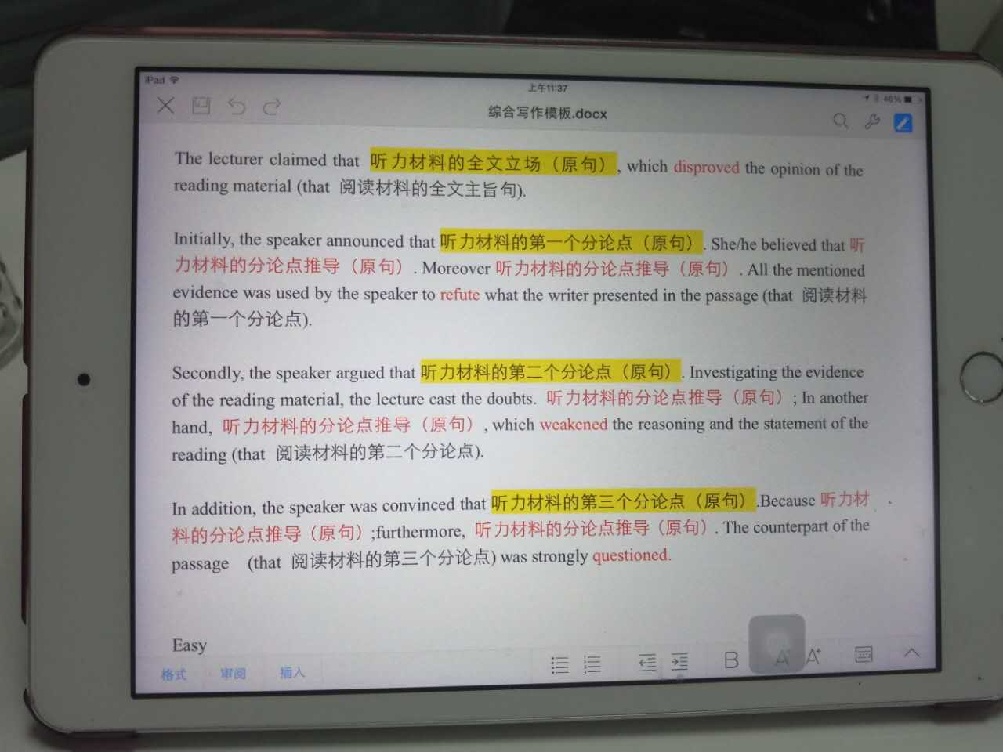

The lecture claims that , which can disproves the opinion in the reading passage.

Initially, the speaker announces that . All the mentioned evidence are used by the speaker to refute what the writer presented in the reading material.

Additionally, the speaker argues that , which can weaken the reasoning and statement in the reading.

Eventually, the speaker points out that . The counterpart of the reading is strongly questioned.