Do you agree or disagree: The way people dresses is a good indication of his or her personality or character?

一个人的着装风格是其个性的体现吗？

Dressing style reveal his or her individual preference 🡪 which are associated with the personality 🡪 For example, if one person often selects casual clothing 🡪 might enjoy a relaxing way of living and might also be interested in physical activity 🡪 there is possibility that this person might be open minded and easy-going 🡪 on the contrary, if one usually wears formal clothes 🡪 she or he might be businesslike and treat matters very seriously 🡪 if a person very prefer a bright or eye-catching cloth 🡪 she might be very outgoing

Some clues of his or her personal features can be traced from one’s way of dress. 🡪on different occasion, people are supposed to dress themselves suitably 🡪 for instance, evening dress could be the best choice for the dancing party 🡪 everyone should dress formally when an important conference is being held 🡪 if a person frequently fails to wear suitable cloths on special occasions 🡪 she or he may be very careless in dealing with daily matters 🡪 in addition, if someone always wears out-dated clothing 🡪she or he may be backward in personal taste🡪 By contrast, if a person always has successes in attracting one’s attention and dress fashionably 🡪he or she `might be smart and adaptable to changes.

Do you agree or disagree: It is impossible to always be completely honest with your friends?

人们不可能一直对朋友诚实

People may be willing to tell some white lie instead of saying something true that may hurt their friends. You know that if you tell your friends the truth of one thing that your friends want to know what exactly happened, that truth may be of capacity to broke your friends heart so that you may think secondly when you explain it to your friend, which is white lie. 🡪 for example, my friend’s sister once told me that my friend’s cat dead suddenly at the day before the final test day. An important thing worth mentioning is that the cat meant so much to my friend. Besides I exactly knew that the final exam is to my friend what the foundation is to the skyscraper, therefore, I thought that I shouldn’t tell my friend the truth to hurt her when she asked my why her sister called me. I answered:” everything is ok, you sister just asked me when you start the test tomorrow.” I told a white lie for her but instead, she wouldn’t feel unhappy, which might affect her final exam tomorrow.

Everybody has secrete 🡪 I have secret too 🡪 sometimes I may just want to hide something at the bottom of my heart instead of telling the truth of it to others🡪 as an old saying goes: ”family scandal should not be broadcasted” 🡪 which means that everybody has their own secrete🡪 some secrete may very important for me so that there is no necessary for me to speak out all the thing to my friends 🡪 this point is easy to understand: I may not be willing to tell my friends that my parents isn’t the real parents who born me if they want to know the truth.

A city wants to help teachers of its high school students (age14-18) improve their teaching. It is considering two plans:

1. Choose a small group of excellent teachers; these teachers will attend a class led by an expert for additional training in how to teach effectively, and they will then come back to their schools and provide that training for other teachers in school.

2. Provide additional training in teaching effectively for high school teachers, using online material that each teacher will study individually.

Improving the efficiency of studying of teachers

I always hold the view that experts possess rich experience in this field. The reason why they called experts is that they may do abundant number of research or be proficient in this field so that they can obtain this certification. Basically, they at least know what approaches or methods are better for educators to teach their students, what material is the best for them to utilize and what content that teachers should give the proof to lead students understand and what knowledge teachers can just explain instead of providing the proof or talking about its background information. Apparently, this process occupies an indispensable position in the formation of saving both time of students and mentors. In this manner, there is unnecessary for president of university to find out the perfect material online for teachers. By the way, those material may not be an appropriated content for teachers to exploit. Therefore, experts can enhance their proficiency.

There is possibility that an expert work many years in this education field and do some researches 🡪 An expert has many years experiences 🡪 he or she knows that what is the most important thing that he should use to train those excellent teachers and what is useless thing that he shouldn’t to say to waste his or teachers’ time

Besides, if teachers have something they don’t understand when they are training they can ask it to individual who sit beside her so that they can communicate about this question and solve this kind of problems quickly instead of putting it off. Furthermore, they are of capacity to speak out their wondering to the expert and the expert may give them a better answer.

“Teaching others is a good opportunities for individuals to learn”, just as Thomas once expressed, teaching others and reviewing these opinions and knowledge that they learned before are capable of accelerating the process of learning these again and reinforce the knowledge by themselves. Take this point is easy to understand, when you acquire some knowledge such as how to repair the broken computer, and then you teach others about it again so that process can help you review this knowledge again and also force you to explain the skills that you may use in repairing in your mind before you speak them out.

Children rely too much on the technology, like computers, smart phones, video games for fun and entertainment. Playing simpler toys or playing outside with friends would be better for children’s development

出去于小伙伴玩可以更好地发展

When kids playing the computer, they are concentrated highly on the computer games so that their muscles and brain will feel exhausted when they spend long time playing the computer while children will feel relaxed and pressure relieved when they play with their toy or play with their friends outside. As far as I am concerned, playing with their friends outside, their brain needn’t to be highly focused on one thing and they are of capacity to breathe the fresh air outside. This process occupies an indispensable position in the formation of relieve their pressure. Furthermore, Playing with friends provide me with more opportunities to create many situations that I have never thought before. For example, when I play with my friends, I may imagine some stories and regard my friends and me as father and mother and assign our toys as our children. We may play extensive quantities of games together. It is associated with the chances for me to have fun hand do and accomplishing thing as whatever as I want instead of being dominated by the computer that I can make such creativity. Besides, Full of creativity is beneficial for children in the future because lots of people in this material word lack creativity so brains that full of imagination and creativity is to adding an increase number of fun in their future life what the foundation is to the skyscraper.

Besides, it is not advisable for children to be overly obsessed with computer games🡪 most computer games boast a large number of elements that are dramatically appealing to the hearts of children 🡪 true-to-life visual and sound effects combined with smartly-designed plots and fascinating game modes allow participants to vividly experience the magical power of electronic world.--> owing to these superior characteristics 🡪 computer games are able to tie an addicted youngster to the chair before the computer screen for a long time. 🡪 without doubt 🡪it will not only do harm to children’s health and homework but also waste much valuable time that can be spent engaging in more meaningful activities. 🡪 Concrete evidence can be seen in many families nowadays 🡪 my brother used to be so addicted to computer games that he would consume half of his weekend in front of the computer. As time went by 🡪 he became nearsighted and his studies were also negatively affected.

You have long been friend with someone. If they do something that you don’t like , should you still be friends with him or her

Advantages that friends bring to me outweigh the disadvantages that they bring to me 🡪 friends are good for health🡪having communication with a friend and participating in dance party together 🡪 chatting while you feel alone 🡪share thought and experience🡪 offer simple but powerful ways to connect 🡪 the connection of friendship 🡪 increase one’s sense of belonging purpose and self-worth 🡪 promote positive mental health 🡪 besides, friendship can help you weather the trauma of an unexpected failure 🡪 a job loss or a death of a love one 🡪 your friends may encourage you to convert unhealthy lifestyle habits 🡪 such as excessive drinking 🡪 or they may urge you to visit your doctor when you feel overly anxious, sad or hopeless 🡪 friends can also share in your good times 🡪a new school a new favorite a new house 🡪 in the great time they can celebrate with you 🡪 during the bad times they can offer comfort and be with you through the tough days🡪 just knowing that friends are there for you 🡪 help you avoid unhealthy reactions to stressful situations 🡪 friends mean too much in my life 🡪 I don’t think it is worthwhile never forgiving a friend for a tiny thing that she or he did that I don’t like

Do you agree or disagree with the following statement. It is better to make friends with intelligent people than with the people who have a good sense of humor.

To some extent 🡪 a sense of humor is a quality that outweighs intelligence 🡪 being the distillation of wisdom and intelligence 🡪 it can be regarded as a demonstration of one’s overall character 🡪 ample knowledge and a rich accumulation of work experience are major source of a sense of humor 🡪 in other word, intelligent people may not be humorous but humorous people must be intelligent 🡪 some professor who obtain high prestige due to their remarkable academic achievement 🡪 however, lack of sense of humor may shrink their friends circle

马斯洛原理

XXX is a luxury when citizens are still struggling to a decent life. According to the Maslow’s hierarchy of needs theory, which is often depicted as the shape of a pyramid with the fundamental needs at the bottom which related to survival and the need for safety follows this basic level, and for self-actualization and self- transcendence at the top, only when the most fundamental basic level of needs is achieved will individuals have desire for secondary and higher level of needs. It is common knowledge that hardly could residents in poor places make their basic needs satisfied, for example, they may lack food or water and other daily necessities. In this manner, how can we expect them to XXX.

团队：

XX 🡪 improve teamwork

Studying together instead of studying alone can improve teamwork. The modern world values teamwork, which is a key to career success. Studying together can involve many activities, including communicating with each other about the assignment so that everyone in this team will be more concentrated on accomplishing this task. At school, there are many projects or group work assigned to students. The participation in any project requires the united efforts of all team members. During the process of group project, each individual has to work together with their partners. Bearing in mind their common goal, all members are devoted to their assigned part of the work. Therefore, they can have more time working together and have more opportunities to cooperate with others, which can improve their teamwork.

合作 🡪 提高工作效率

a higher work efficiency could be achieved if the group members could obey the whole group’s plan and targets. Team cooperation occupies an indispensable position in the formation of accomplishing a team project, which could be realized by the wholehearted dedication of all members with their conflict being eliminated. Needless to say, a bunch of time will be saved if they possess no divergences and coordinate with their partners perfectly. Evidently, in this manner, they are of capacity to obtain a higher working efficiency.

团队 🡪 激励每个人努力

Xx can motivate everyone in team to work hard and develop their self-discipline. Evidently, working in a team, there are many assignments assigned to group members. From my perspective, some people will work constantly whereas others may sometimes want to slack off. During the process of all members of a group working together, one sees others struggling and working hard in order to accomplish their mission, he or she may be stimulated and gains the initiative to make great efforts to work without being lazy since they understand that if they take a break, the progress of whole team will be dragged. In this manner, it may lead to bad consequence. Only one’s progress is as fast as others can whole team’s finish time be consistent and fast.

信任

头脑

Xx 🡪 can let my imagination run wide

Books show us the detail plots without displaying the specific characters on screens or pictures. Therefore, we are free to imagine without the constrains of movies. On the contrary, the characters in the movies have already been chosen and designed including their facial expression, body language and even dressing style, which leaves us with few chances to make full use of imagination and curiosity to think logically.

技能

兴趣

Emphasis should be placed on what has been suggested in the famous saying “interest is the best teacher.” Evidently, the primary step toward people’s success is to have an emotional preference, which is the biggest impetus in learning. Being interested in one thing is to keeping one refreshed what the foundation is to a skyscraper. Besides, it can also prevent the feelings of boredom and tiredness. Those unprecedented accomplishment in scientific field owe much to the initial interest of the scientist. To illustrate, my brother is famous for his research. His interest in nature led him to quit his computer study in Beijing university and explore nature science instead. Further education in Qing Hua university arouse his passion for nature science. Al least, his enthusiasm and untiring effort paid off. His story can be used exactly to demonstrate the importance of interest.

社交

竞争

毅力

压力

Being with those who have sense of humor is conducive to soothing our mind whenever we feel stressed. This because humorous person generally possesses a positive personality that makes him or her skillful in tackling stressful situations. With the company of that kind of people, we will find it is easy for us to get rid of the negative feelings.

权利

责任

A great sense of responsibility is of great necessity especially for successful businessman. Success cannot readily be achieved by oneself so that he or she needs some helps from others. Patience must be paid to cope with the difficulties along the road to success. They must be responsible for their team members and their employments so that the whole team members are more likely to stay together and cooperate perfectly with each other to win the final fight instead of breaking up.

环境

Global warming in China’s vast places is still “increasingly acute”. The environmental situation remains tough and serious. The current priority for government is to reduce the greenhouse effect. Riding bike 🡪 reduce the number of vehicles on the road 🡪 decrease the emission of carbon dioxide 🡪 help dissipate heat from earth 🡪 exerts good impact in alleviating the global warming

健康

Doing exercise 🡪 render two feet do locomotion 🡪 exercise their muscles 🡪 strengthen the muscles 🡪 to promote metabolism🡪 make blood circulation smoother 🡪 increase the immunity of body 🡪 be good at their physical health.

就业

XX🡪 prepares the youth for future academic and career challenges.

The ability to plan and organize prepares the youth for future academic and career challenges. From my perspective, there are many unexpected challenges on the road of people’s struggles. We need to prepare in advance to cope with them. XX🡪clear goal in mind 🡪 they will have impetus to strive for it 🡪 are less likely to get lost on the way 🡪 Planning ahead of time 🡪 accomplishing things in order 🡪 encounter challenges in the middle, civilians will face and deal with it calmly since they know that they still have a bunch of time before deadline. 🡪 this ability 🡪 not be afraid of being confronted with challenges in the future.

效率

XX 🡪 enhance their learning efficiency

Making friends with intelligent people can help individuals enhance their learning efficiency. From my perspective, “top one” is a sacred position in everyone’s mind. No one wishes to fall behind, if a person gets along well with an intelligent people, he or she may want to become as clever as his or her friends do or even better. Thus, once a competition is started among friends, learning efficiency might be enhanced. Those who win will make greater efforts to safeguard their superior results, whereas those who lose in the competition will work harder to correct past mistakes and continue to fight for a better outcome next time. It is due to such a mental state that students gain the initiative to learn. Along with these impetuses of learning, civilians can get high efficiency in studying and learning.

文化

Provide people with ample knowledge of the present magnificent of a country. Museums truly cover a vast area ranging from art science to agriculture.

传统

金钱

XX 🡪 Exert an excessive financial burden on the government.

Not paying for the public transport will exert to much financial burden on the government. Enormous investments are being made to build up more roads, construct more overpasses and develop new bus and subway lines. In addition, it is due to the climb in petrol prices that the cost of running a vehicle has arisen to historic levels. On the other hand, if people don't pay for bus rides, some bus companies might reach the fringe of bankruptcy. In order to maintain the continuous development of the public transport system, precautions ought to be taken in advance for the sake of avoiding the situation that the government can no longer keep up with the demand for traffic funds. Revenue collected from the passengers' fares contributes to a portion of the total amount of money used to build and develop the city's transport systems. Therefore, all citizens are obligated to shoulder the social responsibility and support in a financial way. After all, they are the major beneficiaries.

享受

科技

this will distract them from the class, I mean, with the rapid technological advances, the world is progressing at an unprecedented pace, the internet will be utilized by some technology companies to take advertisements for their products in order to attract potential customers. As a result, an increasing number of people will be more likely to see some small windows of advertisement popped from the bottom of the computer screen. To be specific, those advertisement include some marvelous function of a material, some international news or even some interesting videos. besides, individuals will definitely pay some attention to these small windows and if they are interested in this advertisement, they can't help clicking in.

经济

交通系统

创新

Creativity can lay a solid foundation for a bright future for humans. From my perspective, individuals can possess basic knowledge they learned from the university but they may not be able to make good use of them. If they can combine this knowledge with some of their creative ideas, they would probably come up with some innovative ideas, such as smart-designed plot and online shopping strategies and so on, which will refresh co-workers’ mind and may leave a deep impression on the boss. Therefore, this can provide a premise for their bright future

Creativity may do beneficial and bring proceeds to company. As far as I am concerned, people are more likely to feel bored about the product they previously viewed. If people can make full use of their imagination and put forward some innovative application for the product of their company, customers will receive some information they never experienced before, which means that those innovations will be more likely to catch up the eye of customers or even help companies to attract potential customers. In this manner, civilians can pay more attention to those creative things since they never seen them before so that they will be more likely to purchase them because of the exciting at the bottom of their heart.

品质

教育

经验

朋友

Wide range of social circle is the first benefit when they learn various subjects. All what we do in the society like starting a business and fulfill the ambition in career depend on abundant social resources. The social circle, which provides the greatest help in promoting our work and life, needs to be set up when we are in the university. Various classes are exactly the way that create chances for us to meet friends in various fields. On the contrary, if restricted in own world, we get along with small range of friends who share the same skills and knowledge. When we meet some trouble in future career, it’s merely impossible to cooperate with them. For the sake of future development, making friends through this way is a great opportunity to expand our pool of companions

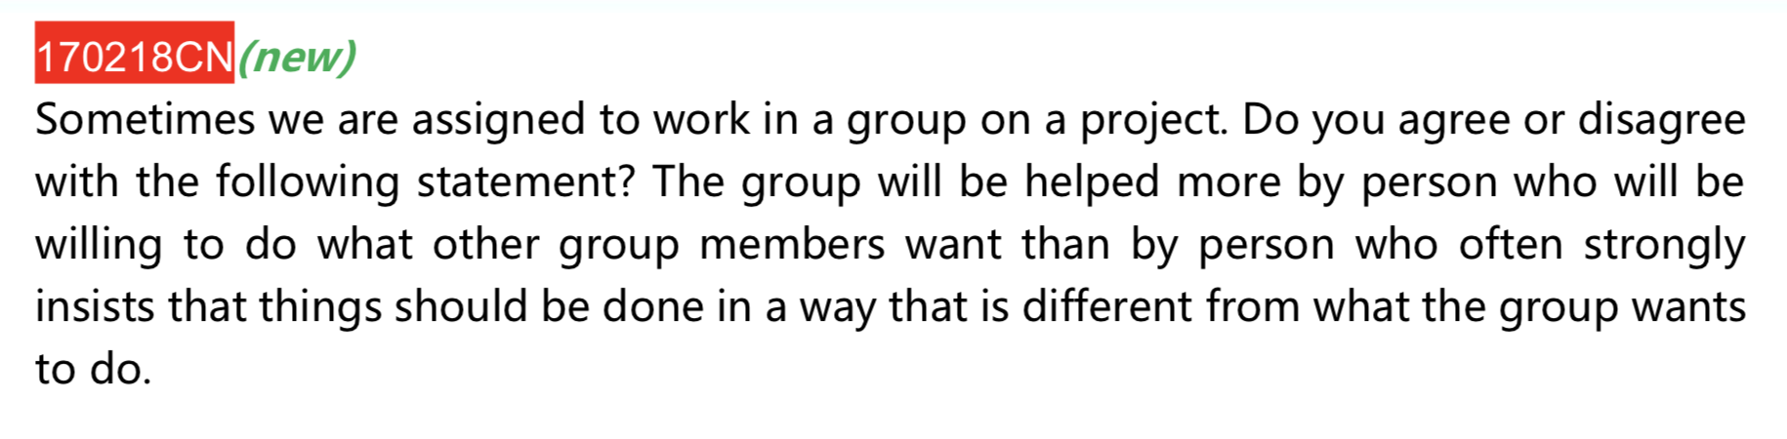

1. 效率

Higher work efficiency could be achieved if all the group members obey the whole team’s target and plan. Team cooperation occupies an indispensable position in the formation of accomplishing tasks quickly, which can be achieved by the wholehearted dedication of all members with their conflict being eliminated. Apparently, a bunch of valuable time will be saved if group members own less divergence. Therefore, they are of capacity to have more time to finish more things, this process is to enhancing efficiency what the foundation is to a skyscraper.

1. Improve their team work

Modern world values team work, which is a key to success. From my perspective, if each member agrees with the whole group’s plan, a common goal will be more likely to be built in everyone’s mind. Basically, fighting for one target contributes to a stepping stone of having a imputes to strive together. In this manner, individuals are capable of coordinate with each other perfectly since they both know what they should do with the same goal. As a result, they will have more opportunities to communicate with each other about the assignment and cope with problems together, which can improve the team work.

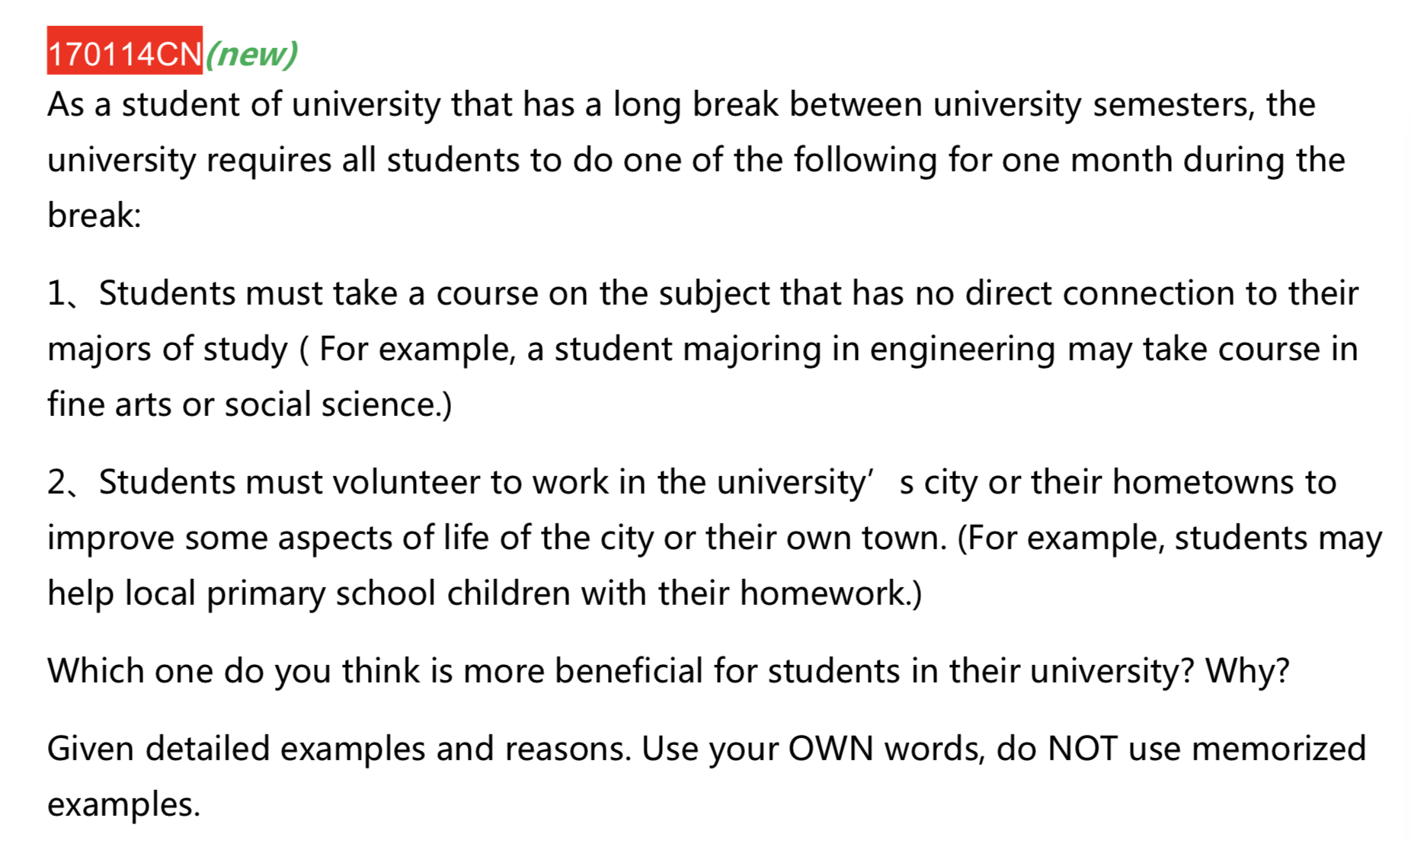

1. 交朋友take course in different subject 🡪 meet people in different fields 🡪sit next to them 🡪have more opportunities to communicate with them at recess or do some activities together, such as hanging out to watch a movie or go shopping 🡪 students are more likely to make friends with them and establish good friendship (we have to take responsibility to volunteer work so that we may not have much more energy in making friends with others)
2. 辅助性作用

Learning writing classes 🡪 provide me with a vast amount of knowledge about writing a good essay 🡪 such as making good sentences 🡪 build up a remarkably frame of article 🡪 utilize these skills in my assignment when I need to accomplish a thesis 🡪 Besides, learning music class 🡪 get to know the types of music and it’s melody🡪 when I go to the concert 🡪 I are of capacity to understand and appreciate the music played 🡪 better enjoyed this concert

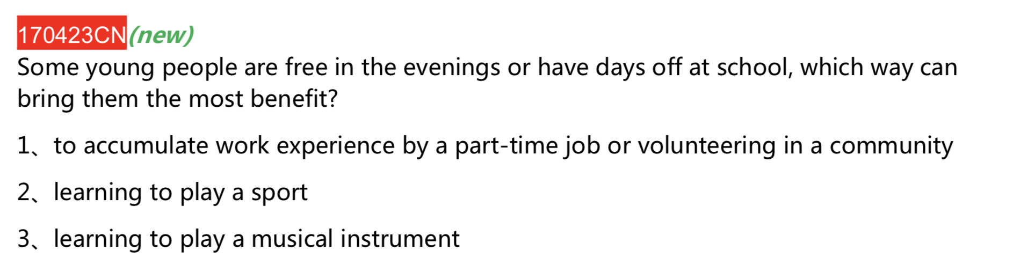社交(expend their social circle)

What we do in society such as working and fulfilling the ambitions of employment requires abundant of social resources. Part-time job 🡪 meet an increasing number of people in companies 🡪 have more opportunities to work together with them or have a lunch with them or plan to watch an NBA together🡪 communicated with them 🡪 get to know each other better 🡪 establish a good friendship

为工作打下基础

Modern world values working experience, which is the premise for promising future. Obtain a part-time job 🡪 divide working hour into many parts 🡪 make to-do list 🡪 accomplishing things in order 🡪 knowing what to do what not to do 🡪 accumulate working experience **+** are confronted with many difficulties 🡪 cooperate with their co-workers to figure out how to tackle them and obtain the solving experience of this kind of problems // participating in volunteer activities🡪 be confronted with many difficulties 🡪 come up with some approaches to tackle and cope with these problems 🡪 won’t be afraid of facing the same problems



高学历

Teachers with high educated 🡪 be proficient in one object 🡪 have good reputation 🡪 attracting more students to come to hear his or her class 🡪 students will cherish this class and listen carefully 🡪 they absorb knowledge quickly 🡪 help professor’s teaching more efficiently

kindly

Professor is kindly and warm-hearted🡪 students won’t be afraid of professor 🡪 be more willing to find professor to ask some extra questions 🡪 be more likely to understand and get to know the exact meaning of one point in the class🡪 have positive effect on students’ study

Interesting

make lots of jokes in classes 🡪 students will feel fun and laugh 🡪 keep one refreshed 🡪 prevent the feelings of boredom and tiredness 🡪 obtain the initial interest in one subject 🡪 enhance study efficiency

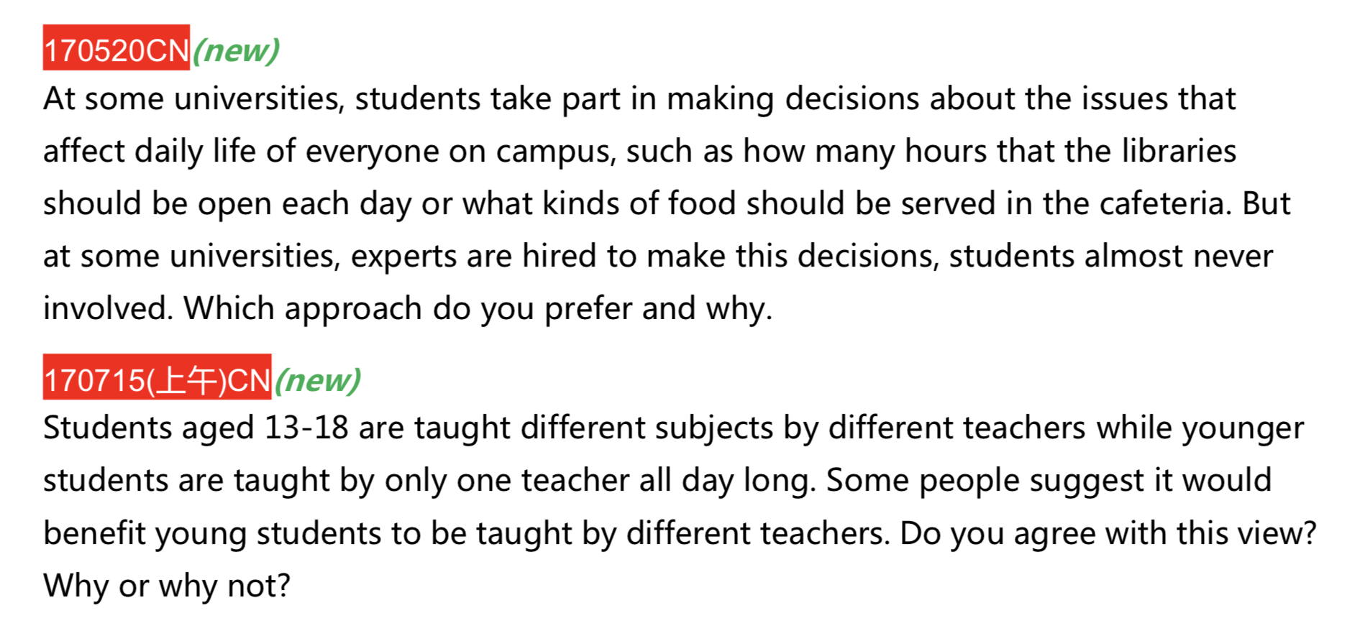

有经验

experts working many years 🡪 accumulate an increasing number of working experience 🡪 they

are proficient in this field 🡪 they know exactly what is better for students and what is not suitable for students 🡪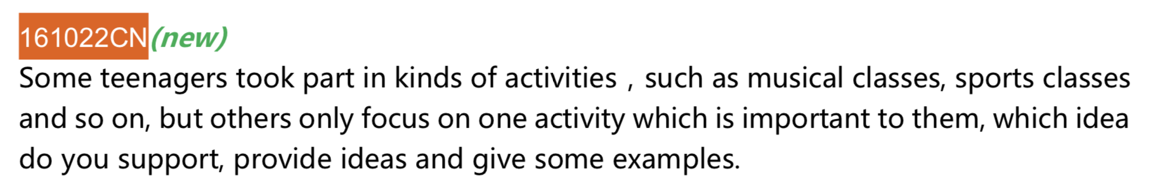 design a better plan for university

省时

Experts deciding this thing can save students time. Besides, students may not be able to take this decision seriously. Apparently, most students not even care about this kind of thing, such as evaluating teachers or make some suggestions for the students’ restaurant or stuff like this. Concrete experience can be seen in my campus life. Take me for example, when teachers or president of university asked us to evaluate the teaching style of professors, I usually click the “good” button without seeing the content that I evaluated cause a bunch of time could be saved for me to do other meaningful things. In this condition, how can we expect students devote their wholehearted to make decisions for university about some detail of daily life, like the opening hours of library and quality of food, they rather be willing to utilize this valuable time to study or hang out with their friends instead of doing something they do not really care about. Conversely, hiring an expert can help students make those decisions, which occupies an indispensable position in the formation of saving students time. Furthermore, those decision are not casual and will be beneficial for students.

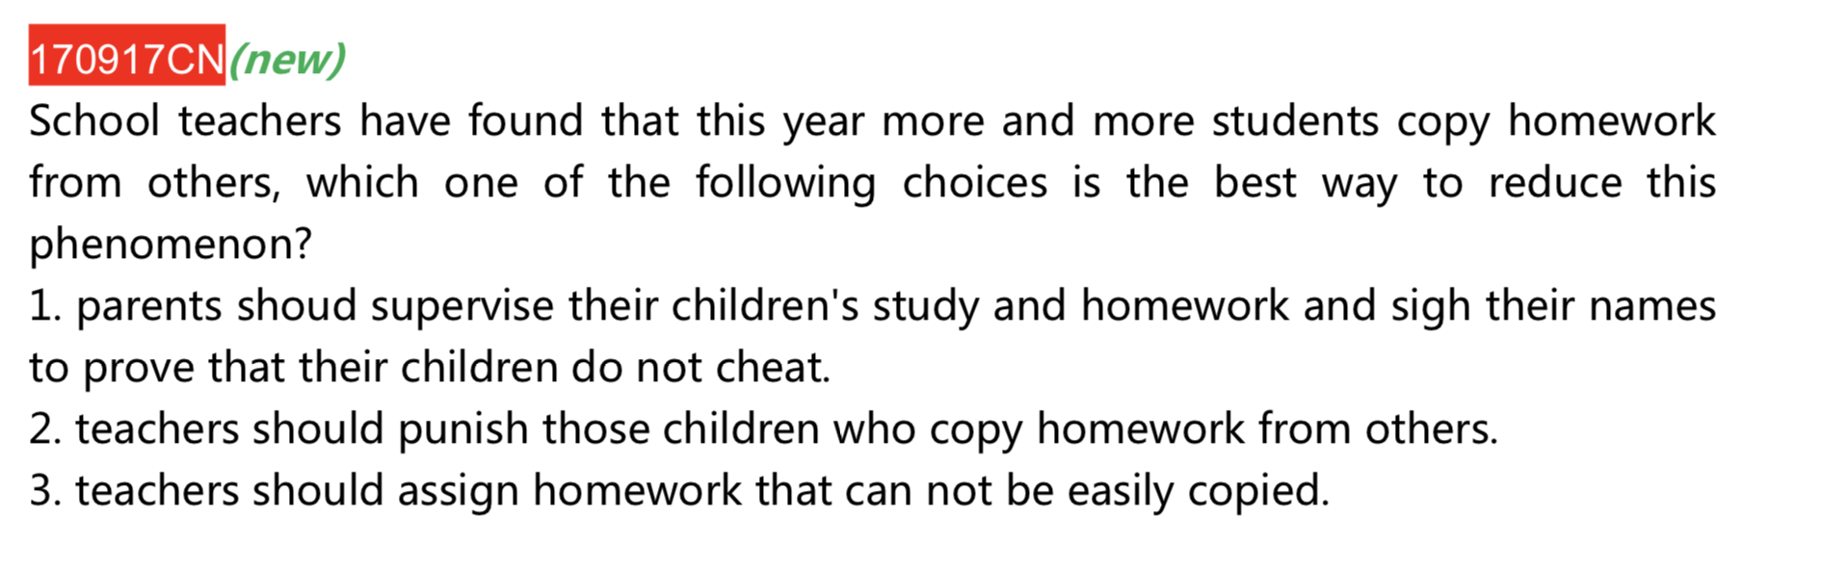

从根部解决问题

Assign home work that cannot be easily copied 🡪 starting realize that it is difficult for them to copy others’ work 🡪 students have to think it by themselves and not rely on others answer 🡪 study hard and make great effort in order to accomplish the assignment 🡪 make full use of their imagination to achieve success 🡪 no longer have the idea of copying home work in a long run.

减轻压力

not have to be supervised by their parents 🡪 no need to

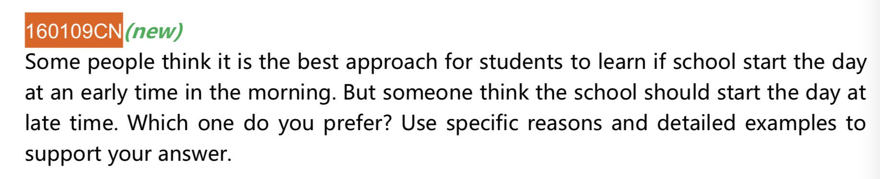

提高效率

Emphasis should be put in what has been suggest in an old saying “ A day in the morning, a year in the spring” , the first step to achieve success is to get a better plan in the morning. Get up early 🡪 have more energy and have a clear mind 🡪 have more time to make a to-do list of day 🡪 dividing studying work into many parts 🡪 doing things in order 🡪 have a clear goal in mind 🡪 give impetus to strive for it 🡪 study more efficiently 🡪 are less likely to get loss on one’s struggle roads

健康

Get up early 🡪 there is still long time before lunch 🡪they are obligate to take breakfast in morning 🡪 provide them with much more energy and nutrition 🡪 eggs can supply individuals with protein that they need every day 🡪 vegetable deliver fiber and vitamin C to people 🡪 feel refreshed 🡪 render body mechanism work properly 🡪 it is beneficial for body.

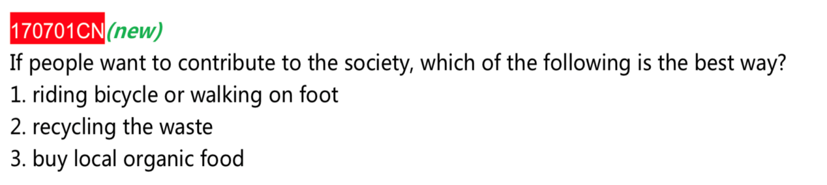

温室效应It can reduce the global warming effect. From my perspective, global warming in China’s vast places is “increasingly acute”. The environmental situation in China remains tough and serious. The current priority is to reduce the greenhouse effect. Ridding bike or walking by themselves 🡪 decrease the number of cars driving on the roads 🡪 reducing the carbon dioxide emissions 🡪 reduce the global warming effect 🡪 ameliorate air quality

锻炼身体It is not merely can people improve the air condition but individuals can also ameliorate their health condition. Ridding bike and walking by themselves 🡪 rendering their two feet move 🡪 exercising their muscle 🡪 strengthening their muscle 🡪 making blood circulation smoother 🡪 having a good mood 🡪 being less likely to get illness 🡪 being more likely to make great effort to work, which may promote social and economic development

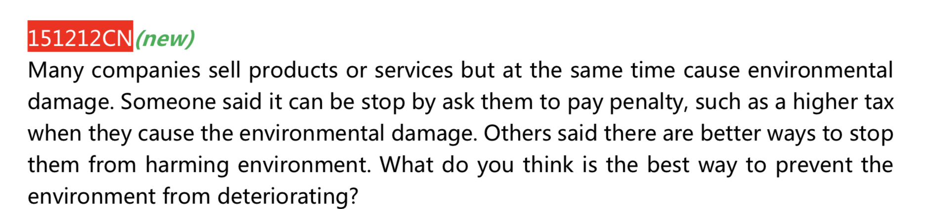

效率Enhance the efficiency of protecting the environment. As far as I am concerned, modern world values high efficiency, which is the key to improve the environmental quality quickly or rapidly. There are an increasing number of large companies pouring contaminated water or pollutant into atmosphere because there exists few laws to penal this kind of behavior and prevent these large companies form polluting the air condition. Evidently, punishing them with pay penalty 🡪 increasing company operating costs 🡪 reducing sales profit 🡪 figuring out other methods and approaches to manufacture products instead of damaging environment 🡪 take action quickly and obey the rules 🡪 enhance the efficiency

投资做别的Not merely can penal large companies which damage the environment but also can help government collect an extensive quantity of money to solve other kind of problems in order to protect the environment. Money collected from companies can be used to fund and invest an increasing population of research on developing environmentally friendly energy, such as wind energy or solar energy. Using this energy in private cars instead of using gasoline 🡪 reduce the carbon dioxide emissions 🡪 reduce the proportion of harmful pollutant in atmosphere such as PM2.5 and so on 🡪 declining the global warming effect 🡪 protect the environment

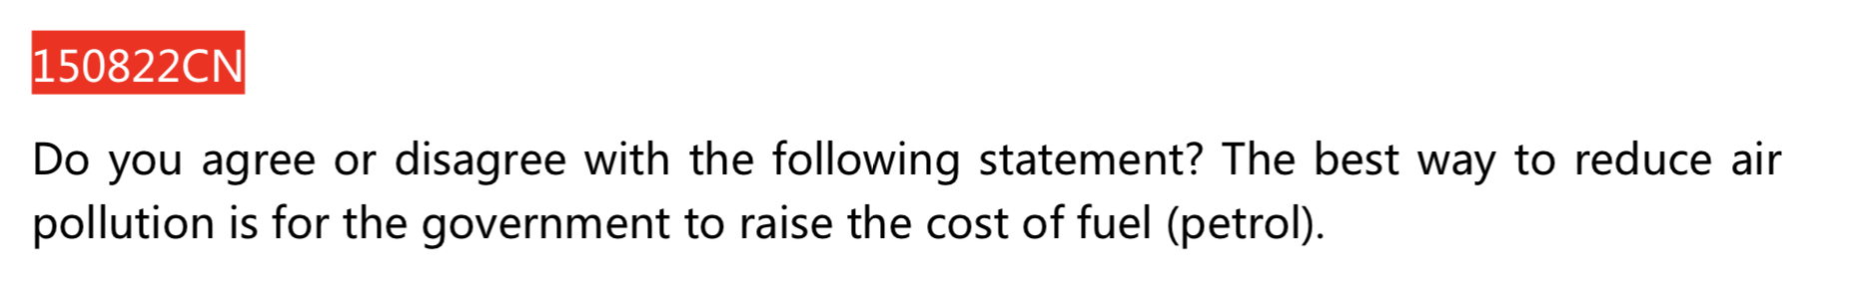

There will be fewer cars driving on the roads 🡪 decrease the carbon dioxide emissions 🡪 improving the air condition 🡪 reducing the global warming effect

受众面广Planting trees 🡪 absorbing carbon dioxide and convert them into oxygen 🡪 improving air quality , Besides, everyone having abilities to make great effort to grow trees 🡪 they just have to plant the trees’ seeds into the soil 🡪 watering them caring for them involve a vast amount of citizens 🡪 having possibilities to plant a big tree in front of their house or garden

效率 enforce laws to punish people who make damage to the environment with fine 🡪 enhance the efficiency of working 🡪 fining people 🡪 increase their product costs 🡪 decrease their profit and interests 🡪 figure out other methods and approaches to cope with problems 🡪 take action 🡪 ameliorate the efficiency

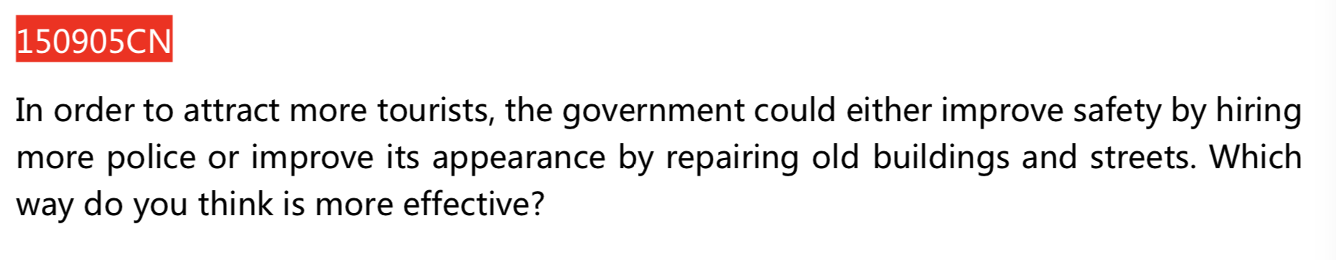

马斯洛原理

效率

Hiring more police individuals 🡪 obtaining training and working experience 🡪 acquiring a vast amount of knowledge about saving skills and methods of copping with dangerous situation 🡪 knowing exactly what they are obligated to do and what they should not to do to protect visitors 🡪 government people only needing to divide police people into many groups and distributing then into specific places 🡪 providing civilians with strong security quickly

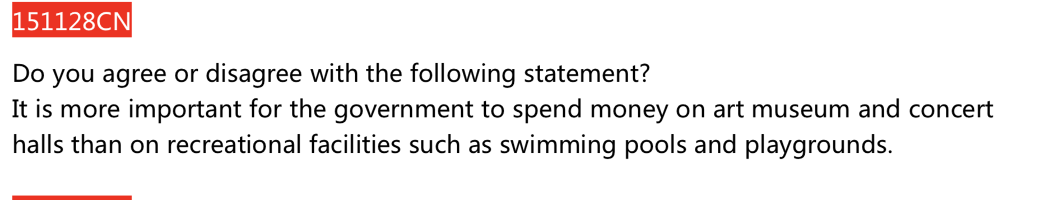

社交

受众面广

锻炼身体

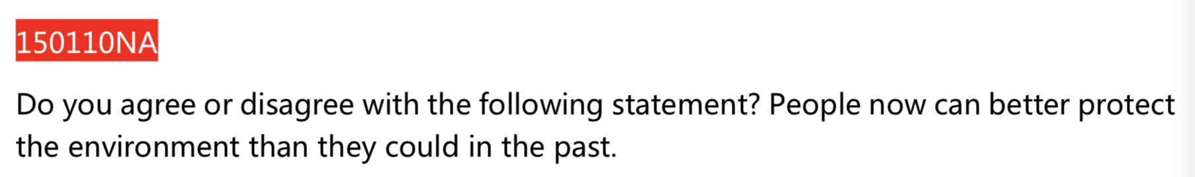

科技发达With the technological advances, the world is progressing at an unprecedented pace so is the standard of citizen’s life. Inventors can make full use their imagination and effort to create an increasing number of convenient technologies. Advanced inventions such as air purifier 🡪 absorbing carbon dioxide in atmosphere and convert them into oxygen and pouring them into air🡪 they can also absorbing an extensive quantity of tiny particles 🡪 people are more likely to acquire a vast amount of knowledge on how to use it 🡪 decreasing the proportion of harmful pollutants in atmosphere such as PM2.5 and PM10 and so on 🡪 improve the air condition. Conversely, citizens even did not know what air purifier is, not to mention the methods and the knowledge that they can obtain.

意识提高environmental situation is severe so that people’s awareness of protecting environment has increased.

The global warming in China’s vast areas is “increasingly acute”. The environment situation in China remains serious and tough. The current priority for government is to cope with and tackle the problem of global warming and greenhouse effect. Global warming 🡪 increase the temperatures in China 🡪 iceberg starting to melt 🡪 increasing the sea and oceanic level 🡪 causing frequently flood 🡪 endangering people’s life 🡪 increasing their awareness of protecting environment 🡪 take action quickly

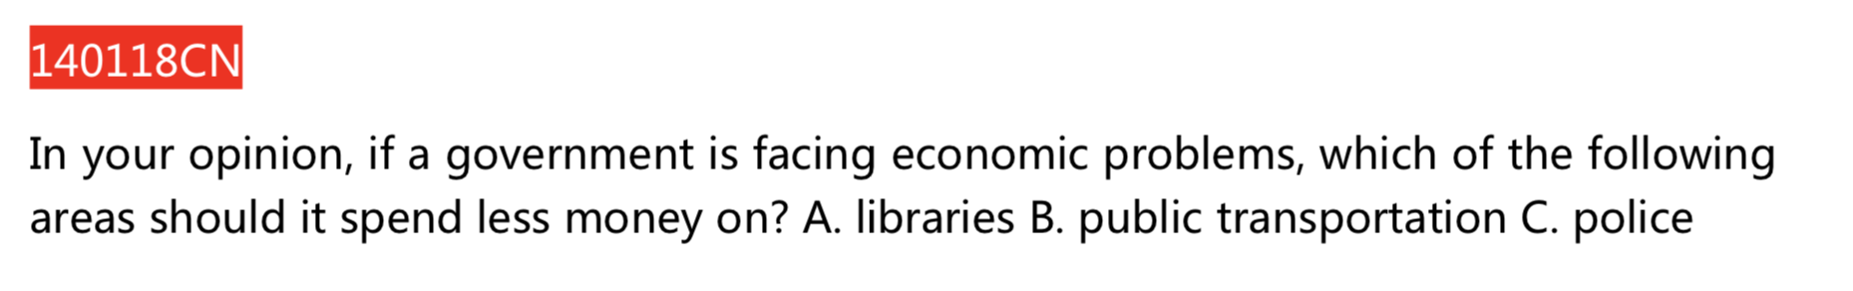

马斯洛原理

受众面少

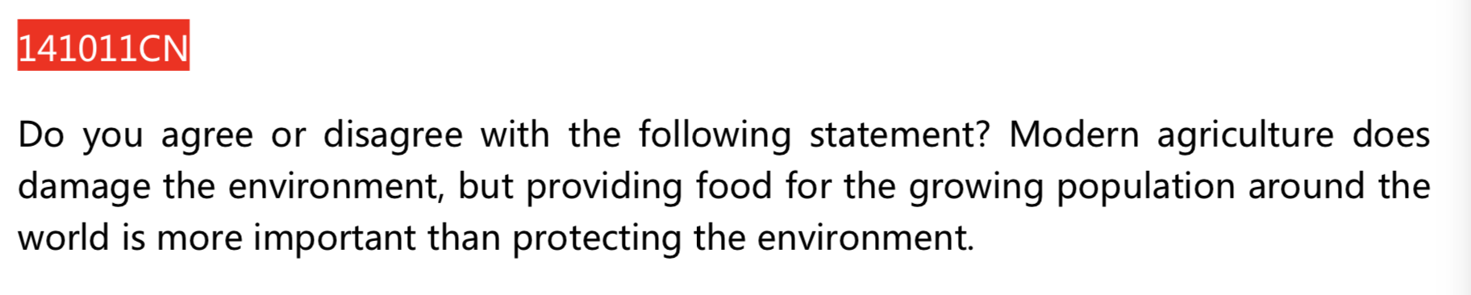

温室效应 –》淹没种植的土壤

**Improve health condition more efficiently .**

**锻炼，吸收新鲜空气 –》 提高身体免疫力**

**食物满足日常所需**

科技类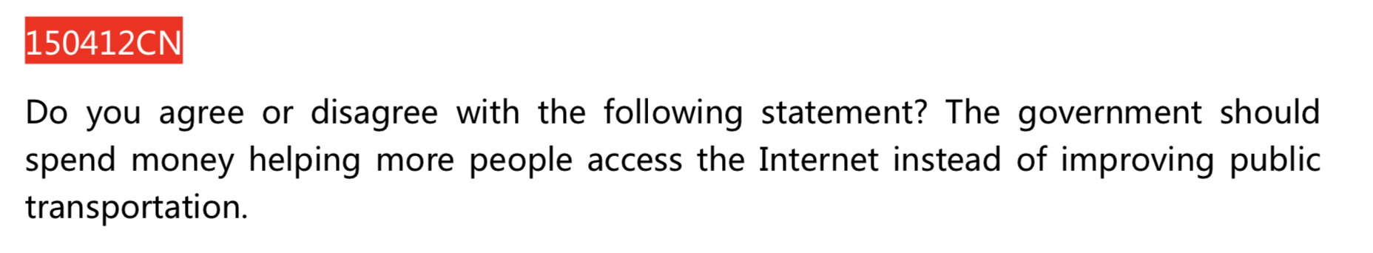

高效 enhance their efficiency

Improving internet 🡪 more people can use the internet 🡪 input some key words into searching engine of computer 🡪 the result will be listed on the screen immediately 🡪just pick up the information they need 🡪 help civilians save their time 🡪 using the saving time to do other meaningful matters 🡪 enhance their efficiency of studying

扩大朋友圈 expand their social circle

More people have opportunities to approach the internet 🡪 have more chance to utilize the WeChat and other social APP 🡪 chatting with some people on the internet 🡪 ameliorate their communicative skills 🡪 be more likely to participate in some outdoor activities 🡪 make more friends

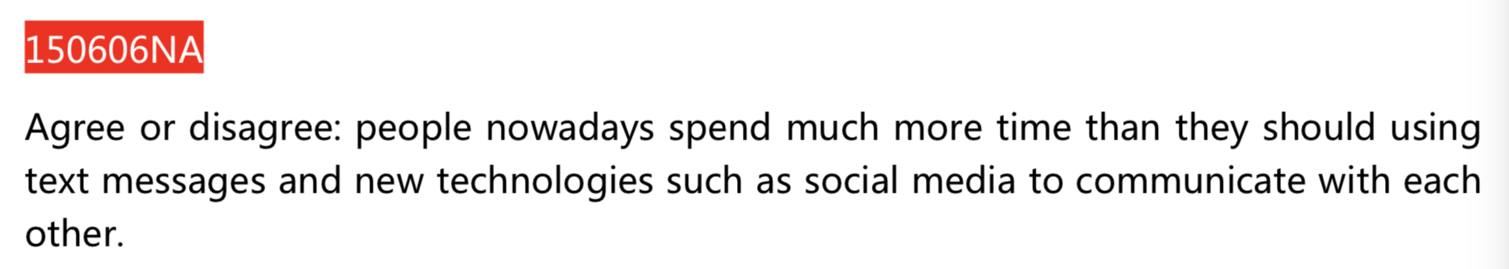

同意：

扩大朋友圈 expands their social circle

Utilize social media and text message 🡪 have more opportunities to approach WeChat or other social App 🡪 chatting with others 🡪 ameliorate their communicative skills 🡪 be more likely to participate in some outdoor activities 🡪 make an increasing number of friends 🡪 enlarge their social circle

高效 enhance their efficiency

Using text message and other social media 🡪 only have to input some words and type the words that civilians want to say 🡪 save time 🡪 exploit this time to do other meaningful things 🡪 enhance their efficiency

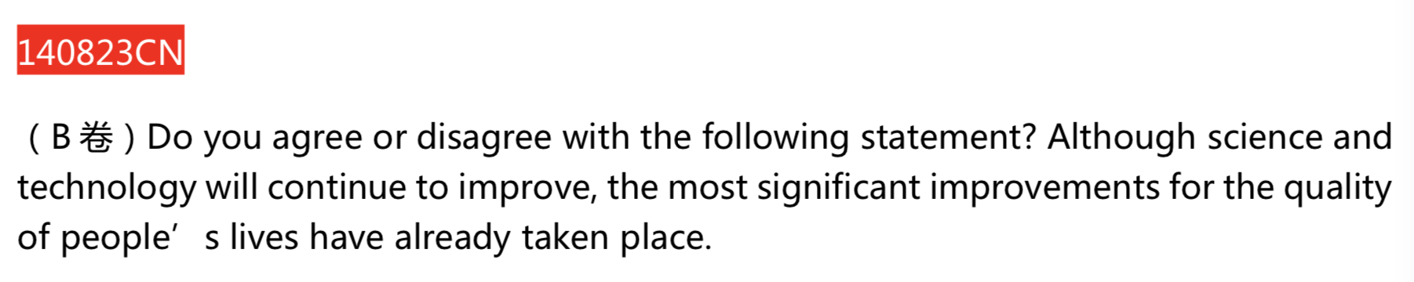

不同意

环境污染

Global warming in China’s vast areas is “increasingly acute”. The environmental situation in China remains tough and serious. the current priority of government is to reduce the green house effect. Increasing number of people drive cars on the road 🡪 increase the carbon dioxide emission 🡪 increase the world’s temperature 🡪 cause the green house effect

身体健康衰退

Technologies have been improved 🡪have more opportunities to utilize the internet to communicate with others 🡪 less likely to go outside to breath some air and do some exercise 🡪 get less chance to strengthen their muscles 🡪 blood circulation will be less smoothed 🡪 heath condition will deteriorate

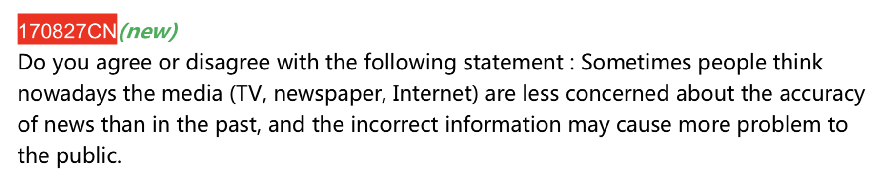媒体类

同意

The technologies have been improved 🡪 people are burdened with much more pressure than before 🡪 they will spear no efforts to earn money in order to live a decent life whatever it takes 🡪 produce some unreal news to attract people 🡪 citizens will obtain this incorrect information and do some extremely unbelievable things. An illustrating example is my sister’s experience. She loved an actress named Yangmi. One day, an unbelievable news, said that Yang mi died because of the heart disease, has been spread out. My sister heard this news and felt sorrow and became crazy about it and then she jumped from a high building! But after a while, Yangmi’s official studio stood out and made announcement that this information was incorrect. Fortunately, my sister was eventually rescued.

Getting disease 🡪 looking for medical treatment on the internet or TV 🡪 get the wrong information such as being offered with the wrong medicines 🡪 eating the incorrect prescription 🡪 the medicine dose not respond to the body or aggravates the condition 🡪 exerts bad effect to patients’ body

In universities, people tend to concern more about the career prospect of the subjects they learn. Some people propose that students should learn subjects with a fast job growth including math, science, technology, and engineering even if they are interested in other subjects. Do you agree or disagree?

Disagree

Interest is more important in one’s struggle road. From my perspective, emphasis should be put on what has been suggested in an old saying: ”interest is the best teacher”. Evidently, the primarily step toward success is to have emotional preference, which is the impetus to study. In addition, being interested in one thing is to keeping one refreshed what the foundation is to a skyscraper. In this manner, it is of capacity to assist people to get rid of boredom and tiredness. As a result, they can gain the initiative in learning and do better in this field. Concrete example can be seen in our daily life, take my brother as an example, he used be admitted to peaking university to study computer science. However, he was inclined with history and not get much interested in the coding field even though computer science can provide him with more job opportunities and has a better prospect. He followed his heart to choose the subject as history and was willing to make great effort in history field. He listened every history classes carefully and always go to the office hour of his professors to ask some questions, since he loved it and finally, he got A in all classes and be hired as a good position in a history company nowadays.

Be more responsible for this subject. In my opinion, a great sense of responsibility is of great necessity for success people. Needless to say, if a person truly be interested in one field, they would like to devote their wholehearted into this subject, which means that they will be more responsible in that area. In addition, success cannot readily be achieved by oneself, she or he may need some helps from others. Furthermore, patience must be paid along the road to success. In this manner, if people are responsible for their team members or co-workers, the whole team will be more likely to work together and coordinate with each other perfectly to win the final fight instead of breaking up.

Professor should prohibit the use of devices that can connect to the internet in class.

Agree

Students being distracted in class. As far as I know, with the rapid technological advances, the world is progressing on an unprecedented pace. As a result, the internet will be more likely to be utilized by some companies to take their advertisement about their product to attract potential customers. Provided teachers allow students bring their laptop to the class, students will see some small window with some advertisements popped from the bottom of the computer screen. In this manner, they must pay some attention to these ads, which includes some amazing computer games, international news and some interesting videos, if students get interested in them, they can’t help clicking in. As a result, they may not be able to listen to the class carefully and will miss some important points and knowledge since they are distracted from those things.

Doing harm to their eye. In my opinion, the computer screen will harm students’ eye and render them nearsighted if they staring it for a long time. It is due to being concentrated highly on computer during the class that eyes being absorbed lots of radiation, which is bad to our eyes. Nearsighted is not conducive to something individuals do, like seeing 3D movie and watching some football games or reading some important documents and so on. Bring computer to the class will accelerate the process of increasing the time students seeing the screen of computer. This may increase the risk of being nearsighted and bring inconvenience to their future life.

Some lessons for young students （5~8 years old）increase their interest to learn，including video games. But some people believe it will distract young students.

It will distract young students.

Being abstracted by some fantasy advertisements. From my perspective, with the rapid technological advances, the world is progressing at an unprecedented pace. Evidently, the internet will be utilized by an increasing number of companies to take their advertisements to attract their potential customers. During the process of playing the video games, they will definitely see some small windows with advertisements popped out from the bottom screen of the computer, which includes some smart-designed plot and interesting parts of movie and so on. However, 5-8 children are not likely to have strong awareness and self-discipline and when they pay some attention to these advertisements, they can’t help clicking in due to those weak awareness and strong curiosity.

Secondly, some social chatting also distracts them. In my opinion, 5-8 year old kids are in the exact period that play with their friends and use some social apps to have fun or connect with their friends. Those apps, such as Wechat or Facebook or Message, is to distracting them what the foundation is to s skyscraper. It is associated with seeing some massage reminder that render students convert their attention from video games into those connection with their friends. In addition, once they communicate with their friends in computer, it is merely impossible for them to stop, their vast topics can go from sports to movie, from games to dressing and stuff like this, which will accelerate the process of forgetting about the video games they played and learned.

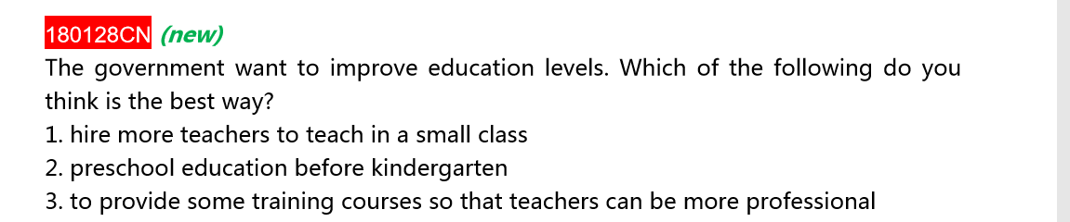

选3

1. More efficiently

Hire an expert to lead a training curriculum 🡪 there must be some reasons for them to be called “expert” 🡪 possess many years of experience 🡪 be proficient in this field or did some research and collect a vast amount of data in this aspect 🡪 knowing what is the best teaching style for most students and how much homework is appropriated for students or even what project difficulty is the best for students 🡪 educate this information they learned for many years to teachers 🡪 save teachers a bunch of time and learned these stuffs directly

1. B possesses some preponderances in consistence in teaching field. Those teachers, who took the same training, will utilize the same teaching style that easy for students to follow. However, if they hire more teachers in a small class, the students in that course will be disorient and discombobulated cause some teachers exploit one way to let students study in this class while others render students harness another approach to study, they do not know which to follow.
2. Be burdened with much more pressure for children.

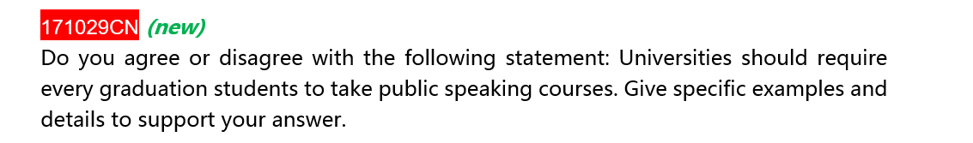

1. Lay a solid foundation for their future career

Taking public speaking courses 🡪 acquire a vast amount of knowledge of presentation 🡪 like how to overcome tension and how to write the sketch of the speech and what stuffs we should pay attention to when we take the presentation🡪 we can utilize those skills in our future career or internship. For example, 讲公司老板让我描述公司产品

1. Make abundant new friends

Friendship, which provides the greatest promoting in our life and study, needs to be set up when we are in the university. Taking public speaking when we are going to graduate 🡪 be offered with more opportunities to meet lots of graduation students in other department, such us physics department, art department and history department. Sitting side by side 🡪 communicate with each other during the interval of the class or cooperate with each other when we be assigned as a group to accomplish a project in speech curriculum. Conversely, if restricted in own world, we will only get along with small range of friends who share the same knowledge and skills. When we encounter difficulties in our future career, it is merely impossible for me to work and coordinate with them. Therefore, for the sake of future development, it is better for school to render graduation students from all departments take the speech course together.

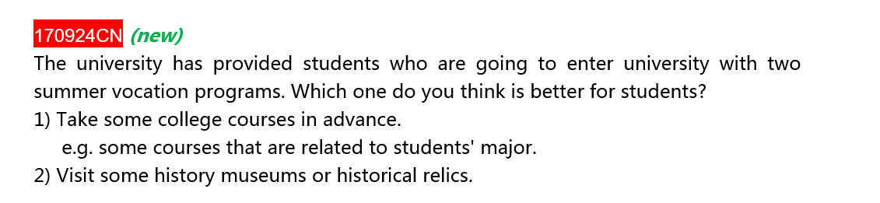

选第一个

* 1. Bring premise for their future academic.

Taking some courses related to their subject in advance 🡪 acquire some prerequisite knowledge in advance 🡪 be confronted with the problem in this field 🡪 possess more chance to figure out the solution 🡪 knowing some background of their major --. Easy to understand some theories professor talked about 🡪 combine this ability with their hard-working 🡪 are more likely to obtain a good grade in their academic performance.

For example,

* 1. making more friends in the same major

friendship, which provides the greatest promoting in our life and study, needs to be set up when we are in the university 🡪 taking courses linked with their major 🡪 is the exact way that offer chances for students to meet abundant people who studied in the same field 🡪 sitting next to them 🡪 having conversation with them 🡪 exchange their ideas and experience or even add friends in Facebook or Instagram 🡪 get to know each other better 🡪 make friends with each other before this new semester. Conversely, it is less likely that a student can get along with another student when the students in the university to have a tour in that place as a whole 🡪 you are more likely to stand with a student studying in other major when you stop to appreciate a history relic. It is merely impossible for you to study or accomplish a group project with them, for the sake of future academic, it is better to let the students participate in the courses related to their major

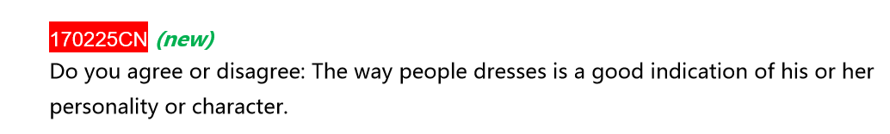

同意



同意

1. white lie

people may sometimes tell white lie to their friends 🡪 when you are confronted with the situation that it is difficult for you to tell the truth of one thing to your friends because you know that the truth will break your friends’ heart, probably, a white lie will be chosen to be told to your friends

1. Everyone has their own secret

Everyone has their own secret, I have secret too. Sometimes, I just want to hide these thing in the bottom of my heart instead of speaking out all the things to my close friends. I will be afraid of being laughed at. Besides, not merely a person needs to keep their secret but also be required to keep others’ secrets, which is the fundamental principle of being a human, especially when others wish you not communicate this thing with others or inform others. In this manner, when you friends ask me about a secret I know but they do not understand but they want to figure out the fact, I am obligation to lie to them that I do not get to know this things either to protect this mystery stuff.

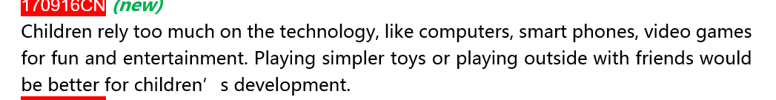

同意

1. Feel relaxed

playing outside with their friends 🡪 do many activities together 🡪 such as going shopping together and riding bicycle go hiking and running to chase each other 🡪 sharing many interesting thing with each other during the process of playing 🡪 forgetting some problems in their school 🡪 ameliorate their mood 🡪 relieve their pressure. For example,

1. Being good to their physical health

Children are unfavorable to play computer games or utilizing technologies for a long time, which will pose an adverse effect on normal development, especially eyesight. It is common knowledge that a vast amount of radiation will me emitted from the computer screen. Staring at these technologies for a long time 🡪 eyes will feel tired and dry 🡪 be more likely to become optical people with nearsighted, which is inconvenience for children in their life and study



Entertainment

1. Easy to be distracted by TV programs.

From my perspective, with the acceleration of technological development, the world is progressing at an unprecedented pace, it is common knowledge that an increasing number of commercial companies are utilizing TV to post their advertisement to attract potential customer nowadays. It is associated with such phenomenon that we are likely to be distracted by these advertisement because these ads may be inserted to the TV programes while we learning. Needless to say, some of them may catch my eye and it may interrupt my thinking about a problem before and I probably be willing to convert my attention from study to the stuff it advertised. As a result I cannot be concentrated on acquiring knowledge from TV and it is difficult for me to keep mine mind in learning either. For example

1. Abundant resources on TV prorammes to entertain

Lots of resources can be reached to have fun during the process of taking a break 🡪 like some serious movies. Some movie is food for thought. Like serious movie. It can provide you with a perfect condition to figure out who is the murder or what is the purpose for he or she killed that man or whether the secret will be exposed or be found out. Evidently viewers will feel so excited and think or analyze the streamline of the episode and features of each person to guess who might be the killer. Forget their problems in their life 🡪 feel happy end enjoy this film 🡪 good medium for entertainment