Both the lecture and the reading discuss whether___. The lecture claims that The three theories are not convinced. ， which disproves the opinion of the reading passage.

To begin with, The speaker announces that by asserting that if it is residential house, there will be many people live there and there are hundreds of fire place to cook, but there is only a few cooking tools. so it is not a residential house. (she believes that) All the mentioned evidence can be used by the speaker to refute what the writer presents in the reading passage.(that阅读对应的内容)

Furthermore, The speaker points out that there is no trees around the building, so it can not maintain the food or make meals to individuals. , which can weaken the reasoning and statement of the reading material.(that阅读对应的内容)

In addition, The speaker argues that the most material of the building is made of stain and stone, and they are not useful for the ceremonial. The counterpart of the reading is strongly questioned. (that阅读对应的内容)

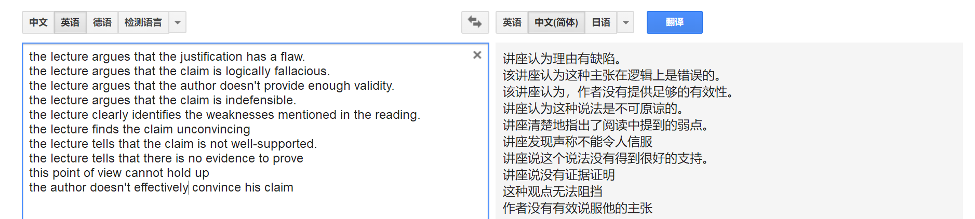

Both the reading and the lecture discuss whether __. The speaker claimes that , which disprove the opinion of the reading material.

Initially, the speaker announced that , all the mentioned evidence can be used to refute what the writer presents in the reading material.

Secondly, the speaker argued that , investigating the evidence of the reading, the lecture cast doubts, ,which weakened the reasoning and statements of the reading material.

In addition, the speaker points out that , the counterpart of the passage

表态度句型：

However, the lecture argues that the justification had a flaw/ a weak link.

However, the lecture argues that the claims is logically fallacious.

However, the lecture argues that the author does not provide enough validity/inaccuracy.

However, the lecture argues that the claim is indefensible.

However, the lecture clearly identifies the weaknesses mentioned in the reading.

However, the lecture finds the claim unconvincing.

However, the lecture tells that the claim is not well-supported.

However, the lecture tells that there is no evidence to prove.

However, the lecture argues that this point of view cannot hold up.

However, the lecture argues that the author does not effectively convince his claim.

小作文 缩写积累：

Chem 化学 chemical

Dama damage

Nec necessary