原因，举例，对比，假设

举例：已经发生了的事情，大量的细节

明确对比

每一段都要有对比

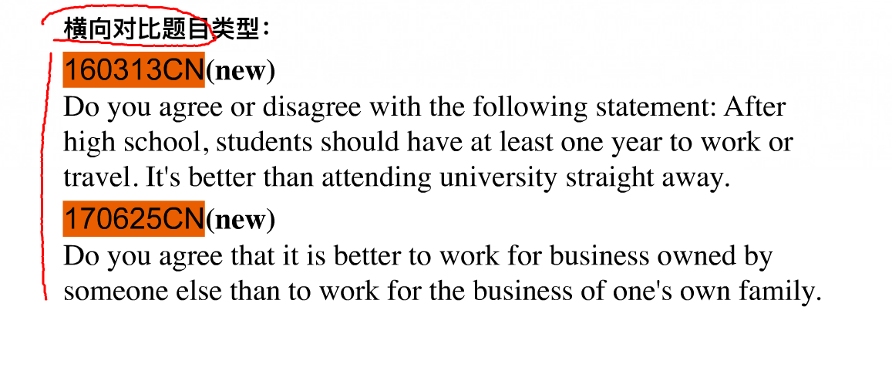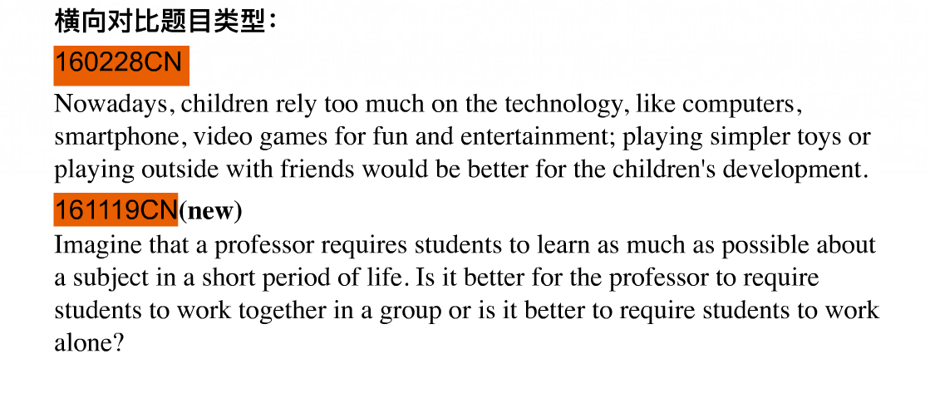两个不同主体在同一方向的对比，横向对比

纵向对比：同一主题在不同时间的对比

横向对比有明确观点，问你同不同意

二选一没有观点，让你自己选一个

听力

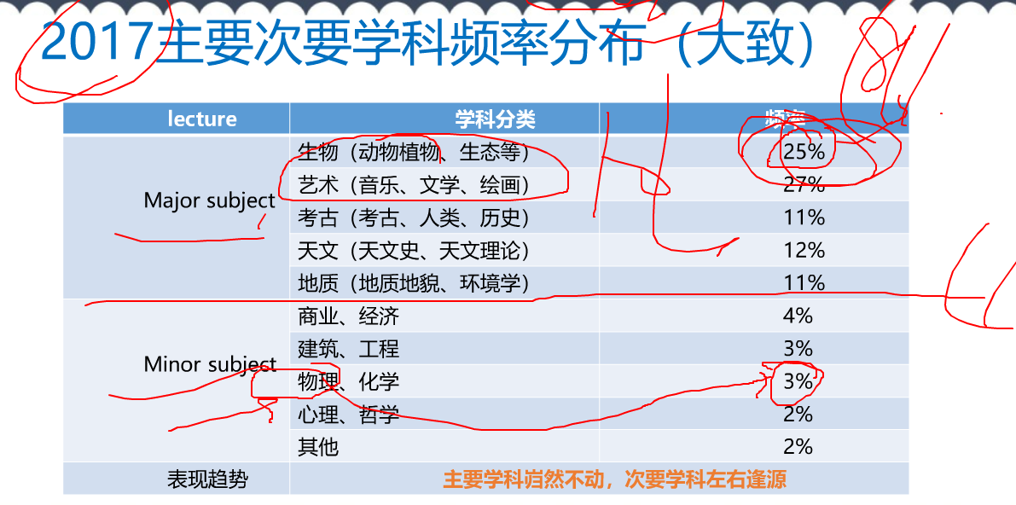

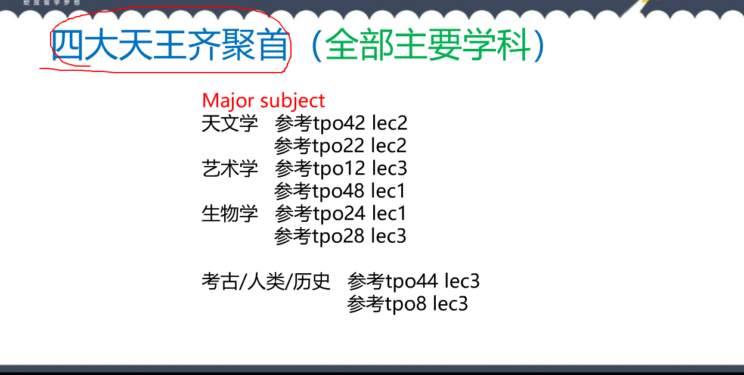

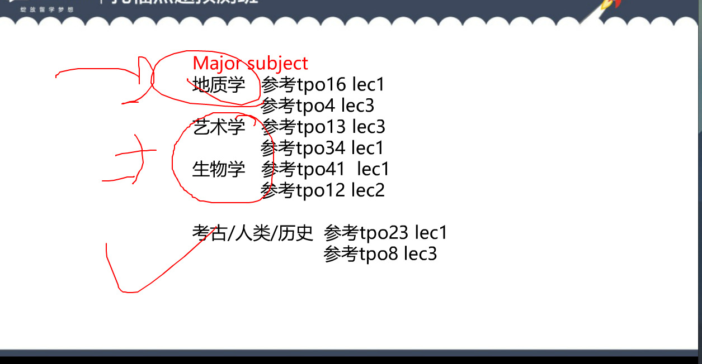

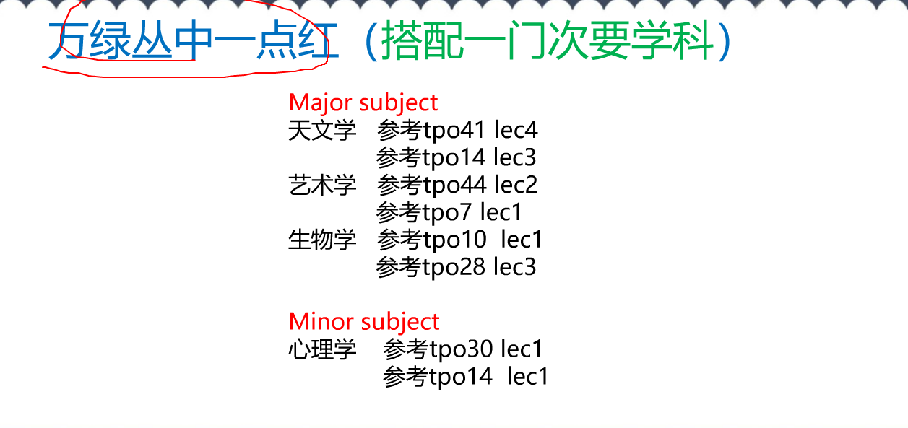

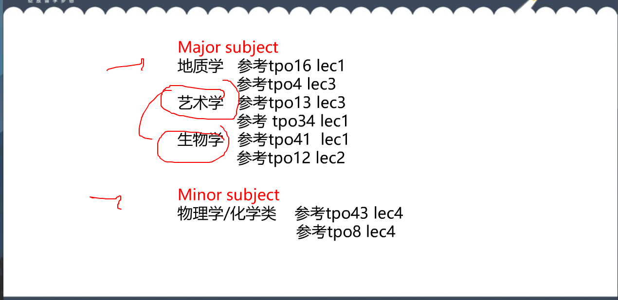

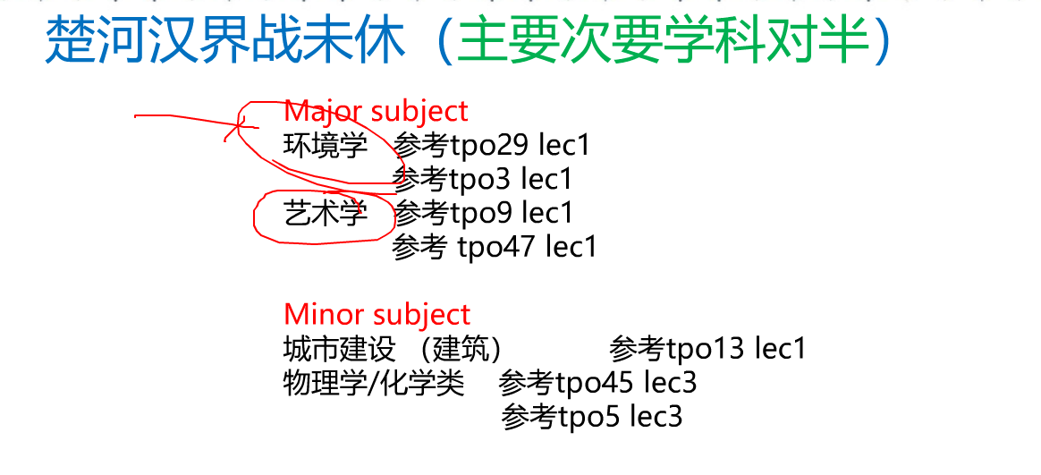

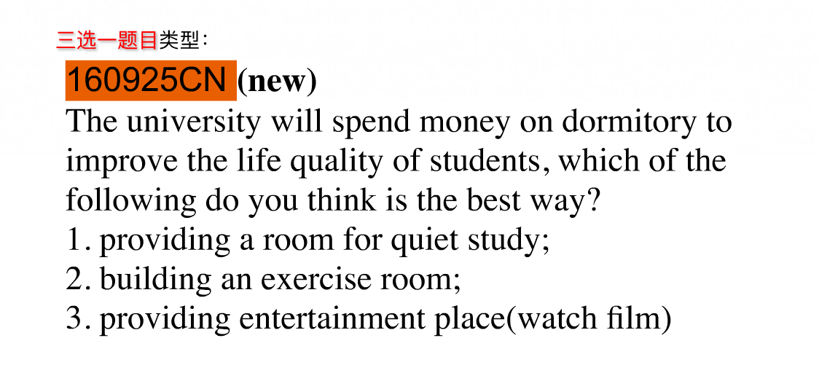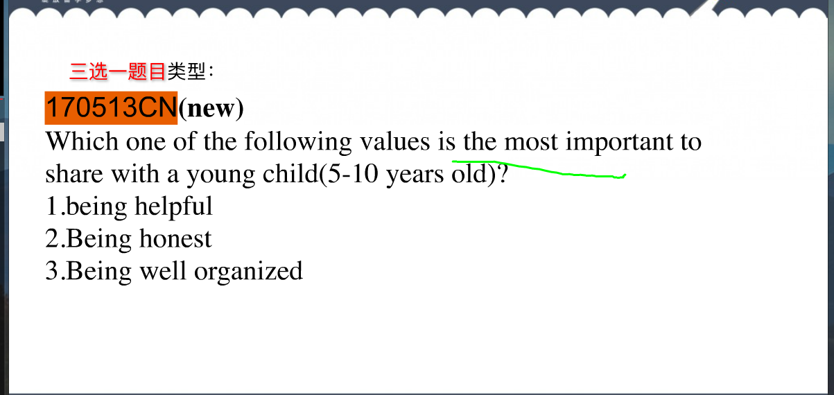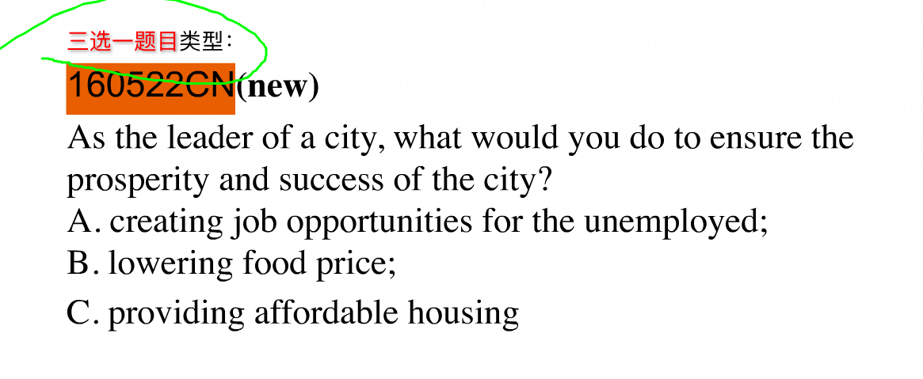

三选一做排序：最不喜欢—》其次—》 最喜欢

1. 》 B –》C

A的缺点， B比A好 B的缺点， C最好，C的优点

University professor : have more chances to get to know young people

Have decent salary and job

Secondly 🡪 on top of that

扩展： 对比+具体数字

罗列细节，5个最好

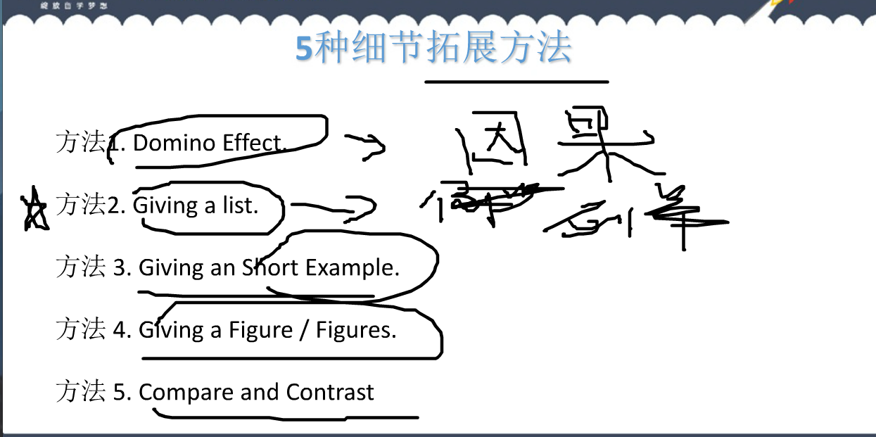

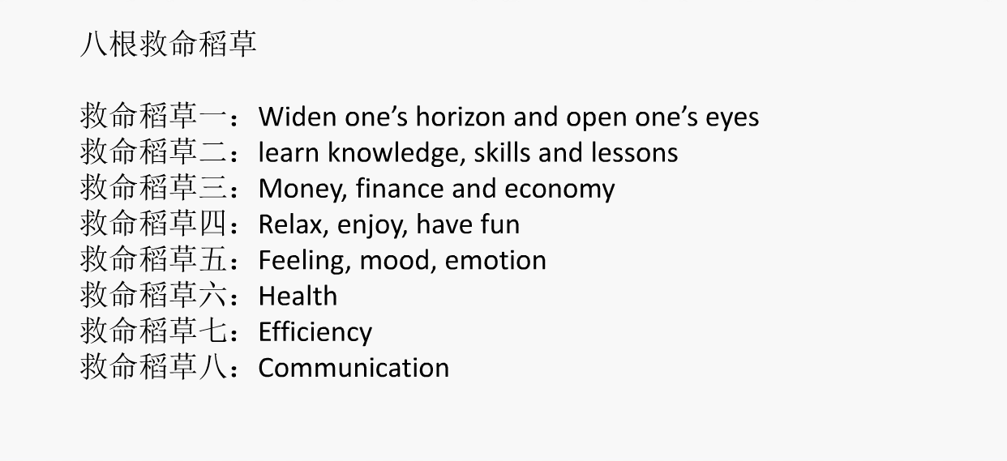

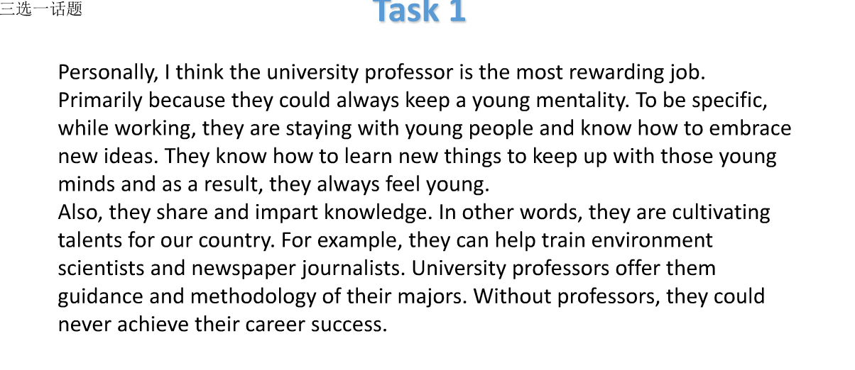

Musician：Jay chou some lyric of his songs are filled with antigovernment, sex, violent, blood or murder, which may exert bad influence to teenagers.

Artist

Actor

Relax

I feel like I am rewarded with feel-good hormone that changes how we look at ourselves and people around us.

Health

Breath the fresh air

Kip fit

Purify the air

Avoid diseases like: lung issues cough fever flue

Professional social connection

I can upload some resume on these online job searching website.

