
Information Flow Diagram
HOT Architecture Documentation

This document provides an overview of an information flow diagram, then digs into the mechanics of creating one in LibreOffice. For a general overview of the technical documentation approach for HOT, check out the technical documentation Wiki at https://github.com/hotosm/techdoc/wiki.
When it comes to solution architecture, an information flow diagram is a simple design view to depict the data movement aspect of any architecture. The goal of an information flow is to provide an approach for understanding a solution architecture. An information flow is often modeled using a block diagram (“boxes and lines”).
Table of Contents
Information Flow Diagram HOT Architecture Documentation 1
What is an information flow model? 1
Boxes and Lines 2
Elements of the diagram! 2
Some Tips 3
Drawing with LibreOffice 3
Getting Started 3
Page Setup 4
Connecting Components 4
Clean Up 5

What is an information flow model?
From our friends at Wikipedia:
The main purpose of an information flow diagram (IFD) is so that sources that send and receive information can be displayed neatly and analyzed. This allows viewers to see the forwarding of information and the analysis of different situations. The creation of an IFD is, in most cases, the first step in information analysis. IFDs are used to:

- Develop a high level overview of the flow of information in an organization.
- Highlight detailed flows in an individual task.
- Describe the flow of information inside and around organizations and between departments.
- Understand business process bottlenecks in sequential, deferred, real-time, parallel, wheel, one-to-many, many-to-many and many-to-one-to-many information flows.
We use Information Flows to capture the components within an architecture where data is at rest (stored) and the flows of information between those components.

Boxes and Lines
Given the high level of abstraction for an information flow diagram, we model it using “boxes and lines”. Each block is labeled with the name of a component and the flow of information is depicted with a line. Arrowheads on the line indicate the direction of flow. These lines are labeled with the specific information flowing.
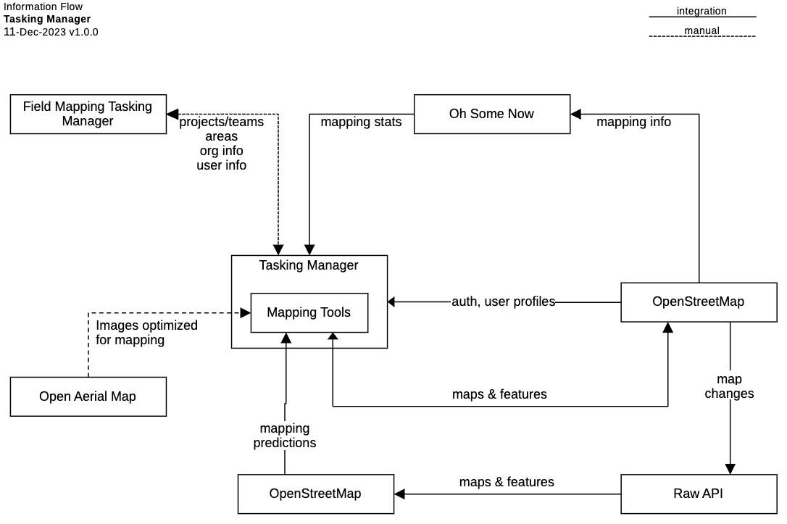

Elements of the diagram!
Here is a quick review of how to think about each element on the diagram:
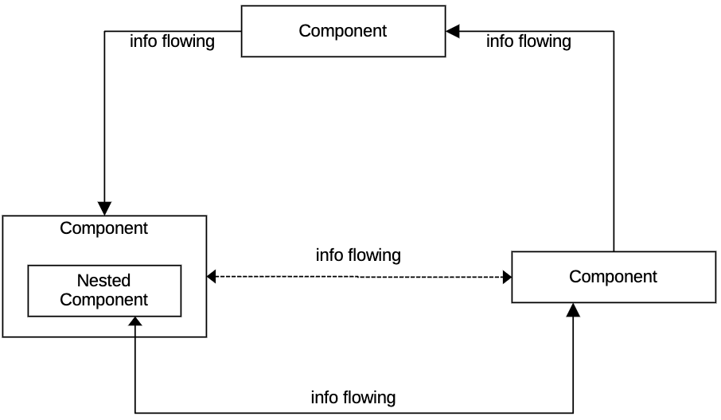
- Each rectangular box is called a component. For our purposes, a component is any place in the architecture where information “rests”.
  - A component can be nested inside another. This is helpful when information flows both from a component and from a nested component within the other component.
- Each line with an arrow indicates the direction of information flow between components. Use dotted lines for manual flow and solid lines for integrated flow.
- A label on the line provides a high-level description of the information that is flowing.
- Use the UML Note shape during drafting to capture open questions and when publishing to provide clarifications. Try to use sparingly on published diagrams.
- Use bounding boxes (with dotted borders), swimlanes, or page placement to add additional dimensions, group together components, or indicate Information Hubs (see “Some Tips”).

Some Tips
Before we get started on the mechanics, here are a few tips:
- Including information hubs can hide where the data is actually flowing. Try using one of these strategies to manage information hubs:
  - Leave them off! If an information hub is always used to move data, add it as a “global” note near the title of the diagram.
  - Use a labeled bounding box (with a dotted border) to indicate which components use the information hub.
  - Use a note attached to a component to identify the information hub used.
- Focus on the primary objective of the interaction instead of any back and forth “conversation” between compenents.
- Keep flow descriptions as high level as possible and use adjectives to make sure information labels are mutually exclusive.
- Keep all the boxes the same size. It makes your diagram look cleaner and more professional.
- Align boxes vertically and horizontally as much as feasible. It makes your diagram look cleaner and more professional.

Drawing with LibreOffice

Getting Started
This assumes you know how to use LibreOffice Draw and provides additional guidance to help you create this specific diagram in LibreOffice. Please checkout these resources to learn more about using LibreOffice:
- https://www.libreoffice.org/get-help/install-howto/
- https://documentation.libreoffice.org/
- https://documentation.libreoffice.org/assets/Uploads/Documentation/en/DG7.5/DG75-DrawGuide.pdf
- https://help.libreoffice.org/latest
It is also often quickest to grab an existing diagram and edit instead if starting from scratch. You can find an existing information flow diagram here: https://github.com/hotosm/techdoc/blob/main/overarching-architecture/tasking-manager/Tasking%20Manager%20Information%20Flow.odg
Otherwise, start by using the file menu to Create a New Drawing.

Page Setup
If you are not using an existing diagram to start, make a copy of the Information Flow template and rename it to the name of your solution, e.g. “Tasking Manager Conceptual Diagram.odg.”
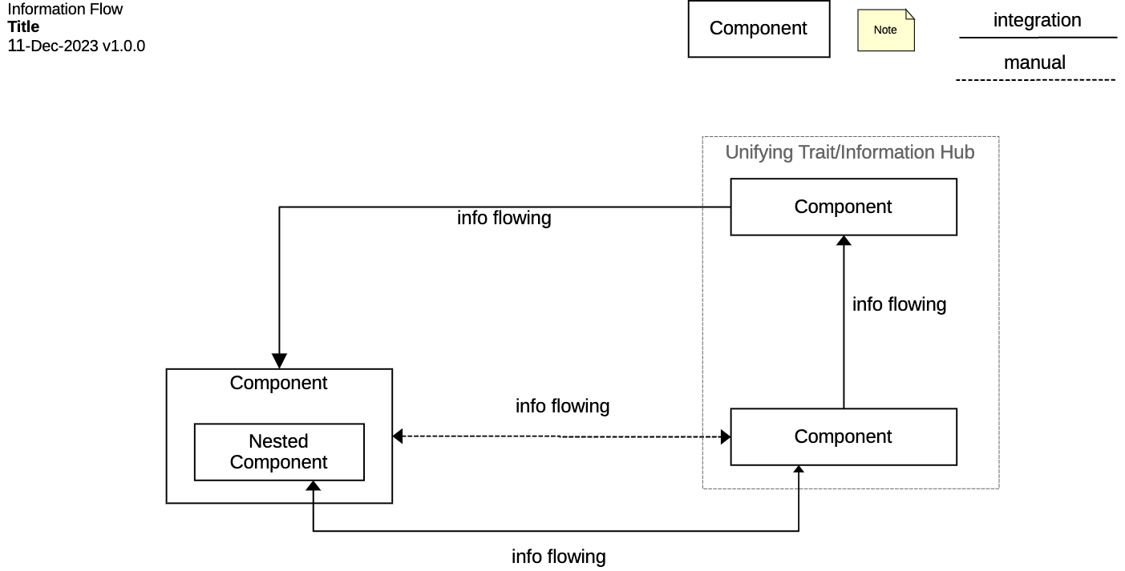
In the upper left, is our standard title block. Change the word “title” to the title of your diagram. It should describe the scope of your diagram. For example, “Tasking Manager.”
To use the template, simply make a copy of the component rectangles, rename, and position appropriately. Make copies of the lines, choosing between information flowing through integration or manual, to connect components. The template provides an example of a possible organization for an information flow. Move components and change connections as much as necessary to fit the specific information flow.

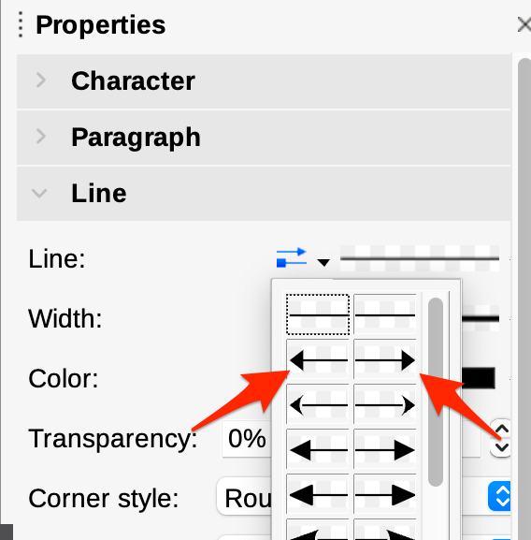
Connecting Components
Once you have some components added to the diagram, and have connected them with labeled dotted or solid lines, use the toolbar to edit the direction of information flow.
You can select a line and use the Properties toolbar on the righthand side to add an arrow to one end depicting the flow of information between the two components. Add an arrow on either side if information flows in both directions.
Pro tip: If you’re having trouble moving text box labels on connectors, highlight the text, then click drag anywhere around the connector. A small square will appear as you drag to show you where the text will move to.

Clean Up
Once you have your whole diagram laid out, delete the template shapes from the top right corner of the diagram, as well as any components within the template that have not been used. Make sure not to delete the two types of lines, as this acts as a key for understanding the diagram.

The Carnegie Mellon University Software Engineering Institute refers to this kind of diagram as a Component and Connector view in their approach for documenting software architectures (“Views and Beyond”). https://resources.sei.cmu.edu/library/asset-view.cfm?assetID=484159
Scott Ambler’s book “Elements of UML Style 2.0” has some great general diagramming tips.

