
Activity Diagram
HOT Architecture Documentation

This document provides an overview of an activity diagram, then digs into the mechanics of creating one in LibreOffice. For a general overview of the technical documentation approach for HOT, check out the technical documentation Wiki at https://github.com/hotosm/techdoc/wiki.
When it comes to solution architecture, an activity diagram is a design diagram for process flows. The goal of this activity diagram is to show step-by-step activities in an easily understandable and streamlined format. Activity diagrams can be thought of as sophisticated flow charts.
Table of Contents
Activity Diagram HOT Architecture Documentation 1
What is an activity diagram? 1
Elements of the diagram! 2
Some Tips 2
Drawing with LibreOffice 2
Getting Started 2
Page Setup 3
Connecting Components 4
Clean Up 5

What is an activity diagram?
From our friends at Wikipedia:
Activity diagrams are graphical representations of workflows of stepwise activities and actions with support for choice, iteration and concurrency. In the Unified Modeling Language (UML), activity diagrams are intended to model both computational and organizational processes (i.e., workflows), as well as the data flows intersecting with the related activities.

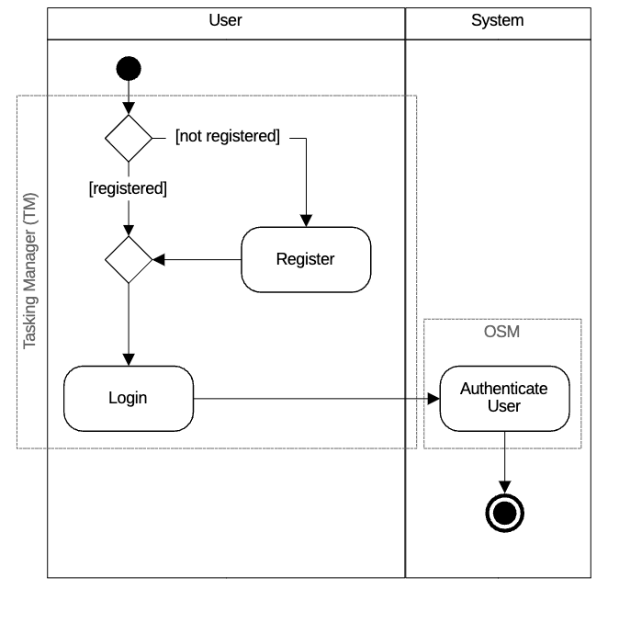
Elements of the diagram!
Here is a quick review of how to think about each element on the diagram:
- Each box on the diagram represents an action. Describe the action being performed using a Verb + noun
- Each directional line connects actions and indicates the direction of the flow
- Decision points allow a single flow to break into multiple flows, each labeled with a guard. The flow of direction is dictated by whether the guard is true or false.

Some Tips
Before we get started on the mechanics, here are a few tips:
- This is intended to be a behavior diagram that is an advanced version of a flowchart. Focus primarily on the logical flow and keep any extra details concise.
- Use swimlanes, columns titled with a role, to depict the actor completing the action. This actor can be a specific role, a general user, or the system itself.
- Use a labeled dotted bounding box to depict the application being used to complete the action.
- Keep all the boxes the same size. It makes your diagram look cleaner and more professional. If you show nested components, the internal components should be the same size as other boxes on the diagram.
- Align boxes vertically and horizontally as much as feasible. It makes your diagram look cleaner and more professional.

Drawing with LibreOffice

Getting Started
This assumes you know how to use LibreOffice Draw and provides additional guidance to help you create this specific diagram in LibreOffice. Please checkout these resources to learn more about using LibreOffice:
- https://www.libreoffice.org/get-help/install-howto/
- https://documentation.libreoffice.org/
- https://documentation.libreoffice.org/assets/Uploads/Documentation/en/DG7.5/DG75-DrawGuide.pdf
- https://help.libreoffice.org/latest
It is also often quickest to grab an existing diagram and edit instead if starting from scratch. You can find an existing activity diagram here: https://github.com/hotosm/techdoc/blob/main/overarching-architecture/tasking-manager/Tasking%20Manager%20Activity.odg
Otherwise, start by using the file menu to Create a New Drawing.

Page Setup
If you are not using an existing diagram to start, make a copy of the Activity Diagram template and rename it to the name of your solution, e.g. “Tasking Manager Activity Diagram.odg.”
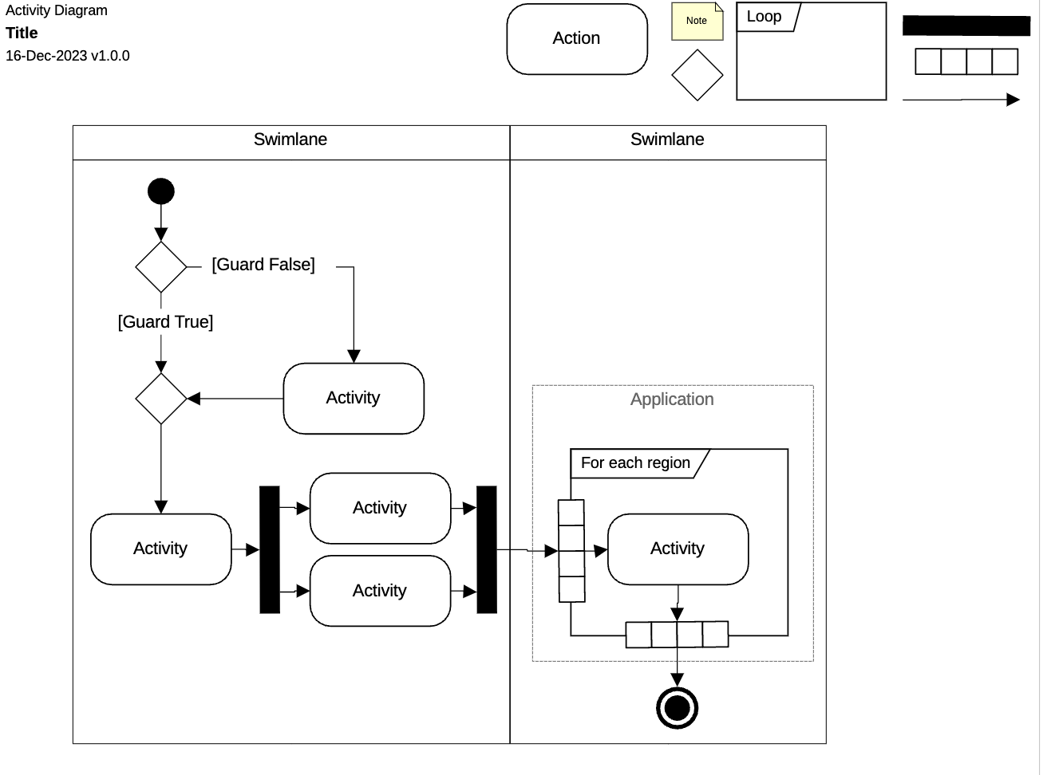

In the upper left, is our standard title block. Change the word “title” to the title of your diagram. It should describe the scope of your diagram. For example, “Tasking Manager.”

In the upper right are shapes you may use on the diagram:
 | Initial Node. This is where the flow starts. Every activity diagram must have 1, and only 1, of these.
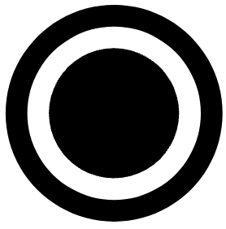 | Final Activity Node. This is where the activity flow ends. Every activity diagram must have 1, and only 1, of these.
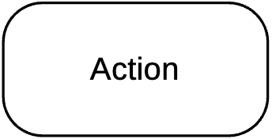 | The Action rectangle is used to describe the action being performed using a Verb + a domain specific noun (aka. “Use Case naming convention”), e.g. “Open Account”.
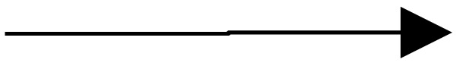 | The Control Flows are directional lines that connect all components on the diagram. They indicate in which order the action should be performed.
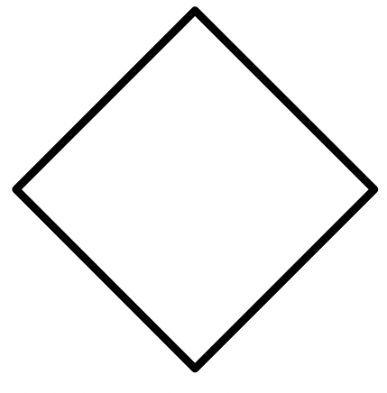 | Decision points all a single flow to split into multiple flows. The multiple flows must have “guards” which indicate in which direction the activity should continue, based on if the guard is true or false.
 | Bars, also called a split or join, depending on whether the bar is splitting the flow or joining split flows, represent the start and end of parallel activity. One flow goes into a split, and multiple flows of action continue concurrently until all flows reach a join.
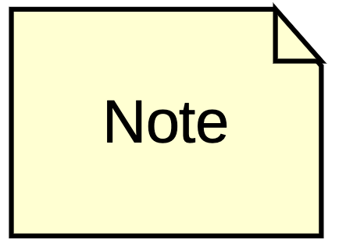 | Notes can be used during drafting to capture open questions and after publishing to provide more clarity. Use sparingly on completed diagrams.
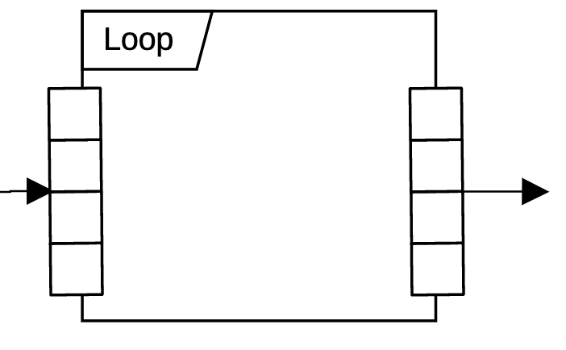 | Iterations allow for a single activity to loop until a defined end (e.g. “For each song”). These loops are made up of a labeled expansion region with expansion nodes at the control flow exit and entrance.

To use the template, simply copy the different shapes, rename and position appropriately. When you are done with the diagram, you can delete any shapes you didn’t utilize, such as the swimlanes, and all the template shapes from the top right corner.

Connecting Components
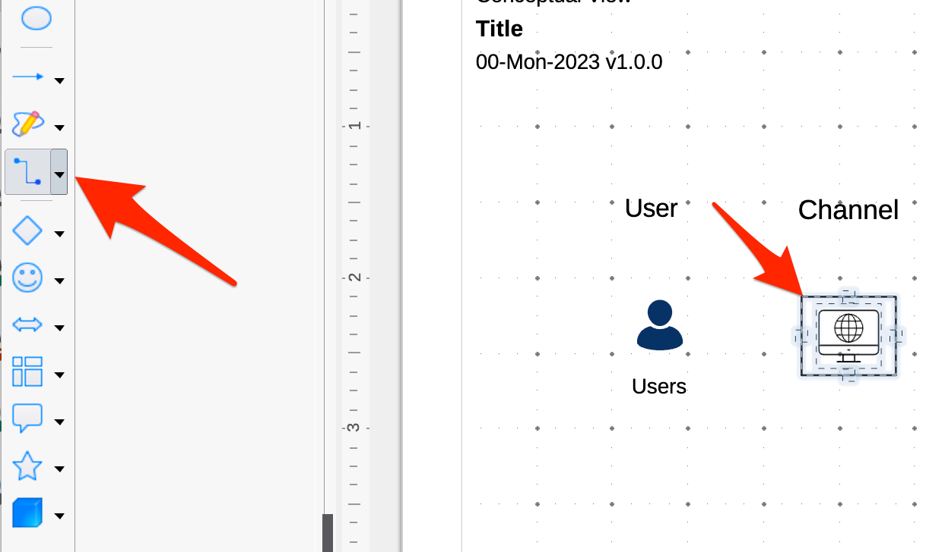
Once you have some actions added to the diagram, click the connector button on the shape bar on the left, then hover over any action or decision. The connectors will appear on the component you are hovering over.
Click on any connector and holding the mouse button down, move the mouse over the other shape you would like to connect. Release the mouse button when it is hovering over one of the connectors on the other component.
Alternatively, copy and paste the connectors from the template and move either end to your desired components.
You can use the toolbar at the top to fix the connection style:
- Increase the thickness of the line to 1pt and change the color to black.
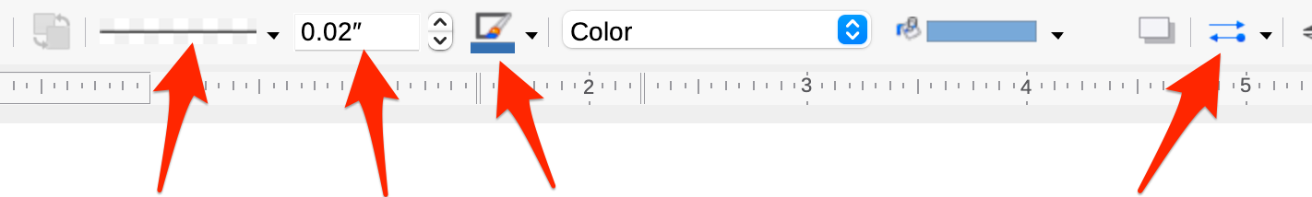
Line Style Line Thickness Line Color Line Arrows
Pro tip: If you select the right Line attributes with no connector selected, it will become your default for all future connectors.

Clean Up
Once you have your whole diagram laid out, make sure all actions and decisions are aligned horizontally and vertically, as much as possible.

Scott Ambler’s book “Elements of UML Style 2.0” has some great general diagramming tips.

