What is new for Mappers in the Tasking Manager 3

What is new for Mappers in the Tasking Manager 3
This guide may be downloaded as tm3-news-for-mappers_en.odt or tm3-news-for-mappers_en.pdf

Your User Profile
Please make your first activity in the new Tasking Manager visiting your User Profile, which can be selected from the popdown menu under your OpenStreetMap (OSM) user name in the upper right corner.
Here you will find a number of new features, some of which will affect your regular mapping activity.
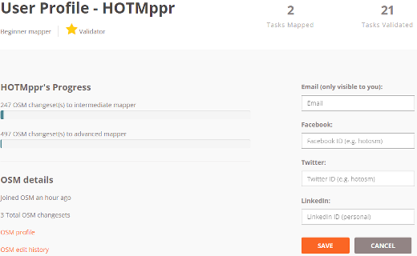
- Contact information - Please add your email address by clicking on the Add/Edit Contact Details button. This is critically important as OSM does not share your email address with anyone (and neither will we) so that you can get emails about your mapping and projects you have contributed to.
- Your Mapper Experience Level - This is a gauge of how much mapping you have done and some mapping projects might require a certain level of experience before you can contribute. This same area will indicate if you are an "Experienced Validator" as well.
- A list and map view of all the projects you have completed tasks in. This makes it very easy to come back and keep working on projects you have contributed to.

Finding Projects to Map
Clicking on the Contribute link in the menu bar will bring you to the familiar list of projects sorted by priority, but along the left hand side of the screen you will find a full text/project number search box as well as some filters you can apply. Please note: We have all of the projects from the previous version of the Tasking Manager, most of which will not have these tags applied, so you still might need to search by text or project number to find them.
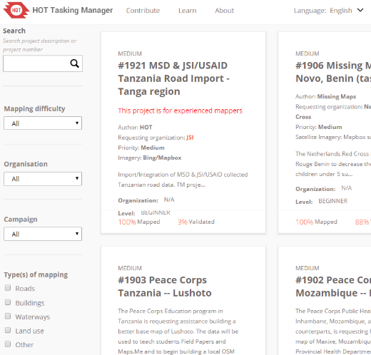
- Mapping Difficulty - Projects can now have a difficulty assigned to them. This corresponds to your mapper experience level mentioned above. As you gain more experience mapping, you should try to work on projects that need your level of experience. Some projects may require you have certain level of experience to contribute to them.
- Organization and Campaign - These filters will let you find projects for specific organizations or groups or for specific mapping campaigns.
- Type of Mapping - Now you can find the projects that are asking for the kinds of mapping you like to do most or are in the mood to map.

Project Mapping Page
The Project mapping page has a number of changes that affect mappers. The most significant change is to the "Tabs" for the project.
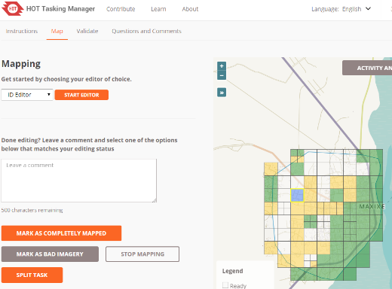
- The Description Tab is gone and now the project description is always at the top of the page along with other detailed information about the project. The default tab open when you visit a page is the Instructions tab. Like always, you should read the instructions fully and check them often during crisis mapping in case they are updated or change.
- Mapping and Validating tabs - There are now two separate tabs for mapping and validating. You will need to make sure you are on the correct tab depending on whether you are mapping or validating. If you see a message about a task not being in the correct state, it is likely because you are on the wrong tab.
On the Mapping tab you will also see a new option to mark a Task as "Bad Imagery," please use this if there is no high resolution imagery or the square is covered significantly by clouds.
On the Project Task map, in the lower right corner you will find a button that allows you to see what the area looks like in satellite imagery.
- Questions and Comments tab - this is a project level (not task level) place to ask questions and leave comments for the project manager and other mappers. If you have any questions about mapping in general or the project overall this is the place to put them. There is a link "Contact project manager" that will automatically put the project manager's OSM username into the comment to make sure they see it.

