LearnOSM

JOSM - Adding Aerial Imagery
Reviewed 2016-09-09
Not all aerial imagery is within the JOSM imagery menu, but it is easy to add if you have been given the link information. In this example we are working from the HOT Tasking Manager and the imagery required to complete one of the projects needs to be manually added to JOSM. The principle of adding the image link is the same whatever the project you are working on, as long as you are provided with the link. There are also occasions when the intended links do not work as expected and it may be necessary to add the imagery manually, if you can obtain the link information.
From the Tasking Manager information tab, copy all of the information contained within the Imagery section.

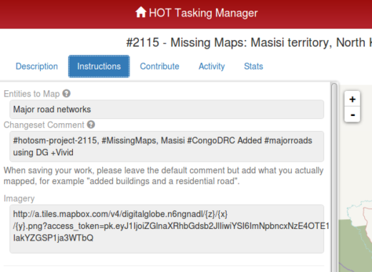
http://a.tiles.mapbox.com/v4/digitalglobe.n6ngnadl/{z}/{x}/{y}.png?access_token=pk.eyJ1IjoiZGlnaXRhbGdsb2JlIiwiYSI6ImNpbncxNzE4OTE1dm51a2x5dzlkMXI0eHUifQ.TPHGd-IakYZGSP1ja3WTbQ

Go to the Preferences menu of JOSM (Edit / Preferences, or on an Apple machine JOSM / Preferences)
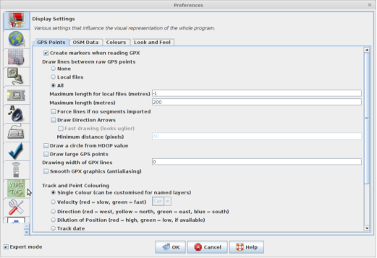

Click on the  icon, and in this case the  icon.
There may be occasions when you are not sure if your imagery will be tms or wms - try adding whichever you think it could be, and if that does not work, try the other.
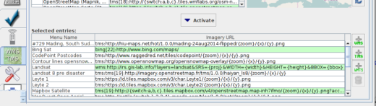
Box 1. Paste the information you copied from the Tasking Manager information tab into the first box on the window. JOSM will verify it, and if it is correct the verification process will repeat the information in box 3 (see below). If it does not appear in box 3 within a few seconds, check that you have not accidentally missed letters, or accidentally added ‘white space’ at the beginning or end - just the actual link must be copied and pasted.
Box 2. This is normally left blank, unless you have received any other instructions.
Box 3. now contains a duplicate copy of Box 1, generated by the verification process within JOSM.
Box 4. Enter a name for the layer - as my imagery was identified in the Tasking Manager as “Satellite imagery for this project is kindly provided by Digital Globe through their +Vivid service.” I have named my layer “Digital Globe + Vivid”.
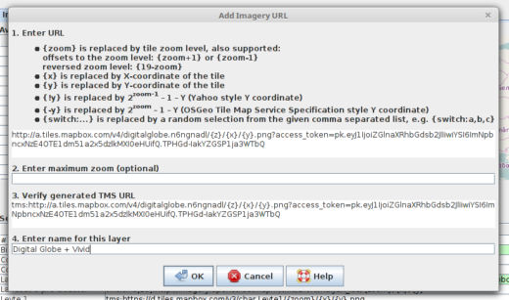
Click on the  button, and the imagery you have added will appear at the bottom of the list - you may have to scroll down to locate it.
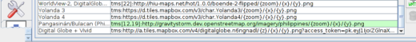
Click the button to close the preferences window and return to JOSM. When you need to use the imagery, click on the word Imagery in the menu at the top of the screen and select it from the alphabetical list. Alternatively Alt + I should show the imagery menu (These shortcuts may vary according to the language setting).
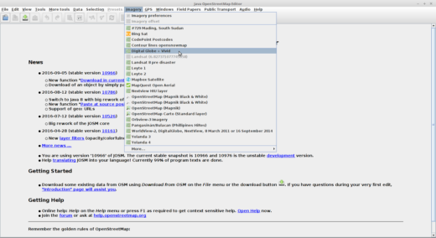

Was this chapter helpful? Let us know and help us improve the guides!
- learnosm@hotosm.org
- @learnOSM
- Hosted on Github
Official HOT OSM learning materials


