LearnOSM

JOSM Building Tools & Utilsplugin2 plugins
Reviewed 2016-09-12
The buildings_tools and utilsplugin2 plugins add great additional functionality into JOSM. In this section we’ll take a closer look at the functions they provide.

The Buildings Tools Plugin
If you haven’t already, install this plugin following the instructions in JOSM Plugins.
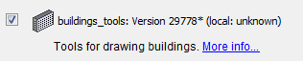
The Buildings Tools plugin is very helpful for digitizing buildings. It allows you to trace one side of a rectangular building, and easily extend the shape. If you are digitizing many buildings, this plugin will save you clicks, and thereby save you time.
Once the plugin has been installed you will see a new button on the left side of JOSM, which looks like this: 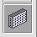
Start JOSM and download an area where you wish to trace buildings.
- Select the building tool and click twice to draw a line on the map.
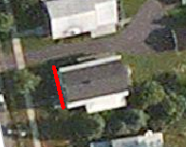
- Then extend the mouse and click again to draw a rectangle.
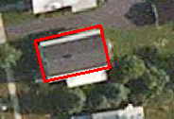
- This will not only create a rectangle with only three clicks, but it will also automatically apply the building=yes tag to the shape.

Complex Buildings
You can also create more complicated buildings by first drawing several overlapping buildings and then merging them together.
- Draw two buildings which over lap, so that they form an L shape.
- Select both buildings (hold SHIFT to select more than one object).
- Go to Tools->Join overlapping Areas or press SHIFT+J on your keyboard.
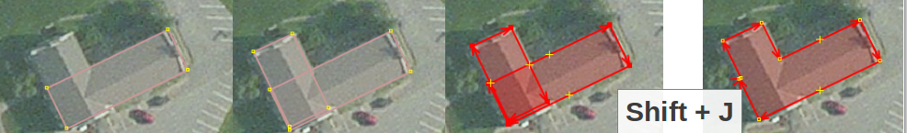

Edit Settings
Furthermore, you can alter the default settings of the plugin.
- Go to Data->Set buildings size. 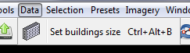
- If you are creating many similarly sized buildings, you can set specific width and height dimensions of the buildings, such as 6 x 10 meters (the unit is in meters).
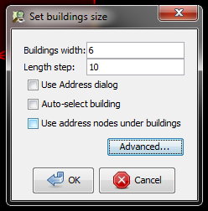
- By setting the dimensions you will only need two clicks to create precisely sized buildings.
Lastly, you can click on the Advanced button if you would like to add additional tags that will automatically be applied to every building. For example, if every building you draw is on the same street, you might add a tag which identifies the street that will be automatically applied.
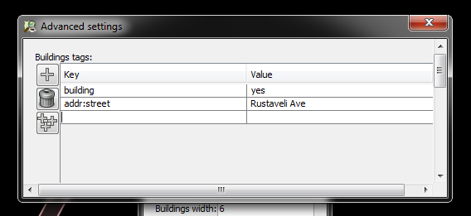

Utilsplugin2
- If you haven’t already, install this plugin following the instructions in JOSM Plugins.
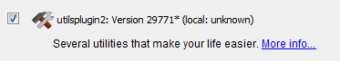
After you have installed the plugin and restarted JOSM, you will have a new menu at the top named “More Tools.”
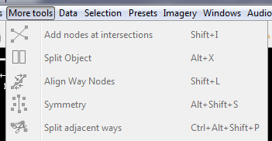
Create a new layer and experiment with some of the new tools. Here we describe some of the most useful new tools:
- Add Nodes at Intersections: This tool is very helpful for adding missing nodes in intersections of selected ways. It is good practice that roads should always have common nodes where they intersect.
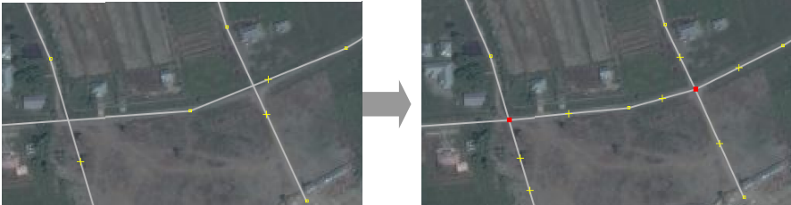
- Copy Tags from Previous Selection: This function makes copying tags easier. If you want to create many objects with the same tags, first draw the objects. Then add the tags to one object. Click on another object and press Shift + R to copy the tags from the previously selected object. You can do this for all objects that you want to tag. Remember that the tags will be copied from the previously selected object, so if you click on an untagged object and then another untagged object, you will not be able to copy any tags.
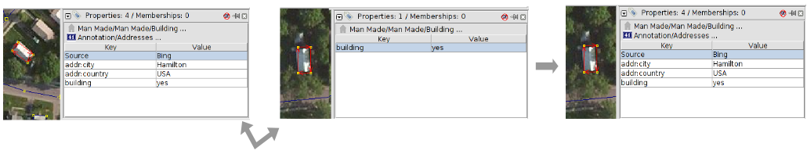
- Add Source Tag: This tool simplifies adding a source tag. It remembers the source that was specified last and adds it as remembered source tag to your objects. You can insert the source with just one click.
- Replace Geometry: This tool is great if you want to redraw a poorly shaped object, but want to keep the history, attributes and ID number of that object. For example, if you come across a building that is complicated and drawn in a poor fashion, then instead of painfully changing each node, you can draw the object again, select the old and new objects, and select ¨Replace Geometry¨ to transfer all the information over.
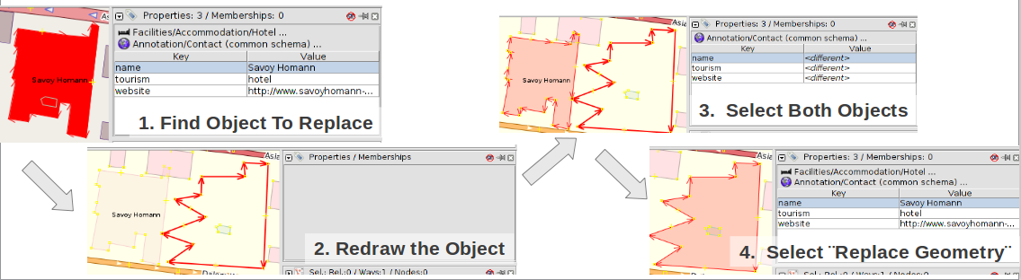

More Selection Tools
Utilsplugin2 also provides more tools on the “Selection” menu. Try experimenting with them.
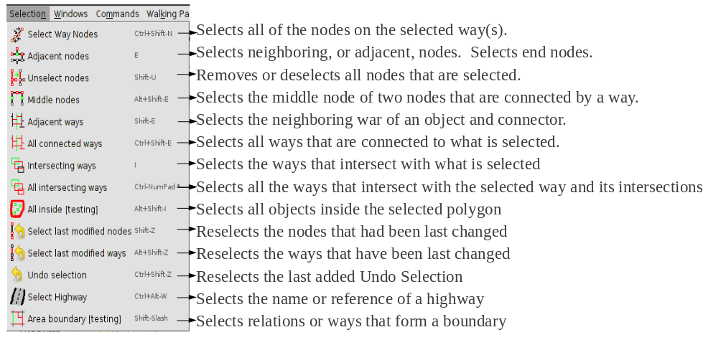
One of our favorite selection tools is Unselect Nodes: This tool deselects all nodes. This can be useful if you draw a box to select many objects, but you do not want to select the nodes contained within all the lines and shapes.
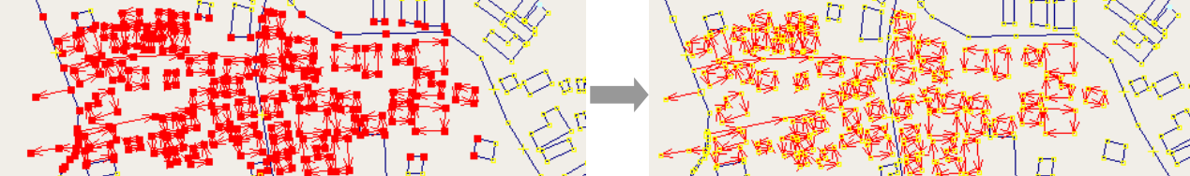
Good luck!
Was this chapter helpful? Let us know and help us improve the guides!
- learnosm@hotosm.org
- @learnOSM
- Hosted on Github
Official HOT OSM learning materials


