Visual Tag Chooser / JOSM Preset Builder
HOT Tech Challenge May-July 2013

The HOT Visual Tag Chooser / JOSM Preset builder application was developed in response to the first HOT Tech Challenge posted at http://hot.openstreetmap.org/hot_tech_challenge_visual_tag_chooser.

It was developed by Tim Waters tim@geothings.net a HOT Member and developer from May to July 2013.

The code for the application can be found at https://github.com/timwaters/visualtags

A demo deployment can be found at https://visualtags.herokuapp.com/

This document outlines the original proposal, and gives a quick user guide.

Table of Contents

1.Proposal 2

2.User Guide 3

Proposal

Description of problem

The HOT Export tool requires a list of tags to be specified when downloading an extract. This list is generated by a user uploading a JOSM Preset XML file. The preset file is a structured format with groups of tags, translations of tags, defaults etc. Creating and editing a preset is essential for the HOT Exports application. That process is not easy at all for users and involves text editing a raw XML file.

Solution

An application that will create and edit a JOSM preset visually using a more user friendly interface.

Proposal

The proposal is to focus on the needs of the HOT export tool initially, then expand to JOSM Presets in general, and finally to incorporate fine editing tools for the presets. At each phase the generated presets will work with the HOT Export application.

Phases

First phase
Preset upload
Preset show - as list of tags
List of tag editing - add, create, update, remove tags
Output is a simplified XML preset which will work with the HOT Exports application.

Second Phase
Preset list
Preset clone from existing
Preset displayed as it would appear in JOSM
presets display icons
After preset saved, presets could be uploaded to HOT Exports.

Third Phase
Internationalisation of application
Preset fully editable using drag and drop user interface.
Items can be rearranged, edited with nicer widgets.
Widgets include text boxes, select boxes, checkboxes, etc
Icons can be chosen for an item (from default JOSM icon set)
Advanced attributes added and editable using popup form

User Guide

Overview
This application allows users to find, add and edit collections of OSM tags in the form of JOSM Presets. It displays a JOSM preset file as it would appear. A user can add items (categories) to the collection and add tags (keys) to each item.

Adding Preset

Uploading XML Preset
Choose a name for the new preset collection and find a existing XML JOSM preset and upload.
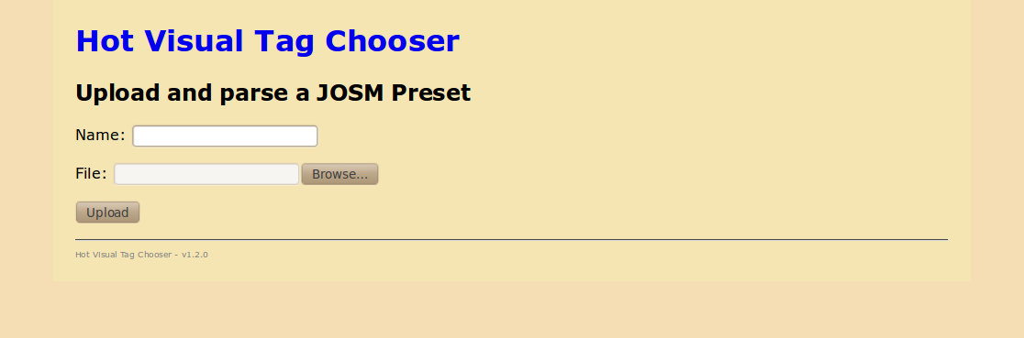

Creating New Preset
You can create a new preset from scratch by choosing a name, and filling out some additional information.
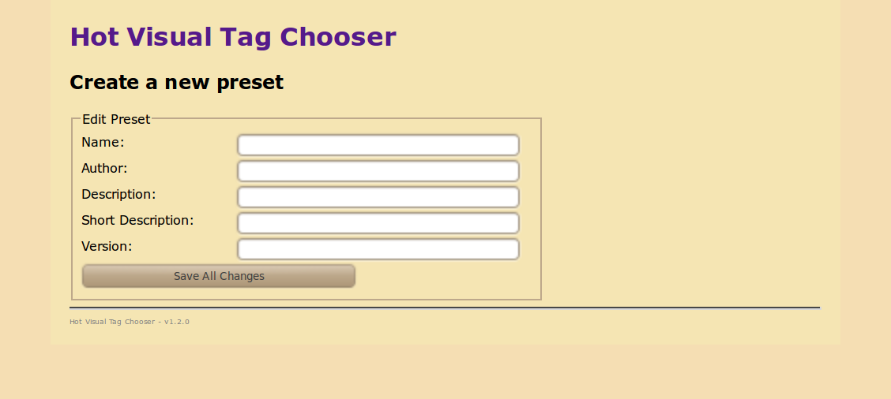

Cloning Preset
Alternatively you can clone an existing preset to make a copy.
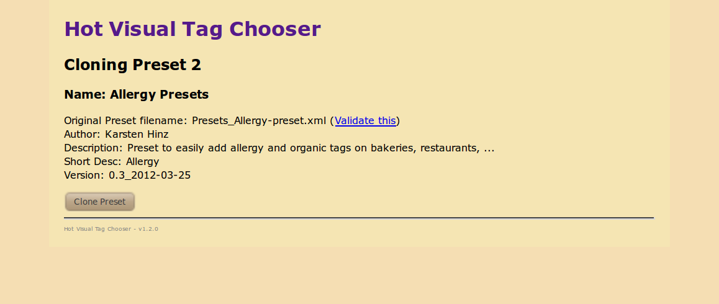

Validating Preset
Uploaded presets can be optionally validated - to make sure they will load correctly within the JOSM application. This step is optional, and is provided as a utility
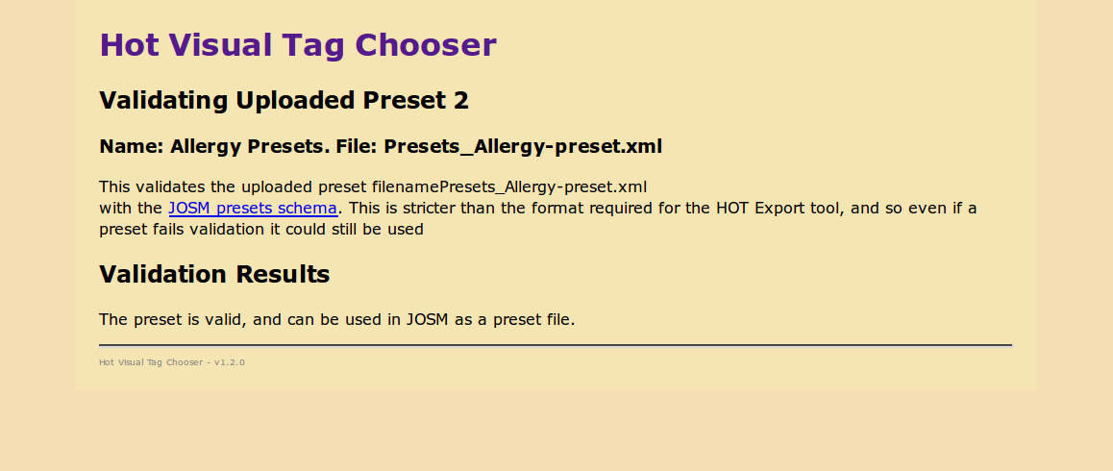
  - Below gives an example of an uploaded XML preset that had errors in validation. This file is, however, able to be used in this application.
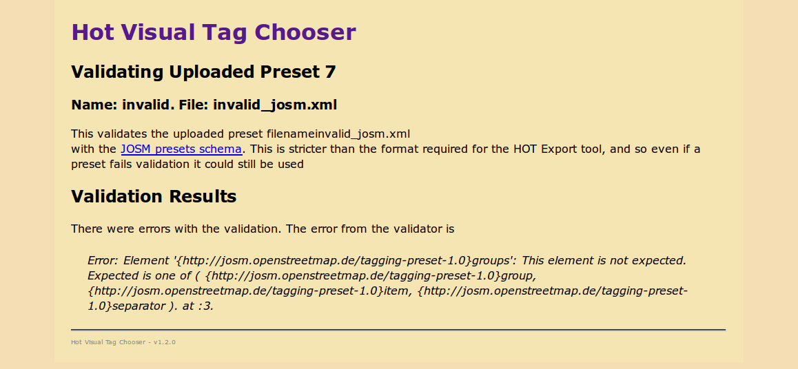

Viewing Preset / Items
Viewing a preset, shows the metadat and a tree structure. On the left, is the Items or categories. Clicking on an item shows the form, the tags associated with the category. The user can edit the preset, delete the preset or clone the preset from here. Additionally the use can download the resulting JOSM preset file.
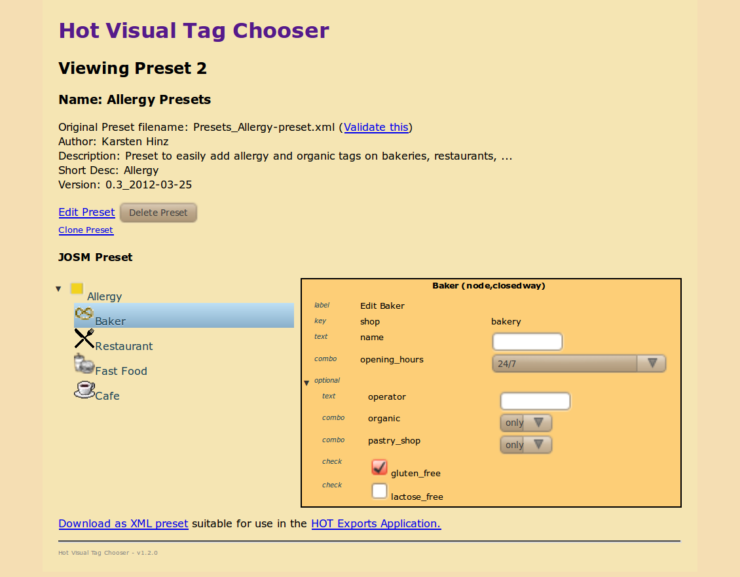

Edit Items
On the edit page, clicking on the gear icon for an Item or Category opens a dialog box where you can edit the attributes, icon and types of OSM geo types for that Item.
Clicking on the "Add New Item" link enables the user to add new items to the list.
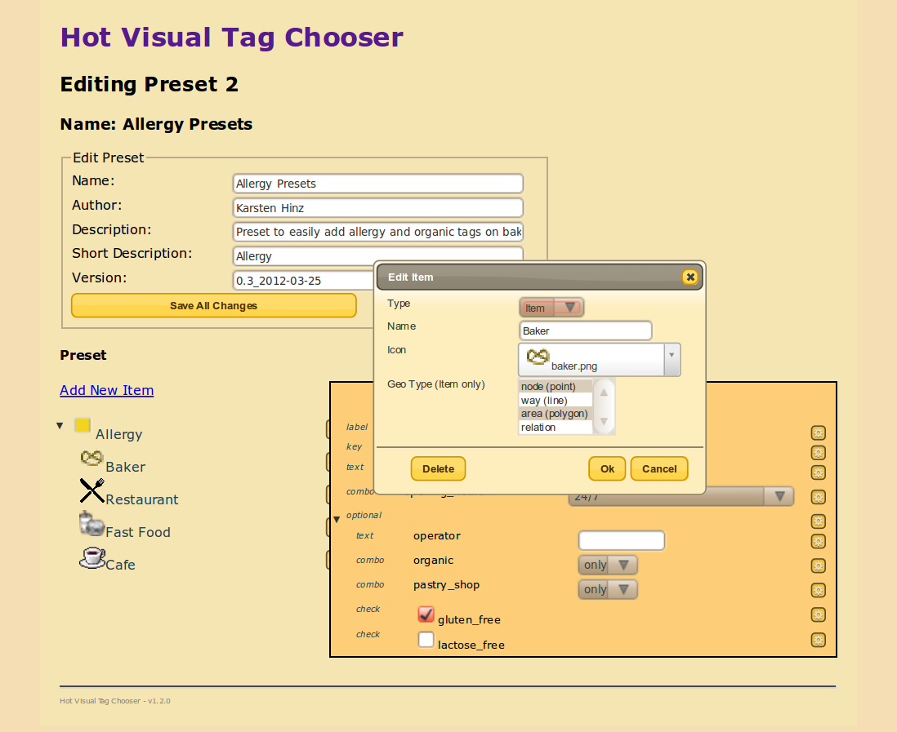

Editing Tags
Clicking on the gear icon for a tag on the right hand side list opens a box showing the form for that tag. The user can add or delete the tag here.
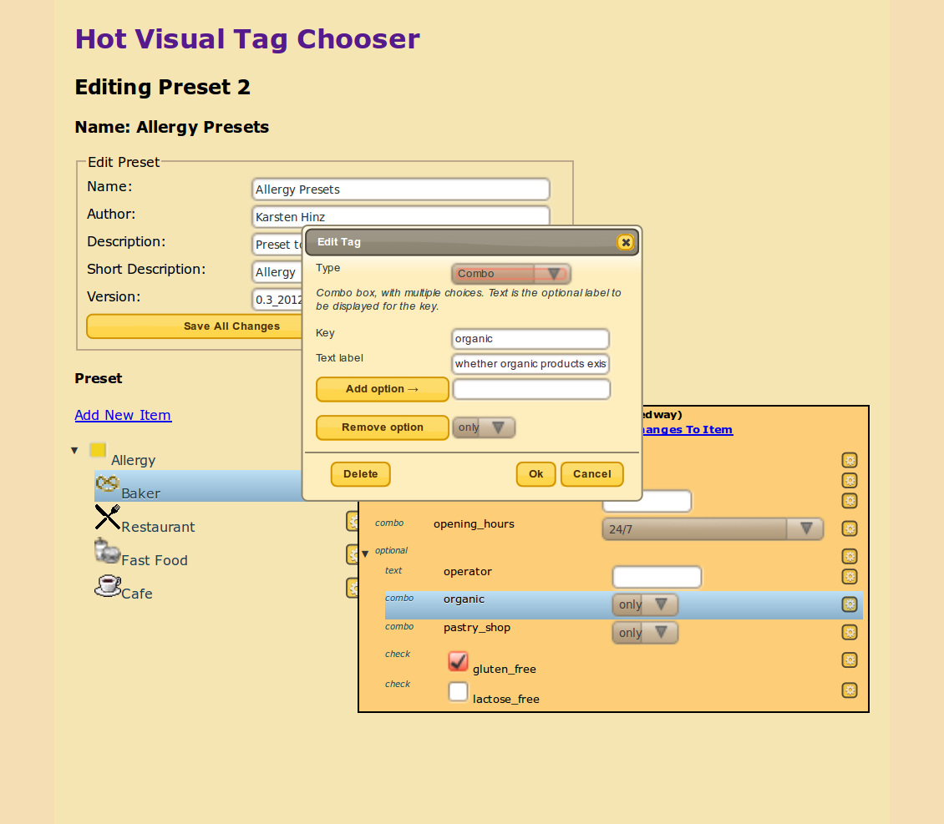
Clicking on the "Add Tag Element" link open the form to add a new element.

Saving Changes

To Tags.
Once a tag has been deleted, added or edited, changes are saved automatically.

To Items and Preset as whole
The yellow button "Save All Changes" should be pressed to save all the changes in both trees.

Just Want a List of Tags?
if the user just wants to make a list of tags - to make a preset for the HOT Exports Application the following steps should do:
  - Create new empty preset
  - Click Edit
  - Click Add New Item - give it a name like "Tag List". Select all geo types
  - Select item
  - On right, Click "Add tag element"
  - Choose "Text" for type (the default, first option)
  - In Key box, add in the name of the key. Click OK
  - repeat steps 5-7 until you have enough keys
