1a  
dcb

2

|  |  |  |
| --- | --- | --- |
| A | b | c |
| D | e | f |

3

4

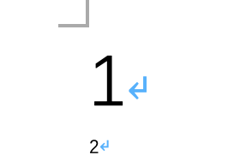

5

6