

|  |
| --- |
|  |

|  |
| --- |
| **FPT UNIVERSITY** |
| **SOFTWARE DESIGN**  **DESCRIPTION** |
| Internet-connected Devices Checking System |
|  |
| |  |  |  | | --- | --- | --- | | **IDCS TEAM** | | | | **Group Members** | Nguyễn Quý Đôn | SE04468 | | Nguyễn Quý Tuấn | SE04330 | | Phạm Công Minh | SE04098 | | **Supervisor** | Lecture : Phan Duy Hùng | | |
|  |

|  |
| --- |
| - Hanoi, 11/2019 - |

1. ***Purpose***

This chapter is to give developer team the overview and detailed design of what the system’s architecture is, and how they should be implemented. This chapter included are:

* Architecture overview
* Component diagram
* Detailed design
* Detailed description of components
* Database design

1. ***Architecture Overview***
   1. ***System Architecture***
   2. ***Diagram***

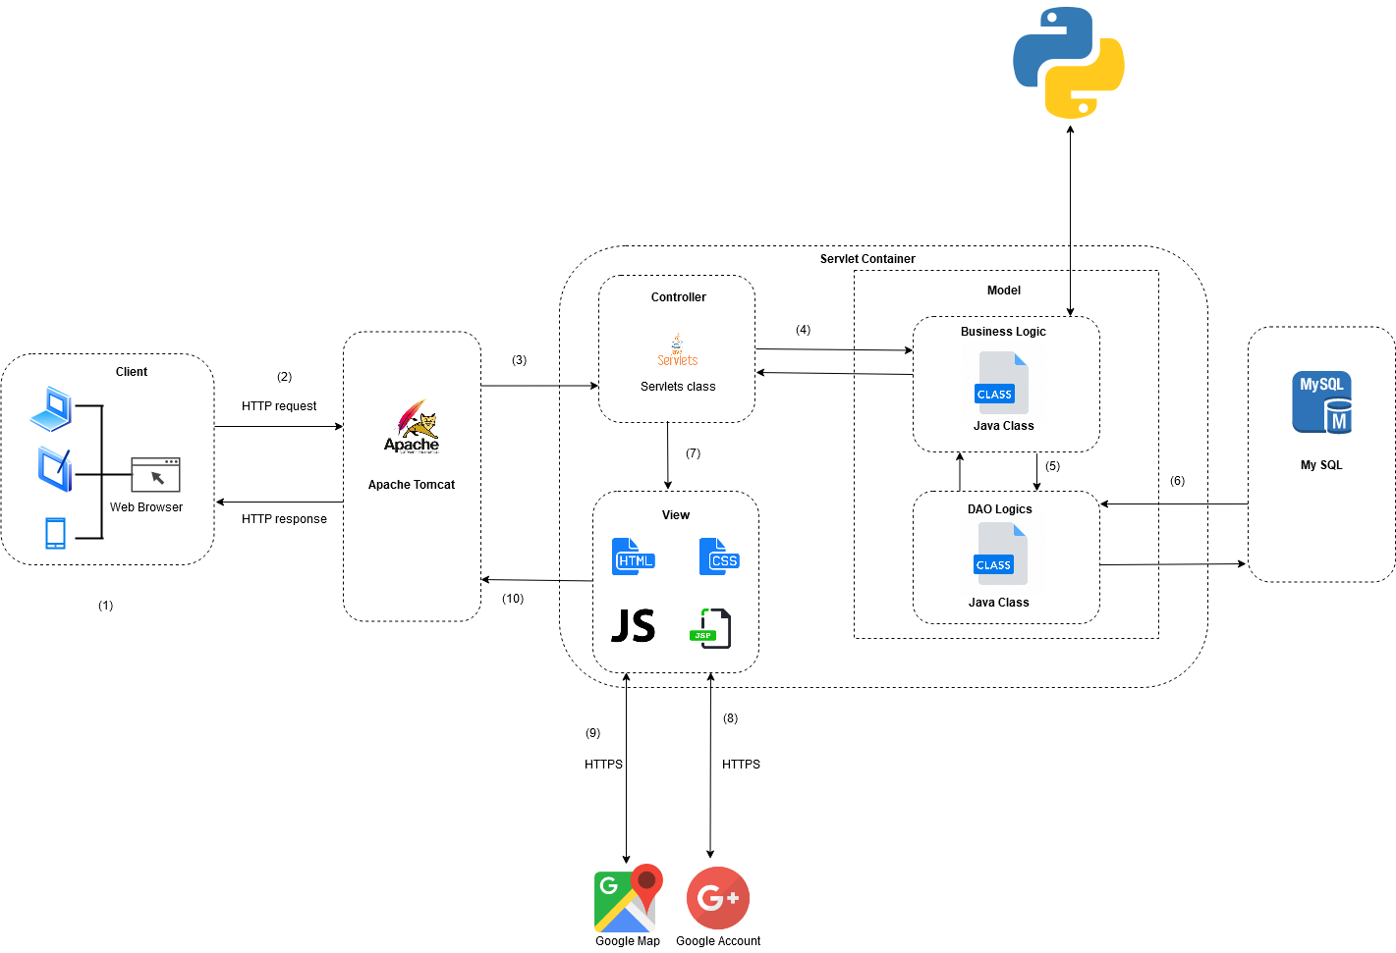

* 1. ***System Architecture Explanation***
     1. ***Apache Tomcat***



**The Apache Tomcat**® software is an open source implementation of the Java Servlet, Java Server Pages, Java Expression Language and Java Web Socket technologies. Tomcat provides a "pure Java" HTTP web server environment in which Java code can run.

* + 1. ***MySQL***

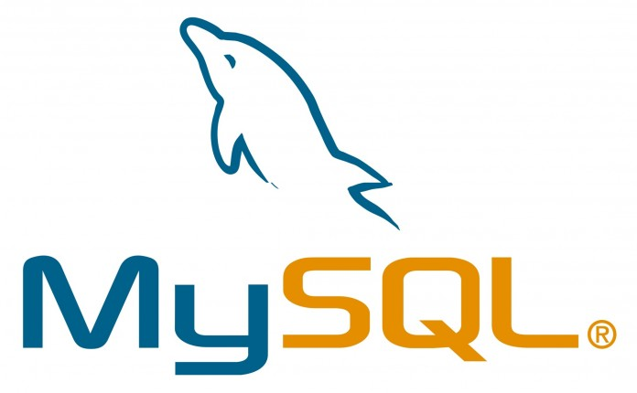

**MySQL** is the world's most popular open source database. With its proven performance, reliability and ease-of-use, **we use it to stores database.**

* + 1. ***Python***

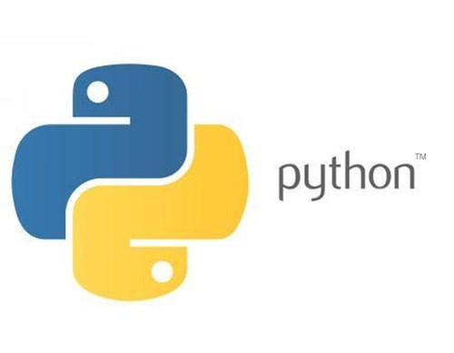

**Python** is an interpreted, high-level, general-purpose programming language. Python is dynamically typed and garbage-collected. It supports multiple programming paradigms, including procedural, object-oriented, and functional programming. With Python, **we use it to scanning server and client target**

1. ***System Design***
   1. ***Architecture Layers Design***
   2. ***IDCS – Backend Layer Design***

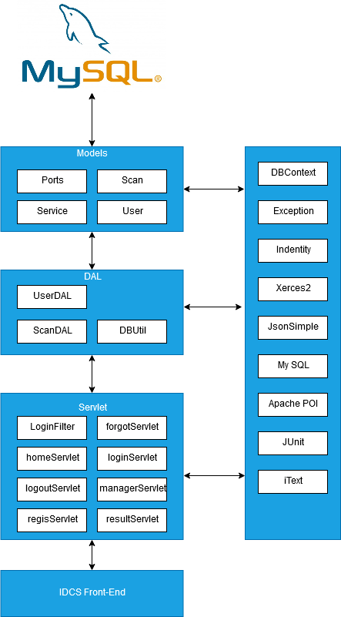

* + 1. ***Explanation choice of architecture design***

For the back-end of IDCS, we have decided to use a 3-tier architecture style.

1. **Presentation tier**: The presentation tier is the front end layer in the 3-tier system and consists of the user interface. The main function of the interface is to translate tasks and result to something the user can understand.
2. **Logic tier:** This tier contains the functional business logic. Its consists of all the data of the application