**Window PC/Mac Deploy Document**

**\*\*This document is based on Window PC, you can deploy on Mac too.**

1. Copy the whole **dental** folder to the path what you want. E.g.: C:\Users*{{user}}*\Downloads\dental
2. Open Docker Desktop & open the Terminal  
   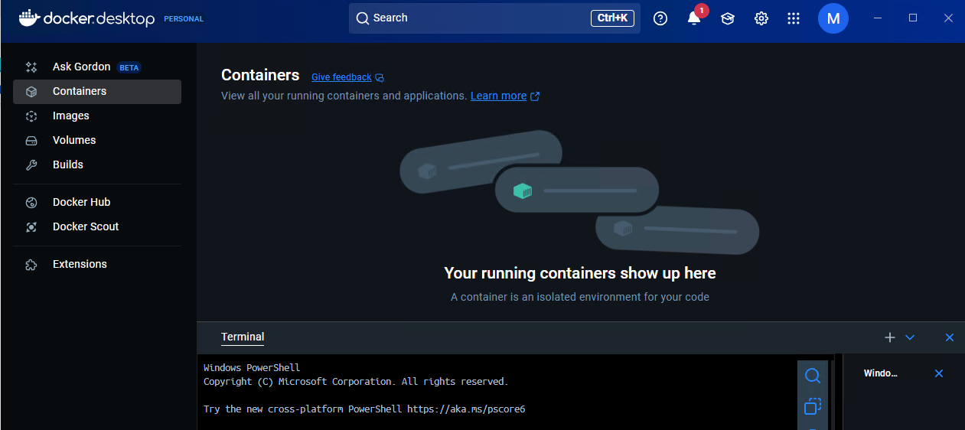
3. Type command to go the **dental** folder: cd C:\Users*{{user}}*\Downloads\dental  
   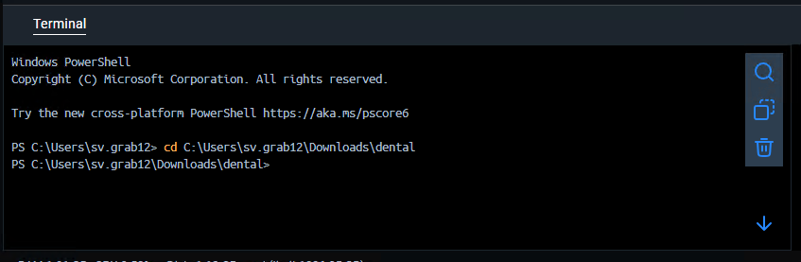
4. You can type command to clear all docker cache first, an **optional step**: docker builder prune  
   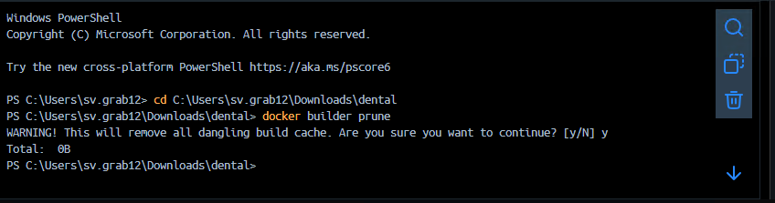
5. Type command to build project: docker compose up --build  
   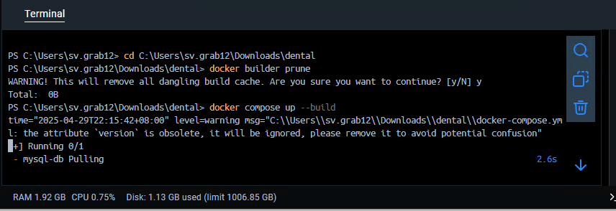
6. You may need allow this  
   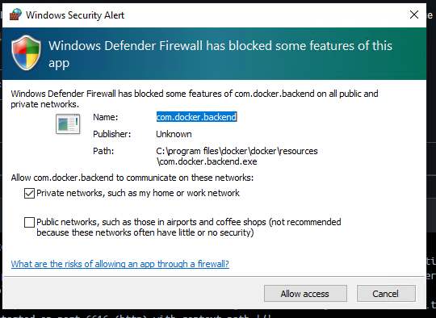
7. Deploy success  
   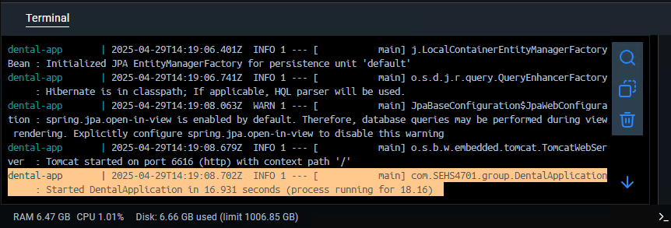
8. Access the frontend: <http://localhost:3000>
9. Or access spring boot API directly: <http://localhost:6616/item/list>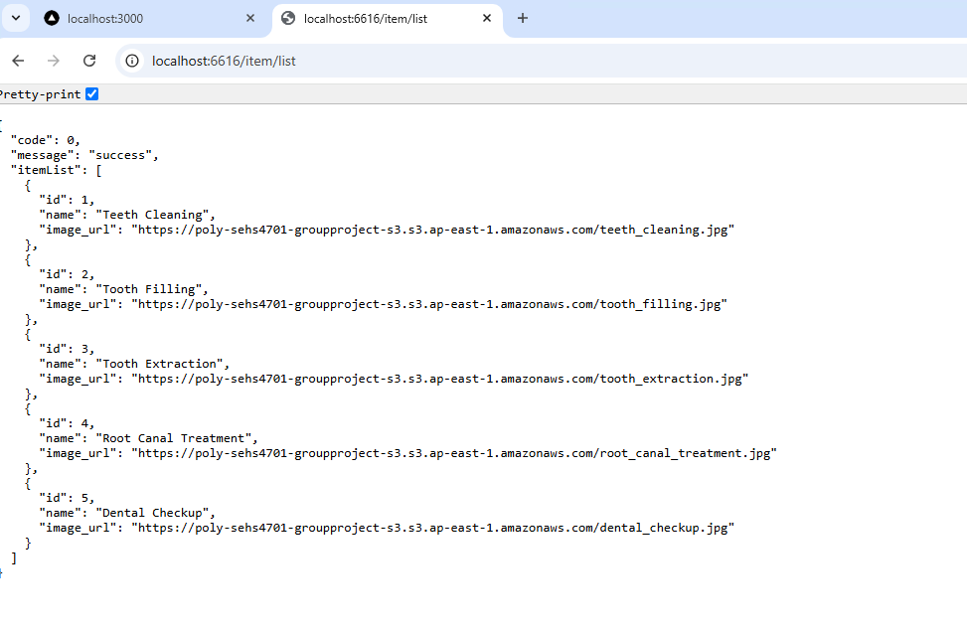
10. You can use **Postman** to import the json to check all API endpoint: C:\Users*{{user}}*\Downloads\dental\dental.postman_collection.json  
    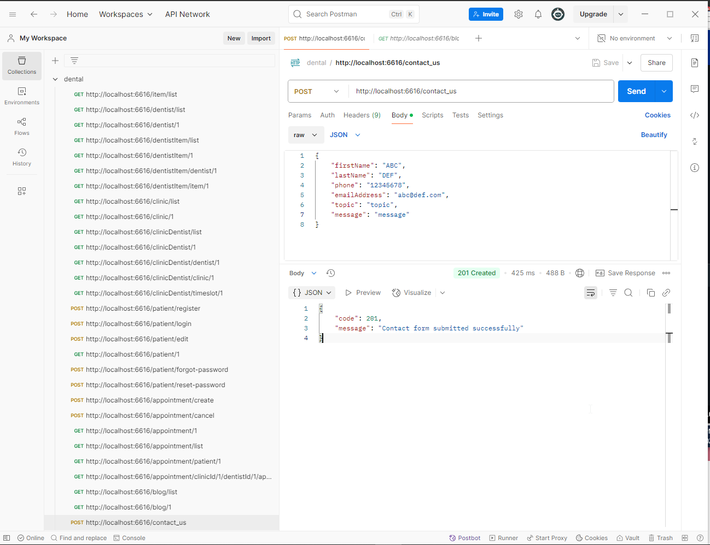
11. Type Ctrl + C to stop the service  
    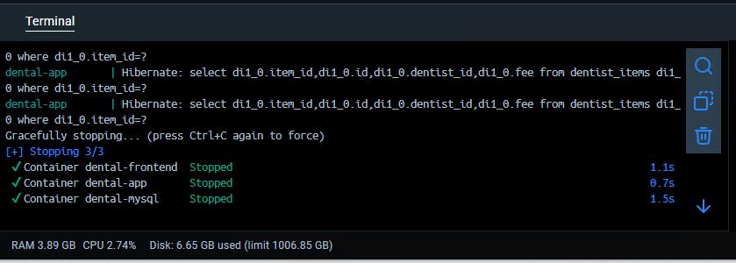
12. Type Command to remove docker images: docker compose down -v  
    