Ting Yu
CPE 301
Design Assignment 1
Code:
/*
* Design Assignment1.asm
*
* Created: 2/17/2014 8:23:24 PM
* Author: Tingyu
*/

/* Macro to set the stack pointer to end of ram */
.MACRO SET_STACK
LDI R16, HIGH(RAMEND)
OUT SPH, R16
LDI R16, LOW(RAMEND)
OUT SPL, R16
.ENDMACRO

SET_STACK

LDI R18, 0x32 ;load 50 to R16
LDI R19, 0x14 ;load 20 to R19 to be use as a counter
LDI R20, 0
LDI R21, 0
LDI R23, 0
LDI R24, 0

L1: PUSH R18 ;loop to push 20 value to a stack
INC R18
DEC R19
BRNE L1

LDI R19, 0x15
LDI R30, 0
LDI R27, 0x3
LDI R28, 0x5

NEXT:
DEC R19 ;parse throught the 20 numbers
CP R19, R30
BREQ END
POP R15 ;pop a number from the stack
LDI R25, 0x1B ;load 27 to R25
LDI R26, 0x19 ;load 25 to R26

L3:
CP R25, R15 ;compare the number with R25 if it's greater or equal to, jump to the next number
BRGE NEXT
ADD R25, R27 ;add 3 to R25
ADD R26, R28 ;add 5 to R26
CP R25, R15 ;compare R25 with the number if equal
BREQ SUM3 ;branch to add to the sum of all number divisible by 3
L5:
CP R26, R15 ;compare R26 with the number if equal
BREQ SUM5 ;branch to add to the sum of all number divisible by 5
RJMP L3
SUM3:
ADD R21, R15 ;add the number divisible by 3 and store in R20:21
ADC R20, R30 ;add carry bits in R20
RJMP L5
SUM5:
ADD R24, R15 ;add the number divisible by 5 and store in R23:24
ADC R23, R30 ;add carry bits in R23
CP R19, R30
BRNE L3

END:
RET

Flowchart:
-Load number, counter, RAM End
-Initialize SPH:SPL

-Push number
-Increment number
-Decrement counter
-Compare counter to 0
-Branch if not yet pushed 20 numbers
-Load counter
-Initialize register
-
-Decrement counter
-Pop number
-Load number

Counter !=0 Counter = 0
-Compare number to register for n*3
-Branch if equal
-Compare number to register for n*5
-Branch if equal

Greater than
-Compare counter to 0
-Compare number to register
-Branch if greater than or equal to
-Increment register by 3 and by 5
or equal to

-Add number to register holding the sum of all numbers divisible by 3
-Add carry bit if there’s carry
-jump to check if divisible by 5

equal

not equal
-Add number to register holding the sum of all numbers divisible by 5
-Add carry bit if there’s carry

equal

not equal
-Compare counter to 0
-Loop if not yet parse through all 20 numbers
Debugging screenshots:
Task A Beginning-only first instruction executed so far
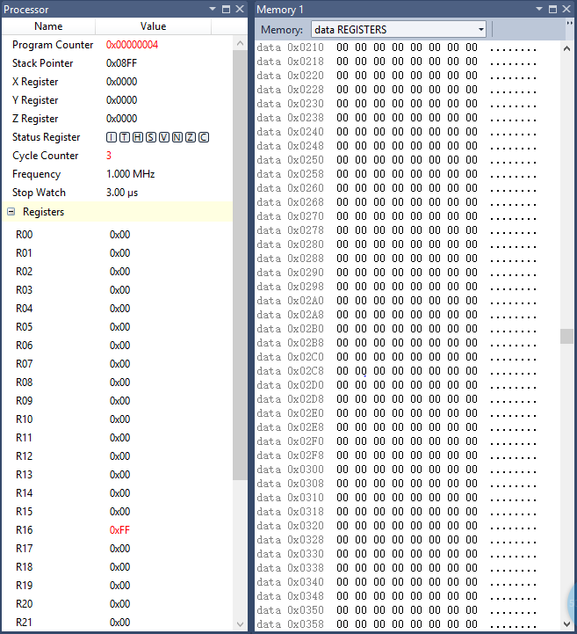
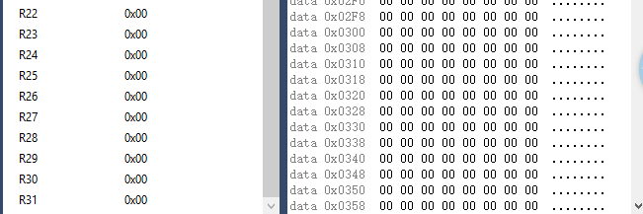

Task A end and Task B and C beginning all numbers in memory
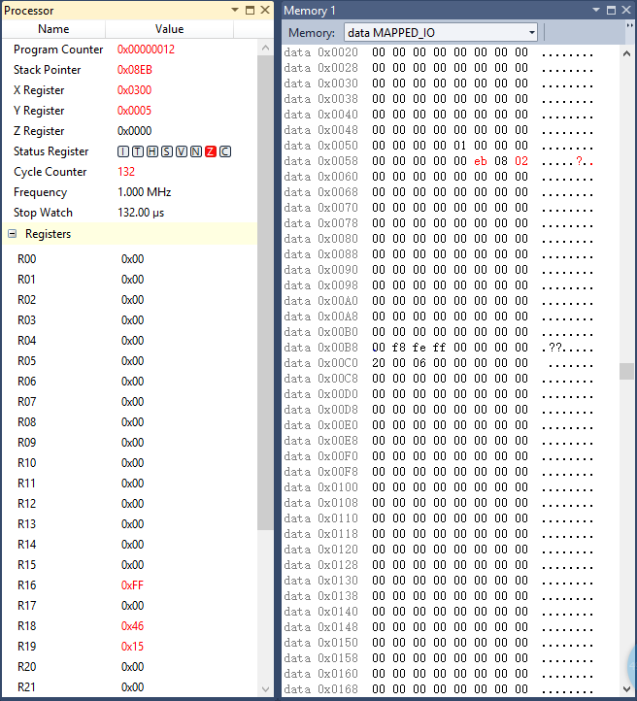
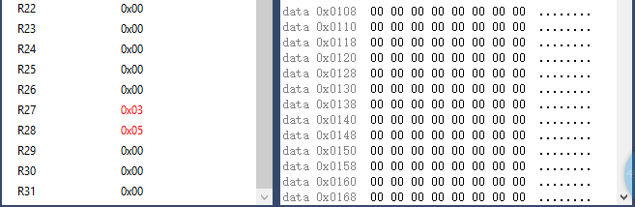

Task B and C end-sums are in the appropriate registers
