Ting Yu
CPE 301
Design Assignment 5

Code:
#define F_CPU 8000000UL
#include <avr/io.h>
#include <util/delay.h>
#include <ctype.h>
#define MOSI 3 //defines the output pin for MOSI
#define SCK 5 //defines the output pin for SCK
#define SS 2 //defines the output pin for SS

void usart_init (void)
{
UCSR0B = (1<<TXEN0)|(1<<RXEN0); //enable receiver and transmitter
UCSR0C = ((1<<UCSZ01)|(1<<UCSZ00)|(0<<UMSEL00));
UBRR0L = 0x33;
}

void usart_send (unsigned char ch)
{
while(!(UCSR0A & (1<<UDRE0))); //waiting for buffer to be clear
UDR0 = ch;
}

void execute (unsigned char cmd, unsigned char data)
{
PORTB &= ~(1<<SS); //initializes the packet by pulling SS low
SPDR = cmd; //begins CMD transmission
while(!(SPSR & (1<<SPIF))); //just waiting for the transfer to finish
SPDR = data; //begins DATA transmission
while(!(SPSR & (1<<SPIF))); //waiting for the transfer to finish
PORTB |= (1<<SS); //terminates the packet by pulling SS high
}
int main(void)
{
ADCSRA |= (1<<ADEN)|(1<<ADPS0)|(1<<ADPS1)|(1<<ADPS2); //enable ADC and select clk/128
ADMUX |= (1<<REFS0)|(1<<ADLAR); //Vref, ADC0 as input
DDRD = 0xFF; //Enable Port D for output
DDRB = (1<<MOSI)|(1<<SCK)|(1<<SS); //MOSI and SCK set as output
SPCR = (1<<SPE)|(1<<MSTR)|(1<<SPR0); //SPI set as master
execute(0x09,0b00011110); // enable decoding for digits 1, 2, 3, and 4
execute(0x0B,0x04); // scan two 7-segments
execute(0x0C,0x01); // turn on the chip

usart_init();
uint16_t temp;

while(1)
{

ADCSRA |= (1<<ADSC); //begin conversion
while (!(ADCSRA&(1<<ADSC))==0); //wait for end of conversion
temp = (ADCH << 8) | ADCL; //store ADC value
//1 degree = 10mV, 0.1V = 0x05 in ADCH
//calculation for the temp
execute(0x05, temp%10000/1000); //4th digit
execute(0x04, temp%1000/100); //3rd digit
execute(0x03, temp%100/10 | (1<<7)); //2nd digit
execute(0x02, temp%10); //1st digit

//usart_send to monitor
usart_send(temp%10); // send temperature
usart_send(temp%100/10);
usart_send(46); //send a decimal point
usart_send(temp%1000/100);
usart_send(temp%10000/1000);

usart_send('\n');
_delay_ms(1000); // Display temperature
}
return 0;
}
Flowchart:
-Initialize ADC
-Enable Port D for output

-Enable 7-segments
-Initialize USART
-Declare variable

-Read in ADC value
-Calculate Temperature
-Calculate the 1st, 2nd, 3rd, and 4th place

loop
-Display on 7-segments
-Display on PC

Circuit board:
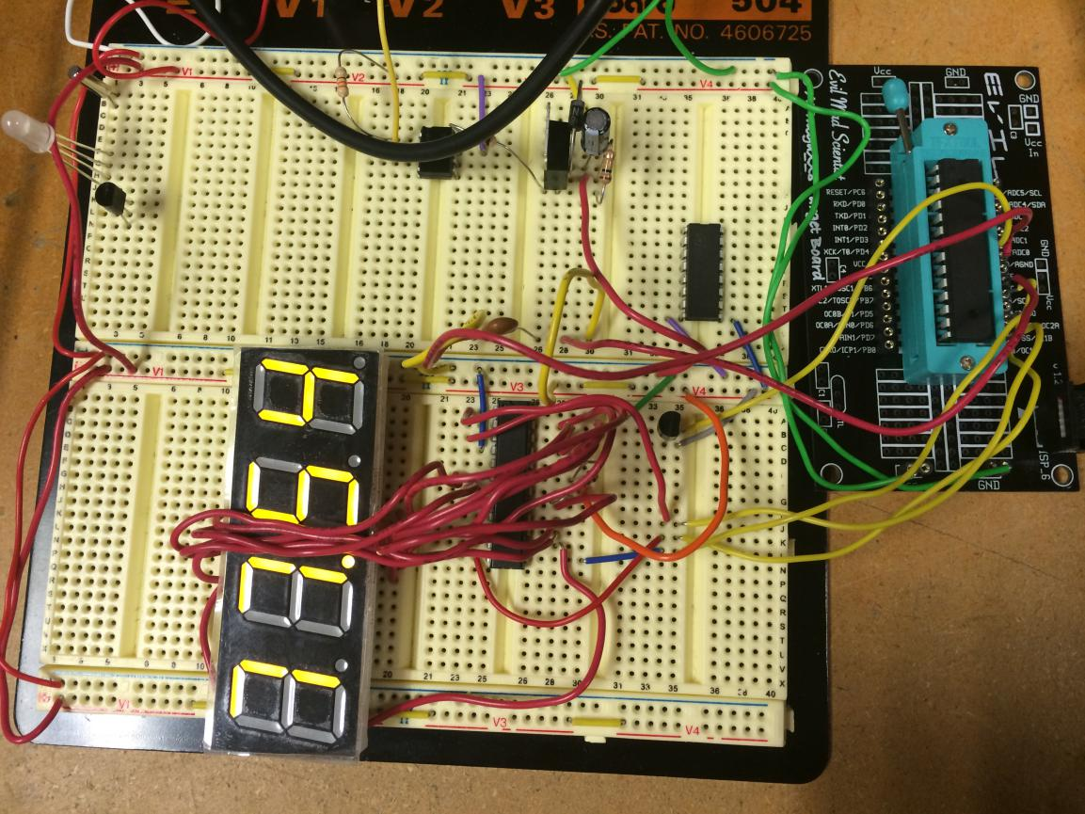

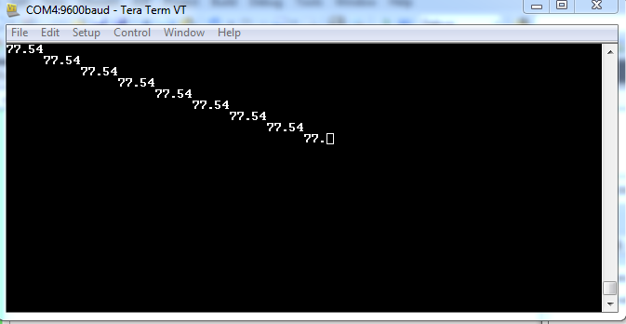
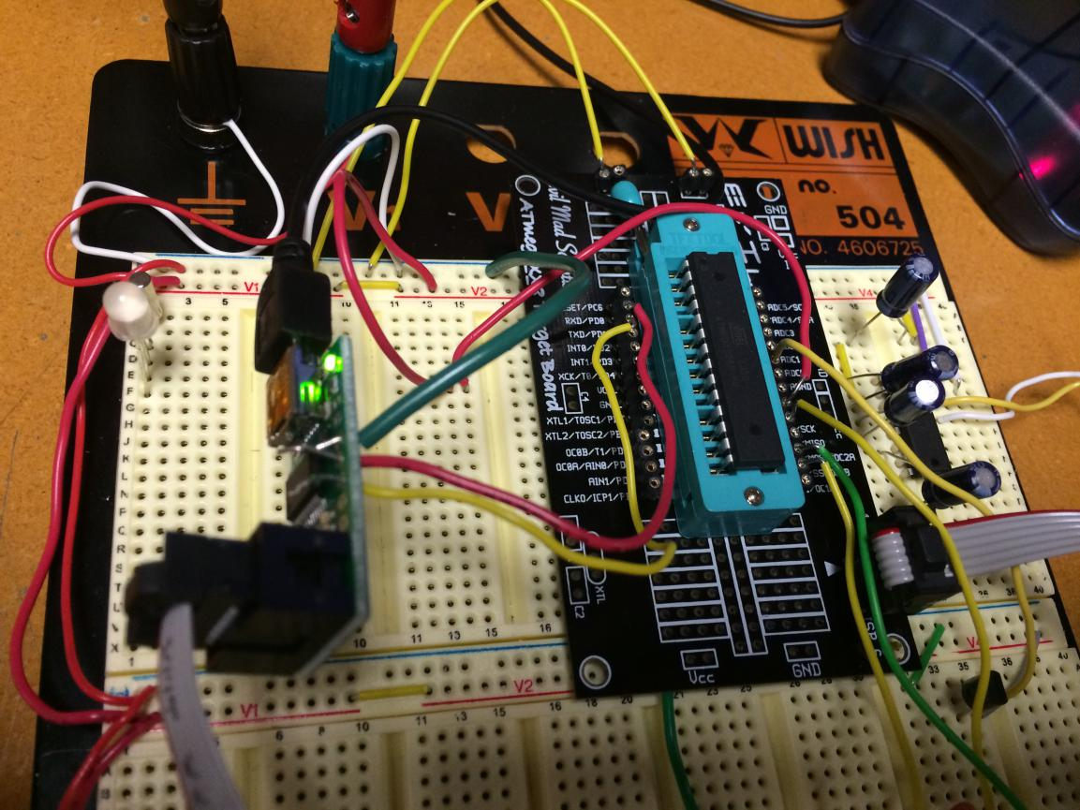

Video: http://youtu.be/hT94mosvcYM

