Ting Yu
CPE 301
Design Assignment 3
#include <avr/io.h>
#include <avr/interrupt.h>

volatile uint8_t count = 0;

int main(void)
{

DDRD = 0b11000000; //make PD6 and PD7 as output
DDRB = 0b11111111; //Port B as output for the counter
TCCR1A = 0b01000000;
TCCR1B = 0b00001011; //CTC mode prescaler 64
TIMSK1 = 0b00000010; //timer1 interrupt mask reg
OCR1A = 7812;

TCCR0A = 0b00000000;
TCCR0B = 0b00000111; //set external clock source
EIMSK = 0x01; //enable int0 as interrupt
EICRA = 0x02; //trigger on falling edge
sei(); //enable interrupt

while(1)
{
//wait for interrupt
PORTB = TCNT0; //output the count to Port B
}
}

ISR (INT0_vect)
{
//This will call every falling edge of INT0
count++;
if (count == 16)
{
count = 0;
PORTD ^= 1<<7; //output to 9th bit LED
}
}

ISR (TIMER1_COMPA_vect)
{
TCNT1 = 0;
PORTD ^= 1<<6; //Toggle PD6, connect to PD4 for timer0 clock input
}

Flowchart:
-Initialize the timers, interrupts
-set all the pins need

-Check rising edge of timer1

-Toggle the 9th bit LED
-Reset count

-Increment timer0

else

-IF interrupt, then enable -interrupt for Timer 0

-check if count = 16

else

-Reset timer1

Simulation:
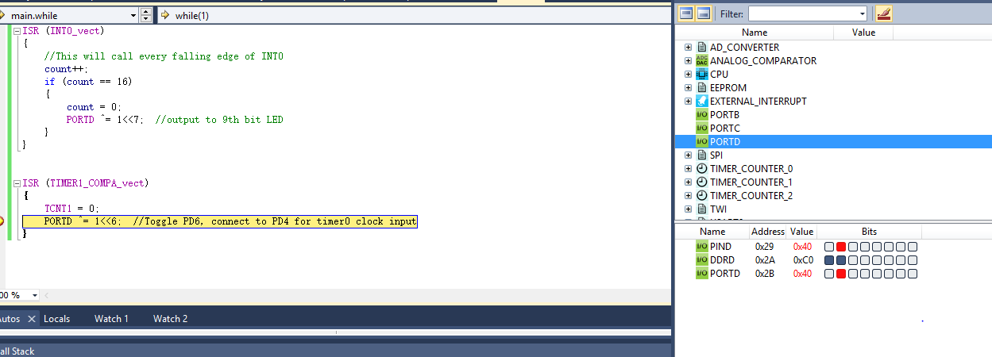

Circuit board:
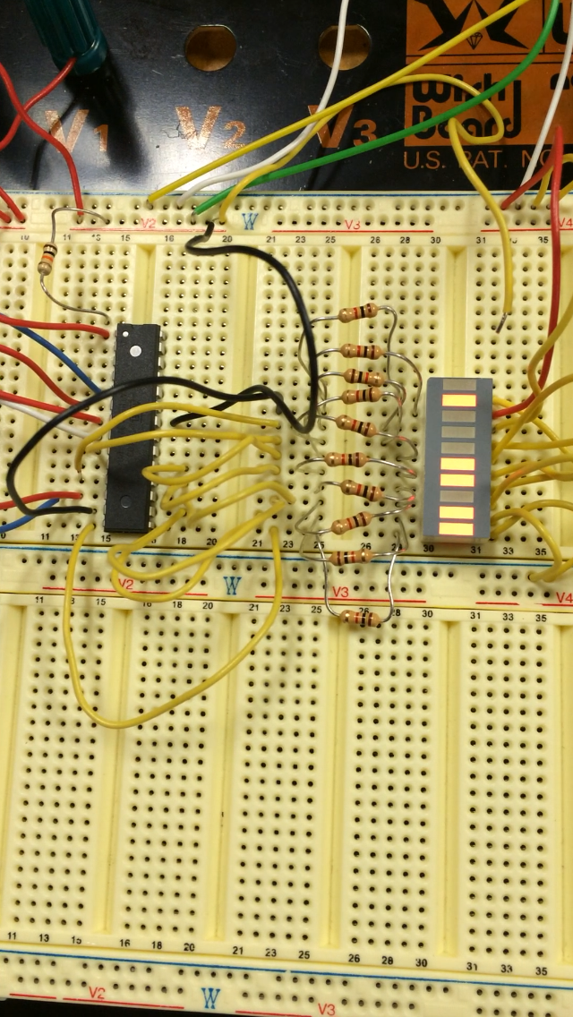
Video:
http://www.youtube.com/watch?v=GQ0_zxMZQt0

