Ting Yu
CPE 301
Design Assignment 7

/*
* DA7.c
*
* Created: 4/22/2014 11:31:09 PM
* Author: tingyu
*/

#define F_CPU 1000000UL
#include <avr/io.h>
#include <util/delay.h>
#include <stdio.h>
#include <avr/pgmspace.h>
#include "nokia5110.h"
#include "main.h"

int main()
{

LcdInit(); //initialize LCD
LcdContrast(0x7F); //display image
_delay_ms(1000);
LcdClear();

LcdContrast(0x3F); //adjust contrast
_delay_ms(1000);
LcdClear();

LcdImage(waitImage); //wait image
LcdUpdate();
_delay_ms(4000);

ADCSRA |= (1<<ADEN)|(1<<ADPS0)|(1<<ADPS1)|(1<<ADPS2); //enable ADC and select clk/128
ADMUX |= (1<<REFS0)|(1<<ADLAR); //Vref, ADC0 as input
DDRC = 0x00;

uint16_t temp, temp1, temp2, temp3;

while (1)
{
ADCSRA |= (1<<ADSC); //begin conversion
while(!(ADCSRA &(1<<ADSC))==0); //wait for end of conversion
temp=(ADCH<<8)|ADCL;
//calculation for temperature
temp1 = temp%10;
temp2 = temp%100/10;
temp3 = temp%1000/100;
char digit[4];
sprintf(digit, "%d%d.%d ", temp1, temp2, temp3); //display temperature
LcdClear();
LcdGotoXYFont(1,1);
LcdFStr(FONT_1X,(unsigned char*)digit);
LcdGotoXYFont(1,2);
LcdFStr(FONT_1X,(unsigned char*)PSTR ("Fahrenheit"));
LcdUpdate();
_delay_ms(1000);
}
return 0;
}

Flowchart:

-Initialize LCD
-Adjust contrast
-Display wait image

-Initialize ADC
-Read in ADC value
-Calculate for temperature value

-Display temperature

Circuit board:
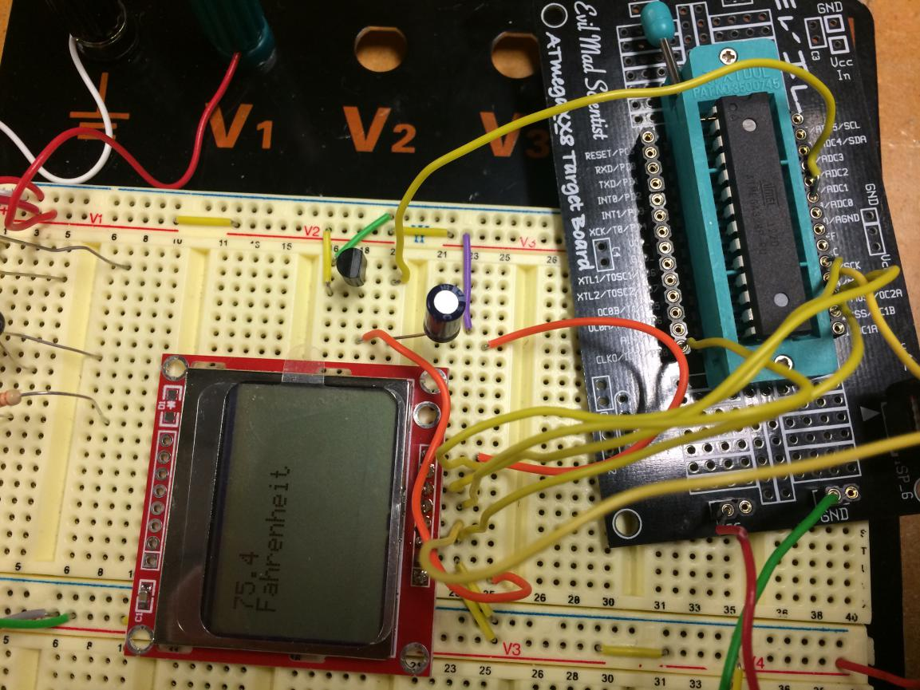

Video:
http://youtu.be/DiXRzBoNVYM

