Ting Yu
CPE 301
Design Assignment 4

Code:
#define F_CPU 1000000UL //XTAL = 1 MHz
#include <util/delay.h> //util, delay library
#include <avr/io.h> // library for avr/io
int main ()
{
while (1) //wait here forever after dimming is done
{
unsigned char R, G, B; // var declarations
DDRB = 0xFF; //PB3 as output
R = 255; // R set to 255
B=0; //B set to 0
OCR1A = 255; //duty cycle = 50%
TCCR1A = 0xC1; //Phase Correct PWM, inverted, N = 64
TCCR1B = 0x03;
OCR2A = 255; //duty cycle = 50%
TCCR2A = 0xC1; //Phase Correct PWM, inverted, N = 64
TCCR2B = 0x03;
OCR0A = 127; //duty cycle = 50%
TCCR0A = 0xC1;
TCCR0B = 0x03;

while (R != 0 ) // start loop2
{
OCR1A = R;
_delay_ms(10); //use AVR studio library delay
while (B !=255)
{
OCR2A = B;
_delay_ms(10);
B++; // B is incremented
}
R--; // R is decremented
}

DDRB = 0x02; //PB3 as output
DDRD = 0xff;
R = 255; // R set to 255
G=0; // G is set to 0
OCR1A = 255; //duty cycle = 50%
OCR2A = 127; //duty cycle = 50%
OCR0A = 255; //duty cycle = 50%

while (R != 0 ) // starts loop 3
{
OCR1A = R;
_delay_ms(10); //use AVR studio library delay
while (G !=255) //start of 4th loop
{
OCR0A = B;
_delay_ms(10); //delay of 25ms
G++; //G is incremented
}
R--; // R is decremented
}

DDRB = 0x04; //PB3 as output
DDRD = 0xff;
R = 255;
G=0;
OCR1A = 127; //duty cycle = 50%
OCR2A = 255; //duty cycle = 50%
OCR0A = 255; //duty cycle = 50%
while (R != 0 ) // stars loop 5th
{
OCR0A = R;
_delay_ms(10); //use AVR studio library delay
while (G !=255) // starts 6th loop
{
OCR2A = B; // sets register to B
_delay_ms(10); // delay of 100ms
G++; // G is incremented
}
R--; // R is decremented
}
}
return 0;
}

Flowchart:
-Variable declaration
-Phase correct PWM mode

-RGB LED use timer 1 to display color red

-RGB LED use timer 1 to display color green
-RGB LED use timer 1 to display color blue

-Increment to get new color

-Increment to get all 255 colors

Simulation:
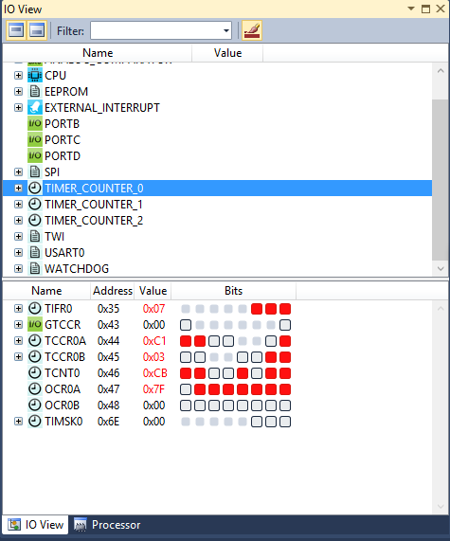
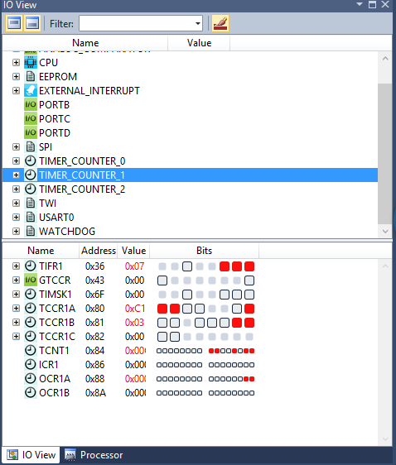

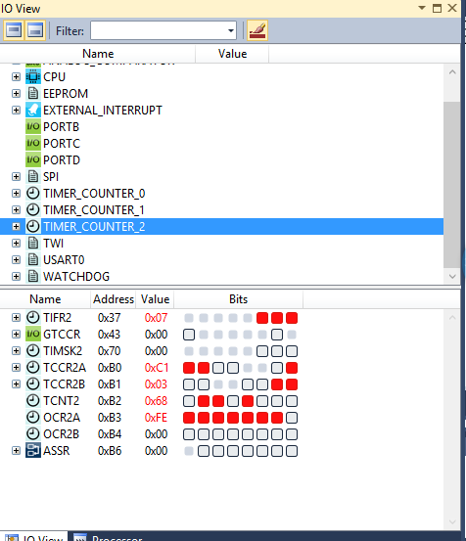

Circuit board:
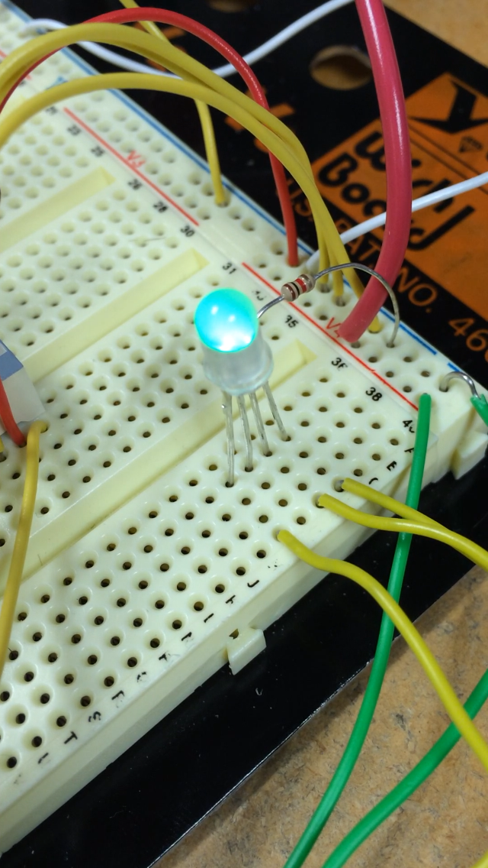

Video:
https://www.youtube.com/watch?v=2j9562XghfM&feature=youtu.be

