Ting Yu
CPE 301
Design Assignment 6

Stepper Motor Code:
#define F_CPU 8000000UL //XTAL = 8 MHZ
#include <avr/io.h> //standard AVR header
#include <util/delay.h> //delay header
void delay_ms(int count);

int main()
{

DDRB = 0xFF; // B ports set
DDRD = 0xFF; // D ports set
DDRC = 0x00; // C ports set
ADCSRA = 0x87;
ADMUX = 0xC0;

while(1)
{

ADCSRA |= (1<<ADSC);
while ((ADCSRA& (1<<ADIF)) == 0); //loop begins

int speed = ADC; // declared int = ADC
speed+= 10;

PORTB = 0x11; //port B set for speed of motor
delay_ms(speed); //delay speed
PORTB = 0x22; //port B set for speed of motor
delay_ms(speed); //delay speed
PORTB = 0x44; //port B set for speed of motor
delay_ms(speed); //delay speed
PORTB = 0x88; //Port B set for speed of motor
delay_ms(speed); //delay speed

}
}
void delay_ms(int count)
{
for (int i=0; i < count; i++)
_delay_ms(1);
}

Servo Motor Code:
#define F_CPU 8000000UL
#include <util/delay.h> //delay header
#include <avr/io.h>
int main()
{
//PORTD pins as input
DDRD = 0x00;
//Enable internal pull ups
//PORTD = 0xFF;
//Set PORTB1 pin as output
DDRB = 0xFF;

DDRC = 0x00; // C ports are set
ADCSRA = 0x87;
ADMUX = 0x40;

//TOP = ICR1;
//output compare OC1A 8 bit non inverted PWM
//Clear OC1A on Compare Match, set OC1A at TOP
//Fast PWM
//ICR1 = 20000 defines 50Hz pwm
ICR1 = 20000;
TCCR1A|=(0<<COM1A0)|(1<<COM1A1)|(0<<COM1B0)|(0<<COM1B1)|(0<<FOC1A)|(0<<FOC1B)|(1<<WGM11)|(0<<WGM10); //TCCR1A = 0x82
TCCR1B|=(0<<ICNC1)|(0<<ICES1)|(1<<WGM13)|(1<<WGM12)|(0<<CS12)|(1<<CS11)|(0<<CS10); //TCCR1B = 0x1A
//start timer with prescaler 8

while(1) //begins loop
{
ADCSRA |= (1<<ADSC);
while ((ADCSRA& (1<<ADIF)) == 0); // begins loop

float speed = ADC;
speed *= 1.8; // speed is calculated
speed+= 530;

OCR1A = speed;
_delay_ms(10); //delay set to 10ms

}
}

Flowchart:

Stepper motor Servo Motor

-Enable Port B for output
-Enable Port C for input
-Initialize ADC
-Enable Port D & C for input
-Enable Port B for output
- Initialize ADC

-Start Conversion
-Read in ADC value
-Determine delay/speed

-Start Conversion
-Read in ADC value
-Determine speed

-Rotation of the motor
-Rotation of the motor

Circuit board:
Stepper Motor
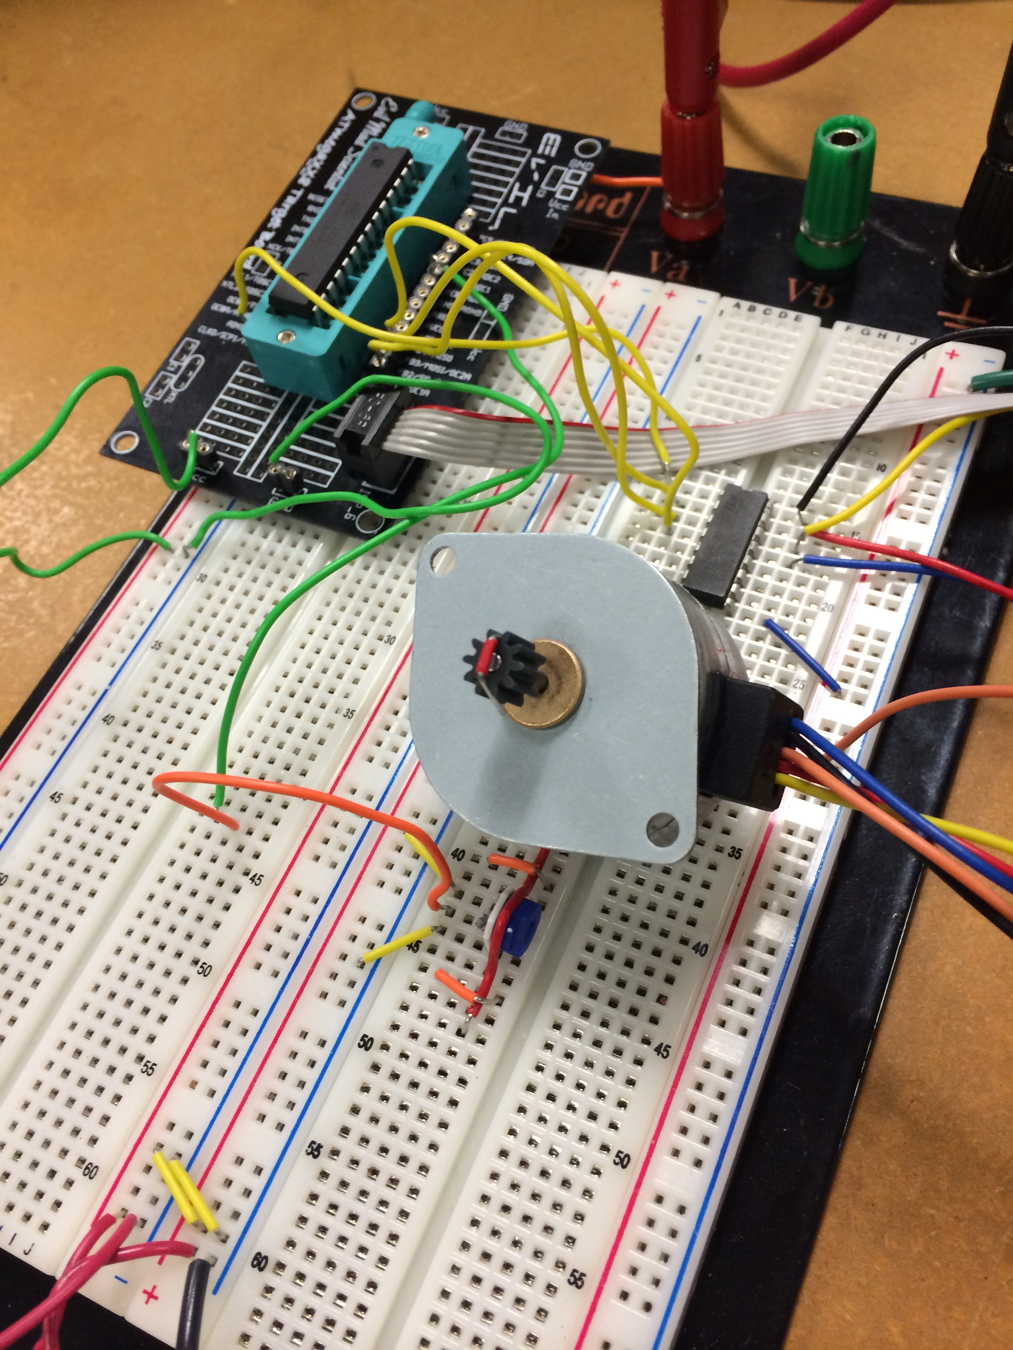

Servo Motor
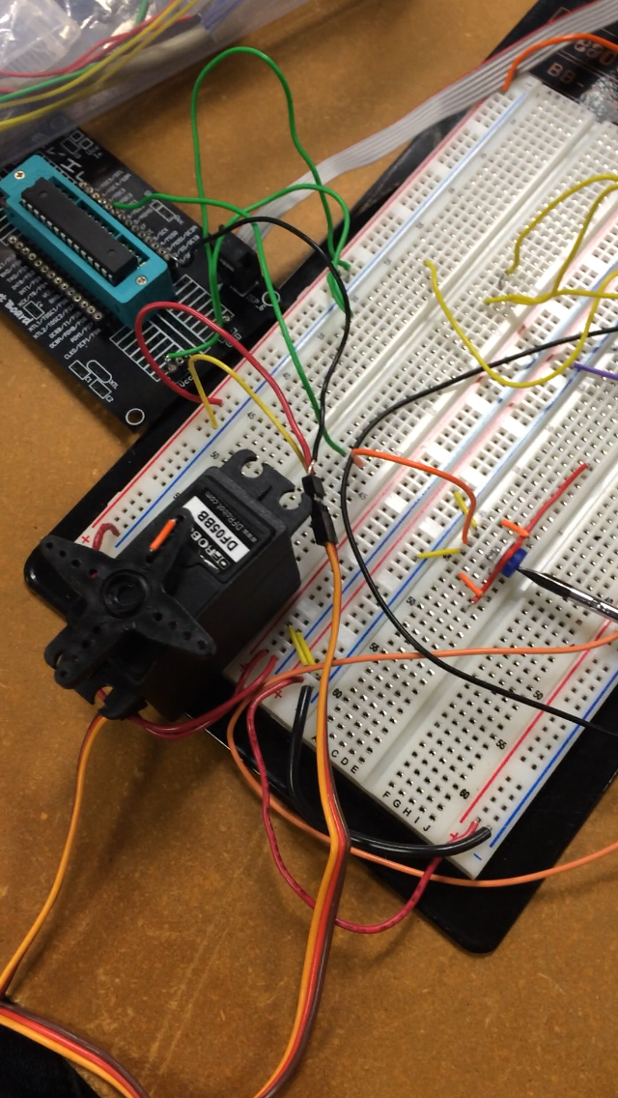

Video:
Stepper Motor: http://youtu.be/9_bcxSty6qc
Servo Motor: http://youtu.be/NCZ7_Sk5zuE

