In this section, we provide numerical results for the cellular-only method in the first two sub-problems, the proposed D2D method in the third sub-problem, and a reference greedy cellular-only method, which based on current CSI only. In the reference cellular-only method, in each time slot, we find and choose  ships that have highest transmission speed under given BS broadcast power and current CSI.

As for the simulation parameters, the BS is located in the central position at the  plane, while the ships traverse along two intersecting shipping lanes. Moreover, the two lanes have same amount of ships. Ships leave the harbors every 15 minutes, and all sail at the speed of . We assume that the system uses a carrier frequency of , and has 3 subcarriers, which have identical bandwidth . The BS power for cellular-only transmission is set to be  whereas the ships have  for D2D transmission, since they are arguably smaller in size. The antenna height of the BS and the ships is  and  respectively. The power density of the additive white Gaussian noise is .

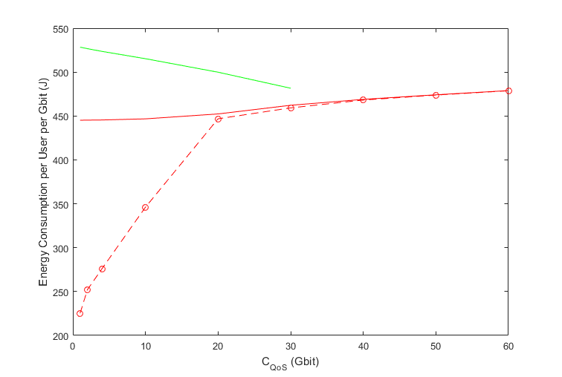

Fig. xx shows the bit-wise average power consumption under different QoS constraint.  

As we can see, our proposed D2D method outmatches the cellular-only method and the reference method, especially when there is a smaller QoS constraint. When the QoS constraint is , the D2D method consummates 50% less energy than the cellular-only method. The proposed D2D method’s energy consumption approaches the cellular-only method as the QoS constraint gets larger. This is because the cellular-only part in first two sub-problems might take up too many time slots and left the D2D method in the third sub-problem few time slots with feasible D2D links to choose from.

The reference method’s energy consumption decreases as the QoS constraint get larger, while the proposed methods’ energy consumptions increase. The decrease in reference method’s energy consumption is because the reference method is a greedy one, and it aims to meet the QoS constraint as soon as possible. When the QoS constraint is smaller, the reference method may choose many time slots with relatively low  and can still satisfy the QoS constraint. When the QoS constraint gets larger, the reference method has to choose more time slots, and therefore the ratio of time slots with relatively low  to total chosen time slots decreases. Thus, the reference method’s energy consumption per user per Gbit decreases.

The rise in proposed methods’ energy consumption is because the proportion of chosen time slots with relatively low speed gets larger when the QoS constraint increase. Moreover, the reference method can only meet the QoS constraint of  while our proposed method can serve as much as .

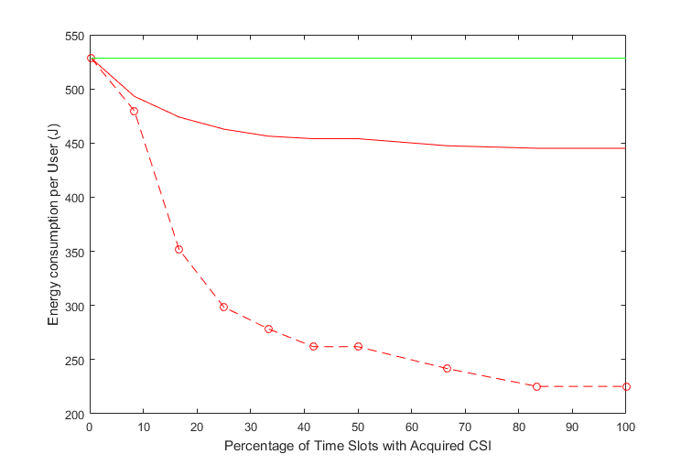

Fig. xx demonstrates the relationship between average energy consumption and the percentage of time slots whose CSI we can acquire in advance. The QoS constraint here is .

When we can only acquire present CSI, our proposed method retrogresses to the reference method. The longer can we predict the CSI, the more feasible transmission time slots we can choose from in our method and therefore the more improvement we can get from our process-oriented D2D and cellular-only methods.

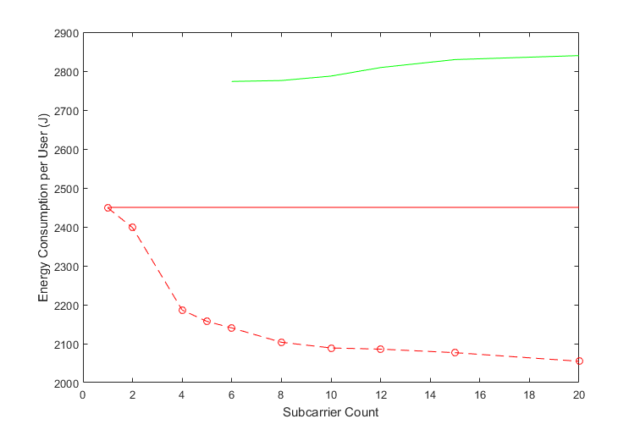

Average energy consumption count versus total subcarrier is shown in Fig. xx. Half of the ships in the system randomly choose their shipping lane within the BS coverage, while the other half still traverse along the shipping lanes at . The QoS constraint here is for traversing ships and  for ships that hold still.

When there is only 1 subcarrier, our proposed D2D method’s average energy consumption is very close to the cellular-only method. This is because the QoS constraint is relatively large and hence cellular-only method takes up too many time slots since there being only 1 subcarrier. As a result, there are few time slots available for the D2D optimization.

Our proposed D2D method gets better when there are more subcarriers. The reference cannot meet the QoS need until there are more than 5 subcarriers. Since the reference method is a greedy one and aims to meet the QoS need as soon as possible, its average energy consumption gets larger as the subcarriers increases.

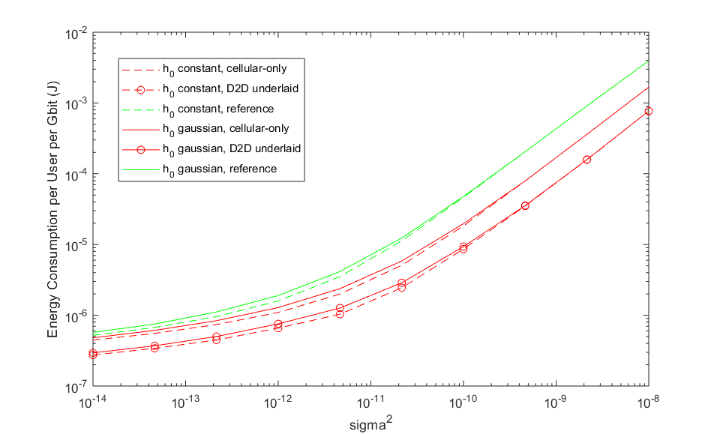

Fig. xx shows average energy consumption versus noise function . While energy consumptions increase as the noise rises, the gap between large-scale fading approximation ( constant) and the actual channel ( gaussian) shrinks. The increase in energy consumption is due to the worsening in CSI.



When carrying out the large-scale estimation, we approximate  in xx where  and . Since when ，the estimations is smaller than the original ones when  is concerned. Therefore, the energy consumptions with the large-scale fading estimation are smaller than the original ones, just as showed in Fig. xx.

Since the large-scale fading approximation is based on a low SNR assumption, as the noise function  increases, the proposed large-scale fading estimations approximate the original ones in energy consumption. These characteristics justify our large-scale fading estimation. 