In this section, we provide numerical results for the proposed D2D method, the non-D2D method, and a reference greedy non-D2D method, which based on current CSI only. In the reference non-D2D method, in each time slot, we find and choose  ships that have highest speed under given BS power and current CSI.

As for the simulation parameters, the BS is located in the central position at the  plane, while the ships traverse along two intersecting shipping lanes. Moreover, the two lanes have same amount of ships. Ships leave the harbors every 15 minutes, and all sail at the speed of . We assume that the system uses a carrier frequency of , and has 3 subcarriers, which have identical bandwidth . The BS power for non-D2D transmission is set to be  whereas the ships have  for D2D transmission, since they are arguably smaller in size. The antenna height of the BS and the ships is  and  respectively. The power density of the additive white Gaussian noise is .

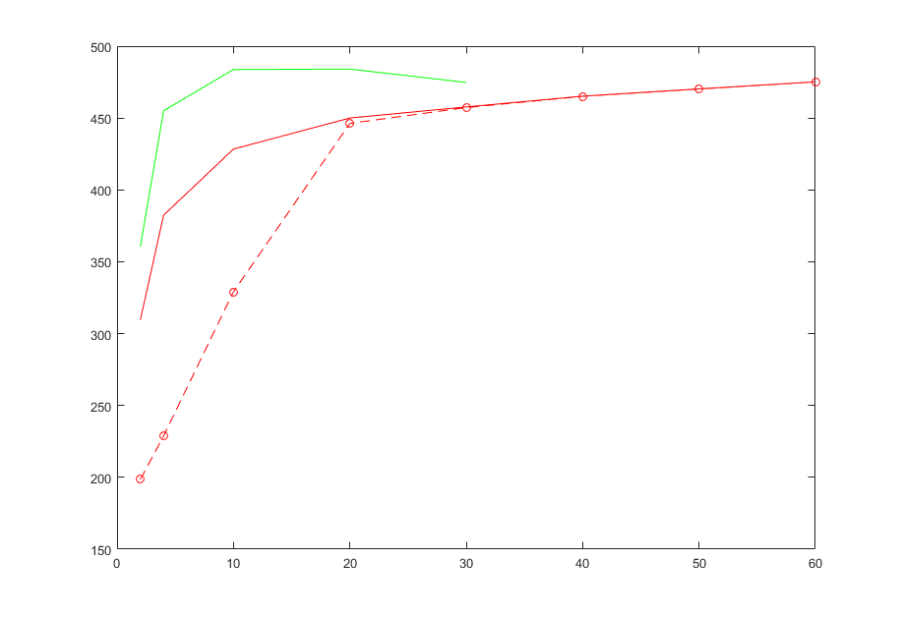

Fig. xx shows the bit-wise average power consumption under different QoS constraint. As we can see, our proposed D2D method outmatches the non-D2D method and the reference method, especially when there is a smaller QoS constraint. The proposed D2D method approaches the non-D2D method when the QoS constraint gets relatively large. This is because the non-D2D part might take up too many time slots and left the D2D method few time slots with feasible D2D links to choose from. The reference method’s energy consumption first increases and then decreases as the QoS constraint get larger, while the proposed methods’ energy consumptions get larger and approach the reference one. The reference method’s energy consumption decreases after the QoS constraint gets larger than . This is because the reference method is a greedy one, and it aims to meet the QoS constraint as soon as possible. The rise in proposed methods’ energy consumption is because the proportion of chosen time slots with relatively low speed gets larger when the QoS constraint increase. Moreover, the reference method can only meet the QoS constraint of  while our proposed method can serve as much as .

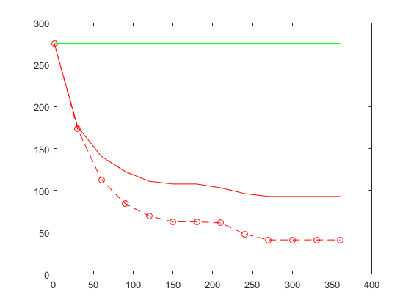

Fig. xx demonstrates the relationship between average energy consumption and the number of time slots whose CSI we can acquire in advance, i.e., the time range . The QoS constraint here is . When we can only acquire present CSI, our proposed method retrogresses to the reference method. The longer can we predict the CSI, the more feasible transmission time slots we can choose from in our method and therefore the more improvement we can get from our process-oriented D2D and non-D2D methods.

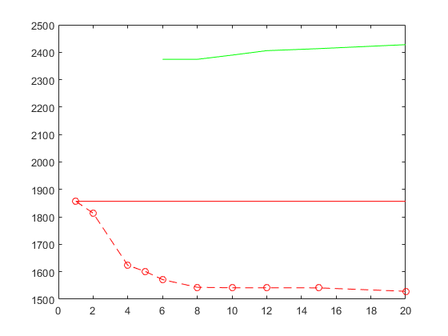

Total subcarrier count versus average energy consumption is shown in Fig. xx. Half of the ships in the system hold still in the BS coverage, while the other half still traverse along the shipping lanes at . The QoS constraint here is . When there is only 1 subcarrier, our proposed D2D method’s average energy consumption is very close to the non-D2D method. This is because the QoS constraint is relatively large and hence non-D2D method takes up too many time slots since there being only 1 subcarrier. As a result, there are few time slots available for the D2D optimization. Our proposed D2D method gets better when there are more subcarriers. The reference cannot meet the QoS need until there are more than 5 subcarriers. Since the reference method is a greedy one and aims to meet the QoS need as soon as possible, its average energy consumption gets larger as the subcarriers increases.