A Report on

Big Data Analysis Using HADOOP and MAPREDUCE

Submitted for partial fulfillment of award of

BACHELOR OF TECHNOLOGY

degree

In

Computer Science & Engineering

By

Ila srivastava(1103010073)
Surbhi Singh(1103010159)
Shailaja Chaudhary(1103010130)
Swati Shukla(1103010162)

Under the Guidance of
Dr. Pooja Tripathi



INDERPRASTHA ENGINEERING COLLEGE, GHAZIABAD,

UPTU, LUCKNOW

DECEMBER,2014

Certificate

This is to certify that this project entitled “Big Data Analysis using Hadoop and MapReduce” for the award of Bachelor of Technology from Inderprastha Engineering College, Ghaziabad, under my supervision. The report embodies result of original work and studies carried out by Student herself and the contents of the report do not form the basis for the award of any other degree to the candidate or to anybody else.

Mentor:

(Dr. Pooja Tripathi)

Date:

Acknowledgement

We take this opportunity to thank our teachers and friends who helped us throughout the project.

First and foremost I would like to thank my guide for the project (Dr. Pooja Tripathi, Computer Science Department) for her valuable advice and time during development of project.

We would also like to thank (HOD Prof. Ram Gopal Varma, Computer Science Department) for his constant support during the development of the project.

DECLARATION
I hereby declare that this submission is my own work and that, to the best of my knowledge and belief, it contains no material previously published or written by another person nor material which to a substantial extent has been accepted for the award of any other degree or diploma of the university or other institute of higher learning, except where due acknowledgment has been made in the text.

Name:
Ila Srivasatava(1103010073)
Surbhi Singh(1103010159)
Shailaja Chaudhary(1103010130)
Swati Shukla(1103010162)

Abstract

Big data is the term for the collection of data sets so large and complex that it has become difficult to process using on-hand database management tools or traditional data processing applications.
Organizations are generating huge amount of data. This data is related to three dimensions .The 3 V’s of big data which are required for big data analysis.
- Volume –data has large volume.
- Variety-data is coming from different sources and in many formats.
- Velocity-high speed at which large data is being generated and the speed it needs for processing.
The aim of the project is to study about big data and related technologies.
Hadoop gives us a way to store data in distributed system known as Hadoop Distributed File System (HDFS) and a way to process data by a way called Map Reduce.
In our project, we analyse the logs of a store chain and access logs of a website to perform operations on them.
● We study the transaction logs of a store chain and web access logs of a website.
● In the store logs we have the details of all the transaction in text form. We analyse these logs to get the sales per category, highest sales per store, total number of sales/ total value of sales.
● In the web access logs of a website, we find the number of hits to a page, number of hits by an IP and the most popular page.
● We have later built a GUI based Java application for this. The user will be presented with a form in which he is required to browse the required log file. Once the file is selected he is required to upload it to the hadoop cluster. Once the user presses the analyze button, the logs are analyzed and the results are shown on the screen.

The project is divided into following basic modules:
(i) Mapper program: Mapper code is written in python programming language. It reads the log file and extracts the required details from it and at the same time discards faulty data from it. The output of the mapper is sorted and fed to reducer program.
(ii) Reducer Program: Reducer code is written in python programming language. The mapper program reads the sorted output from mappers and processes it to produce the output.The project will run on any Linux OS with Hadoop cluster, Java and Python installed on it.

TABLE OF CONTENTS

Certificate i

Acknowledgement ii

List of Figures iii

Abstract iv

CHAPTER TITLE

Chapter 1: INTRODUCTION

1.1 Project background
1.2 Objective and Scope
1.3 Software Development Model Selection
1.4 Development requirements
1.5 Problem Statement and Proposed Solution

Chapter 2: PREPARATION
  - Introduction
    - What is big data?
  - Big Data Analysis
2.2.2 The 3 V’s of Big Data

Chapter 3: REQUIREMENT SPECIFICATIONS

3.1 Functional Requirements
3.2 Non Functional Requirements
3.3 Software and Hardware Requirements
3.3.1 Software Requirements
3.3.2 Hardware Requirements

Chapter 4: Technologies Used

  - Cloudera Distribution Including Apache Hadoop
  - Development Software’s Used

Chapter 5 Requirement Analysis and Design
  - Use Case Analysis
5.2 Activity Diagram
Chapter 6: Modules

  - Hadoop MapReduce
  - Hadoop Distributed File System
6.2.1 Name Nodes and Data Nodes
6.3 MapReduce
6.3.1 Mappers
6.3.2 Shuffle and Sort
6.3.3 Reducers

Chapter 7: PROJECT IMPLEMENTATION

  - Basic Block Diagram
  - Development Knowledge
7.2.1 Linux Installation
7.2.2 Python
7.2.3 Java

Chapter 8 CONCLUSION AND FUTURE WORK

8.1 Conclusion
  - Future Work

References

Screen Shots

Code

LIST OF TABLES AND FIGURES

Figure Description
1.1 Graph showing rate of data growth over years
1.2 The grey circles represent tower coverage and red portion represent
dead spot
3.1 MapReduce logical data flow.
3.2 MapReduce data flow with multiple reduce tasks.
5.1 CDH architecture
6.1 Use Case Diagram Components
6.2 Use Case Diagram 6.3 A client reading data from HDFS
6.4 A client writing data to HDFS
6.5 Hadoop Process Activity Diagram
6.6 Application Activity Diagram
6.7 Application data flow diagram
8.1 Basic Block Diagram

CHAPTER 1

INTRODUCTION

  - Project Background

Big data basically refers to a collection of data sets or information too large and complex to be processed by standard tools. It is about the art and science of combining enterprise data, social data and machine data to derive new insights, which are otherwise not possible. It is also about combining past data with real-time data to predict outcomes.

In this project we have used hadoop ecosystem provided by cloudera to analyze big data log files of a store as well log files of a website and we have analyzed both these log files. Using hadoop technology we were able to determine many information from this large set of data, for example we were able to determine the store to make highest sales from the given set of stores, similarly this technique was used to determine many other result.

We have used java for building the graphic user interface of our application, in this application the user can select the log file to be processed using hadoop, and this file is then uploaded on to the hadoop server and then analyzed using three step process.

  - Objective and scope:

Big data have a key role to play in analysis of several business domains like healthcare, automotive, insurance, banking, consumer products, oil and gas, energy and utilities, retail, e-commerce applications etc.
● The objective of our project is to study the transaction logs of a store chain and web access logs of a website.
● In the store logs we have the details of all the transaction in text form. We analyse these logs to get the sales per category, highest sales per store, total number of sales/ total value of sales.
● In the web access logs of a website, we find the number of hits to a page, number of hits by an IP and the most popular page.
● We have later built a GUI based Java application for this.

  - Software Development Model selection

Several models exist to streamline the development process. Each one has its pros and cons, and it's up to the development team to adopt the most appropriate one for the project.

1.3.1 Iterative and incremental development

Iterative development prescribes the construction of initially small but ever-larger portions of a software project to help all those involved to uncover important issues early before problems or faulty assumptions can lead to disaster.

1.3.2 Agile development

Agile software development uses iterative development as a basis but advocates a lighter and more people-centric viewpoint than traditional approaches. Agile processes use feedback, rather than planning, as their primary control mechanism.
We chose to follow the iterative method, the steps that we followed are listed below:
● In the first step we created a command line application for analyzing the log files of stores
● In the second step we created a command line application for analyzing the log files of a website
● In the third step we created a GUI application for performing the analysis of the store logs as well the website logs

  - Development Requirements

1. Operating System: Linux(Cent OS)
2. Programming Languages: Java, Python
3. Softwares:
- Eclipse-Juno
- Python IDLE IDE
- Java runtime environment
- Oracle Virtual Box
4. Testing and Debugging: Testing and debugging done on oracle Virtual box on a linux machine

  - Problem Statement and Proposed Solution :

Today there are a number of organizations generating huge amount of data and according to statistics by IBM it has been estimated that more than 90 %of the data in the world today has been created in last two years alone.

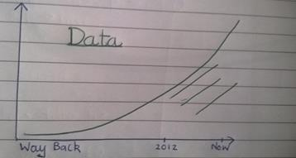

Fig 1.1 Graph showing
rate of data growth over years

For instance if we take the example of our cell phone whenever it is switched on it tries to connect to the nearest cell tower to get reception and depending upon our distance from the cell tower different signal strength is received in our cell phones, in a day we may be travelling to many locations and at each location this data is collected by the carrier company and this data is collected for each user using the sim card of the company. This data comes in handy while calculating the dead spots in the region and hence helps to find region that need more cell towers for better
Big Data Analysis Using Hadoop and Map-Reduce
connectivity to its users. So discarding this seemingly unimportant data may be a bad idea.

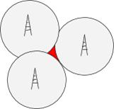

Fig 1.2 The grey circles represent tower coverage and red portion represent dead spots

With the amount of data increasing every day, the companies need to come up with ways to handle, store and process data. We need to be able to store the data in a cost-effective way, and to be able to process it efficiently which is not an easy problem to solve when we’re talking about large amounts of data.

CHAPTER 2

PREPARATION

2.1 Introduction

One typical drive from 1990 could store 1,370 MB of data and had a transfer speed of 4.4 MB/s, so you could read all the data from a full drive in around five minutes. Over 20 years later, one terabyte drives are the norm, but the transfer speed is around 100 MB/s, so it takes more than two and a half hours to read all the data off the disk.

This is a long time to read all data on a single drive—and writing is even slower. The obvious way to reduce the time is to read from multiple disks at once.

2.1.1 What is Big Data?

There’s no one definition for ‘big data’ it’s a very subjective term. Most people consider a data set of terabytes or more to be ‘big data’, but there are certainly people using big data concepts with great success on smaller chunks of data than that. One reasonable definition is that it’s data which can’t comfortably be processed on a single machine.

2.2 Big Data Analysis:

When analyzing big data there are three main things that we take into consideration they are volume, variety and velocity which is often referred to as 3 V’s of big data. Volume refers to the size of data that you’re dealing with, Variety refers to the fact that the data is often coming from lots of different sources and in many different formats, and Velocity refers to the speed at which the data is being generated, and the speed at which it needs to be made available for processing.

2.2.1 The 3 V’s of Big Data Analysis

(i) Volume:

This refers to the amount of data that is generated by a company during a particular period.

The price to store data has dropped incredibly over the last 60 years. In 1980, the cost per gigabyte was several hundred thousand dollars. In 2013, it’s well under 10 cents.
(ii) Variety:

Second thing that we take into consideration is variety. For a data warehouse to effectively process information, all the information has to fit nicely into a predefined set of tables. The problem is that these days, lots of the data that we want to store is what we tend to call ‘unstructured data’, or ‘semi-structured data’ .By ‘unstructured’, we mean the data arrives in lots of different formats.

(iii) Velocity

The last of the three V’s is velocity , this refers to the rate at which new data is received and is ready to be processed

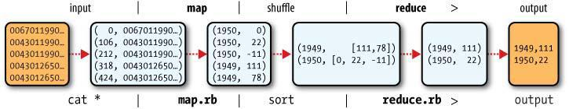

Fig 3.1 MapReduce logical data flow

CHAPTER 3

REQUIREMENT SPECIFICATION

3.1 Functional Requirements

The application should satisfy the following functional requirements:

  - Allow user to select a log file to upload on hadoop server

  - Among the given analysis option allow the user to select one of the radio button which mentions the task that needs to be done

  - Perform the required MapReduce job

  - Show the final result to the user in a label in the gui application

  - Non-Functional Requirements

Performance- The system should be prompt in response to user actions, the application should have minimum lag time.

Usability– The user interface of the application should fairly simple for any user to understand. The wordings and buttons should be of visible size to the user.

Dependency– The application should have a network connection

Backward Compatibility– The application should function without any faults on a system on which hadoop ecosystem is installed correctly and also it has appropriate mapper and reducer file to process uploaded logs.

Recovery– The application should be able to recover from an error upon re-launch and the data should rollback to the state prior to the error.

3.3 Software and hardware requirements

3.3.1 Software requirements

(i) Cent OS :

CentOS (abbreviated from Community Enterprise Operating System) is a Linux distribution that attempts to provide a free enterprise class computing platform which aims to be 100% binary compatible with Red Hat Enterprise Linux (RHEL)

Virtual Box: Virtual Box is a powerful x86 and AMD64/Intel64 virtualization product for enterprise as well as home use.

- Gedit text editor

Gedit is the default text editor of the GNOME desktop environment and part of the GNOME Core Applications.

(iv) Eclipse

In computer programming, Eclipse is an integrated development environment (IDE).

(v) Java runtime Environment

The Java Runtime Environment (JRE), also known as Java Runtime, is part of the Java Development Kit (JDK), a set of programming tools for developing Java applications.

(vi) Linux Operating System

Linux is a popular open source operating system as its source code is freely available. It is free to use. Linux was designed considering UNIX compatibility. It's functionality list is quite similar to that of UNIX.

(vii) Python 2.5 or above

Python is a general-purpose interpreted, interactive, object-oriented and high-level programming language.

3.3.2 Hardware requirements

Although Hadoop is designed to run on industry-standard hardware, recommending an ideal cluster configuration is not as easy as delivering a list of hardware specifications. Selecting hardware that provides the best balance of performance and economy for a given workload requires testing and validation.

CHAPTER 4

TECHNOLOGIES USED

4.1 CDH (Cloudera Distribution Including Apache Hadoop):

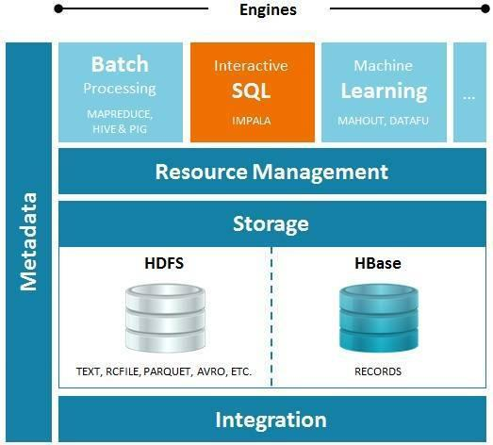

Fig 4.1 : CDH architecture
CDH delivers the core elements of Hadoop – scalable storage and distributed

computing – along with additional components such as a user interface, plus

necessary enterprise capabilities such as security, and integration with a broad

range of hardware and software solutions.

4.2 Development Software’s used:

The project runs on Linux operating system(Cent OS in our case). The mapper and reducer codes written in python programming language. The development environments used in development of mappers and reducers is IDLE python IDE. We chose IDLE because it is the free default and the most easy development environment available.

- Operating System: Linux (Cent OS)

- Programming Languages: Java, Python
- Softwares

  - Eclipse-Juno

  - Python IDLE IDE

  - Java Development Kit

  - Oracle Virtual Box

4.Testing and Debugging:

Testing and debugging done on oracle Virtual box on a linux machine

5. Selection of development environment

We have used Eclipse for writing and running our source code. In the Java development community, there are two main Integrated Development Environments (IDEs): Eclipse, which is associated with IBM and NetBeans which is a Sun/Oracle environment.

CHAPTER 5

REQUIREMENT ANALYSIS AND DESIGN

This chapter describes the design approach for the application using Use Case Diagram and Activity Diagram. The design of the system is essentially important and must be done in great detail as it will be the basis for future system implementation. The requirements and design approach together has been discussed in the chapter.

5.1 Use Case Diagram

Use case approach uses a combination of text and pictures in order to understand the requirement of the system. Use cases are templates for the description of user requirements in a structured way.

The following components are used in this approach:-
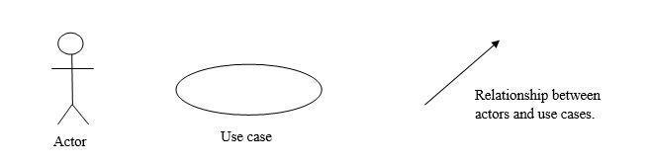

Fig 6.1: Use Case Diagram Components

Actor- An actor or external agent, maybe person or machine that is external to the system model. An actor is represented as a stick figure as shown above. Example of actors is student, administrator, data entity operator etc.

Use cases- Use cases describe sequence of interaction between the actors and the system without going into the internal functionality of the system. Thus use cases tell us who does what with the system and for what purpose.

The following diagram describes the major functionalities of our application.
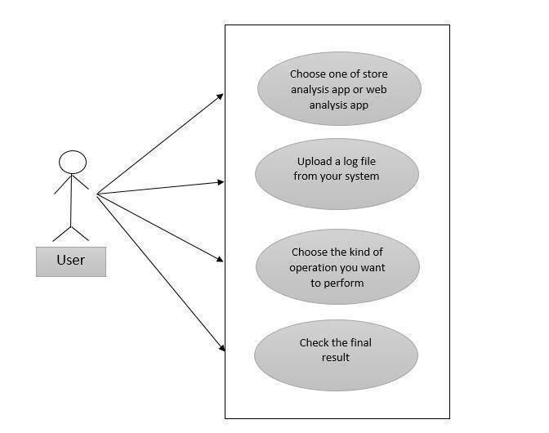

Fig 6.2: Use Case Diagram

5.2 Flow Diagram

A flow diagram is a graphical means of representing or presenting, describing, or analyzing a process. This is done by drawing small boxes which represent sequence and dependency relationships.

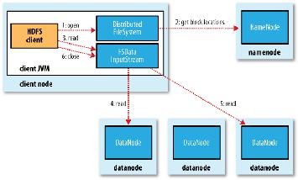

Fig 6.3 A client reading data from HDFS
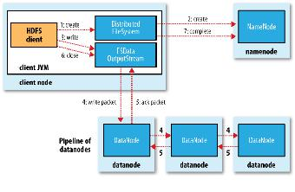

Fig 6.4 : A client writing data to HDFS

5.3 Activity Diagram

Activity is a parameterized behavior represented as coordinated flow of actions. The activity can be described as an operation of the system. Activity diagram is used to describe dynamic aspects of the system. It is basically a flow chart to represent the flow form one activity to another activity. Activity diagrams are not only used for visualizing dynamic nature of a system but they are also used to construct the executable system by using forward and reverse engineering techniques.

The following diagram depicts the activity diagram for our application.
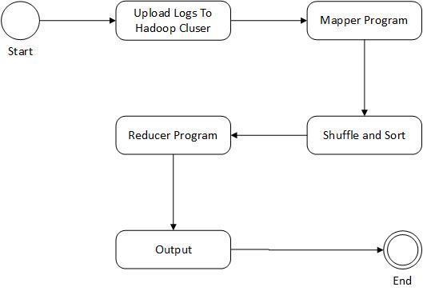

Fig 6.5: Hadoop Process Activity Diagram

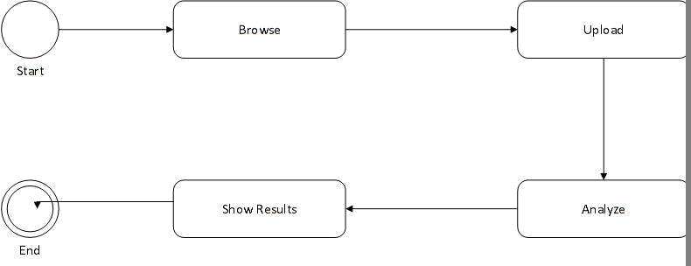

Fig 6.6 Application Activity Diagram

5.4 Data flow diagram

A data flow diagram (DFD) is a graphical representation of the "flow" of data through an information system, modeling its process aspects. Often they are a preliminary step used to create an overview of the system which can later be elaborated. DFDs can also be used for the visualization of data
processing (structured design).

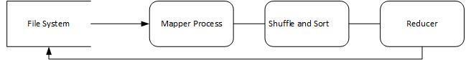

Fig 6.7: Application data flow diagram

CHAPTER 6

MODULES

6.1 Hadoop MapReduce

Hadoop gives us a way to store data in distributed system known as Hadoop Distributed File System (HDFS) and a way to process data by a way called Map Reduce.

6.2 Hadoop Distributed File System (HDFS):

Files are stored in the Hadoop Distributed File System. When a file is loaded into HDFS, it is split into chunks, which are called blocks. Each block is pretty big; the default is 64 megabytes.

As it’s uploaded to the cluster, it is split into 64 megabyte blocks, and each block will be stored on one node in the cluster.

Data nodes contain data in blocks. This data need to be indexed which is done by name nodes. Name nodes are servers keeping track of the data.

6.2.1 Namenodes and Datanodes

An HDFS cluster has two types of node operating in a master-worker pattern: a namenode (the master) and a number of datanodes (workers). The namenode manages the filesystem namespace. It maintains the filesystem tree and the metadata for all the files and directories in the tree. The namenode also knows the datanodes on which all the blocks for a given file are located.Datanodes store and retrieve blocks when they are told to, and they report back to the namenode periodically with lists of blocks that they are storing.

6.3 MapReduce

Processing large files of data serially from the top to the bottom takes a long time. So, mapreduce is designed to parallelly process data, such that the data is split into many pieces, and each piece is processed simultaneously.

Mappers and Reducers
6.3.1Mappers: The Mappers are programs which each deal with a relatively small amount of data, and they all work in parallel. The Mappers output what we call
‘intermediate records’. Hadoop deals with all data in the form of records, and records are key-value pairs.

6.3.2Shuffle and Sort: The shuffle is the movement of the intermediate data from the Mappers to the Reducers and the combination of all the small sets of records together, and the sort is the fact that the Reducers will organize the sets of records into order.

6.3.3 Reducers: The Reduce phase works on one set of records at a time; it gets the key, and then a list of all the values, it processes those values in some way (eg: adding them up) and then it writes out its final data for that key.

CHAPTER 7

PROJECT IMPLEMENTATION

7.1 Basic Block Diagram

The Basic Block Diagram of the application is shown here which contains some modules which have been used in the Application
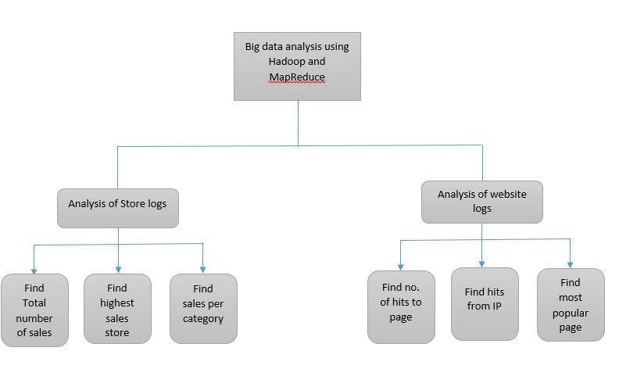

Fig 8.1 Basic Block Diagram

7.2 Development Knowledge

7.2.1 Linux installation

We have developed our program by using cent operating system of Linux, we used this OS within a Virtual box software. So for the development of this application the development team must be able to install Virtual box on the operating system that they are using and then use the cent OS in it provided by cloudera which has hadoop file system image preinstalled in it. Also a user can boot his machine to install cent OS directly and then create a hadoop file system image on it following the required steps

7.2.3 Python

A basic knowledge of python is required for making mapper as well as reducer code, a mapper code will first remove all the new line characters from the uploaded file , it will then split all the all the lines in the file and will then perform the required analysis of the file and will then produce an intermediate file which is then shuffle and sorted , from this sorted file the final result is obtained by passing it to the reducer code.

7.2.4 Java

The front end of our application is created by using java. We have used the swing classes for creating the required graphic user interface. First of all a jframe is used which the parent window is holding all the other components of our application. It comprises of jlabels, jbuttons, jtextarea etc. Filechooser class has also been used to allow user to select and upload a file on to the hadoop file system. A borderlayout has been used to arrange all the components.

CHAPTER 8

CONCLUSION AND FUTURE WORK

8.1 Conclusion

The logs of the website and the store chain were successfully analyzed and the results were displayed using a command line as well as GUI. The mapper code successfully scanned the input logs and gave the required data parallelly. This data was sorted and passed to reducer which processed it to give the required results. Java GUI form was created to display the results in user friendly manner.

8.2 Future Scope

The current application is relevant to be used for analyzing store logs as well as website logs. The results of the current application can be used in a recommender system for a website or they can be used for making strategic decisions about the commodities at stores. What new offers/products should be introduced to attract maximum customers and hence increase profit.

The GUI of the application can be improved to get better user friendly interface. More functionalities can be added to the graphical user interface to show the progress of the ongoing process.

Log file Processing:

Data from log file:
[hadoop@localhost code copy]$ cat testing
2012-01-01 | 09:00 | San Jose |  | Men's Clothing |  |  | 214.05 |  | Amex
2012-01-01 | 09:00 | Fort Worth |  | Women's Clothing |  |  |  | 153.57 |  | Visa
2012-01-01 | 09:00 | San Diego |  | Music | 66.08 |  | Cash
2012-01-01 | 09:00 | Pittsburgh |  | Pet Supplies |  | 493.51 |  |  | Discover
2012-01-01 | 09:00 | Omaha | Children's Clothing 235.63 MasterCard
2012-01-01 | 09:00 | Stockton |  | Men's Clothing |  |  | 247.18 |  | MasterCard
2012-01-01 | 09:00 Austin Cameras 379.6 Visa
2012-01-01 | 09:00 | New York |  | Consumer Electronics |  |  |  |  | 296.8 | Cash
2012-01-01 | 09:00 | Corpus Christi Toys 25.38 |  |  |  |  |  | Discover
2012-01-01 | 09:00 | Fort Worth |  | Toys | 213.88 |  | Visa
2012-01-01 | 09:00 | Las Vegas |  | Video Games |  |  | 53.26 |  | Visa
2012-01-01 | 09:00 | Newark | Video Games |  |  | 39.75 |  | Cash
2012-01-01 | 09:00 | Austin | Cameras |  | 469.63 |  | MasterCard
.

.
.

Mapper Stage:
[training@localhost code copy]$ cat testing | ./mapper.py

San Jose 214.05 Fort Worth 153.57 San Diego 66.08 Pittsburgh 493.51 Omaha 235.63 Stockton 247.18 Austin 379.6

New York 296.8 Corpus Christi 25.38 Fort Worth 213.88 Las Vegas 53.26 Newark 39.75 Austin 469.63 Greensboro 290.82
.

.
.

Shuffle and Sort:

[hadoop@localhost code copy]$ cat testing | ./mapper.py | sort
Anchorage 22.36

Anchorage 298.86 Anchorage 6.38 Aurora 117.81 Austin 327.75 Austin 379.6 Austin 469.63 Boston 418.94 Buffalo 483.82 Chandler 344.09 Chandler 414.08 Chicago 31.08

Corpus Christi 25.38
Fort Wayne 370.55

Fort Worth 153.57

Fort Worth 213.88

.
.
Reducer Stage
[training@localhost code copy]$ cat testing | ./mapper.py | sort |./reducer.py
Anchorage |  | 327.6
Aurora | 117.81
Austin | 1176.98
Boston | 418.94
Buffalo | 483.82
Chandler |  | 758.17
Chicago | 31.08
Corpus Christi 25.38
Fort Wayne |  | 370.55
Fort Worth |  | 367.45
Fremont | 222.61
Fresno | 466.64
Greensboro |  | 290.82
Honolulu |  | 345.18
.
.
.

Running on hadoop cluster:
[hadoop@localhost code copy]$ hs mapper.py reducer.py myinput output1

packageJobJar: [mapper.py, reducer.py, /tmp/hadoop-training/hadoop-unjar6006705902046172643/] [] /tmp/streamjob182306253508586944.jar tmpDir=null

14/03/20 21:12:20 WARN mapred.JobClient: Use GenericOptionsParser for parsing the arguments. Applications should implement Tool for the same.

14/03/20 21:12:21 WARN snappy.LoadSnappy: Snappy native library is available 14/03/20 21:12:21 INFO snappy.LoadSnappy: Snappy native library loaded 14/03/20 21:12:21 INFO mapred.FileInputFormat: Total input paths to process : 1

14/03/20 21:12:22 INFO streaming.StreamJob: getLocalDirs(): [/var/lib/hadoop-hdfs/cache/training/mapred/local] 14/03/20 21:12:22 INFO streaming.StreamJob: Running job: job_201403201550_0002

14/03/20 21:12:22 INFO streaming.StreamJob: To kill this job, run:

14/03/20 21:12:22 INFO streaming.StreamJob: UNDEF/bin/hadoop job -Dmapred.job.tracker=0.0.0.0:8021 -kill job_201403201550_0002 14/03/20 21:12:22 INFO streaming.StreamJob: Tracking URL: http://0.0.0.0:50030/jobdetails.jsp?jobid=job_201403201550_0002 14/03/20 21:12:23 INFO streaming.StreamJob: map 0% reduce 0%

14/03/20 21:12:33 INFO streaming.StreamJob: map 100% reduce 0% 14/03/20 21:12:48 INFO streaming.StreamJob: map 100% reduce 100%

14/03/20 21:13:03 INFO streaming.StreamJob: Job complete: job_201403201550_0002 14/03/20 21:13:03 INFO streaming.StreamJob: Output: output1

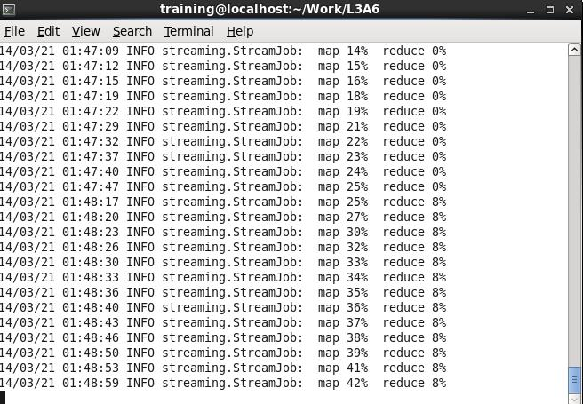
Screenshots :

Code:

(I) Find the monetary value for the highest individual sale for each store

Mapper code

#!/usr/bin/python

- Format of each line is:

- date\ttime\tstore name\titem description\tcost\tmethod of payment

- We want elements 2 (store name) and 4 (cost)
- We need to write them out to standard output, separated by a tab

import sys

for line in sys.stdin:

data = line.strip().split("\t") if len(data) == 6:

date, time, store, item, cost, payment = data print "{0}\t{1}".format(store, cost)

Reducer Code
#!/usr/bin/python

import sys

maxSale = 0 oldKey = None

for line in sys.stdin:

data_mapped = line.strip().split("\t") if len(data_mapped) != 2:

continue

thisKey, thisSale = data_mapped
if oldKey and oldKey != thisKey: print oldKey, "\t", maxSale oldKey = thisKey;

maxSale = 0

oldKey = thisKey

if maxSale<float(thisSale): maxSale = float(thisSale)

if oldKey != None:

print oldKey, "\t", maxSale

(II) Find the value of sales per category

Mapper code

#!/usr/bin/python

- Format of each line is:

- date\ttime\tstore name\titem description\tcost\tmethod of payment

- We want elements 2 (store name) and 4 (cost)

- We need to write them out to standard output, separated by a tab

import sys

for line in sys.stdin:

data = line.strip().split("\t") if len(data) == 6:

date, time, store, item, cost, payment = data print "{0}\t{1}".format(item, cost)

Reducer Code

#!/usr/bin/python

import sys

salesTotal = 0 oldKey = None

- Loop around the data

- It will be in the format key\tval

- Where key is the store name, val is the sale amount

- All the sales for a particular store will be presented,

- then the key will change and we'll be dealing with the next store

for line in sys.stdin:

data_mapped = line.strip().split("\t") if len(data_mapped) != 2:

# Something has gone wrong. Skip this line. continue

thisKey, thisSale = data_mapped

if oldKey and oldKey != thisKey: print oldKey, "\t", salesTotal oldKey = thisKey;

salesTotal = 0

oldKey = thisKey salesTotal += float(thisSale)

if oldKey != None:

print oldKey, "\t", salesTotal

(III) Find the total sales

Mapper code

#!/usr/bin/python

- Format of each line is:

- date\ttime\tstore name\titem description\tcost\tmethod of payment

- We want elements 2 (store name) and 4 (cost)

- We need to write them out to standard output, separated by a tab

import sys

for line in sys.stdin:

data = line.strip().split("\t") if len(data) == 6:

date, time, store, item, cost, payment = data print "{0}\t{1}".format(item, cost)

Reducer Code

#!/usr/bin/python import sys totalSale = 0 noOfSales=0

for line in sys.stdin:

data_mapped = line.strip().split("\t") if len(data_mapped) != 2:

continue

thisKey, thisSale = data_mapped noOfSales=noOfSales+1 totalSale+=float(thisSale)

print ("{0}\t{1}".format(noOfSales,totalSale))

REFERENCES

[1]http://www.mckinsey.com/insights/business_technology/big_data_the_next_frotier_for_innovation

- http://www.mongodb.com/big-data-explained

- http://en.wikipedia.org/wiki/CentOS

- http://www.centos.org/about/

- http://en.wikipedia.org/wiki/Gedit

- Hadoop the definitive guide by Tom White – 2nd edition

