

Composite Experiment on Assembly Language & Microcomputer Interface

Experiment Sing songs with 8253/8254 Timer
Name El Aslouni Houda, Bellaj Rim, Israelyan Varduhi, Fakhri Samya

StudentID 312023704035, 312023704001, 312023704032,
312023704003

Class CS 2023 (International Students)
Teacher Lei Yanjing
College Computer Science and Technology

Contribution of each member to the group work
Member’s Name and StudentID | Main Task and Contribution to the Group Work | Proportion of Your Contribution
El Aslouni Houda  31202370403 | - Design the hardware for the real simulation  - Write the assembly code to run the software for the real simulation  - Implement some new ideas on designing the software  - Complete the report of the composite experiment (Experimental results and debug explanations part) | 25%
Bellaj Rim  312023704001 | - Help in the design of the hardware for the simulation  - Write some parts of the assembly code (like the frequencies) to run the software  - Review the code and make sure there’s no mistakes  - Review the report of the experiment design and make sure all parts are completed | 25%
Israelyan Varduhi  312023704032 | -Complete the report of the composite experiment  -complete the Ideas of the design ( answering the given questions)  -include a part of the hardware design  -Check the running of the code simultaneously.  -Check and review the other parts of the report. | 25%
Fakhri Samya  312023704003 | -> Understand and review the program.  -> Design the hardware and test the program.  -> Answer the report questions.  -> Describe the hardware used in the experiment. | 25%

Task Description
Please drive a speaker with an 8253/8254 timer/counter to sing songs.

Solutions

Ideas of Design
- The general idea:
Our program uses the 8254 Programmable Interval Timer (PIT) to generate the
melody “Ode to Joy.” Square wave signals with different frequencies and durations
are produced and mapped to musical notes through a hashing technique. These notes
are then output and displayed on the terminal. The timer is configured in mode 3,
functioning as a square wave generator, while the timing between notes is controlled
using a predefined sequence of beats. By iterating through the note sequence, the
program reconstructs the melody of “Ode to Joy” and presents the musical output
in an organized format on the terminal.

- Which counter will you use?
The 8254 is a programmable interval timer and counter integrated circuit
commonly used in computer systems. It is part of Intel’s MCS-85 microprocessor
family and contains three independent 16-bit counters, each of which can operate either
as a timer or as an event counter.
In this task, counter 0 (Timer0) was utilized. The following section provides brief
descriptions of the pins that were used.

- GND: Ground pin.
- OUT0 (Output 0): The output pin for Counter 0. In some modes, this pin generates a pulse or a square wave.
- CLK0 (Clock 0) is the clock input for Counter 0. It is connected to an external clock source, and the frequency of this clock determines the counter's timing characteristics.
- GATE0 (Gate 0): Control input for Counter 0. When this pin is low, the counting process is halted; when it is high, counting continues.
- WR (Write): Input. Used to write the control word that defines the mode of operation and other settings for Counter 0.
- RD (Read): Read the input. Used to obtain the count value or status information from Counter 0.
- CS (Chip Select): The Chip Select input. It controls whether the 8254 integrated circuit is enabled or disabled.
- D7-D0 (Data 7-0): Data pins used for programming the control word. The control word specifies Counter 0's operating mode, binary or BCD counting, and other configuration options.

- What is the idea of playing each music note? What theoretical knowledge is concerned?
The program produces each musical note by generating square wave signals with
varying frequencies and durations. This process relies on fundamental theoretical
concepts such as musical notes, their corresponding frequencies, and rhythmic beats

- How to generate the square wave signal? What’s the working mode?
Square wave signals are generated using the 8254 timer configured in mode 3 (control word AL,36H), which operates as a square wave generator. The frequency of each musical note is stored in the FREQ_LIST array, derived from standard musical frequency relationships. Based on these values the initial count required for square wave generation is calculated accordingly.

- How can you get the corresponding frequency and initial value of each music note?
The duration of each note is controlled by retrieving beat values from the TIME_LIST array. The DALLY procedure is invoked to introduce an appropriate delay
corresponding to each beat value.

- How to control the time delay (beats)?
The time delay is controlled by fetching the beats from the TIME_LIST array.
The DALLY procedure is called to introduce a delay based on the beat value.

- How to output the music notes on the terminal?
The musical notes are displayed on the terminal using the PrintNote procedure,
which translates the frequency of each note into its corresponding musical symbol
through the use of the Note Hash array. An index calculated from frequency
manipulation is used as a key to access the appropriate note from the array, and
the selected note is then output to the terminal using the interrupt call MOV AH, 9
followed by INT 21H.

- Which song will you sing? What’s its notion like?
The song played is "Ode to Joy." The musical notes and beats for each part of the song are defined in the FREQ_LIST and TIME_LIST arrays.
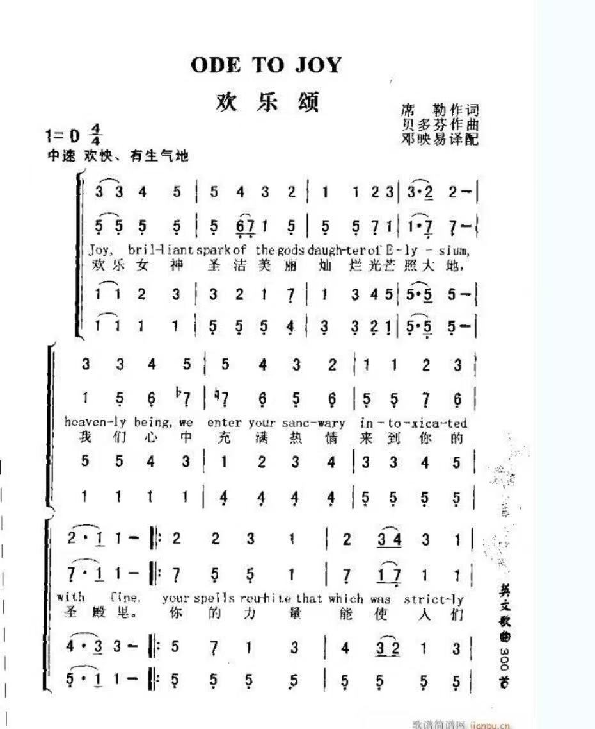
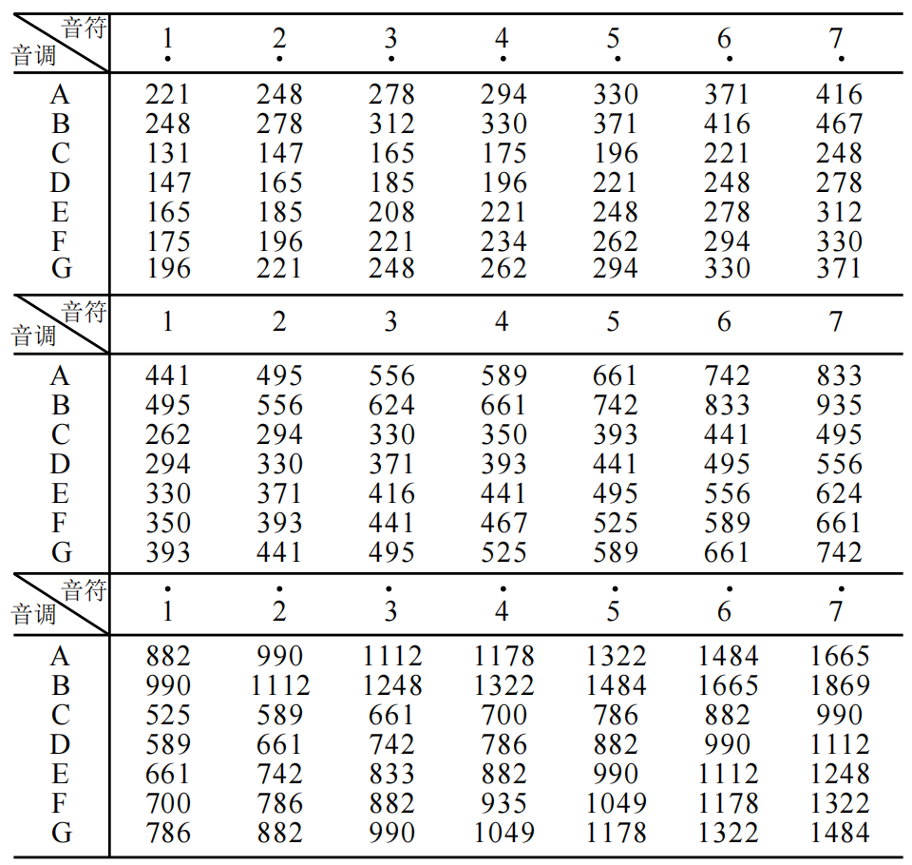
Fig. 1

2.2 Hardware Design
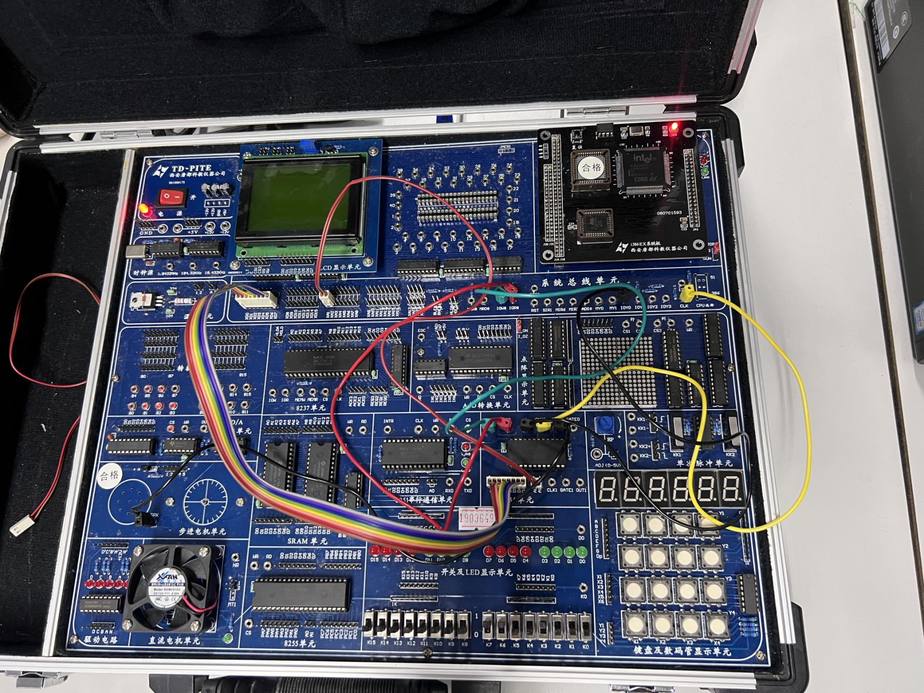

Schematic:
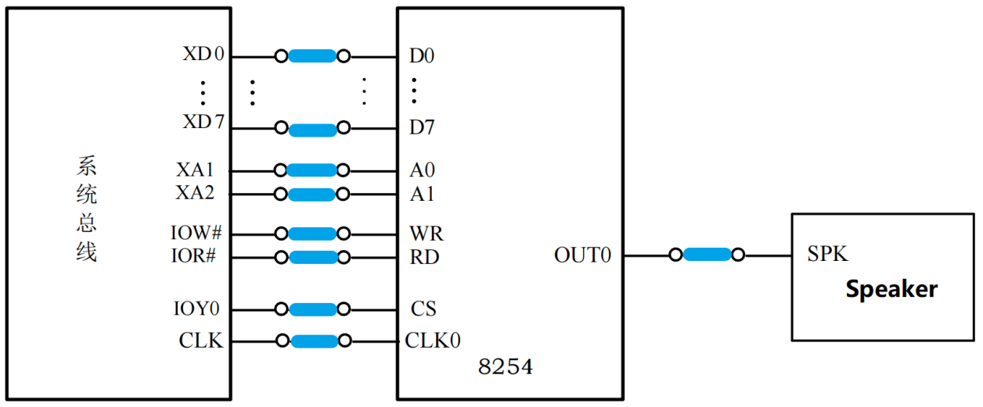
Fig. 2

8088 Microprocessor Pins
- Address Bus (A19-A0): These pins are used to access memory locations, including I/O addresses. These pins determine which register or port the 8088 communicates with. The code addresses the 8254 registers with specific I/O port addresses (IOY0, MY8254_COUNT0, MY8254_COUNT1, MY8254_COUNT2, and MY8254_MODE).
- Data Bus (D15-D0): These pins transfer data between the microprocessor and memory/I/O devices. The code moves data between registers and memory locations as needed.
- Control Pins (RD, WR): These pins determine the direction of data flow. The RD (Read) and WR (Write) signals indicate whether the microprocessor is reading or writing to a specific register or memory location.
- CLK (Clock): The CLK pin sends a clock signal for synchronization. The timing of instructions and operations is determined by the clock signal.

8254 Timer Pins
- Address Pins (A1-A0): These pins control the internal registers of the 8254 IC. Using these pins, the code specifies the address of the control register and three counter registers (MY8254_COUNT0, MY8254_COUNT1, and MY8254_COUNT2).
- Data Pins (D7-D0): These pins transfer data between the microprocessor and 8254 registers. The data pins are used to send count values and control words to the 8254.
- Control Pins (CS, WR, RD):
- CS (Chip Select) enables/disables the 8254 IC.
- WR (Write) is used to write data into the 8254 registers.
- RD (Read) is used to retrieve data from the 8254 registers.

2.3 Software Design
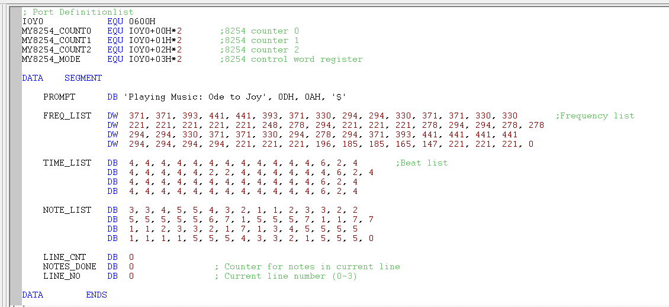

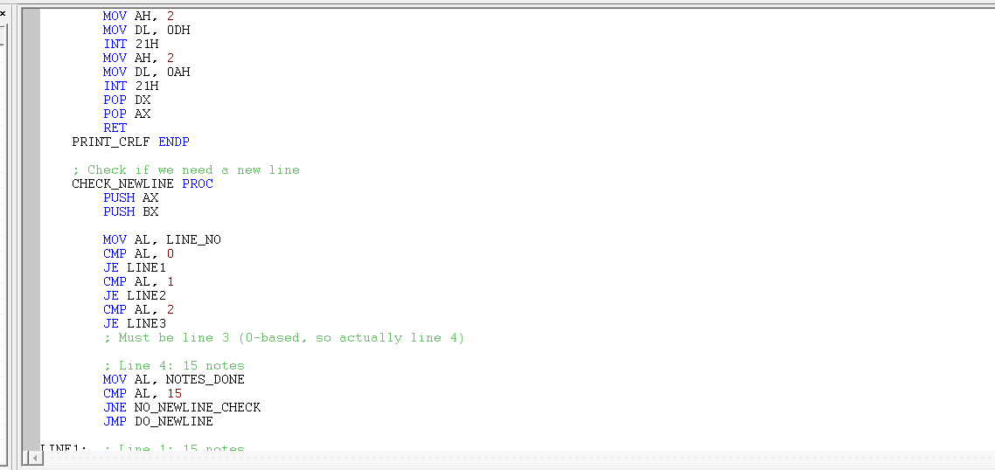
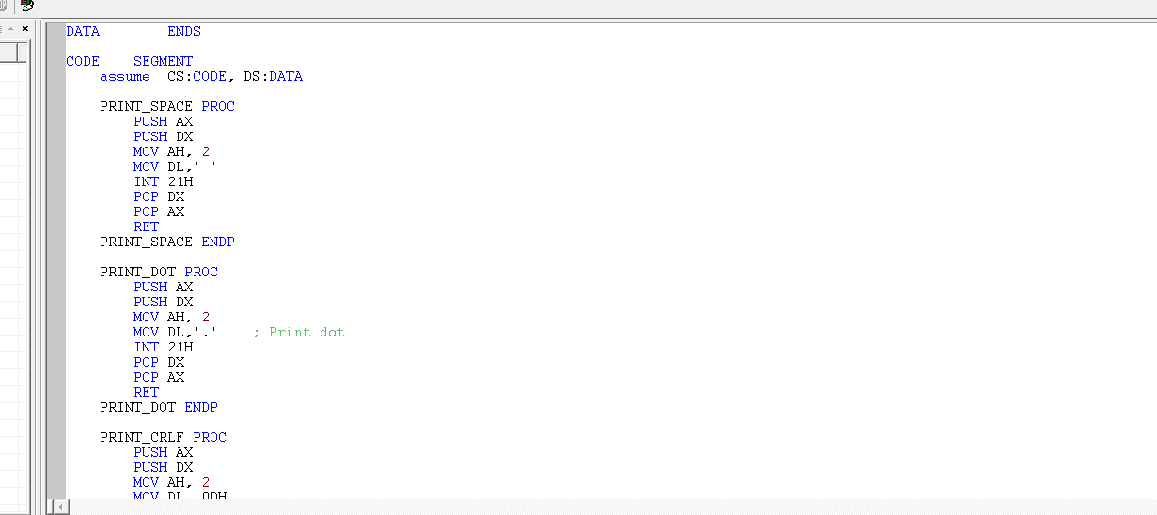
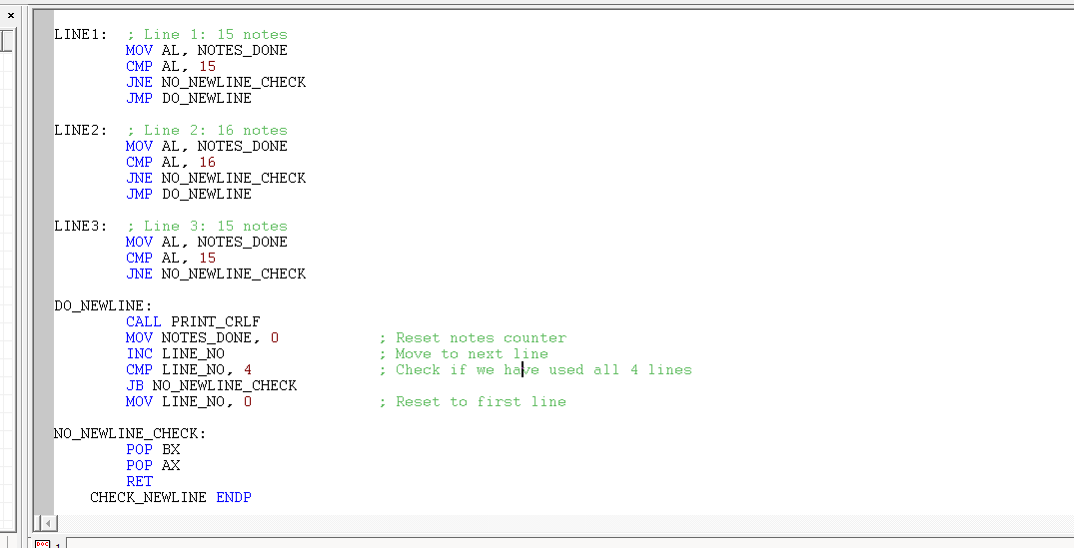

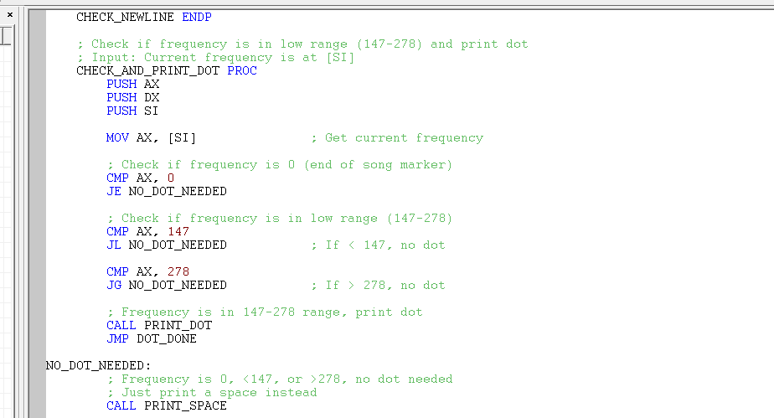

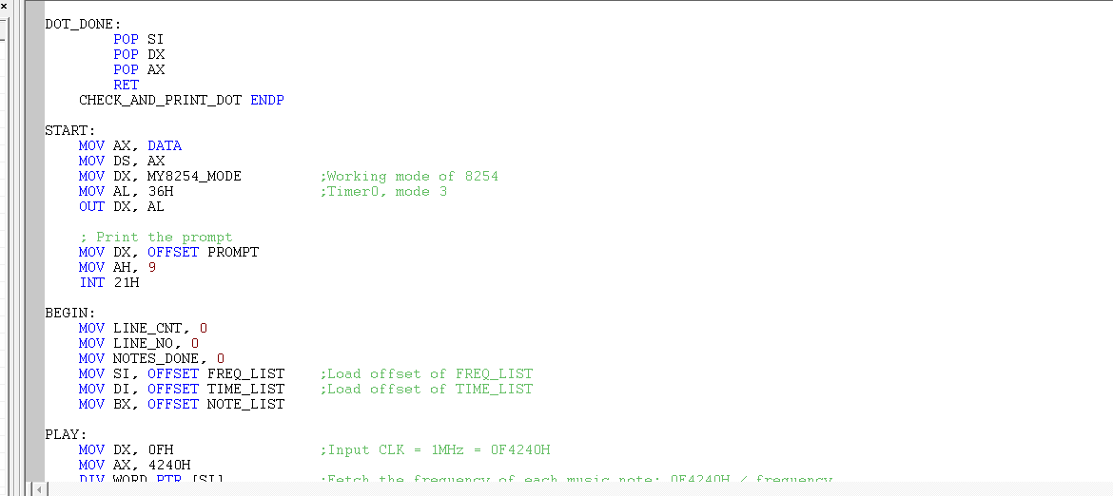

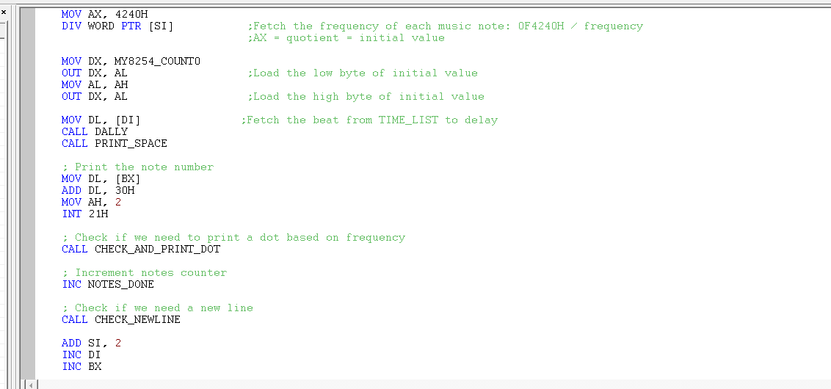

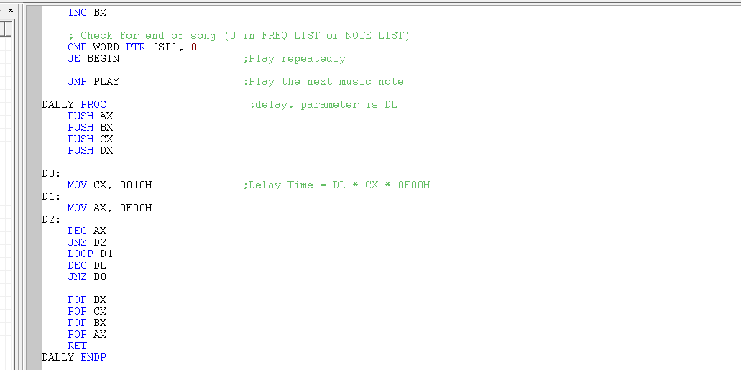

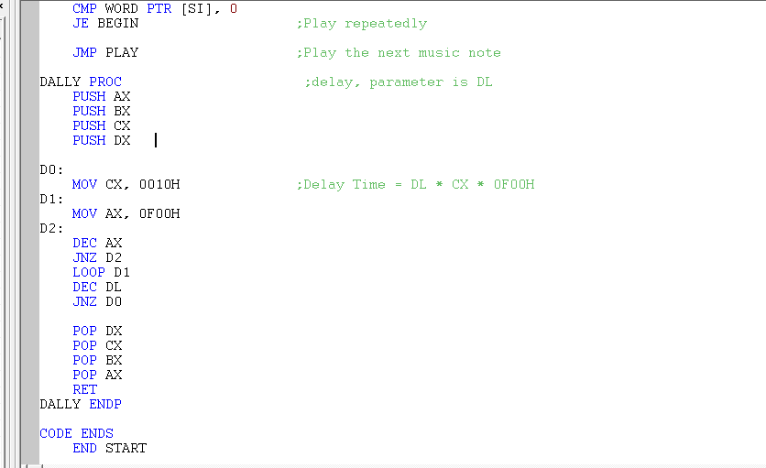

Experimental Results and Debug Explanations
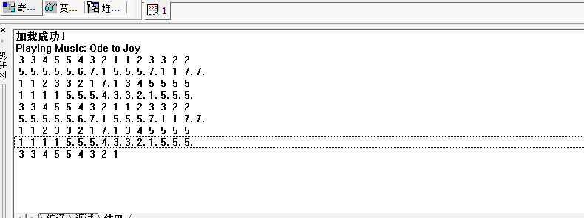
Below is the screen output of our music program. The output shown are the music notes that are being executed each time. The note hash algorithm and the PrintNote function in the assembly code make it possible to do this kind of output as shown below:

When the program runs, it plays the melody “Ode to Joy” and prints a series of numbers on the screen at the same time.
The numbers shown in the output represent musical notes using numeric notation:
1–7 correspond to the basic notes of the scale.
As each number appears, the corresponding note is being played by the speaker.
The order of the numbers follows the melody of Ode to Joy, so the printed output is essentially a visual form of the music.
If a number appears again, it means the same note is played again.
If a number stays longer before the next one appears, it means the note duration is longer.
After all the notes are played, the melody starts again, so the output repeats.

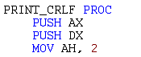
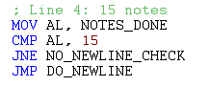
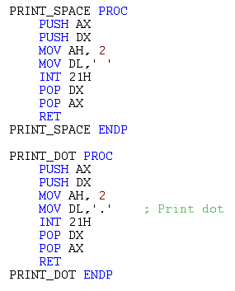
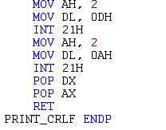
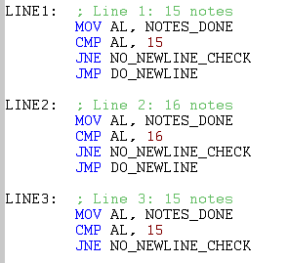

In these parts of the program, separate procedures were implemented to handle formatted output on the terminal. The PRINT_SPACE procedure outputs a single space character, while the PRINT_DOT procedure prints a dot (.). These procedures help improve the readability and structure of the displayed musical output. In the output, a dot (.) after a number means that the note is not taken from the basic table row, but from row D of the frequency table.
So when a dot appears, the program plays the same musical note number, but using a different frequency range.
Additionally, the PRINT_CRLF procedure is used to move the cursor to a new line by printing a carriage return and line feed. This allows each line of musical notes to be displayed on a separate line.
To correctly format the musical composition, conditional checks were added to control when a new line should begin. Since each line of the melody contains a different number of notes, the program compares the current note count with a predefined limit for each line (15 or 16 notes). Once the limit is reached, a newline is inserted, ensuring that each array of notes starts on a new line with the correct length.
Overall, these sections of code manage spacing, line breaks, and note grouping, allowing the musical output to be displayed in a structured and readable format on the terminal.

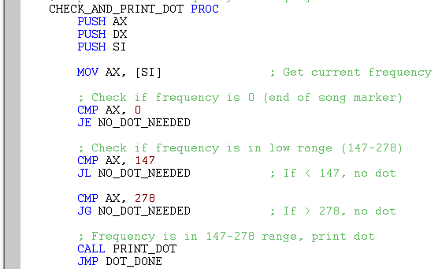

And in this part, we are checking the frequency of the note, so our output is going to be correct, and we will have a note with a dot, if the frequency range is between (147-278) and without a dot if the frequency range is bellow 147.
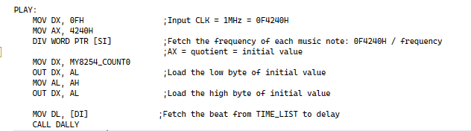
This segment effectively translates musical notes into timer values and controls their duration, enabling audio playback through hardware timing. It forms the core of a simple music synthesis system using timer-based frequency generation and software-controlled timing.

This routine begins at the label PLAY, which marks the start of the sound generation process for one musical note. First, the value 0F4240H (which equals 1,000,000 in decimal) is loaded into the DX:AX register pair. This value represents the input clock frequency of the 8254 timer, which is 1 MHz.
The instruction DIV WORD PTR [SI] divides the 32-bit value in DX:AX by the frequency of the current musical note stored in memory at the address pointed to by the SI register. After the division, the quotient stored in AX represents the initial counter value that must be loaded into the 8254 timer in order to generate the required sound frequency.
Next, the program loads the port address of Counter 0 of the 8254 into DX. The initial counter value stored in AX is then sent to the 8254 in two steps: first the low byte (AL) is sent, then the high byte (AH) is sent. This is because the 8254 counter is 16-bit and must be loaded one byte at a time.
After that, the instruction MOV DL, [DI] fetches the duration (or beat) of the note from the TIME_LIST table. Finally, the program calls the delay subroutine DALLY, which keeps the sound playing for the required amount of time before moving to the next note.
In summary, this routine calculates the correct counter value for each musical note, loads it into the 8254 timer, and uses a delay routine to control how long the note is played.

Conclusions and Experience
- 8088 Assembly Language Proficiency: The project demonstrated foundational mastery of 8088 assembly programming, including register manipulation, instruction sets, and memory addressing modes essential for low-level hardware control.
- 8254 Timer Integration: Successful interfacing with the 8254 timer highlighted its role in time-critical operations, particularly through configuration of square-wave generation modes and I/O port management.
- Acoustic Waveform Synthesis: Square-wave signals generated by the 8254 timer were effectively transformed into audible tones, establishing a direct correlation between timer output configurations and resultant sound waveforms.
- Precision Frequency Control: Mathematical calibration of timer count values enabled precise pitch modulation, facilitating the production of musical notes through calculated frequency relationships.
- Temporal Sequencing: Implementation of timing subroutines (e.g., the DALLY function) demonstrated control over rhythm, tempo, and inter-note intervals, critical for structured audio output.
- Hardware-Software Synergy: Hands-on experimentation with speaker interfacing emphasized principles of electrical compatibility, impedance matching, and iterative debugging in embedded systems.

Experience
The project reinforced the interdependence of software algorithms and hardware constraints. Practical challenges such as tuning count values for accurate pitch, optimizing delay routines, and troubleshooting physical connections underscored the necessity of empirical validation. Code modifications and parameter adjustments served as effective learning tools, cementing theoretical concepts through experiential problem-solving.

Future Work
- Advanced Synthesis Techniques: Implement pulse-width modulation (PWM) or sine-wave generation for richer audio output.
- Multi-Instrument Integration: Extend the system to support polyphonic sounds or layered waveforms.
- User Interactivity: Develop interfaces (e.g., keyboards or sensors) for real-time pitch/rhythm control.
- Embedded System Expansion: Interface additional peripherals (e.g., LCD displays) to visualize frequency data or system states.
- Power Efficiency Optimization: Refactor timing routines to minimize CPU usage and power consumption.

Final Conclusion
This endeavor successfully demystified core principles of microprocessor architecture and hardware interfacing, transforming abstract concepts into functional sound-generation systems. The synthesis of assembly programming, timer configuration, and acoustic engineering not only achieved project objectives but also established a framework for future explorations in embedded systems. The experience highlights the enduring relevance of low-level programming in modern computing and sets a foundation for advanced work in real-time system design.

