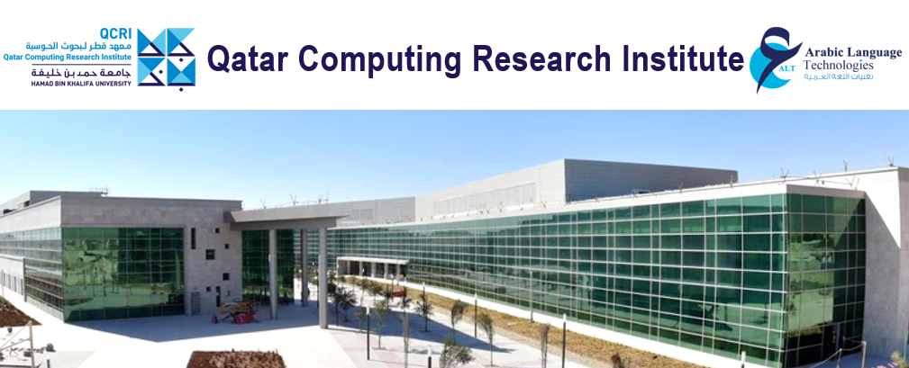

**Join us for the exciting future in research and innovation!**

**Principal Scientist Posts at the Qatar Computing Research Institute**

**The Arabic Language Technologies** **(ALT) Group** at the **Qatar Computing Research Institute** **(QCRI)** is launching new initiatives in research, engineering and incubation of products and services. We are looking for experts in machine learning, deep learning, computational linguistics and NLP to join the ALT team as **Principal Scientists**, to lead projects and take research in exciting new directions. Being familiar with Arabic languages is beneficial but not a pre-requisite.

If interested, contact us at [jobs@qcri.org](mailto:jobs@qcri.org) with a subject header “ALT Scientist Application” and a brief description of how your interests and aspirations align with our needs. Please attach your CV with a publication list and highlight three recent papers or projects that best represent your achievements.

We encourage you to send your information as soon as possible. We will review applications as they arrive, starting from 9 May 2022, and fill the positions as we find suitable candidates. If your application is considered, we will contact you promptly. Otherwise, we will retain your information for future positions, unless you advise us differently.

*About the team*

ALT Group was formed in 2011 as a flagship QCRI research initiative, addressing challenging problems in machine learning, computational linguistics and NLP in the context of machine translation, Arabic NLP stack, multi-lingual speech processing, model interpretability, and fake news detection. Our team has become well known in the research community for our high-quality work and a range of released tools and resources, including state-of-the-art techniques for processing Arabic texts and Arabic media. Our research papers and systems have been featured in top tier conferences and journals such as ICLR, ACL, AAAI, InterSpeech, ICASSP, and similar.

We are now planning a new wave of initiatives that combine research, engineering, and incubation of products and services and enable us to broaden impact of our work. This is motivated by increased opportunities to apply advanced NLP, machine learning, and deep learning techniques to use scenarios across disciplines and industry sectors.

*About the position*

As a Principal Scientist, you will shape new research directions and collaborate with peer researchers and engineers on developing, evaluating, publishing, and demonstrating methods and technologies that address challenging problems.

Depending on your interests, you will have opportunities to work with incubation teams, to support development of concepts, design of products and services, and setting up commercial enterprises. This will enable you to transform your research ideas into usable and impactful applications.

The role of a Principal Scientist is equivalent to a (full) Professor role in academic institutions or senior research roles in industry R&D labs and institutes, requiring a proven track record in leading research, publishing in top-tier conferences and journals, and generating intellectual property in the form of disclosures and patents.

We offer a highly competitive compensation package including an attractive tax-free salary and additional benefits such as accommodation allowance, excellent medical insurance, and generous annual paid leave.

*About the work environment*

Research work at QCRI is supported by research assistants, experienced research engineers, and highly skilled software engineers. QCRI is equipped with a well-serviced state-of-the-art computing infrastructure with a capacity to run large experiments efficiently. This has enabled ALT researchers to release and host a number of technology demonstrators and widely used tools, including:

* [**Farasa**](https://farasa.qcri.org/)– State-of-the-art full-stack of Arabic Language Processing
* [**ASAD**](http://asad.qcri.org/)– Arabic Social media Analytics and unDerstanding toolkit
* [**Shaheen**](https://mt.qcri.org/api) – Multi-dialectal Arabic-English translation service
* [**Tanbih**](http://tanbih.qcri.org/)– News aggregation service detecting “fake news”, disinformation, propaganda, and media bias
* [**NeuroX**](https://neurox.qcri.org/demo) – Toolkit for model interpretability
* [**QATS**](https://qats.qcri.org/)– Multi-dialectal Arabic Transcription technology, now part of [**Kanari AI**](http://kanari.ai/)
* [**Arabic Text to Speech**](https://tts.qcri.org/)– Arabic speech synthesis.

Located within Education City, QCRI is in the proximity of university campuses and two research institutes, with opportunities for cross-disciplinary and multi-disciplinary research. Computer science departments at the Carnegie Mellon Qatar, Hamad bin Khalifa University (HBKU), and Qatar University provide a steady influx of interns who are eager to work on projects.

*About life in Qatar*

With a large international community living and working in Qatar, there are many opportunities to learn about and experience different customs and cultures. Doha is a cosmopolitan city which caters for a diverse population and makes everyone feel at home. By respecting cultural and religious freedoms, it welcomes people from all over the world.