Figure 1: Sample caption above the image



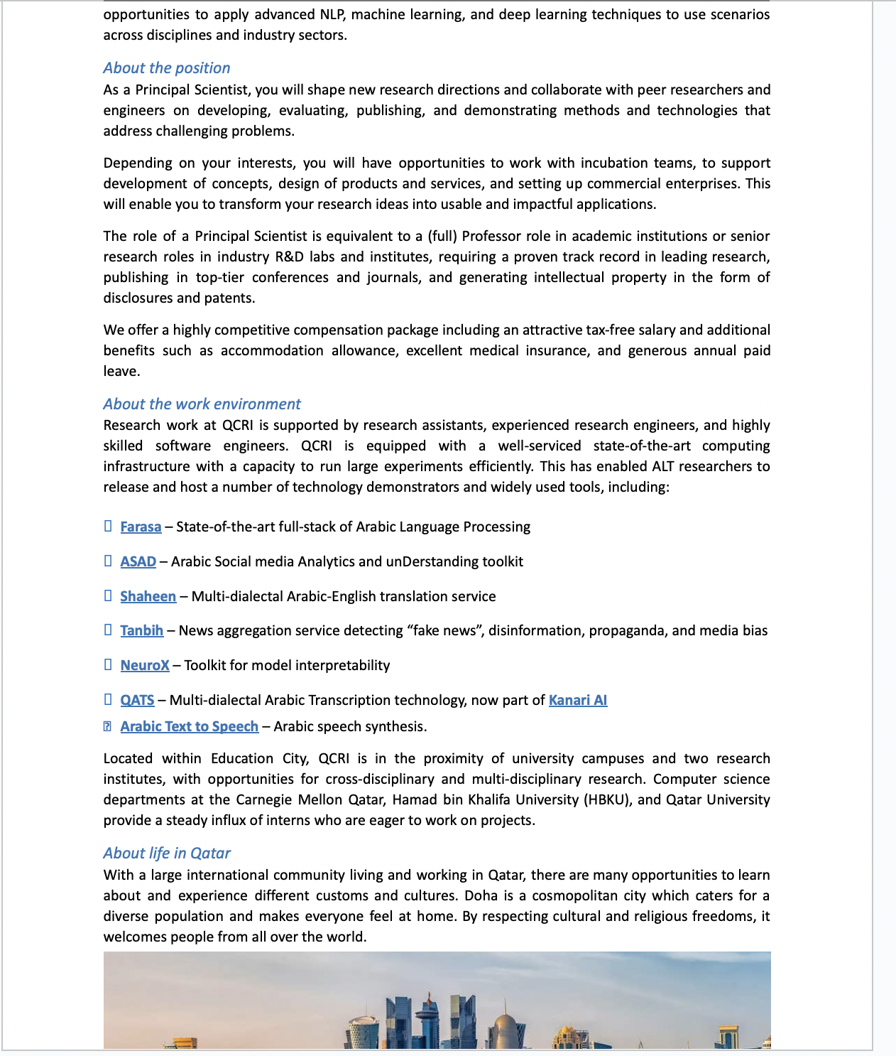

Figure 2: Sample caption below the image

1. 1. Hello world
2. 2. _____
3. 3.

* - Bonjour
* - _______
* -