COMP1531 Group Project

Team name: Trinity Force

Dean Hou z5163159

Siyang (Stephen) Wang z3254606

Duowei Sun z5174073

**USER STORIES**

*1SP = 2.5HR

*Priority is on a qualitative scale - low, medium, high

1. **As a customer, I would like to be able to select my complete meal online so that it saves my time**

|  |  |
| --- | --- |
| **ID** | **US 1.1** |
| **Name** | Customer Create Main Meal |
| **Description** | As a customer, I would like to be able to create my burger or wrap so that I can make the burger or wrap that suits my needs |
| **Acceptance Criteria** | Test – A customer can click on the “Mains” button on the top navigation bar and choose to add to my order a base burger/wrap or a custom burger/wrap by pressing “Add to order”. On this page the customer can see which ingredients are in the base burger/wrap in the “ingredients” column, but only see the words “Custom” in the “ingredients” column for a custom burger/wrap.  Test – A customer who clicks on “Add to order” for a base burger/wrap will have that base burger/wrap added to their order without having to go through any customisation pages  Test - A customer will be redirected to a page that allows them to add ingredients to their burger/wrap if he chooses to add a custom burger/wrap to their order. The process includes selecting the bun type and quantity, the patty type and quantity and other ingredients (tomato, lettuce, tomato sauce, cheddar cheese, swiss cheese) and being able to view their respective prices.  Test – Once the customer has chosen the ingredients to add to their custom burger/wrap they can click the “Add to order” button to add the custom burger/wrap to the order if the custom burger/wrap is valid.  Test - If the order has an invalid number of buns or patties, the customer will be directed to the top of the ordering page with an error message containing the reason why it is invalid. An example would be, “Burger can have maximum 3 patties” One error message will appear for each invalid item.  Test - If *Gourmet Burgers* does not have enough inventory to satisfy the order, the customer will be directed to the top of the ordering page with an error message containing how many of the out of stock item *Gourmet Burgers* has in store. An example would be, “1 beef patty left”. One error message will appear for each item *Gourmet* *Burgers* does not have in stock.  Test – A customer should be able to only input positive whole numbers into the quantity field on the customisation page, any other input would show an error |
| **Priority** | High |
| **Size** | 5SP |

|  |  |
| --- | --- |
| **ID** | **US 1.2** |
| **Name** | Customer Select Drink |
| **Description** | As a customer, I would like to be able to add a drink to my order to complement my burger or wrap and sate any possible thirsts. |
| **Acceptance Criteria** | Test - A customer can click the “Drinks” button on the top navigation bar and see a list of available drinks water or orange juice and their prices. In addition, they will be able to select the quantity of drinks they want – 600ml bottles for water, or the size (small, medium, large) for orange juice. The customer can click “Add to order” to add the drinks to their order.  Test - If *Gourmet Burgers* does not have enough inventory to satisfy the order, the customer will be directed to the top of the ordering page with an error message containing how many of the item *Gourmet Burgers* has in store  An example would be, “Only 3250 orange juice left”. One error message will appear for each item *Gourmet* *Burgers* does not have in stock. |
| **Priority** | High |
| **Size** | 2SP |

|  |  |
| --- | --- |
| **ID** | **US 1.3** |
| **Name** | Customer Select Sides |
| **Description** | As a customer, I would like to be able to add a side to my order to so that my meal is more fulfilling |
| **Acceptance Criteria** | Test - A customer can click the “Sides” on the top navigation bar button and see a list of available sides including fries and nuggets and their prices. In addition, they will be able to select the quantity of sides they want – small, medium or large for fries and nuggets. The customer can click “Add to order” to add the sides to their order.  Test - If *Gourmet Burgers* does not have enough inventory to satisfy the order, the customer will be directed to the top of the ordering page with an error message containing how many of the item *Gourmet Burgers* has in store. An example would be, “Only have 5 fries left.”. One error message will appear for each item *Gourmet* *Burgers* does not have in stock. |
| **Priority** | High |
| **Size** | 2SP |

|  |  |
| --- | --- |
| **ID** | **US 1.4** |
| **Name** | Customer Select Desserts |
| **Description** | As a customer, I would like to be able to add a dessert item to my order to so that I can have something sweet to complement my meal. |
| **Acceptance Criteria** | Test - A customer can click the “Desserts” button on the top navigation bar and see a list of available desserts such as sundaes and their prices. In addition, they will be able to choose the quantity of the dessert they want – small, medium or large. The customer can click “Add to order” to add the desserts to their order.  Test - If *Gourmet Burgers* does not have enough inventory to satisfy the order, the customer will be directed to the top of the ordering page with an error message containing how many of the item *Gourmet Burgers* has in store. An example would be, “Only have 5 sundaes.”. One error message will appear for each item *Gourmet* *Burgers* does not have in stock. |
| **Priority** | High |
| **Size** | 2SP |

1. **As a customer, I would like to be able to place my order online so that the restaurant can start to prepare my meal as soon as possible.**

|  |  |
| --- | --- |
| **ID** | **US 2.1** |
| **Name** | Customer View Order |
| **Description** | As a customer, I would like to be able to see what I have added to my cart, so that I can double check what I have ordered. |
| **Acceptance Criteria** | Test - A customer can click the “Home” button and see a list summary of what they have ordered. They should be able to see their created or base burger(s) and or wrap(s), any drinks, any sides and any desserts along with their respective item name, ingredients, quantity and price. The net price of the customer’s order is displayed.  Test – The customer can click “Reset Order” to begin creating their order anew |
| **Priority** | High |
| **Size** | 2SP |

|  |  |
| --- | --- |
| **ID** | **US 2.2** |
| **Name** | Customer Place Order |
| **Description** | As a customer, I want to be able to checkout my order so that *Gourmet Burgers* can start preparing my meal as soon as possible. |
| **Acceptance Criteria** | Test - A customer can click a “Checkout” button after selecting their meal. If *Gourmet* *Burgers* can fulfil the order, then the customer is directed to the Checkout page with the message “Thanks for your order!” at the top. In addition, the page will display:   1. Their Order ID 2. The total price of the order 3. The order status (preparing, ready) 4. If the order status is ready, then an additional message “Your order is ready to be picked up!” will show under the order status 5. The items in the order (name, ingredients, quantity, price) |
| **Priority** | Moderate |
| **Size** | 3SP |

1. **As a customer, I would like to be able to view the status my order after it has been placed so that I can pick up my meal as soon as possible.**

|  |  |
| --- | --- |
| **ID** | **US 3.1** |
| **Name** | Customer Order Status |
| **Description** | As a customer, I would like to be able to view the status my order after it has been placed so that I can pick up my meal as soon as possible. |
| **Acceptance Criteria** | Test - A customer can click on the “My Order” button on the top navigation bar and be prompted to enter their Order ID and can then press the “Find Order” button to find the order. If a valid Order ID is entered, then the customer is shown the Checkout page for that order which contains the message “Thanks for your order!” as well as:   1. Their Order ID 2. The total price of the order 3. The order status (preparing, ready) 4. If the order status is ready, then an additional message “Your order is ready to be picked up!” will show under the order status 5. The items in the order (name, ingredients, quantity, price)   Test – If the customer does not enter a whole positive number, the then the customer will be directed to the top of the page with the error message, “Order Id not valid”.  Test - If the customer enters a whole positive number, but the number is not a current Order ID, then the customer will be directed to the top of the page with the error message, “Order with this Order ID does not exist”.  Test - If the customer clicks the “refresh” button, the order status should display the most current version. |
| **Priority** | Moderate |
| **Size** | 3SP |

1. **As a staff member, I would like to be able to view and update current orders so that I can make the customers’ orders and notify customers when their order is ready.**

|  |  |
| --- | --- |
| **ID** | **US 4.1** |
| **Name** | See current orders |
| **Description** | As a staff member, I should be able to see current customer orders at any time so that I know which orders currently need to be made |
| **Acceptance Criteria** | Test – The staff member can see the current state of an order at any given time if the order has not yet been completed on the Staff Home page  Test - The staff member can see a list of all current orders with the orders being listed with the oldest at the top and the newest at the bottom on the Staff Home page  Test – The staff member should be able to see each order displayed with the order ID, their order items, and the order status  Test – If there are no current orders then the Staff Home page should show no orders |
| **Priority** | **High** |
| **Size** | **5SP** |

|  |  |
| --- | --- |
| **ID** | **US 4.2** |
| **Name** | Update order status |
| **Description** | As a staff member, I should be able to update the status of current customer orders at any time, so I can alert customers when their orders are ready |
| **Acceptance Criteria** | Test – If the order has been prepared and is ready to be picked up, the staff member should be able to press the “Complete order” button to change the order status of the order to that of ‘ready’ and that order should disappear from the current customer orders list |
| **Priority** | **High** |
| **Size** | **3SP** |

1. **As staff, I would like to be able to view and update current stock levels so that I know which items I need to stock up on and keep the business running**

|  |  |
| --- | --- |
| **ID** | **US 5.1** |
| **Name** | Staff view and update inventory stock |
| **Description** | As staff, I would like to be able to view and update current stock levels so that I know which items I need to stock up on and keep the business running |
| **Acceptance Criteria** | Test – The staff should be able to see stock levels for all the ingredients for the mains, and the stock levels for the base items for the sides, drinks and desserts (e.g. the base item for small nuggets, medium nuggets and large nuggets would be nuggets)  Test – The staff should be able to see an item decrement by the appropriate amount in the appropriate measurements when and order with that item has been correctly placed  Test – The staff can refill the quantity of an inventory item by entering a quantity to refill of that item and pressing the “Refill” button at the end of the page  Test – After the staff has refilled a quantity of a inventory item, the stock level for that inventory item should increase by the amount that was inputted in the refill process |
| **Priority** | **High** |
| **Size** | **4SP** |

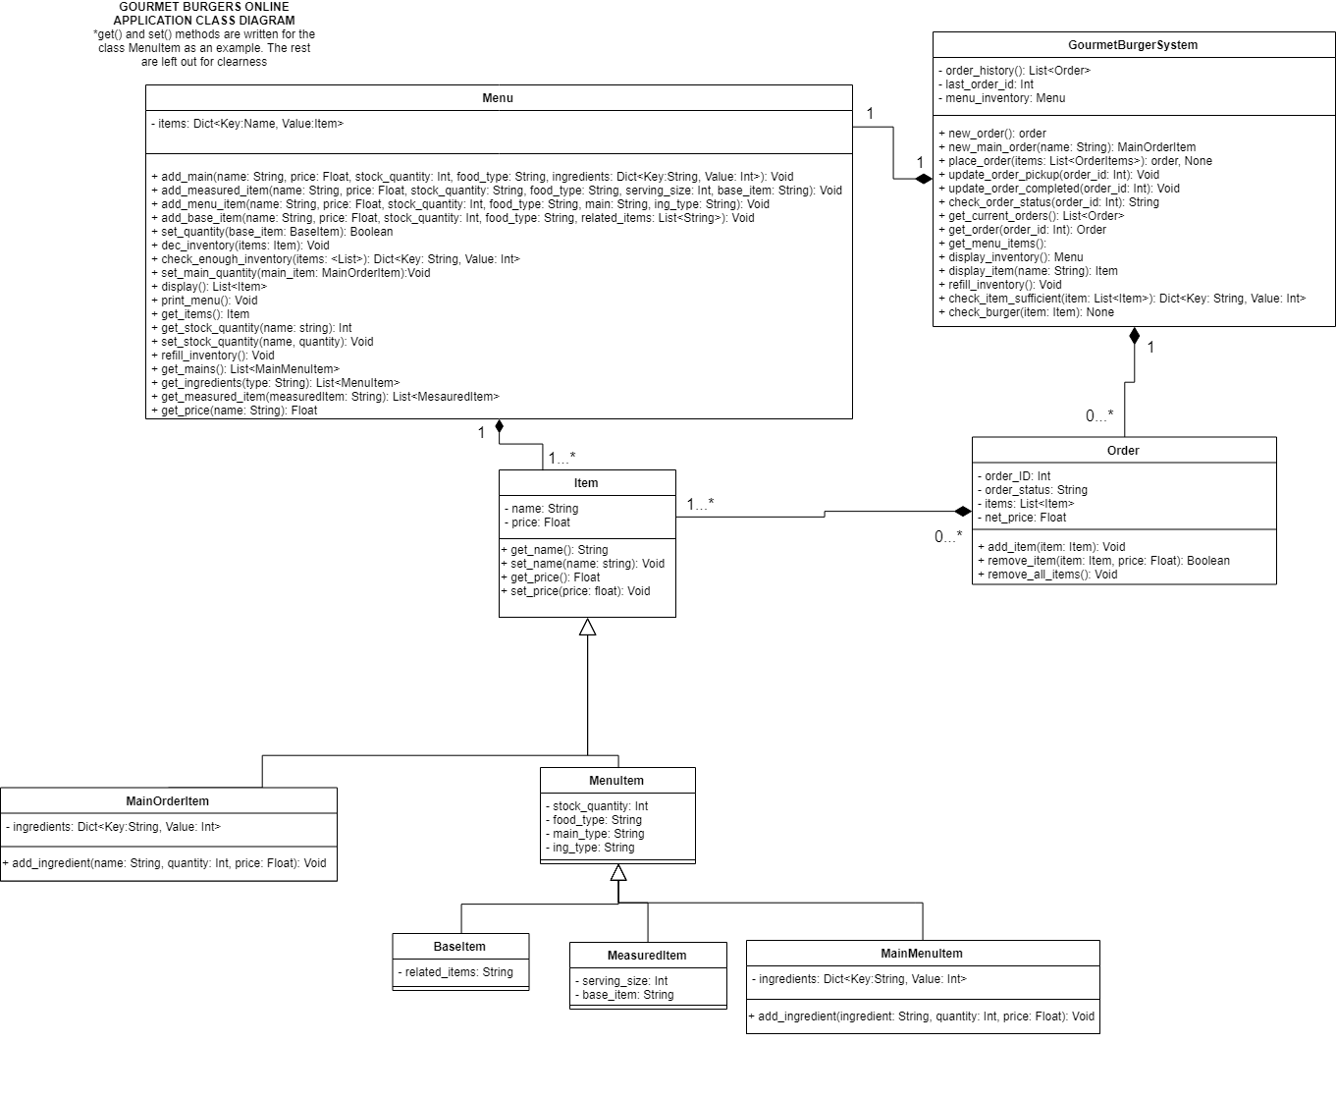Class Diagram

ER diagram

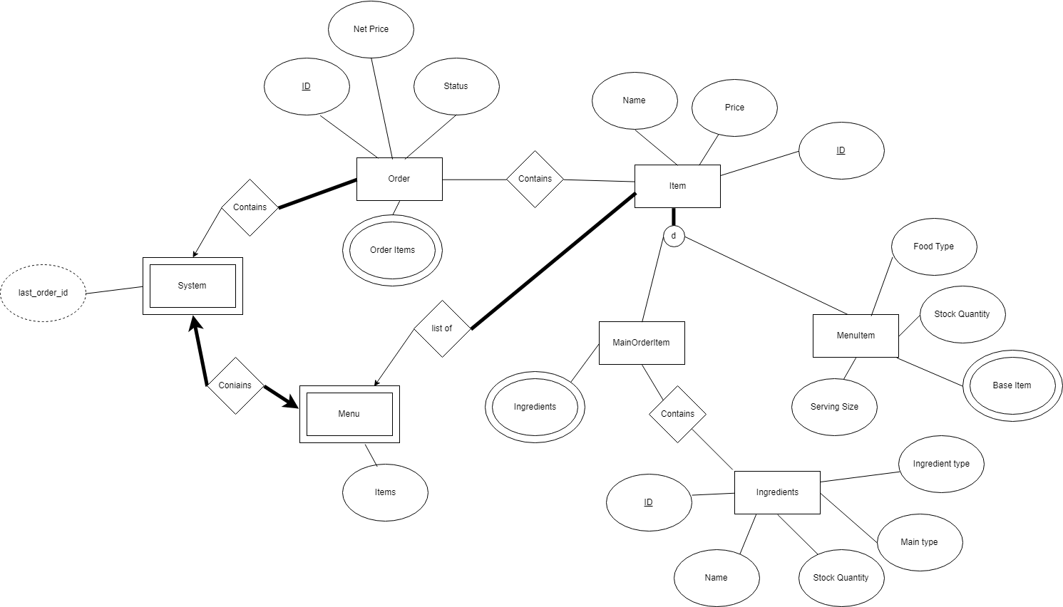

# LogBook

**Meeting Wednesday Week 3 (6/3)**

- Agreed on 6 major epic stories for assignment 1. Wrote up basic drafts for user stories and epic stories.

- Responsibilities: Agreed that Victor will do 1st and 2nd customer related epic stories, Stephen the 3rd and 4th and Dean the staff (5 and 6) epic stories.

- Agreed that the next meeting will be Sunday afternoon 5PM to discuss epic stories and combine for submission.

- Blocks: None

**Meeting Sunday Week 3 (10/3)**

- All team members completed their assigned responsibilities. All assigned team user stories were completed. User stories were combined and submitted.

- Responsibilities: No additional tasks given for assignment.

- Blocks: None

**Meeting Monday Week 5 (18/3)**

- Decided that the first step is to design the program via analysis of possible classes.

- Responsibilities: Team members tasked with reading the assignment specification and producing a list of possible classes.

- Blocks: none

**Meeting Sunday Week 6 (31/3)**

- A list of possible classes was produced which helped the drawing of a draft of the class diagram. - Stephen and Dean elicited advise from tutor about our class diagram. Class diagram implemented with mid term advise from Ian Park and from lab advice. Decided the next step was to start coding. Decided that although a Dictionary data structure could be used for class MenuItems, we will stick to Lists as we are all more confident with Lists than Dictionary.

Responsibilities: Stephen to start implementing the class Menu and Dean to implement the class Order.

Blocks: None

**Meeting Saturday Week 8 (13/4)**

- Discussed where we were at the moment, and what things we had yet to implement, suggestion was made to watch lecture Feb 27 to get better idea of how front end was to operate.

Responsibilities: Dean and Victor to start front end. Dean to start with customer related pages and Victor to start on staff related pages. Victor to help dean with customer related pages after staff related pages. All webpages to be implemented by Tuesday night 7PM except any content related to the back end. Stephen to write unit tests for backend program. Stephen to edit backend code so that they conform with OO design principles - cohesion, coupling, SRP etc. By Sunday night. Stephen to implement pickle.

- Blocks: due to changes in the backend had to wait until Stephen was done to proceed with implementing rest of front end

**Velocity Chart**

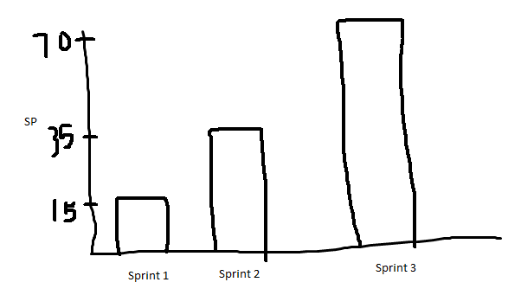

Sprint 1 was the implementation of backend in milestone 2: Weeks 5-7

Sprint 2 was the start of implementation of front-end + improvement of backend: Weeks 7-8

Sprint 3 was the finishing of product Week 8- week 9