Problem 3

Data augmentation

In order to learn features from various images of position of dog and cats, we have augmented the dataset examples with

- Horizontal flipping: the input image is randomly mirrored so the model could learn features of a dog or cat even if it is flipped. The dog shown in the left side below and the right side below should both be recognised as a dog by the model.



- Image rotation: Similarily to the horizontal flipping process, we have added random rotation (up 10 degrees roration) to the training set to learn features of a dog or cat no matter how it is oriented. This is meant to make the model able to recognize a dog or cat even if it is slighty rotated.
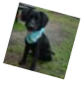

- Image rescale and cropping: the training images have been cropped and then rescale back to the original size. The purpose of the operation is to build some invariance to scaling of dogs and cats features in our model.

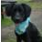

Dataset splitting

To determine the appropriate the hyperparameters (number of convoution layers, kernel size, learning rate, choice of activation function, etc.) for the current task, we have split the initial training set into a final training set and a validation set with a ratio of 90 % and 10 % respectively. This way, we should be able to have enough training examples to learn the features and enough validation set examples so the result of the validation can be considered a good representation of unknown inputs (test set). In this case, we have
- Training set total examples : 19,998 items
- Training set after split (90%) : 17,999 items
- Validation set after split (10%) : 1,999 items

Q3.1
Q1.
We use a CNN which is inspired from VGGNet model with 3 convolution layers followed by max pooling layers from beginning to end and 2 linear layers as shown in the figure 2.
The size of the filter is (3x3) with padding p= 1 and the max pooling windows is (2, 2) with stride s=2.
the total number of parameters are 4584769.
The learning rate is 0.00001
The batch size is 128
The number of epochs is 186

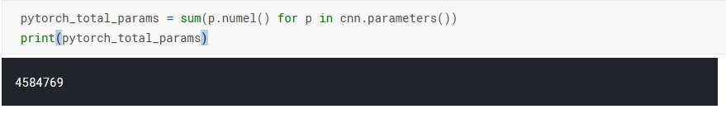
Figure 1. Total numbers of parameters
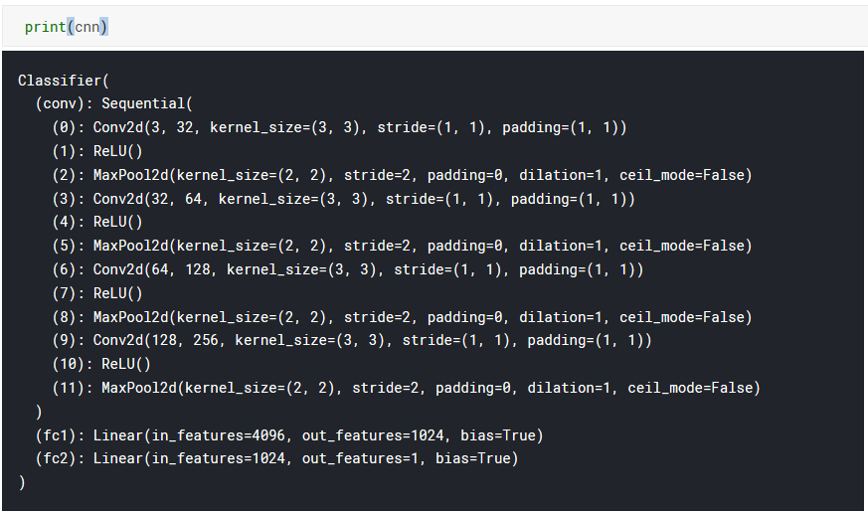
Figure 2. Model architecture

Q3.2

The validation and training losses and accuracy are shown below.

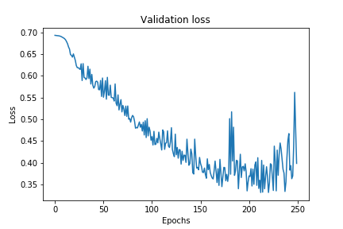
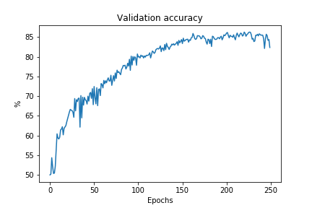
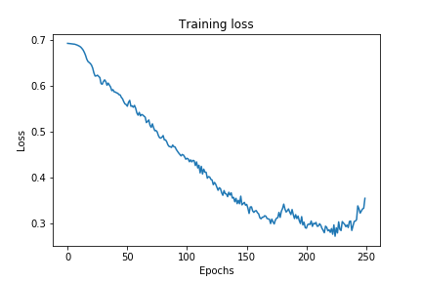
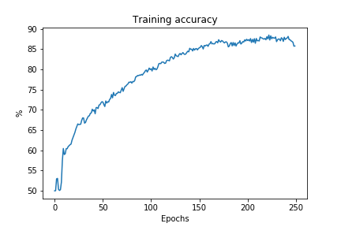

The first trend we can observe is the more training epochs we execute the more the accurate the training and validation are until a certain point. However, as we could see from the validation loss curve, the model starts to overfit on the training set after about 225 epochs. This is because the neural network is now modeled after the training set which degrades generalization perfgormance of the network.

Also, we can see a spike in the training loss and validation loss at about epoch 180. This may be due to an explosion of the gradient somehow. The model then converges back to a suboptimal point in epoch ~ 210.

In order to improve our validation performance and hopefully the test accuracy, we could have added some regularization techniques in the process so our model could be better at generalization. For example, we could have implementend
- Dropout: randomly removing some nonoutput units during training phase. This way, the learned features could be spread across more neurons instead of being “concentred” in certain neurons in the network.
- L1 or L2 regularization: adding a regularizer term in the objective function to “penalize” the weight.

We obtained the best accuracy in validation of about 84.75% with the hyperparameters described in 3.1. Then, we submitted our model to the test set which results in a score of 85.74%. From these numbers, we can suggest that the validation process was good enough so we could have a similar performance with the test set. Our model was able to generalize to the test examples and didn’t overfit either to the training set or the validation set.

Q3.3

a. We will add another linear layer and keep the other hyperparameters, we get:

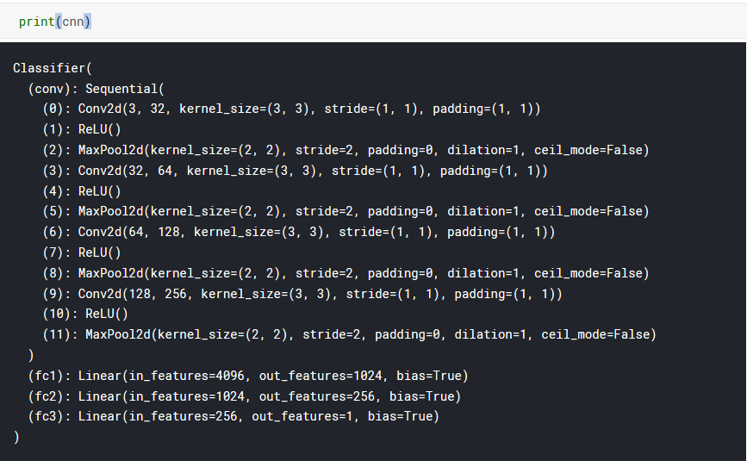
Figure 4. Model architecture

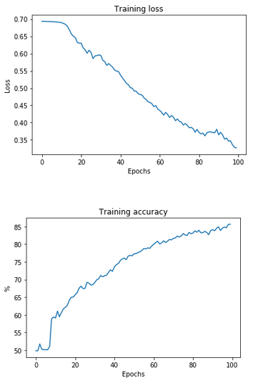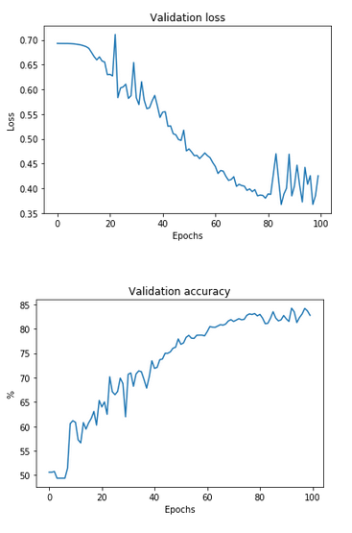
Figure 5. Performance finale sur valide set
b. we try to increase the value of learning _rate by keeping the other hyperparameters.
Learning rate =0.001
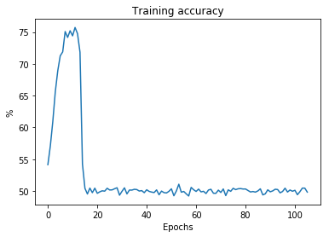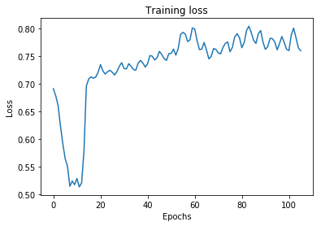
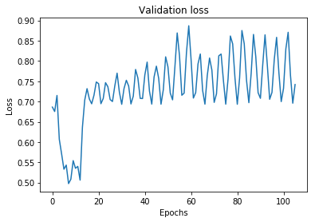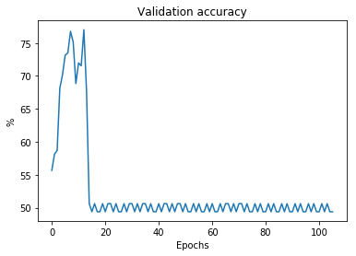
Figure 6. Performance finale sur valide set

Some of the misclassification examples that the network got are shown below

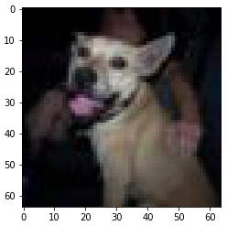
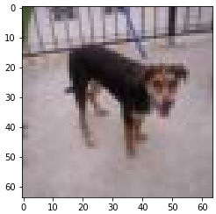
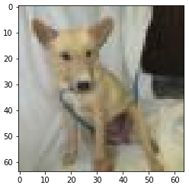

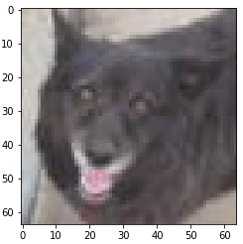
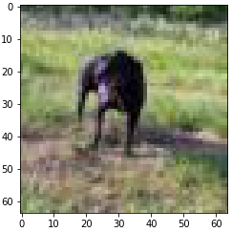
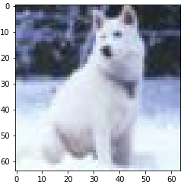

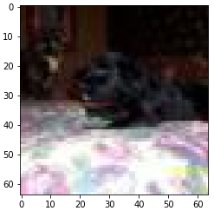
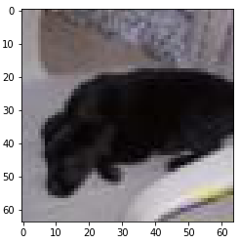

We notice from these samples that dogs with pointy ears are more prone to be classified as cats. Thus, it is highly probable that our model learned features on the ear of the animal and every photo where an animal has pointy ears, it is considered to be a cat. What we also observe is image where the object is not really distinguishable is quite hard for the network to classify as shown on image e).

For a couple of test images, the model ouputs a probability of about 50 % on both classes (we’ve displayed the input images when the output of the neural network is 0.45 < y < 0.55).

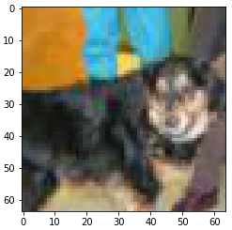
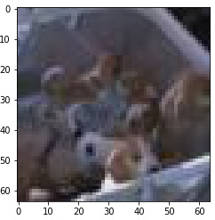
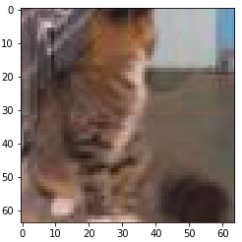

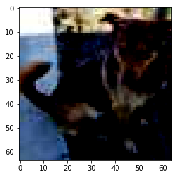
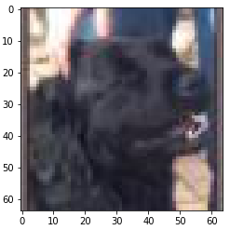
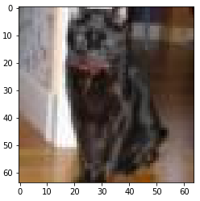

What we notice here is dark object of interested in the image make it harder to the network to be able to classify with high probability the class of the input as shown in the last row of the images above. There is a difficulty to detect facial features on the animal (hard to locate the nose, the eyes, etc.). Also, form the first image, we could clearly see why the convolutional neural network had a gard time predicting the class since the face of the cat is not visible. Another case where there is some difficulties for the model is the presence of multiple object as seen on image #2 on the first row. It is much easier to

To improve the whole model, we could perform additional pre-processing on the image in order to enhance details, edges and features in the image. This way, the network may be able to learn and detect features that were indistinguishable before. This could be done with a high-pass filter. As for dark object, we could add histogram equalization on the image to spread the contrast of the image and thus make it more clearer and brighter. Also, image segmentation could be perform first so we can extract the object of interest and suppress any background information.

